Lab Report

ECPE 170 – Computer Systems and Networks – Spring 2022

Name: Dean Shin

Lab Topic: MIPS Assembly Programming (Basic) (Lab #: 0009)

Question #1:
Take two screenshots of the MIPS register panel: one before your program runs, and one after your program finishes. Put the register panel in Decimal mode (right-click) so it is easy to see register values.
Answer:
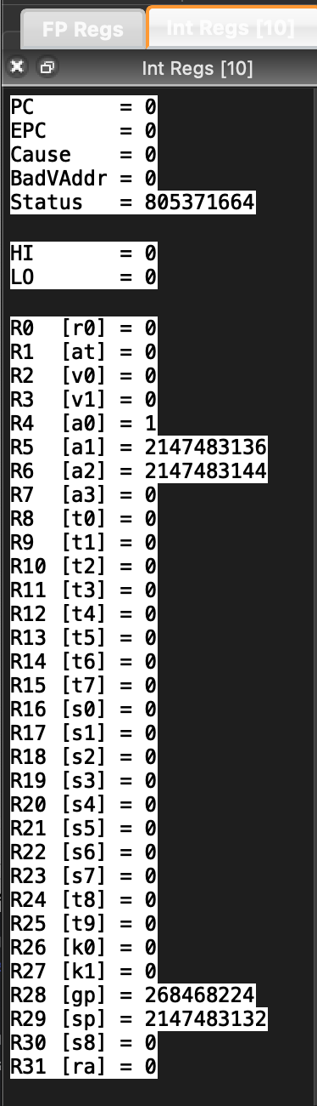
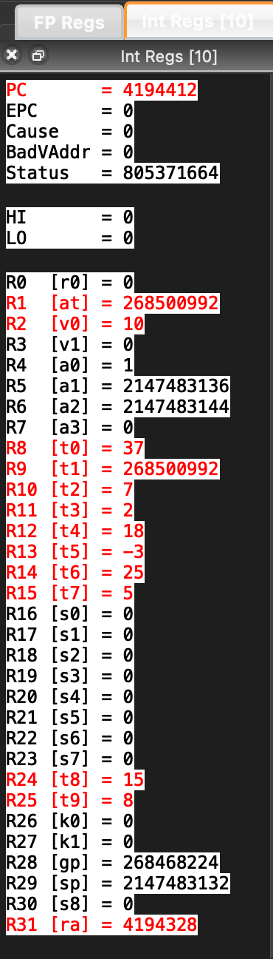

Question #2:
Take two screenshots of the MIPS memory panel (data tab): one before your program runs, and one after your program finishes. Put the memory panel in Decimal mode (right-click), so it is easy to see memory values. In the after-execution capture, circle the memory location (not register) that contains the final calculated value of Z.
Answer:
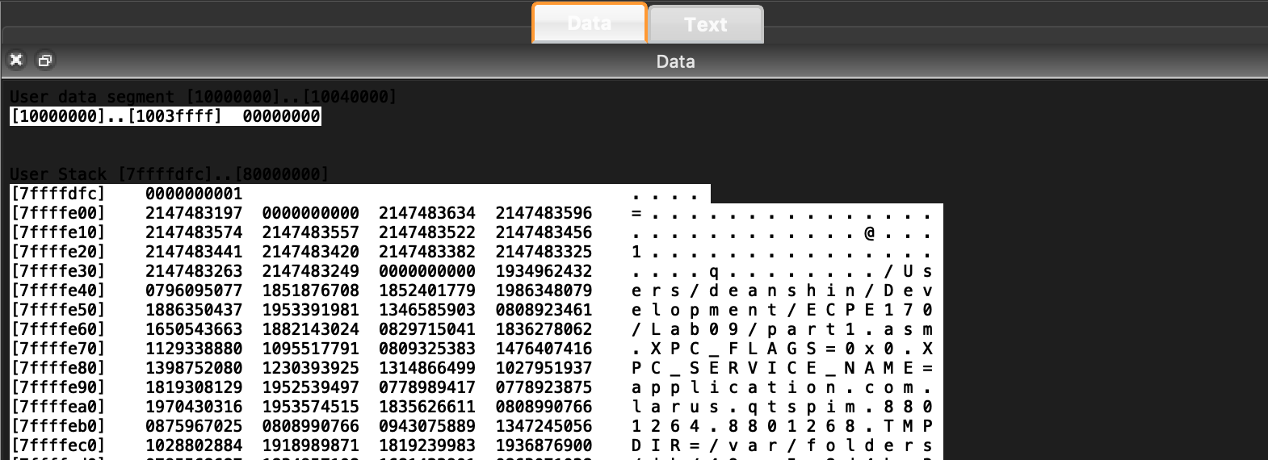
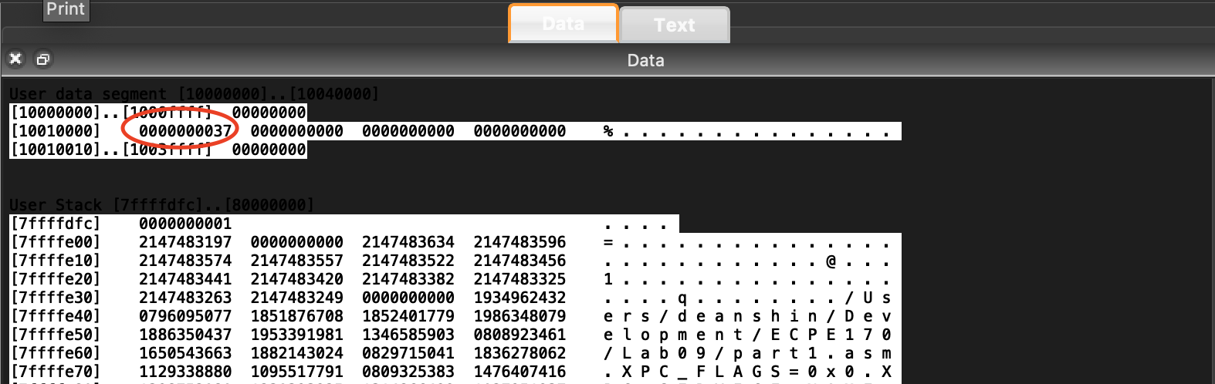

Question #3:
Take two screenshots of the MIPS register panel: one before your program runs, and one after your program finishes. Put the register panel in Decimal mode (right-click) so it is easy to see register values.
Answer:
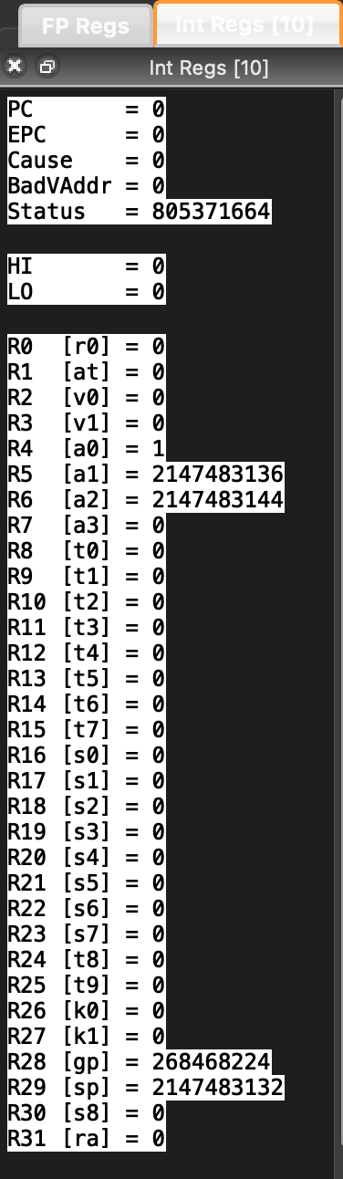
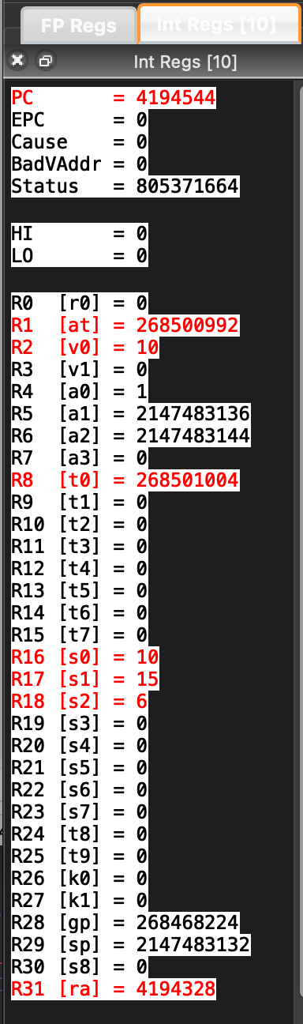

Question #4:
Take two screenshots of the MIPS memory panel (data tab): one before your program runs, and one after your program finishes. Put the memory panel in Decimal mode (right-click), so it is easy to see memory values. In the after-execution capture, circle the memory location (not register) that contains the final calculated value of Z.
Answer:
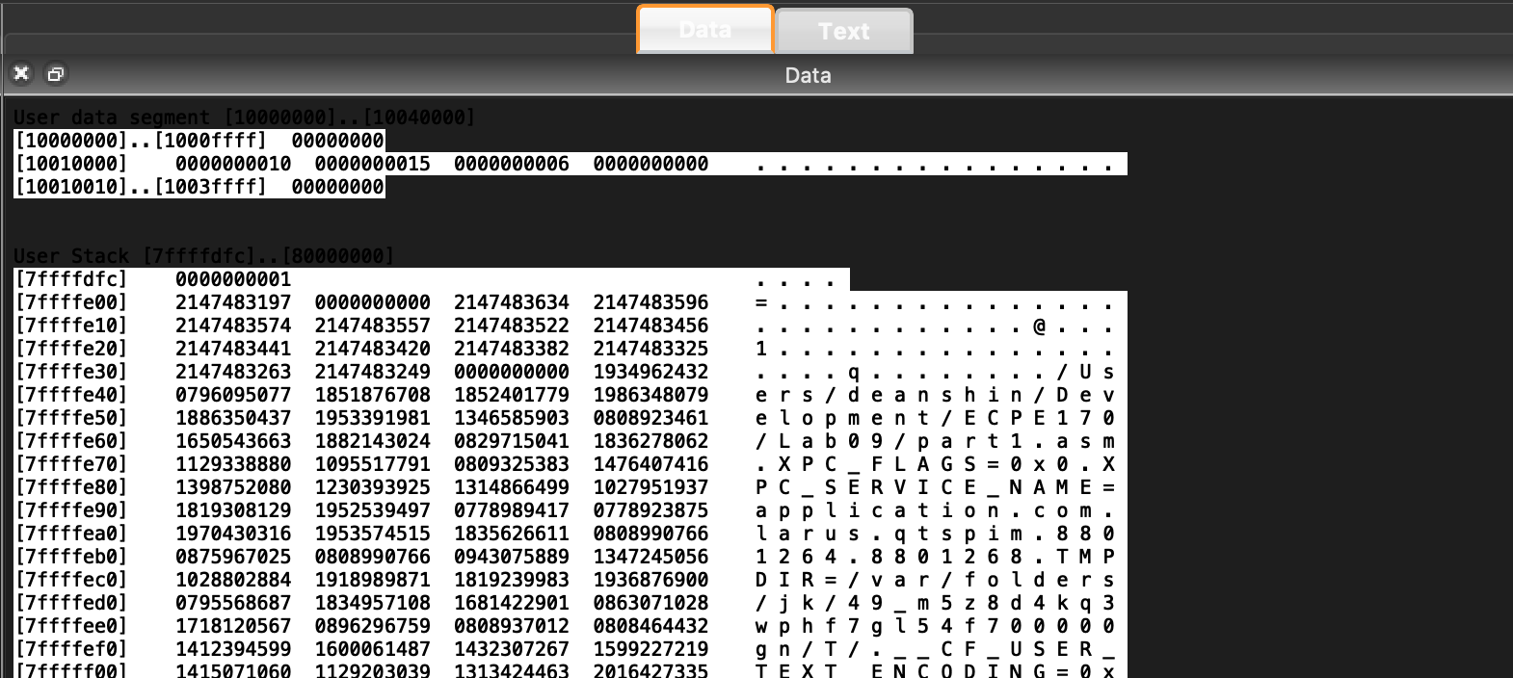
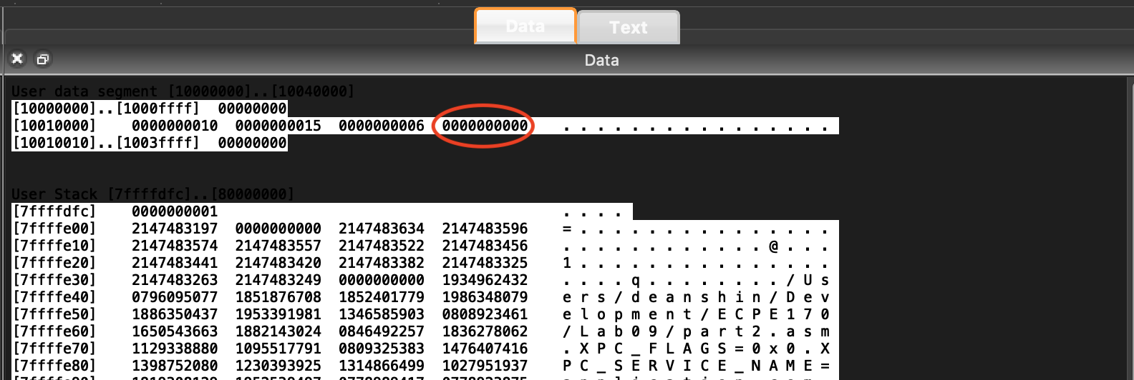
Question #5:
Take a screenshot of the MIPS register panel after your program finishes. Put the register panel in Decimal mode (right-click) so it is easy to see register values.
Answer:
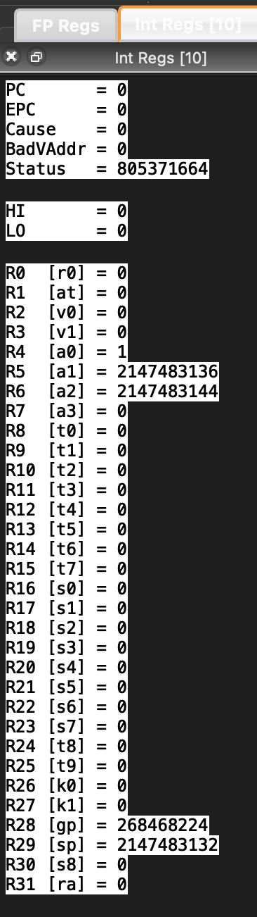
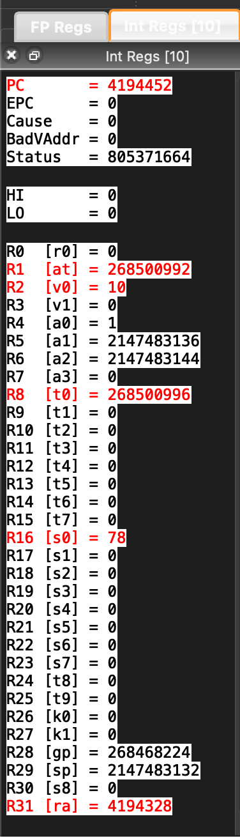

Question #6:
Take a screenshot of the MIPS memory panel (data tab) after your program finishes. Put the memory panel in Decimal mode (right-click), so it is easy to see memory values. Circle the memory location (not register) that contains the final calculated values of I and Z.
Answer:
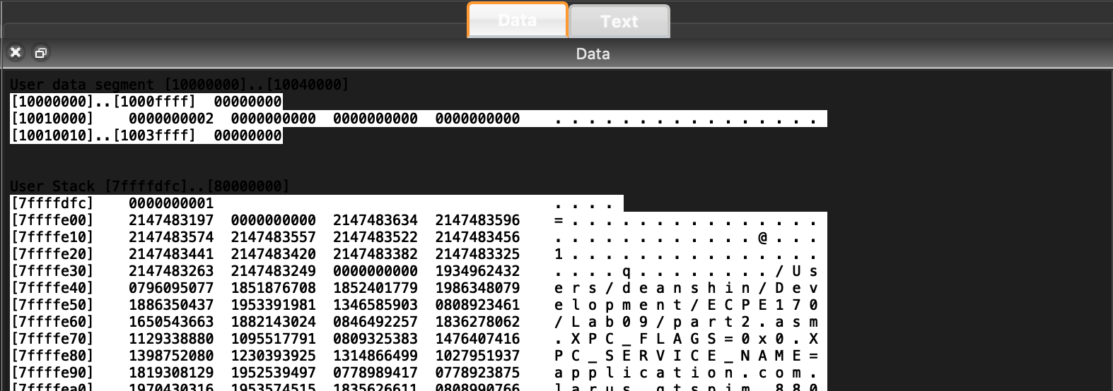
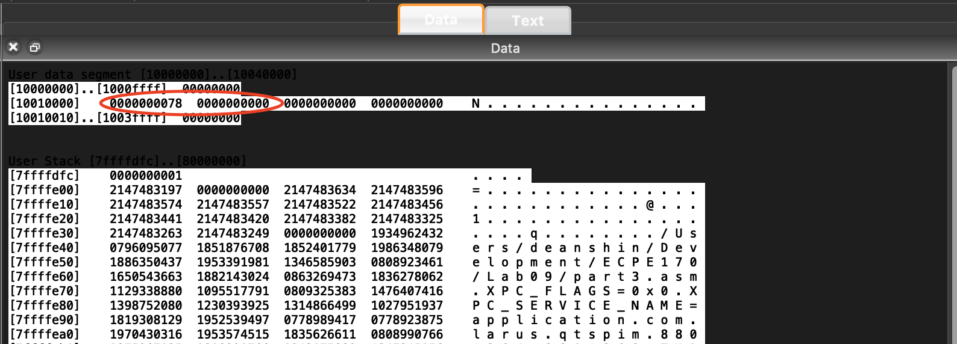

Question #7:
Take a screenshot of the MIPS register panel after your program finishes. Put the register panel in Decimal mode (right-click) so it is easy to see register values.
Answer:
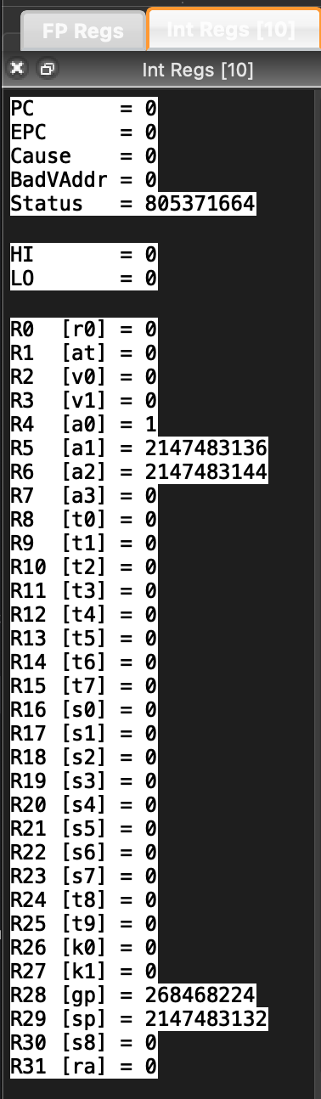
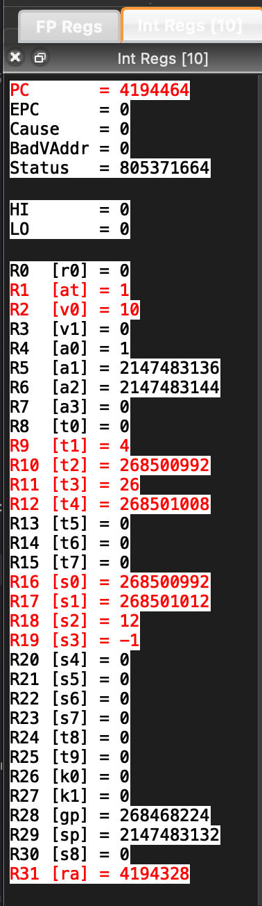

Question #8:
Take a screenshot of the MIPS memory panel (data tab) after your program finishes. Put the memory panel in Decimal mode (right-click), so it is easy to see memory values. Circle the final values of array A.
Answer:
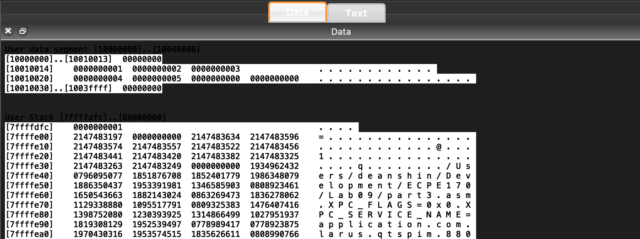
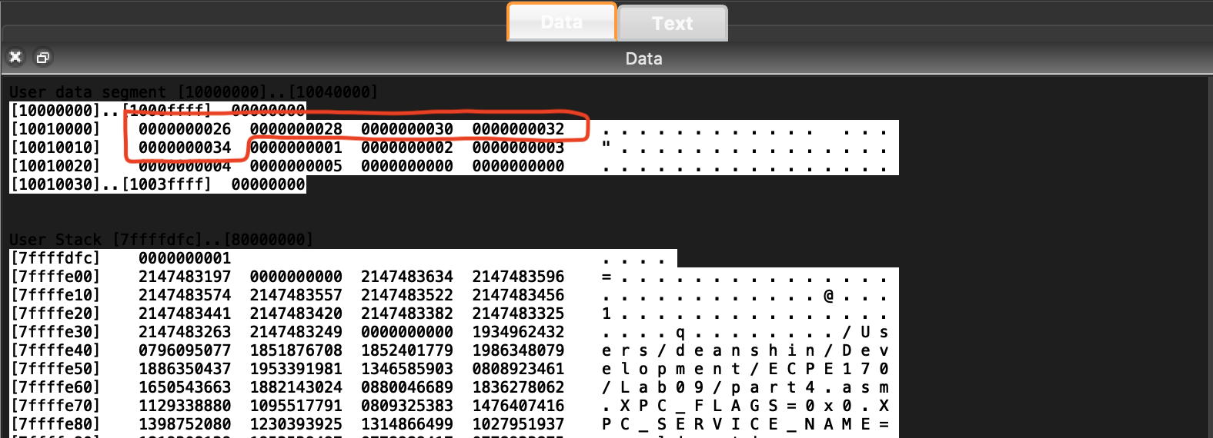

Question #9:
Take a screenshot of the MIPS memory panel (data tab) after your program finishes. Put the memory panel in Hex mode (right-click), since Decimal mode will not allow us to distinguish between bytes. Circle two things: the final value of the pointer 'result' in memory, and the corresponding location that result points to. Does that location in memory contain the ASCII code for the character 'e'? (If not, you had better check your work!)
Answer:
