**Boto3-Automation**

1. Connect to S3 using boto3.

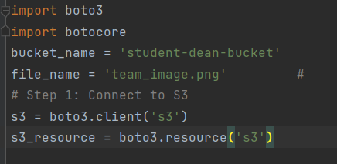

2. Create a bucket called student-dean-bucket

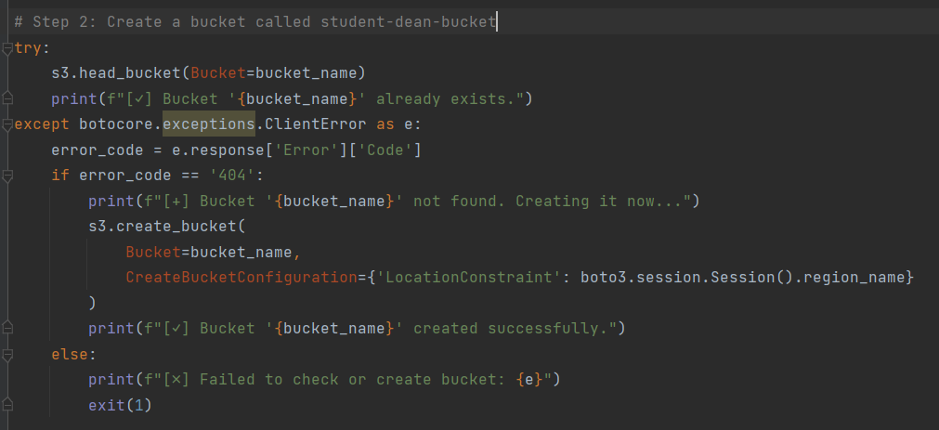

3. Upload the file team_image.png to the bucket

4. List the files in the bucket and print their names.

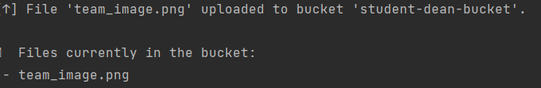

Task2-: Upload Multiple Files Automatically

1.