# Domain Analysis

Homework 04

Dean DeHart

## Part Zero: Overview and Answer Justification

If you would like to just see the actual UML diagram, it’s public (Because I don’t want to pay for an account to make it private):  
<https://www.gliffy.com/go/publish/11376213>

In this assignment, I will be making a few assumptions. I’m aware that the assignment was taken from a book, so this is probably intended, but I would still like to outline certain decisions:

1. There is no need to model features that are a part of Internet Explorer. This means excluding functionality to zoom in, make the page a favorite, press tab to navigate a page, etc....
2. I am incorporating the User groups into the program to allow an expansion of the User class.
3. Roger is a user, but will not be referenced specifically in Object names anywhere in the program.
4. Different funds will be referenced as objects, as they are an established part of the system.

## Highlighting? Not Sure if Literal Highlighting

Just in case, I’ve attached images of my literal highlights. Some were made before deciding to exclude Internet Explorer.

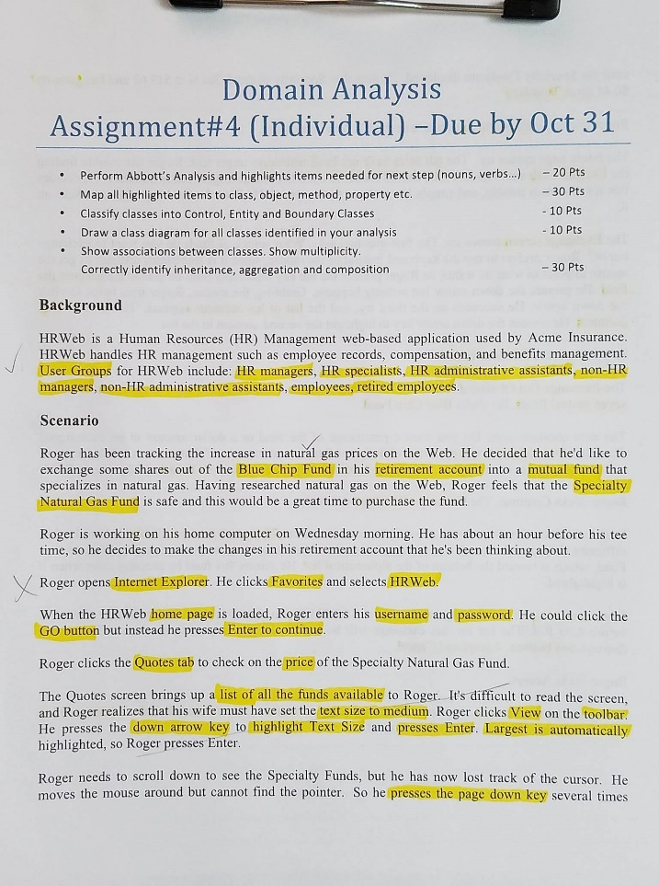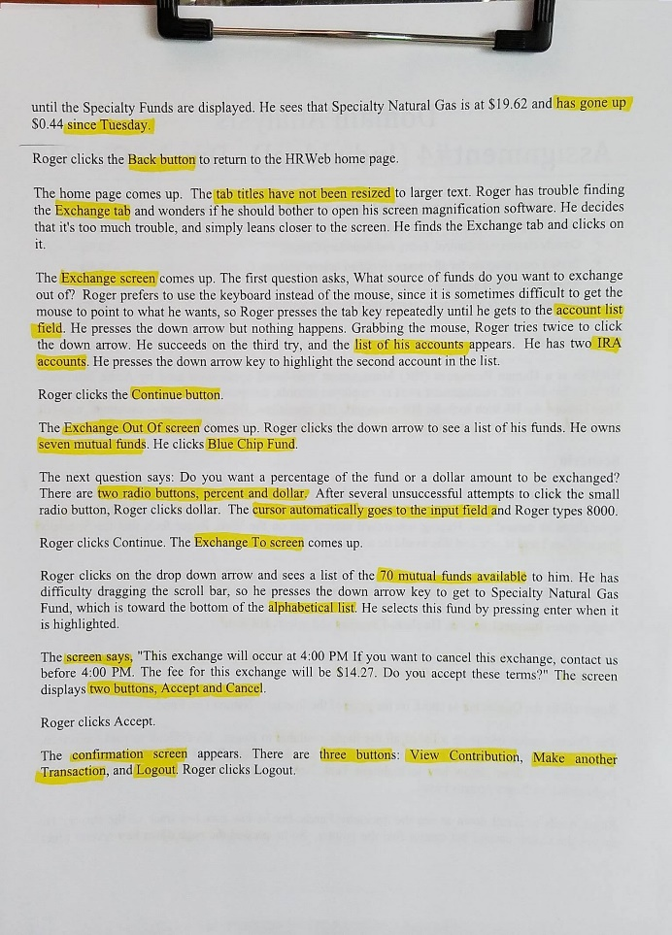

## Parts of Speech and Mapping To Parts of Code

Some changes occurred between Abbot’s Analysis and the final design, but that’s intended with Abbot’s analysis I believe.

|  |  |
| --- | --- |
| Part of Speech | Components |
| Proper Noun [Object] | 1. Blue Chip Fund 2. Specialty Natural Gas Fund |
| Common Noun [Class] | 1. Fund 2. Account 3. Tab 4. Screen 5. Button 6. User – Belongs to a group 7. UserGroup – Has many users, Is One Type 8. Quotes Tab 9. Exchange Tab 10. Exchange Screen 11. Exchange Out Of Screen 12. Exchange To Screen 13. Home Screen 14. Confirmation Screen 15. Retirement Account 16. HR Managers User Group 17. HR Specialists User Group 18. HR Admin Assist User Group 19. Non-HR managers User Group 20. Non-HR Admin Assist User Group 21. Employee 22. Retired Employee |
| Doing Verb [Method] | 1. Get List of User’s Available Funds 2. Fund can Recalculate Price 3. Screen can alphabetize list. |
| Having Verb [Composition] | 1. Pages have buttons. 2. Pages have Radio Buttons 3. Exchange To Screen has Alphabetical List |
| Adjective [Attribute] | 1. User has a username 2. User has a password 3. User has a type 4. User has accounts 5. User has funds |

## Classify Classes, Diagram, Associations, and Multiplicity

These parts are handled by the actual diagram. I’ll include pictures of the three individual diagrams, then one larger image so that you can see what it says. A lot of the attributes and methods were left blank, because of the scenario’s limited scope. I’ll also include the images in the zip file, in case Word doesn’t play nice.

Controllers / Controls:

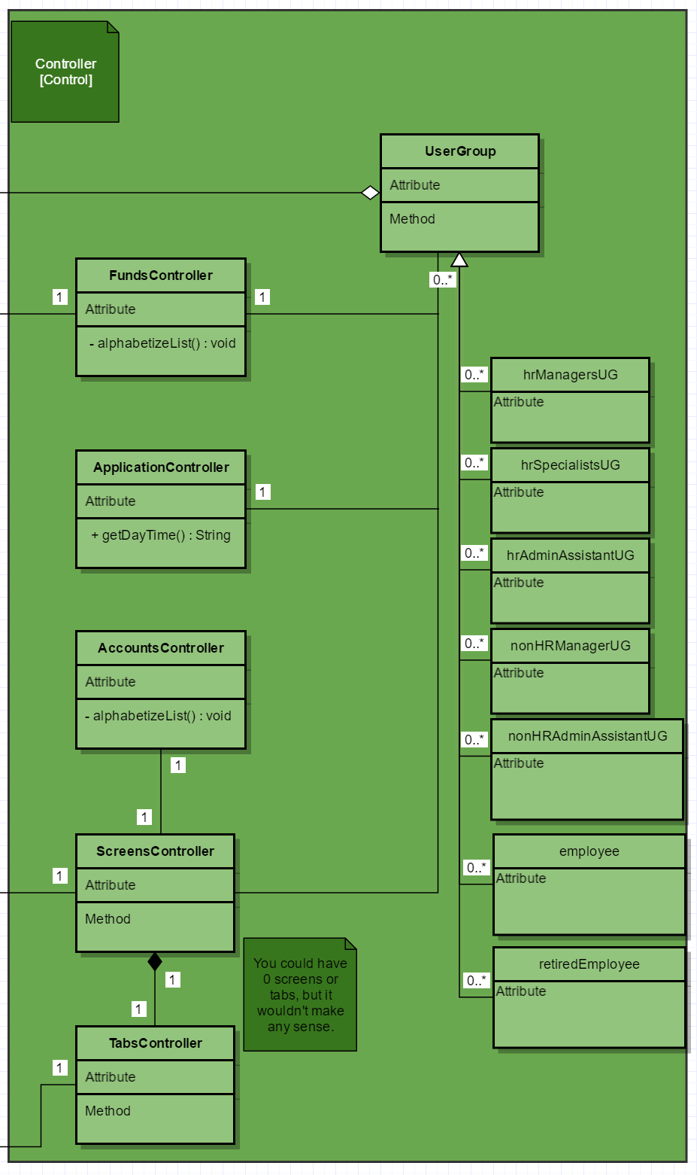

Models / Entities:

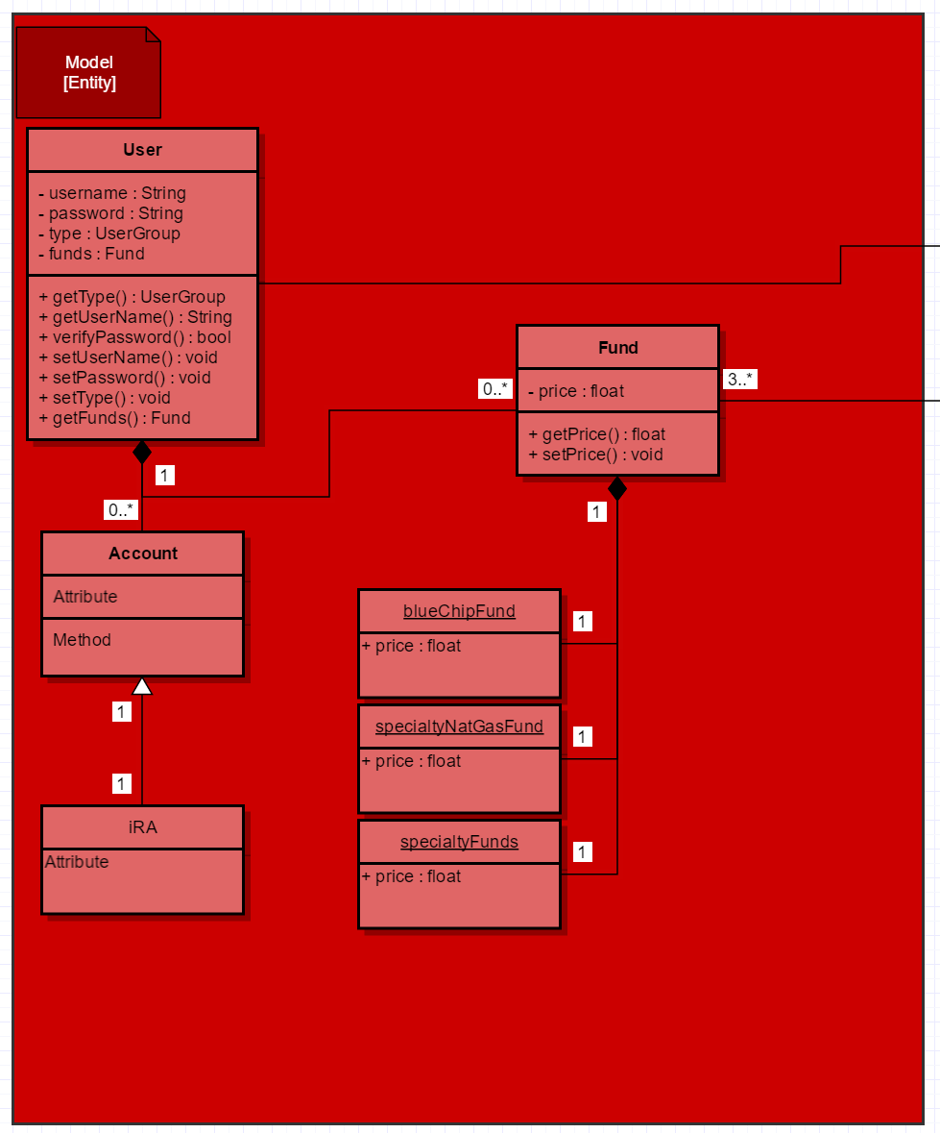

Views / Boundaries:

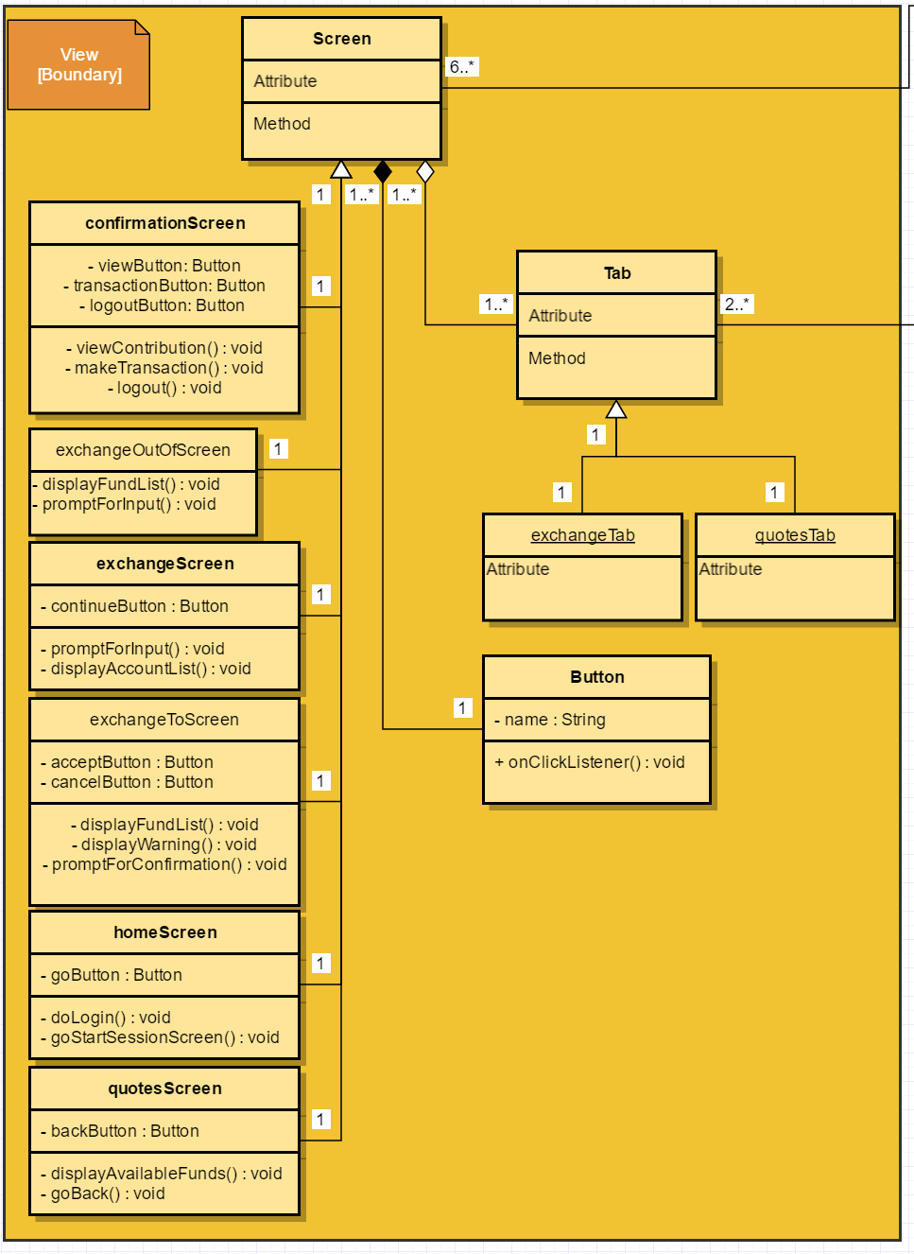

HRWeb Overview:

