学 院：南京大学软件学院

团 队：第5组

成 员：陈书玉 陈俐俐 程芸菲 陈悦

完成日期：2016/10/7

酒店预订系统

体系结构设计模型

目录

一、软件体系结构逻辑设计方案 3

二、开发包设计 4

三、开发包图 7

3.1酒店预订系统客户端开发包图（图一） 7

3.2酒店预订系统服务器端开发包图（图二） 8

3.3酒店预订系统层之间调用的接口 8

3.4制定酒店策略用例层之间调用的接口 9

3.5酒店预订系统用户界面跳转 10

3.6酒店预订系统业务逻辑层的分解 11

## 一、软件体系结构逻辑设计方案

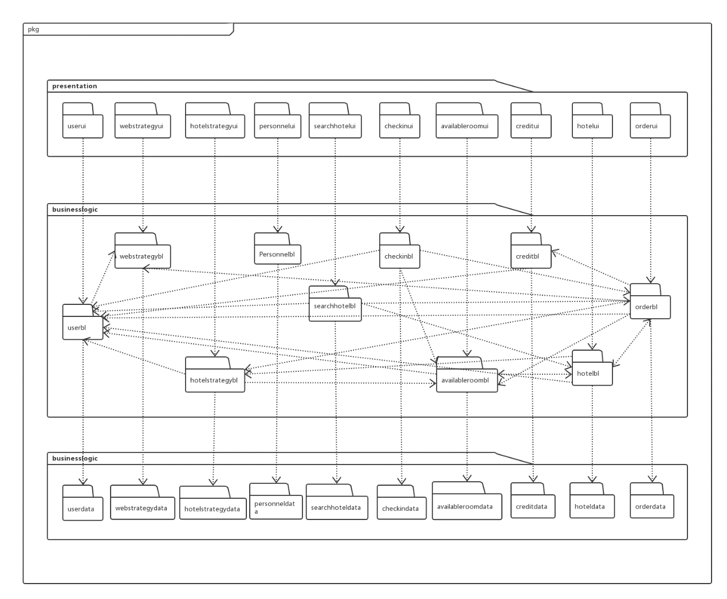

## 二、开发包设计

|  |  |
| --- | --- |
| **开发（物理）包** | **依赖的其他开发包** |
| Mainui | Userui，Personnelui，Orderui，Creditui，Hotelui， AvailableRoomui，Checkinui，HotelStrategyui，WebStrategyui，SearchHotelui ，vo |
| Userui | Userblservice，界面类库包，vo |
| Userblservice |  |
| Userbl | Userblservice ,Userdataservice,po, WebStrategybl |
| Userdataservice | Java RMI,po |
| Userdata | Userdataservice,databaseseutility,po |
| Personnelui | Personnelblservice，界面类库包，vo |
| Personnelblservice |  |
| Personnelbl | Personnelblservice, Personnelblservice,po |
| Personneldataservice | Java RMI,po |
| Personneldata | Userdataservice,databaseseutility,po |
| Orderui | Orderblservice，界面类库包，vo |
| Orderblservice |  |
| Orderbl | Orderblservice, Orderdataservice,po, Availableroombl,Userbl, HotelStrategybl,WebStrategybl, Creditbl |
| Orderdataservice | Java RMI,po |
| Orderdata | Orderdataservice,databaseseutility,po |
| Creditui | Creditblservice，界面类库包，vo |
| Creditblservice |  |
| Creditbl | Creditblservice, Creditdataservice,po,Userbl |
| Creditdataservice | Java RMI,po |
| Creditdata | Creditdataservice,databaseseutility,po |
| Hotelui | Hotelblservice，界面类库包，vo |
| Hotelblservice |  |
| Hotelbl | Hotelblservice, Hoteldataservice,po,  HotelStrategybl,Userbl |
| Hoteldataservice | Java RMI,po |
| Hoteldata | Hoteldataservice,databaseseutility,po |
| AvailableRoomui | AvailableRoomblservice，界面类库包，vo |
| AvailableRoomblservice |  |
| AvailableRoombl | AvailableRoomblservice, AvailableRoomdataservice,po, Userbl |
| AvailableRoomdataservice | Java RMI,po |
| AvailableRoomdata | AvailableRoomdataservice,databaseseutility,po |
| Checkinui | Checkinblservice，界面类库包，vo |
| Checkinblservice |  |
| Checkinbl | Checkinblservice, Checkidataservice,po, Orderbl,Availableroombl,Userbl |
| Checkidataservice | Java RMI,po |
| Checkindata | Checkidataservice,databaseseutility,po |
| HotelStrategyui | HotelStrategyblservice，界面类库包，vo |
| HotelStrategyblservice |  |
| HotelStrategybl | HotelStrategyblservice, HotelStrategydataservice,po, Userbl,AvailableRoombl |
| HotelStrategydataservice | Java RMI,po |
| HotelStrategydata | HotelStrategydataservice,databaseseutility,po |
| WebStrategyui | WebStrategyblservice，界面类库包，vo |
| WebStrategyblservice |  |
| WebStrategybl | WebStrategyblservice, WebStrategydataservice,po, |
| WebStrategydataservice | Java RMI,po |
| WebStrategydata | WebStrategydataservice,databaseseutility,po |
| SearchHotelui | SearchHotelblservice，界面类库包，vo |
| SearchHotelblservice |  |
| SearchHotelbl | SearchHotelblservice, SearchHotelblservice,po, Hotelbl,Orderbl,Userbl |
| SearchHoteldataservice | Java RMI,po |
| SearchHoteldata | SearchHoteldataservice,databaseseutility,po |
| Vo |  |
| Po |  |
| 界面类库包 |  |
| databaseseutility | JDBC |
| Java RMI |  |

## 三、开发包图

### 3.1酒店预订系统客户端开发包图（图一）

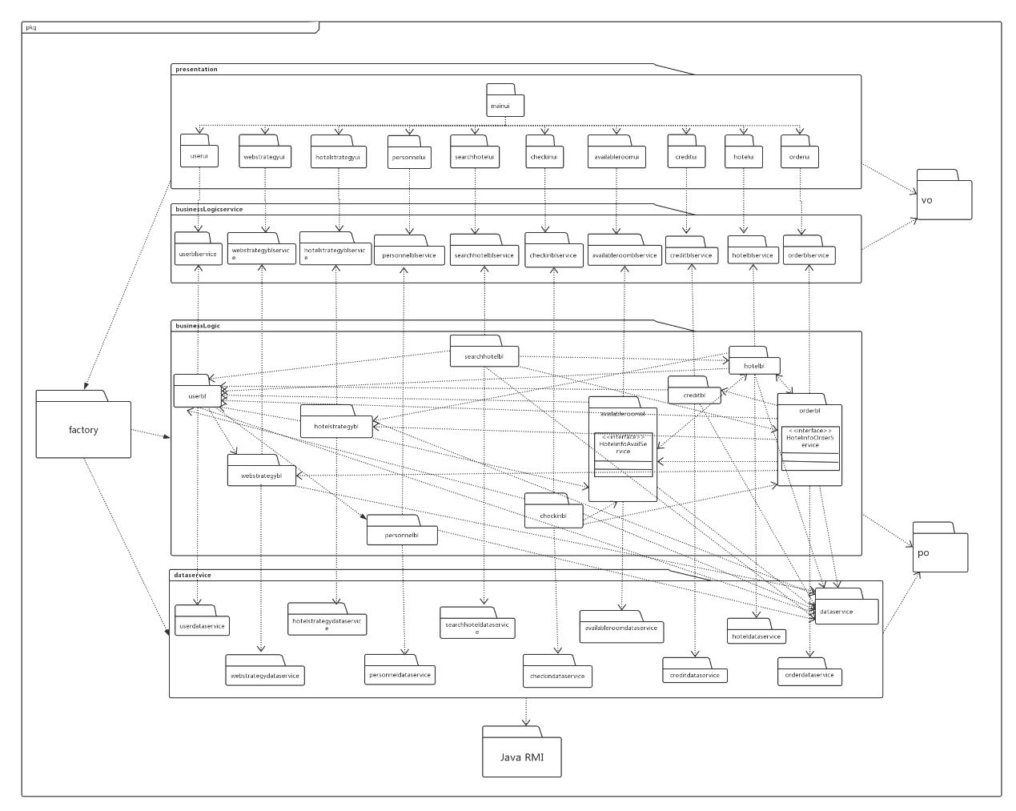

### 3.2酒店预订系统服务器端开发包图（图二）

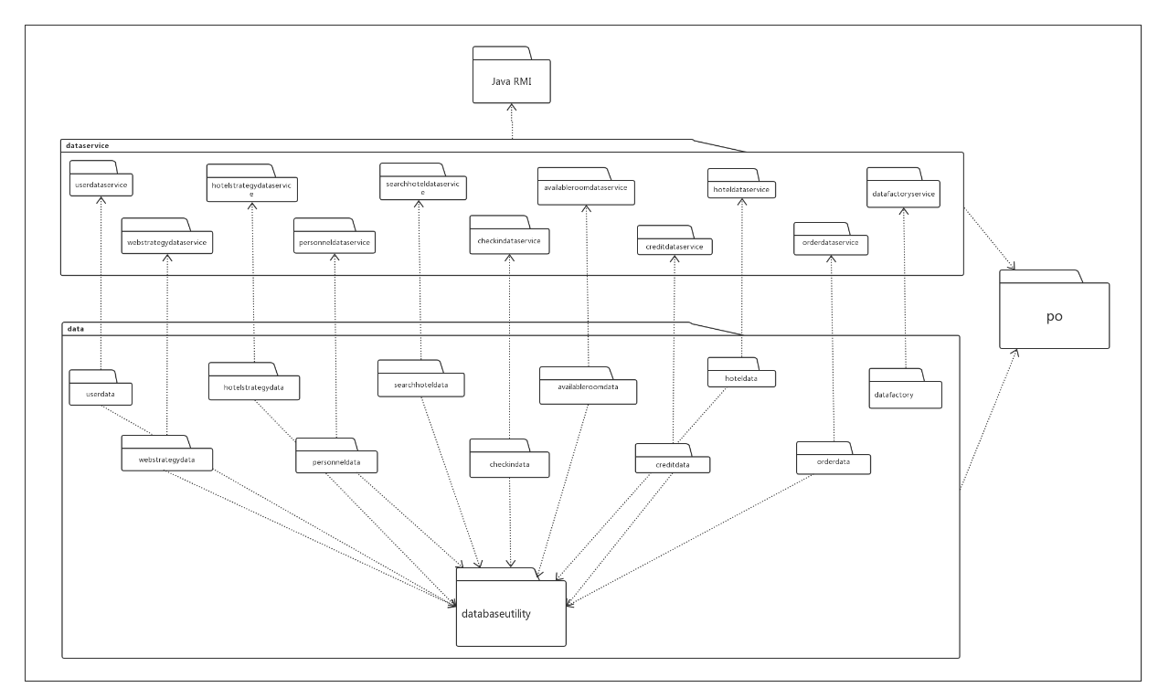

### 3.3酒店预订系统层之间调用的接口

|  |  |  |
| --- | --- | --- |
| **接口** | **服务调用方** | **服务提供方** |
| Userbl  Webstrategybl  Hotelstrategybl  Personnelbl  Searchhotelbl  Checkinbl  Availableroombl  Creditbl  Hotelbl  Orderbl | 客户端展示层 | 客户端业务逻辑层 |
| Userdataservice  Personneldataservice  Orderdataservice  Creditdataservice  Hoteldataservice  Availableroomdataservice  Checkindataservice  Webstrategydataservice  Hotelstrategydataservice  searchhoteldataservice | 客户端业务逻辑层 | 客户端数据层 |

### 3.4制定酒店策略用例层之间调用的接口

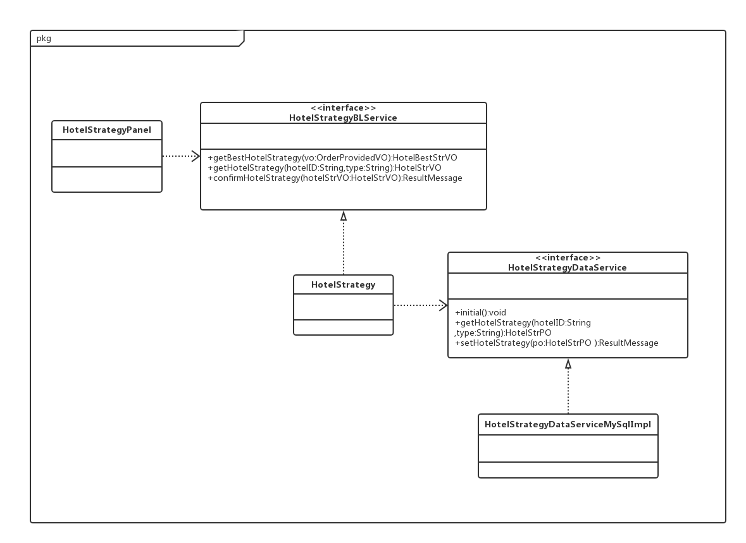

### 3.5酒店预订系统用户界面跳转

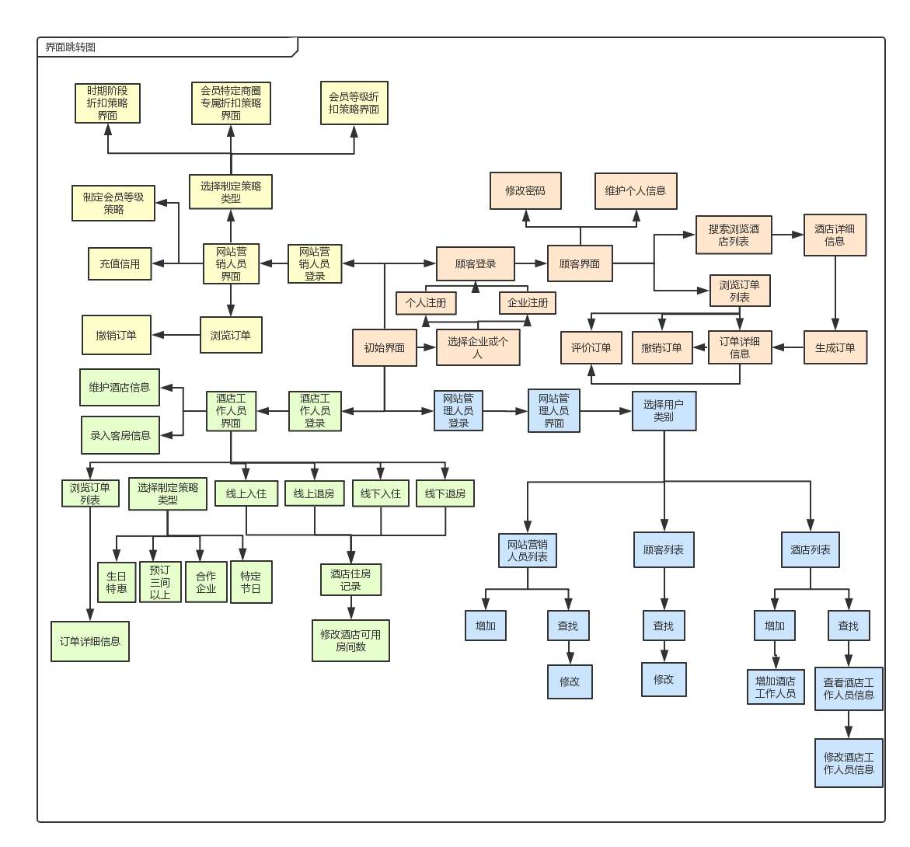

### 3.6酒店预订系统业务逻辑层的分解

