Signature Authentics Web Application

Muhammad Murtaza Saleem
Mobile Computing
Sheridan College
Oakville, Canada
salemuha@sheridancollege.ca

Zach Ficsh
Mobile Computing
Sheridan College
Oakville, Canada
fi@sheridancollege.ca

Ghassem Tofighi
Faculty of Applied Science & Technology
Sheridan College
Oakville, Canada
ghassem.tofighi@sheridancollege.ca

Abstract— The purpose of our project is to create a web application that can be used by Signature Authentics Employee’s to replace their current Excel/Email workflow. Our Software will provide a strict control on the amount of charity bids placed, track product inventory and provide accurate calculation on representative’s commission including the amount raised for the specific charity. Our environment for our client will be under React JS and our backend will be made in .NET Core and SQL Server will adhere to an excel based workflow to provide feasibility for representatives. We Intend to solve the current excel based workflow as it is very cost-ineffective and strenuous for many of the current employees.

Keywords—HCI, Signature Authentics, Receptionist, Representatives, Sales-Screen (5 keywords are enough)

Introduction (Heading 1)
The software we are developing a web application that can be used by Signature Authentics Employee’s to replace their current Excel/Email workflow. Our Software will provide a strict control on the amount of charity bids placed, track product inventory and provide accurate calculation on representative’s commission. The web application will allow representatives to enter and maintain sales data and allow receptionists to generate reports and export them.
The target audience of this application is business users who are experts in the business process and want to get their job done in as few clicks as possible. To accommodate this we will have to display a lot of information at once in a way that won’t overwhelm the user as the business processes can be complex.
A similar website to our product is SalesScreen as it is also a sales management platform for customer representatives. The reviews for this application are mostly positive with a lot of praise for how many options and features it has, but a consistent complaint on several reviews are that it isn’t easy to use and there are some bugs that cause information to disappear.

HCI Principles
After reading academic papers we have found three HCI concepts we can utilize to better the user-experience of our application

Contingency.
- When the user is navigating through multiple screens, each with a variety of information on display, it is important to make the link between each screen the user is on transparent, so they always know where they are and how they got there. A practical implementation of this can be a breadcrumb trail at the top of the page, or a log of user interactions. [1]

Cognitive Load Theory.
- This article details how Cognitive Load Theory defines the relationship between an end-users short term memory and the volume of information that is displayed on a screen. This is relevant to our application because we are required to display a lot of information to our end users.[2]

Dashboard Menu Design.
- This article describes several different ways to design a menu that has many different menu options. It also goes into detail about different items to consider when judging a menu including item presentation, structural cues, and menu path flexibility. This will be helpful for our project as their will be many features in our system that the end-users will require in order for it to meet business needs and presenting all these features in a way that is easy to understand is important.[3]

Prototype Design

Requirement Analysis (NeedFinding)
One user-group and activity in our product is customer representatives + submitting bidding information.
Customer representatives at Signature Authentics current submission workflow includes emailing excel documents that are worked on offline. They have probably designed a lot of workarounds to speed up their process, but there must be some organization errors such as redundant or missing information.

3. Gather data about the activity

- Desk studies

There are several existing solutions, the most common would be cloud based productivity tools such as Google Office or Office 365. However, these are very generalized and won’t solve issues related to how the employees are organizing the information. For this there are more specific solutions such as SalesForce.

- Field studies

Speaking with Richard Comeau the CEO of signature authentics, he says there are a lot of organization issues with the data due to the fact that they are keeping documents in folders and they can easily be misplaced or mislabeled. There are also a lot of human errors in the information due to the fact that there is no real validation being done.

4. Identify product opportunities

- Our product could organize all the data submissions for the user to avoid it getting mislabeled.
- Our product can provide certain input validations
- Our product can be accessed by the receptionist so they can view submissions by the customer representative without them emailing excel documents to them.

Competitive Analysis
For the competitors activity and profile comparison view Table 1.1.
This is a comparative analysis of the features we offer, in relation to our competitors. A total of 13 product features will be weighed against our competitors.
Table 1 : Competitive Score
Product Features | Microsoft | Reveal - Report Plus | Sales Screen | Outreach
Email Chat | Y | Y | Y | Y
Input Sales | Y | Y | Y | Y
Customer Support | N | Y | Y | Y
Document Sharing | Y | N | N | N
Data Visualization | Y | Y | Y | N
Groups/Roles | Y | N | Y | Y
Reception Support | N | N | Y | Y
Sales Export | Y | Y | Y | Y
Attestation | N | N | N | N
Customer list | N | Y | Y | Y
Remove Users | Y | N | Y | Y
Admin Controls | Y | Y | ? | Y
Cross-Platform | Y | Y | N | N
SCORE (13) | +9 / 13 | +8 / 13 | +9 / 13 | +9 / 13

All the competitors listed provide support for data entry and report generation. They also provide support for multiple users and roles which is an important use case in our product. However, only Outreach and Reveal can export data to csv files, which is also a required feature for our application. Also, none of the competitors we analyzed provide the option to attest sales or decline them, which is an important use case when managing bids where representatives are required to contact people who made bids after an auction has ended to finalize purchases.

First Initial Prototype Alternatives
I created my initial prototype and shared it using adobe XD, the current prototype is shared on that current XD host link thus this link may be deprecated:
Adobe XD Prototype 1: https://xd.adobe.com/view/d373056d-87ae-4efe-7a7a-ceecd858a60c-a542/?fullscreen
Here is the youtube video to explain it better:
YouTube Link: https://www.youtube.com/watch?v=dglqHhE34bE

New URL Prototype link: https://xd.adobe.com/view/cd282e9c-e368-4aab-45bc-d879c788f132-bb19/

These are the functionalities of the app:
- Receptionist and Representatives are allowed to login and use the App,
- Receptionist must be able to view the list of representatives,
- Receptionist can attestate bids received,
- Receptionist can export data of sales representatives and bids.
- Representative can edit or delete a form for bids in certain locations.
- Representative can submit a bid report for attestation.
- Representatives can view their sales and commissions in a generated report.
- Representative and Receptionist can edit their profile.
- CEO/Admin can edit existing roles within the system or create new roles.

See Table 3 and Table 4 for screenshots of rejected and revised prototype.

Prototype evaluation
Introduction to scenario:
“Imagine you were recently hired as a receptionist at an easel auction company. The website you will use will help you view the company's information. In this company there are two employees: - Representative - Receptionist As the receptionist, your main goal is to approve/send-back bids sent in from the representatives. And you can view all the representatives in the area and export their data to your downloads folder *this test wont download anything on your device*.”

Tasks
- Launch URL: https://xd.adobe.com/view/cd282e9c-e368-4aab-45bc-d879c788f132-bb19/
You have been taken to a new page. When you see the page, move on to the next step.
- Carefully view the sign in page. Please sign in as the 'Receptionist'. hint *view below form* When you are done click 'Next'
- "Were you able to sign in as the Receptionist? was the task difficult? Please let us know." [Verbal Response]
- Now that you are on the receptionist page, you will be able to see the 'Attestation' page. From the list please select 'details' of any bid item you see. When you are done click 'Next'
- Were you able view the details of the 'Bid'? Please let us know if you found the task difficult or not. [Verbal Response]
- Now that you can view the bids. Press 'Approve' or 'Send Back' to to evaluate the details of the bid. When you are done click 'Next'
- While on the page for attestation hover over the side-bar and select 'Representative List'. When you are done click 'Next'
- Describe your view of the 'Representative List'. [Verbal Response]
- While on the 'Representative List' page lets export their sales data, this will download a .csv file of their sales. *note this is for testing, no download will occur* When you are done click 'Next'
- Congrats you have completed the main task of a 'Receptioniost' Please click the sign-out button on the bottom of the page. When you are done click 'Next'
- Describe your overall experience as an employee who approves and exports sales data. [Verbal Response]

Usability Analysis
Video Response 1:
URL: https://www.usertesting.com/v/6e834e4e-2fe7-49df-8303-45e2c1bc22ca?encrypted_video_handle=de848f8b-c0c5-434f-bb1d-fc69178a94fa&shared_via=link

‘kxkx’ - Female – 23 – 100K-125K – Canada
This user was able to complete all task within 6 minutes.
Below are the response to the video questionnaire:
  - Found the site very clean, simple to use with very easy task. As was the specification of a receptionist.
  - Easily maneuvered between sites pages. Found difficulty at Sign out and side-bar instructions, but was able to complete the task.
  - Feedback: Easy task for a receptionist, maybe a color pallet would allow better visual cues. But overall task was easy to solve.

    - Below are the feedback answers from the Tester : ‘kxkx’
- What frustrated you most about this site?
I had no frustration with the site. It seemed clean, and easy to look at. Simple to use.
- If you had a magic wand, how would you improve this site?
Honestly, the site is very simple which is the best for use. I think it is good the way it is.
- Were you able to view the data in the site appropriately?
Yes, the site is very clean and easy to view data.
- Was the site easy to use?
Yes, it was very easy to use. No concerns, its simple and that is what makes it easy.

Video Response 2:
URL: https://www.usertesting.com/v/1cdc04d1-9b80-454c-9117-861e687fbdfd?encrypted_video_handle=75c0f958-e992-44a9-9b55-e89796d89901&shared_via=link

‘catviet’ – Female – 24 – 20K – Canada
This user was able to complete all task under 11 minutes

Below are the user response to the video questionnaire:
  - Login was a little staggered but was able to complete the task with ease
  - Can view the pages for receptionist.
  - Was able to scroll the bods easily and was able to view the bid details.
  - She can view all the information related to the bid class.
  - Bid details was simple to find.
  - Was quickly able to go over the representative list on the side bar and can view the representative. Needs more information on the data.
  - The download did not occur, I believe the user encountered a clicking error with the prototype. So, I will take that into account with my prototype.
  - The user believes the download occurs like that however a new page was supposed to slide open, but it did not happen.
  - The user was able to sign out easily at the bottom.
  - The questions the user answered were helpful in understanding the role as the receptionist.
  - She was able to manage task and understand her role within the organization.
  - Feedback: Easy task, needs more color design and labeled data. More information would be great but easy to view. And easy to users who not so computer literate.

    - Below are the feedbacks from the Answers : ‘catviet’

What frustrated you most about this site?
The sign out button was a bit hard to notice. I think it should be more eye catching (ie: encased in a border) to ensure that the receptionist remembers to log out, because failure to do so can compromise confidential information.

If you had a magic wand, how would you improve this site?
Add more graphics, colours, and borders to make the website more pleasing to the eye. It is very simple, plain and lacks innovation.

Were you able to view the data in the site appropriately?
Yes! All the bids were organized nicely in a list and I also had the option to view the details of each bid easily.

Was the site easy to use?
Absolutely. Although the basic design is simple, it makes it very user friendly to those who are not so "computer-literate"

Metrics:
Below is a gathered data from the response conducted by the testers. As you can see kxkx was able to complete everything within the managed scope. Making for the optimal user. However, ‘catviet’ difficulties will be analyzed as it was clear UI and guidelines that had confused this tester.

Figures and Tables
Table 1.1: Identify Competitor
Competitor Name | Website URL | Users | Active Since
Microsoft Outlook (Excel/Mail) | https://outlook.live.com/owa/ | ~1.2billion | Current-2013
Reveal - ReportPlus | https://www.revealbi.io/app | ~100 million | Current-1989
SalesScreen | https://www.salesscreen.com/ | ~50 million | Current-2014
Outreach | https://www.outreach.io/ | ~50 million | Current-2014

Table 2: Metrics
/ | Optimum Score | ‘kxkx’ Score | ‘catviet’ Score
Clicks | 9-12 | 11 | 13+
Page Viewed | 6 | 6 | 5
Task Completed | 11 | 11 | 10
Time | 4-7 minutes | 6 minutes | 11 minutes
Overall | - | Perfect | Average

Table 3 Screenshot: Initial Rejected Prototype
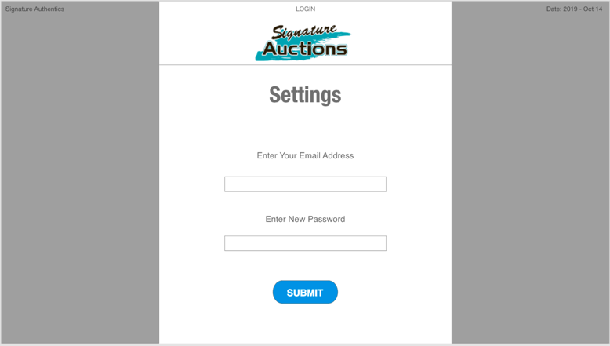
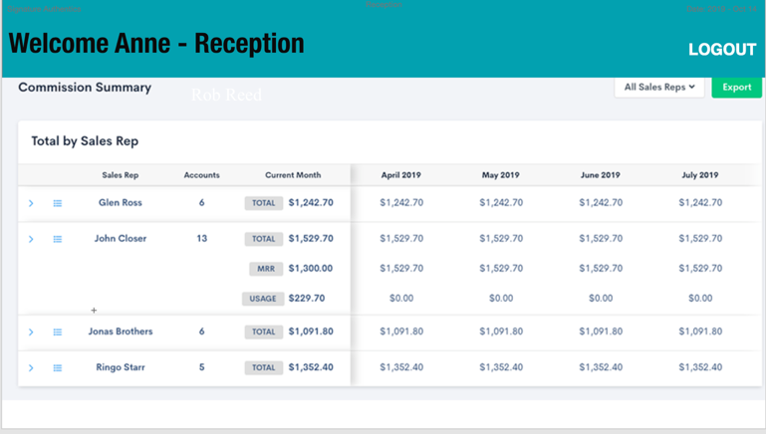
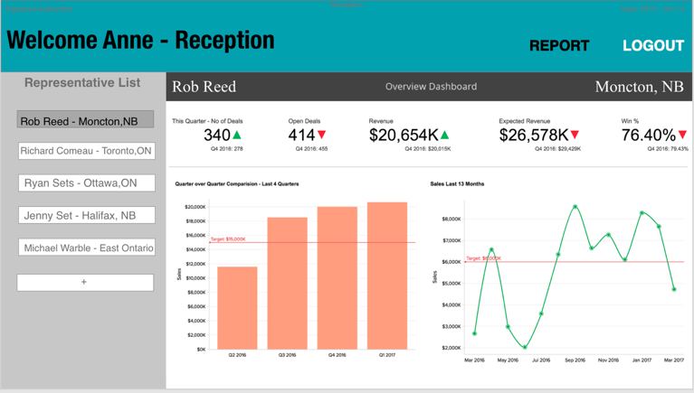
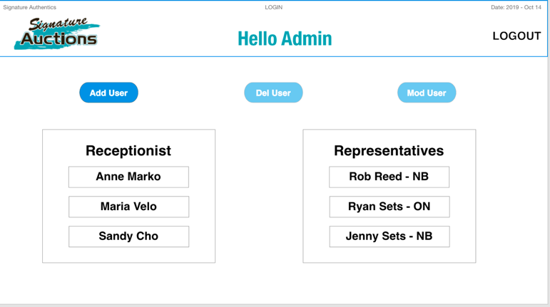
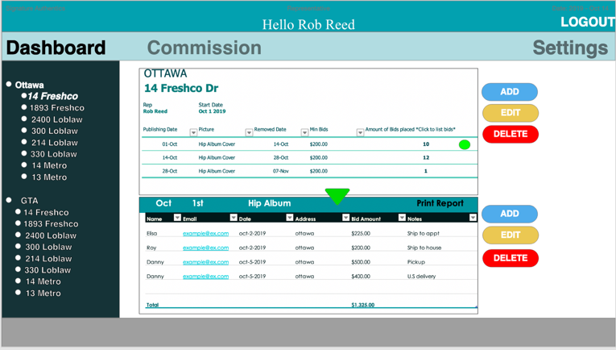
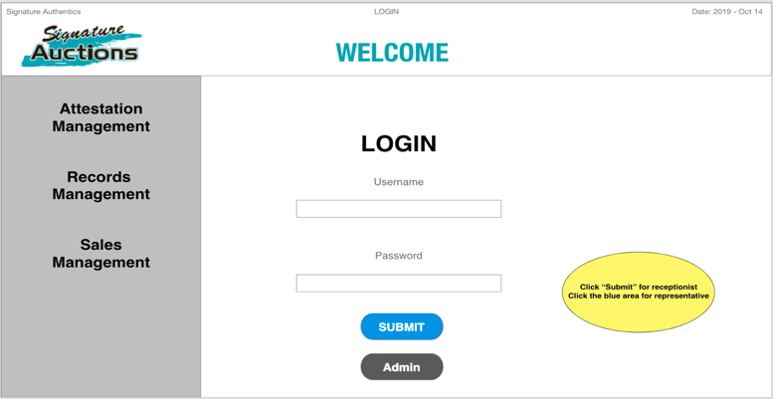

Table 4 Screenshot: Final Revised Prototype
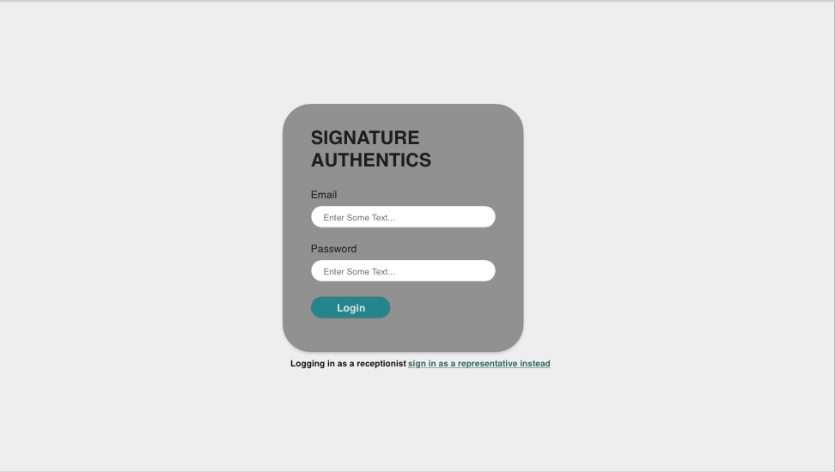
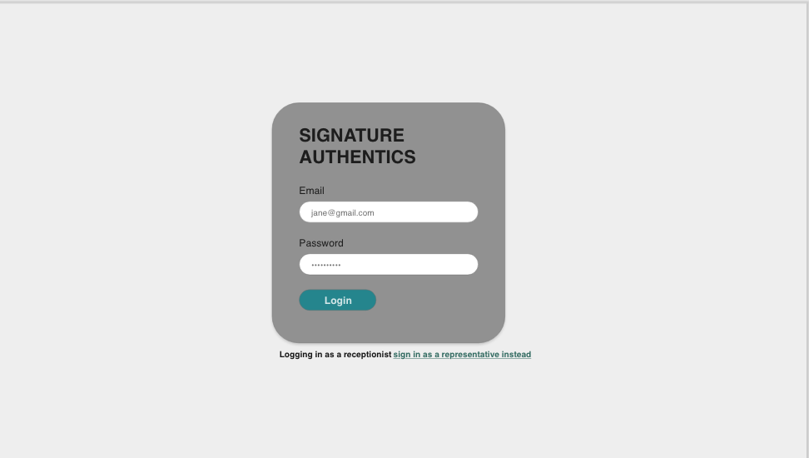
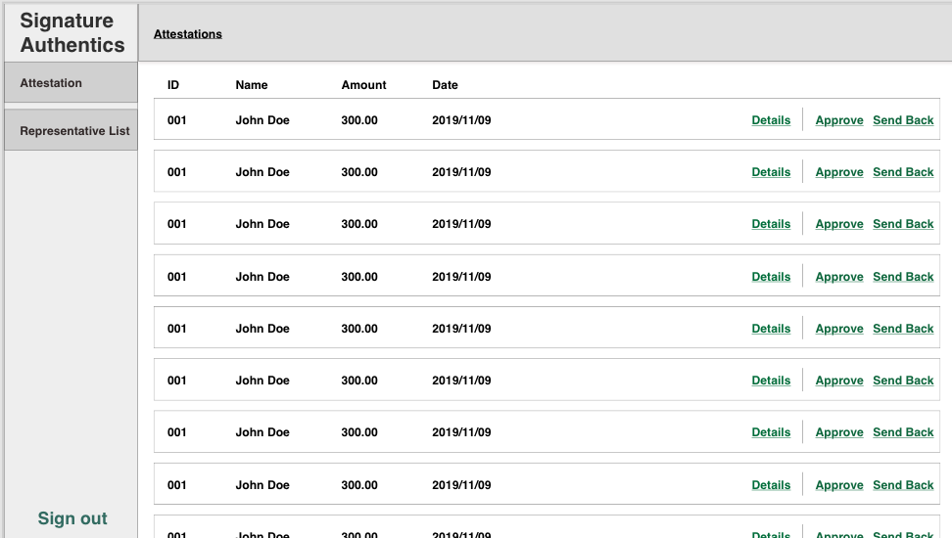
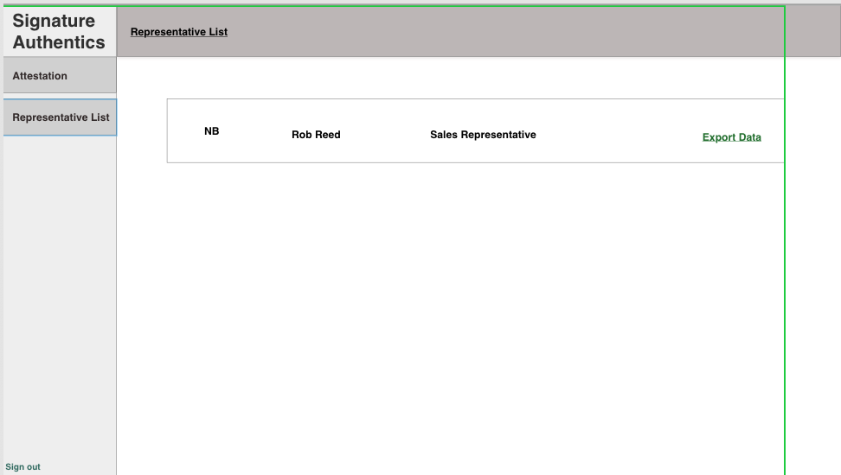
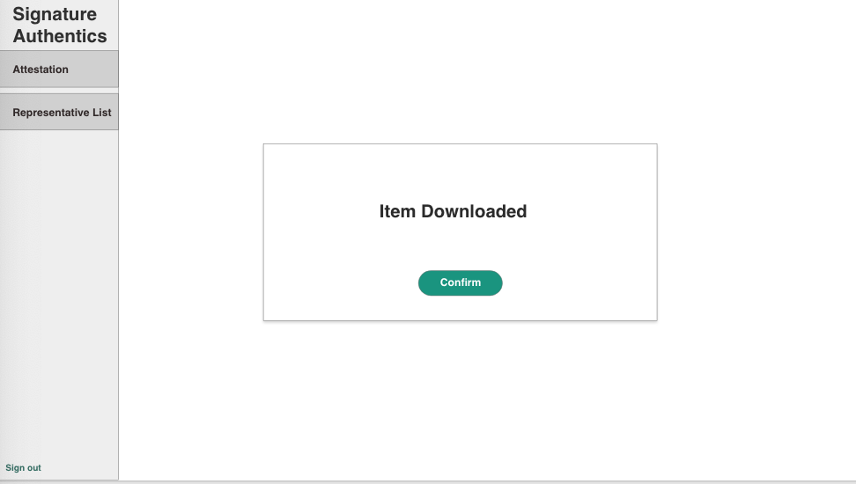
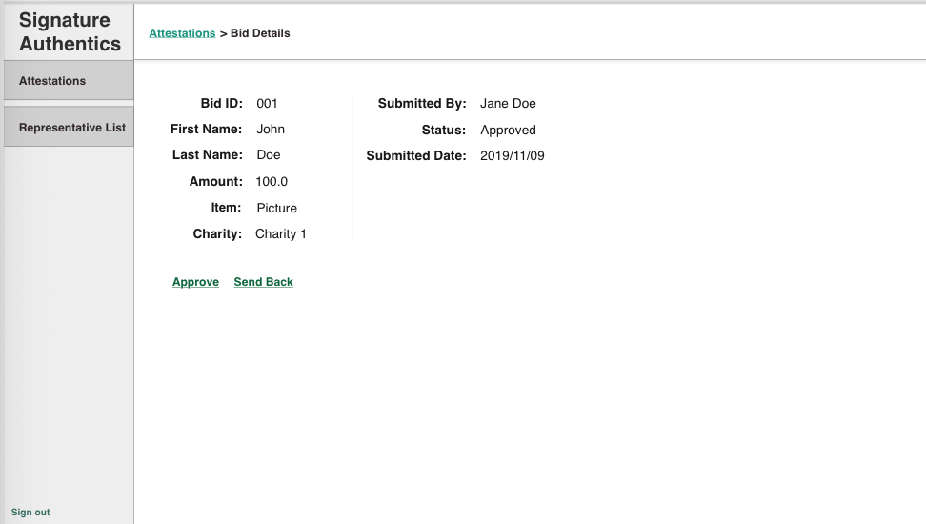

Revised Prototype
Based on the review and analysis the biggest and most notable change to make is the sign-out button and add signature authentics color pallet. Unfortunately, the color pallet was not my scope, so I had fixed the Sign-out function located at the bottom.
The first screenshot is the non-revised version while the second is based on the testers recommendation.
Table 5: Compare Attributes
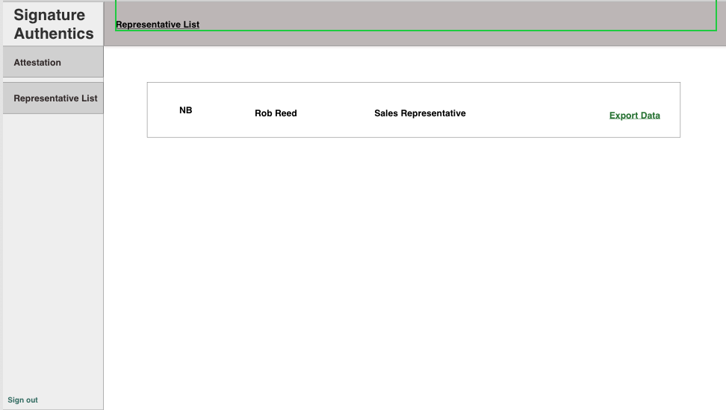
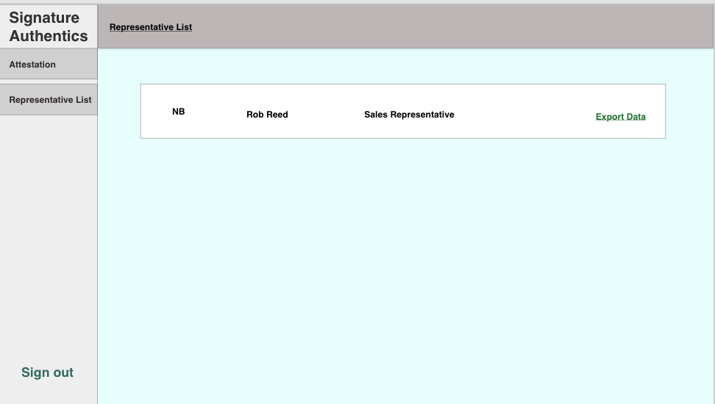

Future works & Conclusions
In the future I could implement this prototype into the web environment that I am building in. The UI of the design guides my software design pattern to match this layered structure of development. To add with adobe XD I can implement new features as a way of presentation before implementing business logic. Improvements will be made with each sprint.

References
- Theoretical Importance of Contingency in Human-Computer Interactions: Effects of Message on User Engagement. – Shyam Sundar [Available] https://journals-sagepub-com.library.sheridanc.on.ca/doi/full/10.1177/0093650214534962?utm_source=summon&utm_medium=discovery-provider& [ Accessed : 2019 ]
- Integrating cognitive load theory and concepts of human-computer interaction – Nina Hollender, Nov 2010 [Available] https://www-sciencedirect-com.library.sheridanc.on.ca/science/article/pii/S0747563210001718 [Accessed : 2019] .
- Exploring User Preserence for the Dashboard Menu Design - A read, [Available] https://ieeexplore.ieee.org/abstract/document/4755377. [Accessed : 2019]

