Neural Networks
Assignment for the
Advanced Concepts of Machine Learning Course
by Kurt Driessen

Introduction
This report describes the developed network and how to use it. In addition to that it contains information on the learning performance of the network, several measurements and an interpretatian of the learned weights. For the development of the code an overall of 17 hours has been spent. The report, benchmarking and evaluation took another two hours.

The Neural Network
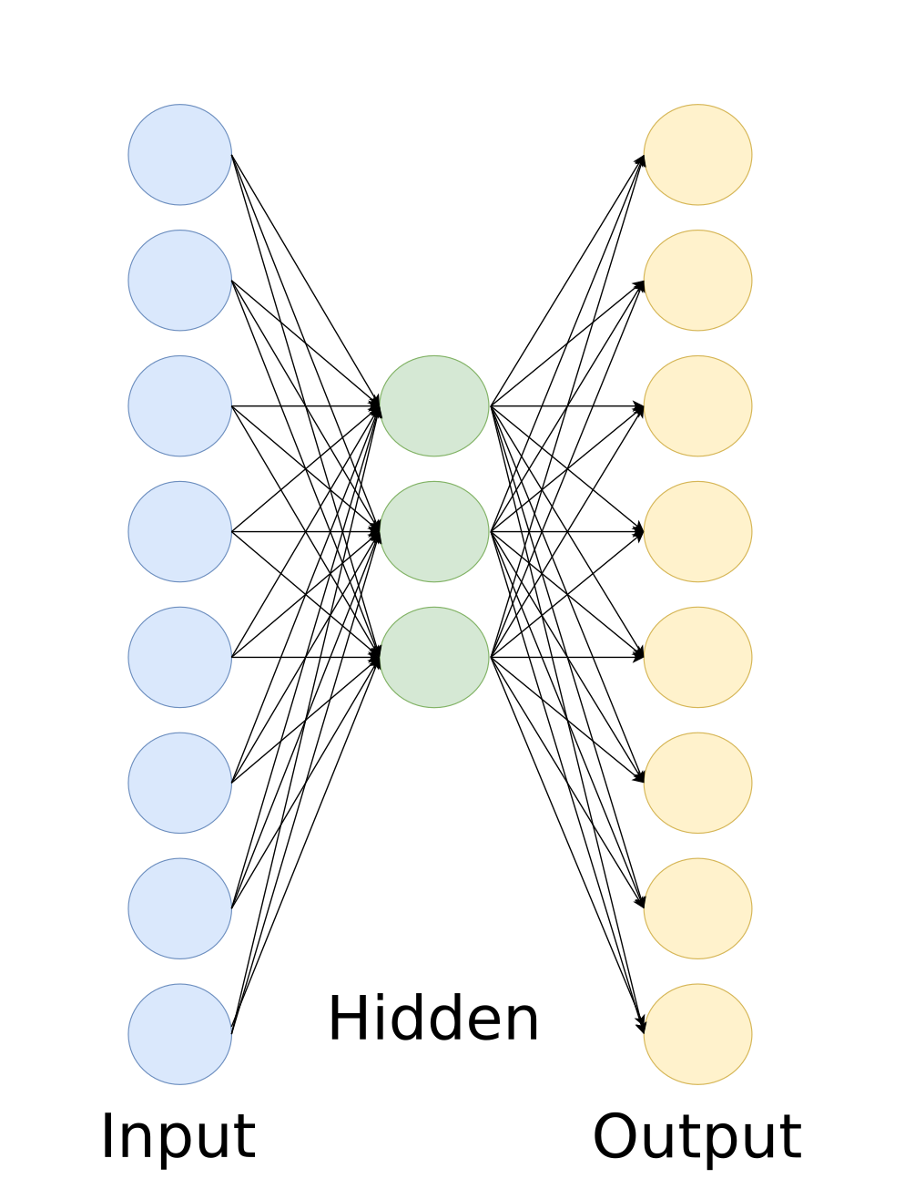
The assignment is to produce and train a 3-layer network. On the input and output layer 8 nodes should be used and the hidden layer is supposed to have 3 nodes. Biases should be used as well. For the training all input nodes will be set to zero, except for one. The output is supposed to look like the input. All eight possibilities should be used for training.
For the implementation of the network an important decision was made in the beginning. While a neural network, especially of larger size, can and should be handled with code iterating over the different layers, this implementation is based on a different approach. The updates of the layers are done manually, so that every single step can be observed.
This does not mean, that every input node is handled manually, but simply that the training data is fed in as a vector rather than a matrix of multiple examples.
Initially basic functions like logging or formatting are set up. Furthermore the learning examples are generated and the weights are initialized to random values. In the core of the implementation a loop over the learningexamples is executed as many times as the network should learn it. In this loop the forward propagation, the backpropagation and the weight updates take place. These make heavy use of the numpy package and utilize the util package for the sigmoid function and its derivative. The code is a straight forward implementation of the underlying mathematics, where the following abbreviations are used : w = weight, b = bias weights, a = activation, d = delta. An added number refers to the layer of the element.
There are some special quirks that might not show up in other implementations of this neural network. For example this implementation seperates a bias vector which is added during forward propagation. This can be done, as the activation of the bias is always one and only the weight changes. The bias therefor is simply added to the final results and moves can move those results either to the left or the right on the coordinate system. As the sigmoid function, also called squashing function, maps all the activations to a range from 0 to 1 moving this result along the abscissa is often a hard requirement. In the given implementation the bias is not part of the weights, but seperated to a vector that contains the weights of the bias. Those are added to the activation before they are passed into the sigmoid function. Mathematical identically to adding a 1 to the input vector and keeping track of the weights of the bias as well.

Analysis
First of all the influence of the random initialization of the weights was tested. Those were then fixed using the same seed for the following tests. Next up it was tested, whether shuffling the learning examples had any influence on convergence and finally different learning rates were tested for their convergence. The interpretation follows afterwards.

