

CS3211 Parallel and Concurrent Programming
Project 1 Report

By

Lee Yik Jiun
Johnson Yep
Chua Hong Beng Henry

Department of Computer Science

School of Computing

National University of Singapore

Mar 2014

Introduction

A parallel system has been developed to simulate a real life (Automatic Teller Machine) ATM system. The system consists of multiple ATMs which allows two-way communication with a dedicated cloud server for each ATM. The cloud server will have shared access to one database. The database process queries and the return results of the queries to each individual cloud. The system was developed based on the idea that each Sub-system in the entire system has its own running thread to simulate what happens in real life. The design criteria and the implementation details are presented in this report.

 |  |  | Table of Contents
 | 1 | Our System
 |  | 1.1  1.2  1.3  1.4  1.5  1.6 | Structure of our System in CSP  Structure of our System in Java  3 Models and their differences  Model 1  Model 2  Model 3 | 3  3  3  3  4  4
 | 2 | Description of each Class |  | 4
 | 3 | Conclusion
 |  | 3.1  3.2 | Technical Knowledge Gained from Assignments  Problems Faced | 5  5
 | 4 | Appendix
 |  | 4.1 | Javadocs | 6

- Our System
  - Structure of our System in CSP
System() = ATMs() || Clouds() || Database() || Channels()
  - Structure of our System in Java
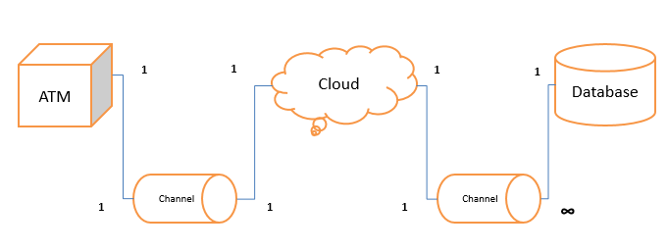
The overall structure of our Java system can be represented by the above diagram. An ATM will each be assigned a cloud and communication will be done via a Channel. The cloud will in turn communicate with one Database which contains all the bank records. However, there will be many of such ATM to Cloud system communicating with a single Database. An unreliable network has also been modeled in the channel.
  - The 3 Models and their differences
We were asked to come up with 3 models each with their own differences namely:
    - A version which exhibits deadlock due to some plausible failure of your system (perhaps in the communication protocol).
    - A version which exhibits incorrect calculations due to a plausible interleaving of transactions (as discussed in lecture 3).
    - A version which has these two errors fixed.
  - Model 1 (The perfect version)
CSP: We chose a level of abstraction such that there will be no state space explosion. There will be an arbitrary number of ATMs in our system based on the variable N. (To simplify our model, we chose N to be 2).
To model the communication, we had ATM sync with Channel via atmSendCloud, atmReceivesCloud and atmToCloudTimeout. We also had Cloud sync with the same channel via cloudSendAtm, cloudReceivesAtm and cloudtoAtmTimeout.
Java: We started with the end goal in mind and designed our model such that it will not have any deadlocks or failures. In Main.java, Main is the System thread which creates all the other threads that will run in parallel. The example in main() does a simple deposit and withdraw from a single ATM and shows the correct result. There are 2 modes of operation for Model 1, one is the free mode where you can do anything you like, another the other is the test mode where it will do the simple deposit and withdraw mentioned.
  - Model 2 (The model with a Starvation)
The model was supposed to show a deadlock situation. However, due to the nature of our design implementation of using queues in our model, it was difficult to model a deadlock on purpose, so we decided to model a plausible situation that might lead to starvation instead.
The implementation of the code can be found in Failure1.java and cspfile . This model in our Java model runs from Failure1.java instead of Main.java.
In this model, we have 2 ATMs but only 1 Cloud. If there is no proper fairness system implemented, it is possible for Atm[0] to repeatedly allocate and de-allocate the cloud before Atm[1] ever gets a chance to allocate cloud! Hence, atm[1] will be starved.
  - Model 3 (The model with interleaving)
The implementation of the code can be found in IncorrectCalc.java and cspfile . This model in our Java model runs from IncorrectCalc.java instead of Main.java. To model interleaving, we asdasdsad
- Description of each Class
    - ATMs
Atms is used to make each running thread of an ATM. It’s main function is to perform transactions based on user input.
    - ATM
A single running thread to simulate an ATM machine. It can authenticate/withdraw/deposit/transfer.
    - Clouds
Clouds is used to make each running thread of a Cloud. It’s main function is to allocate a single Cloud and link them up together with an ATM via a Channel object. Upon initialization, Clouds will create N number of Cloud which will be handed out via a queue to ATMs which requests for a new Cloud.
    - Cloud
Cloud is used by ATM to interact with database to perform transactions. It performs calculations for withdrawal/deposit/transfer and updates the database after calculations. It will also return the result to the assigned ATM.
    - Database
Database stores all the information for the bank accounts currently in the System. Cloud will retrieve these information and work with it or update new information to it. Database has a Queue to store Queries and process it one at a time.
    - BankAccount
A Storage class to store bank account info. It stores the Account ID, pin number and balance of the account.
    - Channel
A link between ATM and Cloud or cloud and database.
    - Query
A data object for cloud to send its query to database.
    - ChannelQueryPair<Channel, Query>
A class for database to store the Query and it’s corresponding Channel into the queue in Database for processing
    - Process
A superclass for ATM Cloud and Database

- Conclusion
- Appendix

