PrintFlow Software Design Document
Version: 2026-06-17 | Target executable: PrintFlow | Scope: Linux desktop and Android APK architecture

1. Project Overview
PrintFlow is a Qt 6 C++/QML raster image processing application for preparing print jobs, previewing and editing artwork, managing printer settings, and generating raster/PRN output through pluggable vendor backends. The product target was renamed to PrintFlow so the base executable, app identity, and public documentation can stay vendor-neutral while customer display branding is handled through theme configuration.
- Linux desktop is the primary native development target and uses the full RIP dependency stack with CUPS, ImageMagick, and Little CMS.
- Android builds are structured to boot safely in an x86_64 emulator without a direct-print SDK and to package a local vendor direct-print SDK for arm64-v8a physical devices when explicitly configured.
- Public documentation uses generic vendor SDK wording. Proprietary SDK drops and filenames remain local and ignored.

2. Repository Structure
Path | Responsibility
android/ | Qt Android package template and manifest resources.
docs/ | Editable flowchart, exported flowchart PNG, and this design document.
resources/assets/ | Tracked ICC profiles, linearization XML, and small runtime assets.
resources/i18n/ | JSON string-resource files loaded by the string system.
resources/qml/ | Qt Quick views and reusable QML controls.
resources/themes/ | Built-in theme JSON files and theme asset folders.
scripts/ | Linux, Android, packaging, emulator, and test helper scripts.
src/app/ | Application bootstrap and QML context setup.
src/core/ | Shared models, managers, output interface, assets, themes, strings, and capability flags.
src/platform/android/ | Android-safe platform facade and boot-safe RIP stubs.
src/platform/desktop/ | Desktop platform facade, including CUPS output support.
src/rip/ | Native image load/edit, color management, screening, multi-ink, and PRN pipeline.
src/third_party/stb/ | Single-header image validation dependency.
src/vendor/nocai/ | Isolated direct-print vendor adapter and PRN writer boundary.

3. Runtime Architecture
The application starts in src/app/main.cpp. Bootstrap creates QApplication, sets the PrintFlow application identity, migrates legacy app data when needed, loads the selected theme, configures Qt Quick Controls, constructs long-lived backend objects, exposes them to QML through context properties, loads persisted color settings, links output backends to shared managers, caps image decode allocation size, and loads resources/qml/Main.qml.
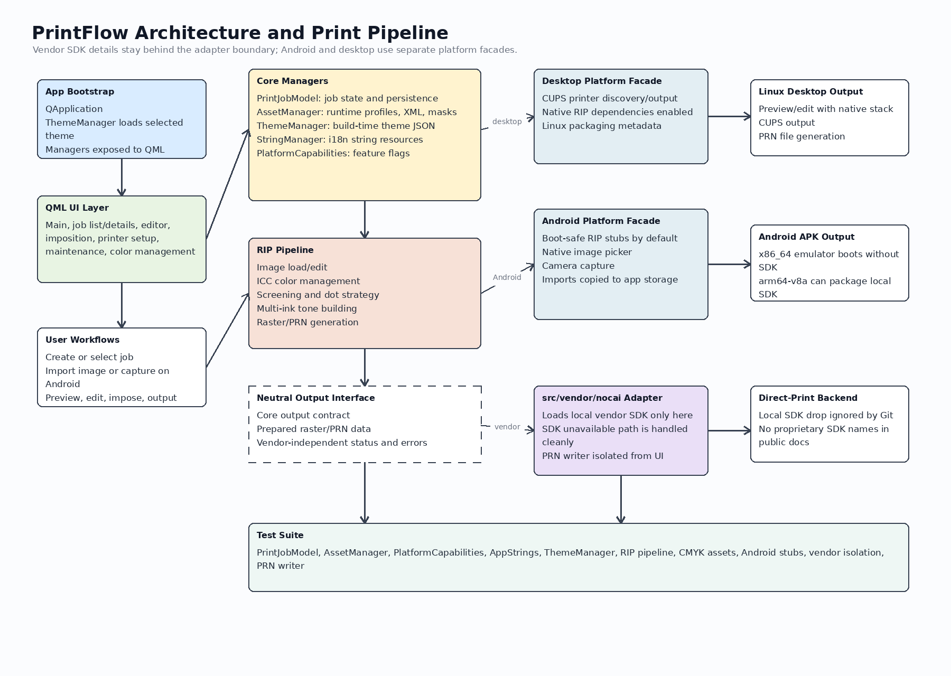

4. Core Managers
Component | Current role
PrintJobModel | Stores job state, exposes QML roles, handles selection and persistence.
AssetManager | Prepares runtime assets such as ICC profiles, linearization XML, logos, and local blue-noise masks.
ThemeManager | Loads selected theme JSON from built-in resources or a configured custom file; exposes colors, logos, labels, and support metadata to QML.
StringManager | Loads resources/i18n JSON files, tracks selected language, exposes trKey lookups, and falls back safely for missing keys.
PlatformCapabilities | Reports platform name and feature availability for CUPS, RIP processing, and direct-print workflows.
ColorManagementManager | Persists color-profile and dot-strategy settings shared by CMYK and multi-ink paths.
ImageImportManager | Bridges image import and camera capture into app-local files, especially on Android.

5. QML UI Layer
The QML layer is resource-backed and communicates with C++ managers through context properties. Main.qml coordinates navigation and shared application state. The primary views cover job lists, job details, image editing, imposition, printer setup, printer maintenance, and color management. Reusable controls such as themed buttons and toast messages consume ThemeManager and StringManager data so UI styling and display strings are centralized.

6. RIP Pipeline
The native RIP pipeline lives under src/rip/ for Linux desktop and Android builds where native processing is explicitly enabled. It handles image load/edit, ICC conversion, stochastic screening, linearization, multi-ink tone building, and PRN generation. Android x86_64 emulator builds use src/platform/android stubs by default so the APK can boot without desktop-only native dependencies.
- Image load/edit: ImageLoader and ImageEditor validate and transform input artwork.
- Color management: ColorProfile and ColorManagementManager coordinate ICC conversions through Little CMS-backed logic.
- Screening: MultiInkScreenEngine and tone-building classes prepare thresholded channel data and dot decisions.
- Output generation: PrintJobCMYK and PrintJobMultiInk generate prepared raster/PRN output through the neutral output interface and vendor adapter when needed.

7. Vendor SDK Isolation
Vendor-specific direct-print code is intentionally isolated behind the neutral output interface and the src/vendor/nocai adapter boundary. Core managers and QML workflows should treat direct print as an optional capability, not as a compile-time assumption. Local SDK loading, symbol lookup, SDK availability errors, and physical-device packaging remain inside the adapter layer.
- The local vendor SDK root is configured through DIRECT_PRINT_SDK_ROOT when packaging direct-print support.
- The SDK is not required for tests or emulator boot builds.
- Public docs should refer to a vendor direct-print SDK or local vendor SDK drop rather than proprietary drop names or library filenames.
- PRN writer behavior is covered separately from SDK availability so generated output can be tested locally.

8. Platform Facades
Facade | Behavior
Desktop facade | Uses CUPS-capable output paths and native RIP dependencies. This is the full Linux development workflow.
Android facade | Provides boot-safe implementations for emulator APK builds and keeps unsupported desktop behavior behind capability checks.
Android import flow | Uses ACTION_OPEN_DOCUMENT for image picking, ACTION_IMAGE_CAPTURE for camera capture, copies returned URIs or bitmaps into app-local incoming_images storage, and emits a local URL to QML.
Physical-device direct print | arm64-v8a builds can package a local vendor direct-print SDK when DIRECT_PRINT_SDK_ROOT is set.

9. Theme and String Systems
Theme resources are selected at CMake configure time through RIP_THEME or RIP_THEME_FILE. Built-in and custom theme JSON include app identity, colors, logo paths, sizing, support metadata, and copyright text. Required identity fields are validated during configuration for custom theme files.
String resources live under resources/i18n. The AppStrings manager exposes available languages, tracks the selected language, loads JSON resources from Qt resources, and provides QML-safe key lookup with fallback behavior. Current resources include English and Simplified Chinese.

10. Build and Deployment
- Linux desktop: cmake -S . -B build -DCMAKE_BUILD_TYPE=Debug, then cmake --build build --parallel, then ./build/PrintFlow.
- Development wrapper: ./Dev_Build_App.sh delegates to scripts/dev_build_linux.sh for dependency checks, ImageMagick policy setup, build cleanup, and runtime asset preparation.
- Android emulator: scripts/setup_android_emulator.sh prepares local SDK/emulator packages; scripts/dev_build_android.sh builds the APK; scripts/android_build_install_run.sh builds, installs, and launches.
- Android ABI split: x86_64 is used for emulator boot without the direct-print SDK; arm64-v8a is used for physical-device builds that package a local vendor SDK drop.

11. Test Suite
The robust local test suite is configured from tests/CMakeLists.txt and run through scripts/run_tests.sh. It configures build-tests, builds app/test targets, and runs ctest --output-on-failure. The suite avoids requiring a direct-print SDK, blue-noise mask fixtures, or an Android device.
Test | Coverage
PrintFlow.Core.PrintJobModel | Model roles, add/update/remove/select behavior, and persistence-facing state.
PrintFlow.Core.AssetManagerAndPlatformCapabilities | Runtime asset helper and platform capability reporting.
PrintFlow.Core.AppStrings | Language resources, lookup behavior, and fallbacks.
PrintFlow.Core.ThemeManager | Theme loading, required fields, and exposed theme properties.
PrintFlow.Rip.PipelineValidation | Linearization, screening, tone building, and multi-ink pipeline checks.
PrintFlow.Rip.CMYKAssetManager | CMYK output behavior with managed assets.
PrintFlow.Platform.AndroidSafeStubs | Android-safe image/RIP stubs that allow APK boot paths to stay dependency-light.
PrintFlow.Vendor.DirectPrintUnavailable | Unavailable SDK behavior stays contained behind the adapter.
PrintFlow.Vendor.NocaiPrnWriter | PRN writer packing and file-generation behavior independent from SDK availability.

12. Documentation and Security Rules
- The editable flowchart is docs/RIP-APP_Flowchart.drawio and the exported image is docs/RIP-APP_Flowchart.png.
- The root README is the public entrypoint and should keep SDK wording generic.
- The docs README summarizes the design artifacts and build notes.
- No public documentation should expose proprietary SDK drop names, package names, or local library filenames.
- Local job data, imported images, SDK drops, and blue-noise masks remain local unless a user explicitly chooses to save or package them.

