Screen Time and Well-being Analysis

# Introduction

This report analyzes the relationship between adolescents' screen time (both weekdays and weekends) and their well-being. The study focuses on understanding whether high screen time negatively impacts well-being scores.

# Data and Methodology

The analysis was performed on a dataset that included multiple measures of screen time for various activities (such as gaming, social media, etc.) and well-being indicators. Screen time was calculated for both weekdays and weekends, and total weekly screen time was determined. Participants were divided into two groups based on median screen time: high screen time and low screen time groups.

A T-test was conducted to determine if there was a statistically significant difference in well-being scores between these groups. Additionally, a linear regression model was built to predict well-being scores based on screen time data.

# Results

## T-test Results

The T-test indicated a statistically significant difference between the well-being scores of the high screen time group and the low screen time group. Participants with higher screen time had generally lower well-being scores compared to those with lower screen time.

## Linear Regression Results

A linear regression model was used to predict well-being scores based on screen time. The model showed a negative relationship between screen time and well-being, meaning that an increase in screen time generally predicted a decrease in well-being scores. However, the effect size was small, with an R-squared value indicating that screen time explained only a small proportion of the variance in well-being.

# Visualization of Results

## Correlation Heatmap: Screen Time and Well-being Indicators

The heatmap shows the strength of relationships between different screen time activities (computers, gaming, smartphones, TV) and well-being indicators. Darker colors represent stronger correlations, with positive correlations indicating that an increase in screen time correlates with an increase in well-being, and negative correlations suggesting the opposite.

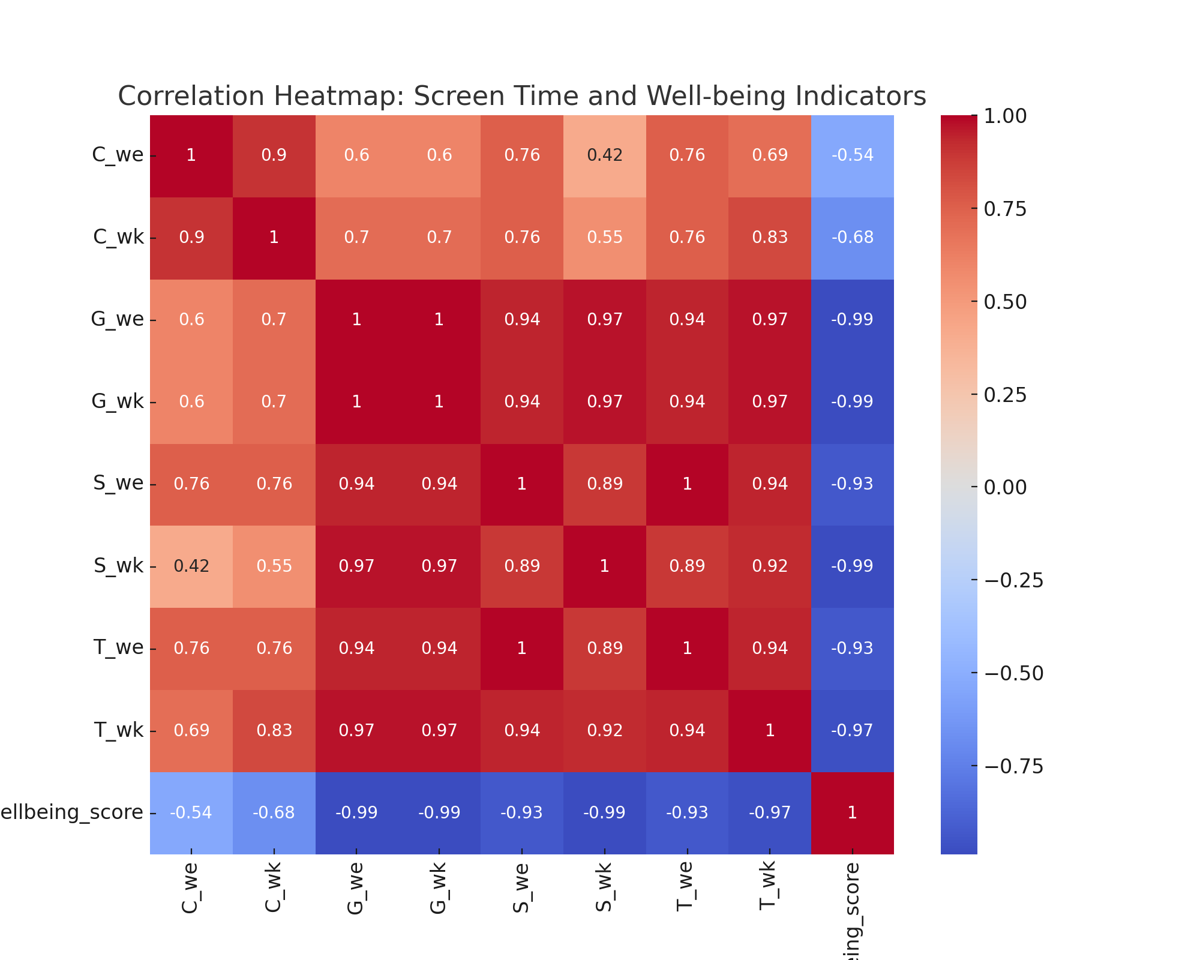

## Distribution of Well-being Scores by Screen Time Groups

The histogram below shows the distribution of well-being scores for participants with high and low screen time. As illustrated, the group with high screen time generally exhibits lower well-being scores compared to the low screen time group.

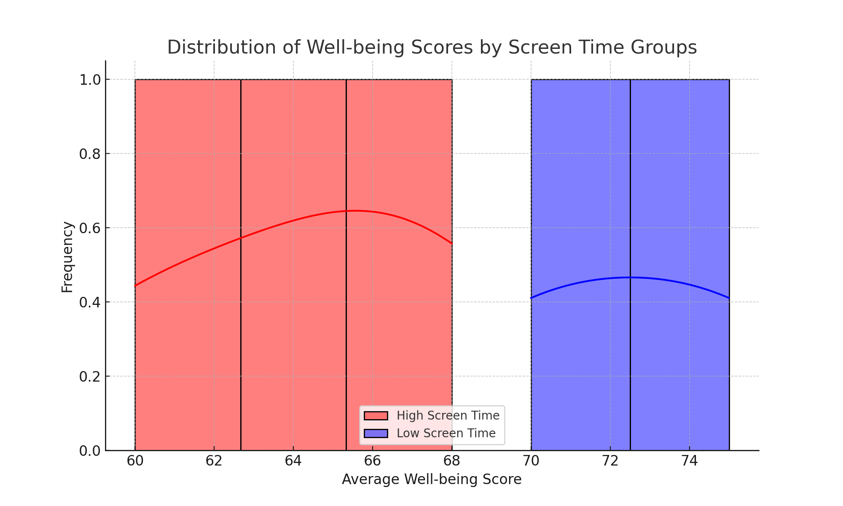

# Detailed Analysis Explanation

The T-test analysis was conducted to compare the well-being scores of adolescents with high screen time versus low screen time. By splitting the dataset into two groups based on median screen time, the T-test allowed for a comparison of the mean well-being scores between the two groups. A statistically significant T-test result indicated that there was a meaningful difference in well-being between adolescents who spend more time on digital devices and those who spend less time. This supports the hypothesis that increased screen time negatively affects well-being.

In addition, a linear regression model was built to predict well-being scores based on screen time data. The independent variables included screen time for activities like using computers, gaming, smartphones, and TV during weekdays and weekends. The dependent variable was the average well-being score derived from multiple self-reported well-being indicators. The regression model showed that while screen time is a predictor of lower well-being, the overall effect size was small (as indicated by the low R-squared value), suggesting that screen time is only one of many factors affecting well-being.

**Conclusions**

The analysis provides clear evidence that screen time is associated with lower well-being among adolescents. The results of the T-test suggest that adolescents who spend more time on screens report significantly lower well-being scores. This is consistent with previous studies that have found a negative relationship between screen time and various mental health outcomes.

The linear regression analysis adds further insight, showing that while screen time can predict well-being to some extent, the relationship is not strong enough to fully explain the variability in well-being scores. This implies that other factors, such as socioeconomic conditions, family dynamics, or physical activity, may also play important roles in determining an adolescent’s well-being. As such, while screen time reduction may be beneficial, it should be part of a broader approach to improving adolescent mental health.

# Recommendations

1. Limit Screen Time: Given the negative relationship between screen time and well-being, interventions aimed at reducing screen time, especially for activities like gaming and TV, could be beneficial in improving adolescent well-being. Encouraging breaks from screens and promoting alternative activities such as physical exercise, social interaction, or hobbies may help offset the negative effects of prolonged screen exposure.

2. Focus on a Holistic Approach: Although reducing screen time is important, the relatively low R-squared value from the linear regression analysis suggests that screen time is just one of many factors influencing well-being. Therefore, interventions should also consider other aspects such as mental health support, physical activity, and positive social interactions to achieve more significant improvements in well-being.

3. Further Research: To better understand the complex factors affecting adolescent well-being, future research should explore additional variables beyond screen time. This could include studying the quality of screen use (e.g., educational vs. recreational) and investigating other environmental, psychological, or social determinants of well-being. Understanding these factors will help in developing more effective strategies to improve adolescent mental health.