User Guide

JD Dog Care

# **Introduction**

This is a Software Application which has been designed and developed to replace the current booking system at JD Dog Care. This guide explains how each menu was intended to be used. The primary purpose of this system is to manage the dogs and customers of JD Dog Care, and to keep record of any previous or upcoming bookings.

# **System Requirements**

|  |  |  |
| --- | --- | --- |
|  | **Minimum** | **Recommended** |
| **CPU** | Intel I3 1.5 GHz processor | Intel I5 2.8 GHz processor |
| **Memory** | 2GB | 4GB |
| **Disk Space** | 2GB | 8GB+ |
| **GPU** | Direct X9 with WDDM 1.0 driver | Direct X9 with WDDM 1.0 driver |
| **Operating System** | Windows 10 Home (x32) | Windows 10 Professional (x32) |
| **Other Software** | Visual Studio 2015 Community | Visual Studio 2015 Community |
| SQL Server 2016 | SQL Server 2016 |

## **Notes**

* Do not use any Visual Studio after 2015, as the Reports feature was removed and will not work.
* Do not use any Visual Studio before 2015, as the database will not be supported.

## **Other Important Information**

The program should automatically connect to the database when it is started. You will know if it has not as in the bottom left-hand side of the application, there will be the text “Database Disconnected”, and it will be in red.

If this is the case, close the application, then find a file named “Database1.mdf” in the file explorer. Right-Click this file, then click “open” and wait for Visual Studio to open the file. After this, start the application again.

Doing this refreshes the database, allowing it to be connected to.

If the database is not connected, you will not be allowed to progress to the Grooming Menu.

# **Application Usage**

## **Main Menu**

From this first window, you can navigate to the different management sections for JD Dog Care. The only one available in my system is “Grooming” as I was not focusing on the other areas.

## **Grooming Menu**

From this menu, you can switch between all the management sections. If there are no dogs that are not deleted available, the bookings section will not be accessible.

## **Manage Dogs**

From this menu, you can add, edit, and “delete” any dogs from the system.

*Note: The following mini-sections assumes you have only just opened this window. This is for simplicity of the guides.*

*If, for whatever reason, you want to stop adding or editing a dog, it is possible to press the “Cancel Edit Dog” or “Cancel Add Dog” button, depending on which option you initially chose. This button is only visible when adding or editing a dog.*

### **Adding Dogs**

* Click “Add New Dog”.

* Enter all the dog’s details.

* Click “Save New Dog”.

* The system will now ask for confirmation. Click “Yes” to add the dog.

* The system will respond that the dog has been added, and you will see it has added the new dog to the list on the left-side.

### **Editing Dogs**

* Select the dog to edit by clicking its name in the list, or by using the “Next Dog” and “Previous Dog” buttons. The list can also be filtered using the search boxes above.

* Click “Edit Current Dog”.

* Change any of the details that need changed.

* Click “Save Changes”.

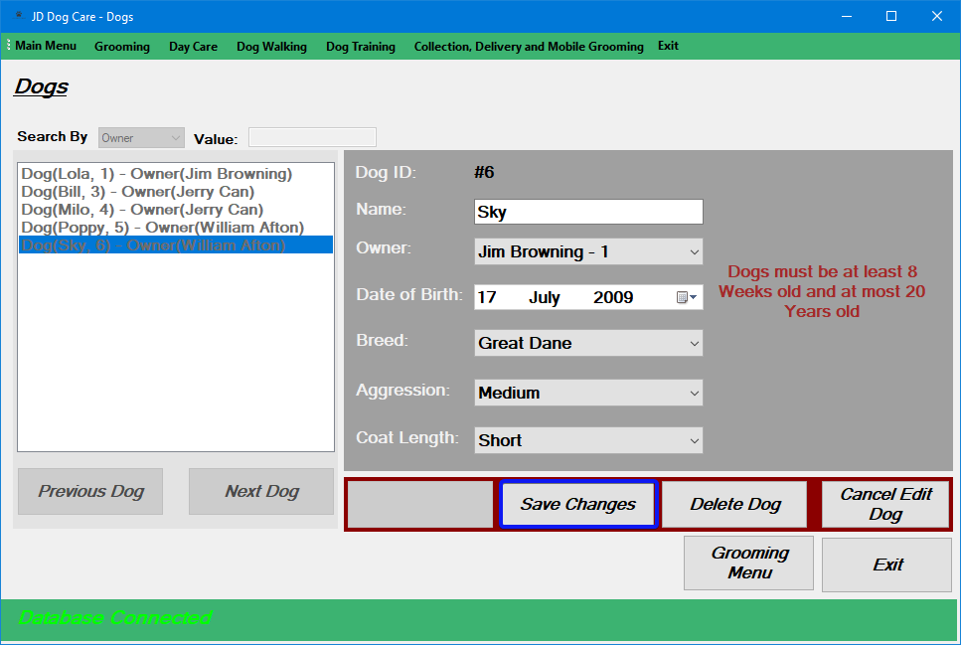

* The system will now ask for confirmation. Click “Yes” to edit the dog.

* The system will respond that the dog has been edited.

### **Deleting Dogs**

* Select the dog to delete by clicking its name in the list, or by using the “Next Dog” and “Previous Dog” buttons. The list can also be filtered using the search boxes above.

* Click “Edit Current Dog”.

* Click “Delete Dog”.

* The system will now ask for confirmation. Click “Yes” to delete the dog.

* The system will respond that the dog has been deleted.

## **Manage Bookings**

From this menu, you can add, edit, and cancel any bookings from the system.

*Note: The following mini-sections assumes you have only just opened this window. This is for simplicity of the guides.*

*If, for whatever reason, you want to stop adding or editing a booking, it is possible to press the “View Booking” button. This button is only visible when adding or editing a booking.*

### **Adding Bookings**

* Select the date for the booking using the provided calendar. Under normal circumstances, this must be 3 weeks in advance, however if there are less than 21 bookings in the next 3 weeks, you can add a booking before this.

* Click “Add Booking”.

* Enter all the booking information into the input slots on the right-hand side.

* When selecting Start Time and the Staff Member, you must click the “Select” buttons to the right-hand side. This will display the options on the left-hand side, where the available and unavailable options are colour coded.

* Click “Add Booking”.

* The system will now ask for confirmation. Click “Yes” to add the booking.

* The system will respond saying that the booking has been created. This booking will now be visible in the room it has been assigned to, as a red series of boxes, depending on how much time the booking will last.

### **Editing Bookings**

* Select the date of the booking you want to edit, using the provided calendar.

* Select the booking, highlighted in red, from the room displays.

* Click “Edit Booking”.

* Change any of the booking details to be edited.

* Click “Edit Booking”.

* The system will now ask for confirmation. Click “Yes” to edit the booking.

* The system will respond that the dog has been edited.

### **Cancelling Bookings**

* Select the date of the booking you want to cancel, using the provided calendar.

* Select the booking, highlighted in red, from the room displays.

* Click “Edit Booking”.

* Click “Cancel Booking”.

* The system will now ask for confirmation. Click “Yes” to cancel the booking.

* The system will respond saying that the booking has been cancelled.

## **Reports**

In this window, you can view all the orders, their income, and the total income in a time frame that you specify.

### **Displaying Order Income**

* Select the starting and end times using the provided calendars.

Click “Display Data”.

* After roughly 10 seconds, the report will be loaded.

