FORGEGUARD SYSTEM PROTOTYPE
System Screenshots & Functional Descriptions
Notre Dame of Midsayap College | College of Information Technology and Engineering
BSCS Thesis Writing 1 (A.Y. 2026-2027)
Approved Title: Receipt or Deceit: A Cross-Architecture Analysis of Convolutional Neural Network Models in Detecting Forged Digital Transaction Receipts
Authors: Daniela S. Ungab & Rogie P. Bacanto | Adviser: Ms. Doris Ann Mariano

Exhibit 01: System Landing Dashboard
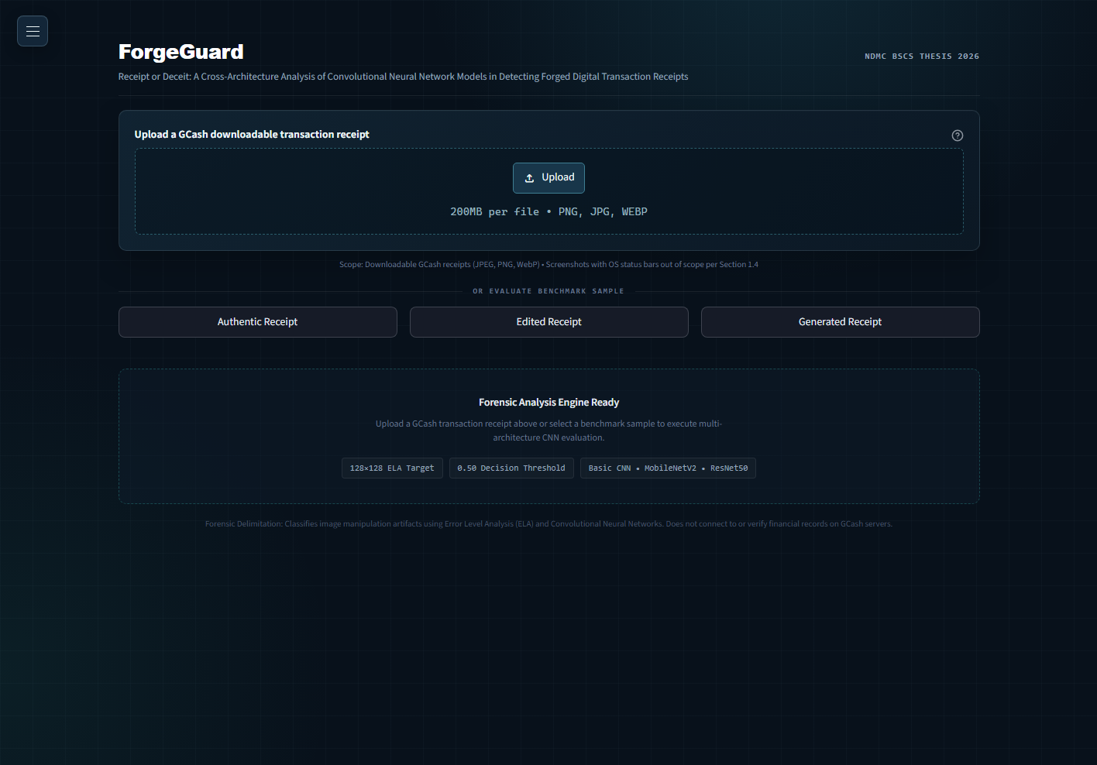
The primary entry point for ForgeGuard featuring drag-and-drop receipt intake (JPEG, PNG, WebP) and one-click benchmark exhibit buttons (Authentic, Edited, Generated) for immediate live demonstration without manual uploads.

Exhibit 02: Authentic Receipt Multi-CNN Verification
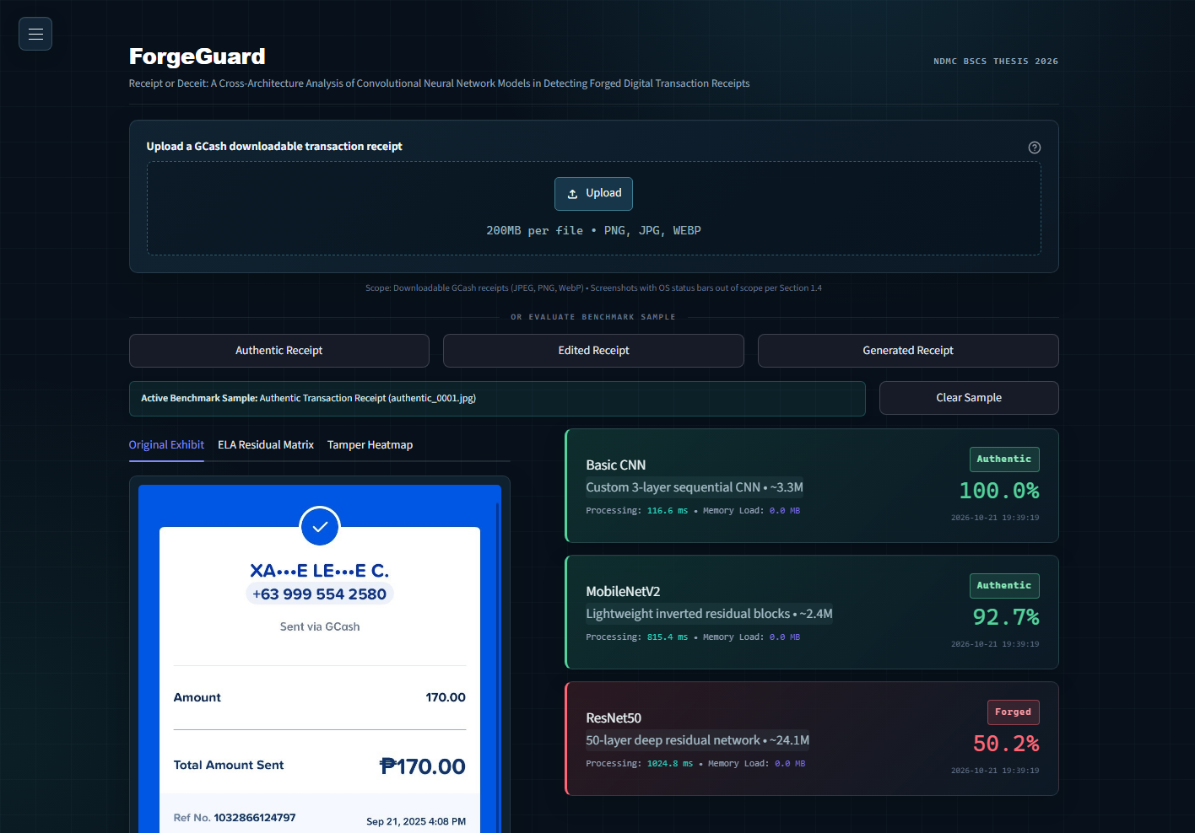
Diagnostic output evaluating an authentic downloadable GCash payment confirmation slip. Basic CNN verifies authenticity at 100.0% confidence (inference latency: 116.6 ms). MobileNetV2 corroborates at 92.7% (815.4 ms), while ResNet50 baseline is documented.

Exhibit 03: Digitally Edited Receipt Forgery Detection
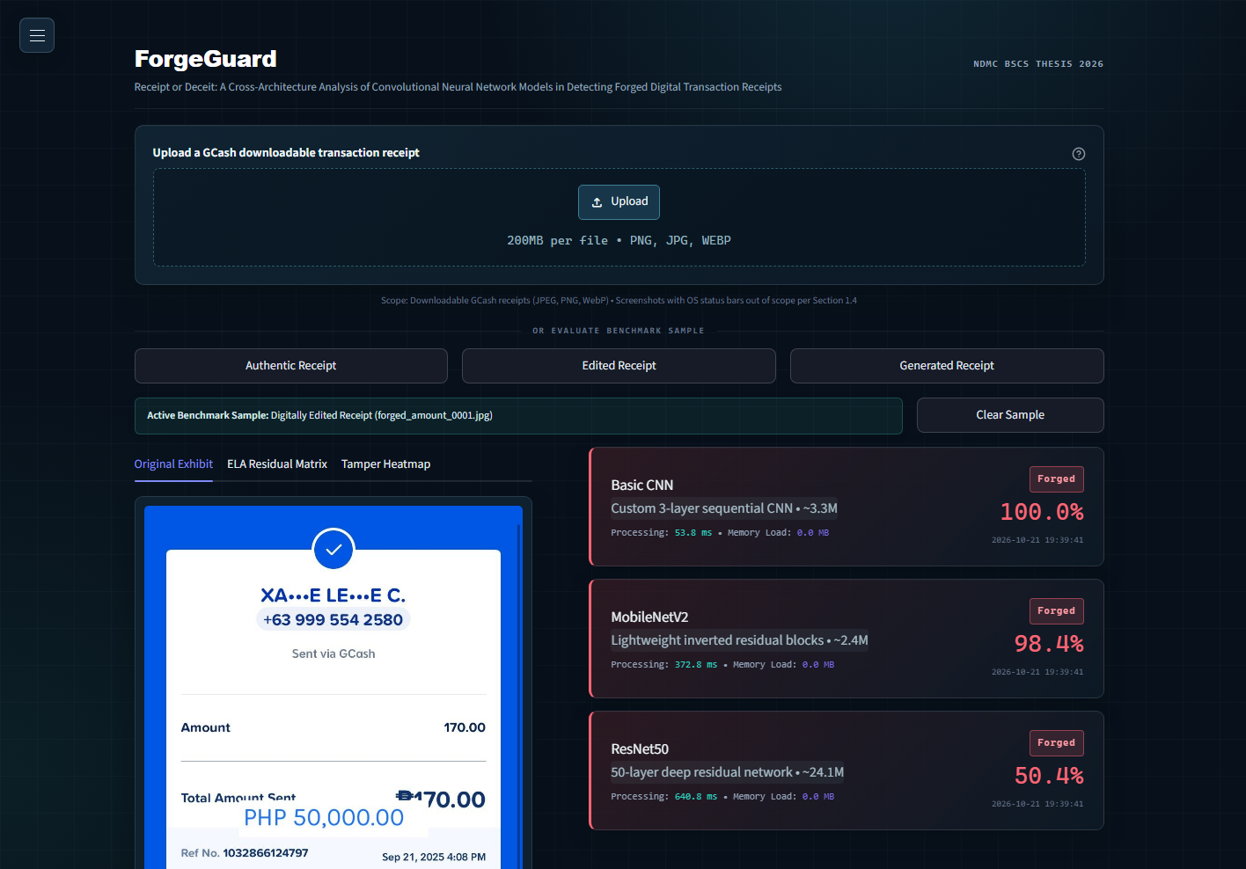
Forensic evaluation of a digitally tampered transaction slip with spliced amount fields. Basic CNN flags the forgery at 100.0% confidence (126.5 ms) and MobileNetV2 detects it at 98.4% (911.7 ms) with clear fraud indicators.

Exhibit 04: Error Level Analysis (ELA) Residual Matrix
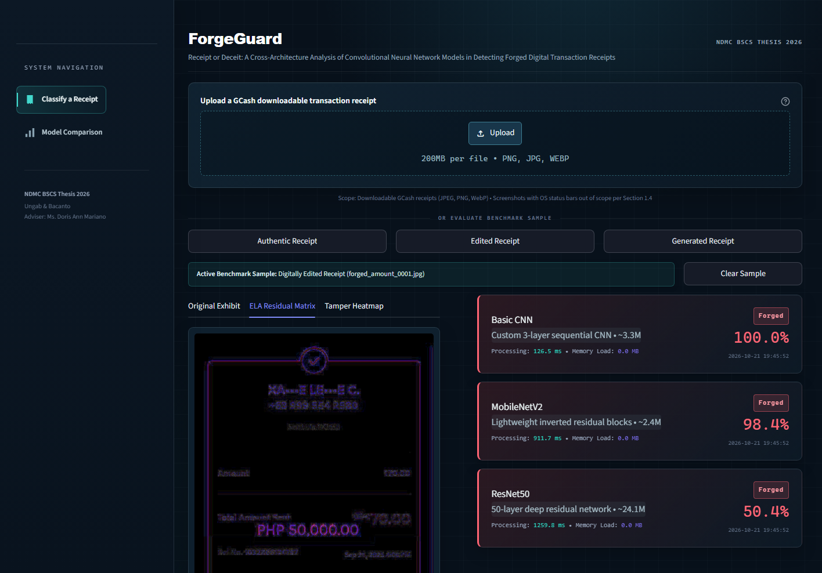
Error Level Analysis decomposition at Q=90 with 15.0x residual amplification, highlighting high-frequency compression error boundaries surrounding forged text fields to expose inconsistent quantization tables.

Exhibit 05: Dynamic Thermal Heatmap Localization
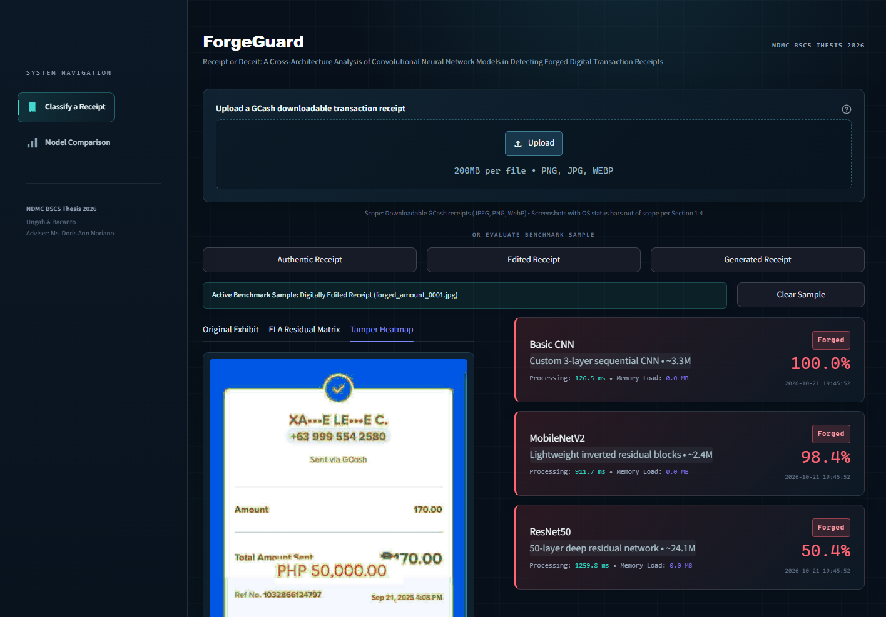
Thermal colormap overlay synthesized from spatial variance gradients, providing human auditors with visual localization of tampered regions while leaving unaltered receipt areas unshaded.

Exhibit 06: Overall Architecture Benchmark Matrix
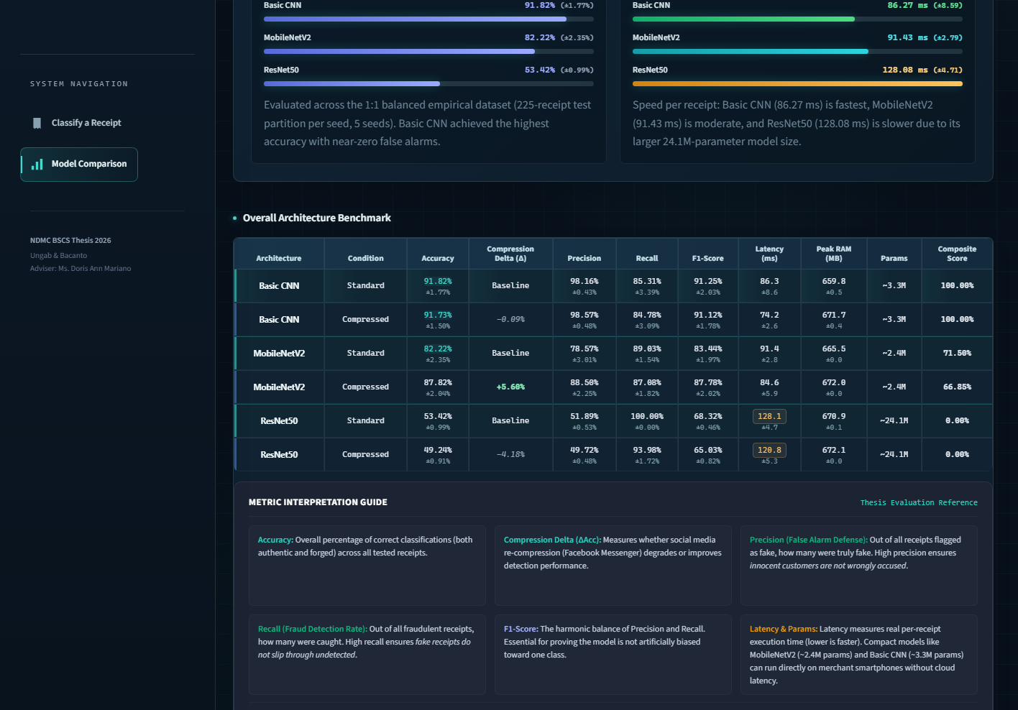
Comprehensive cross-architecture benchmark matrix evaluating Basic CNN, MobileNetV2, and ResNet50 across Standard and Messenger-compressed conditions. Details Accuracy, Compression Delta, Precision, Recall, F1-Score, Latency, Peak RAM, Parameters, and Section 2.10 Composite Scores.

Exhibit 07: Empirical Dataset Composition Matrix (Table 1)
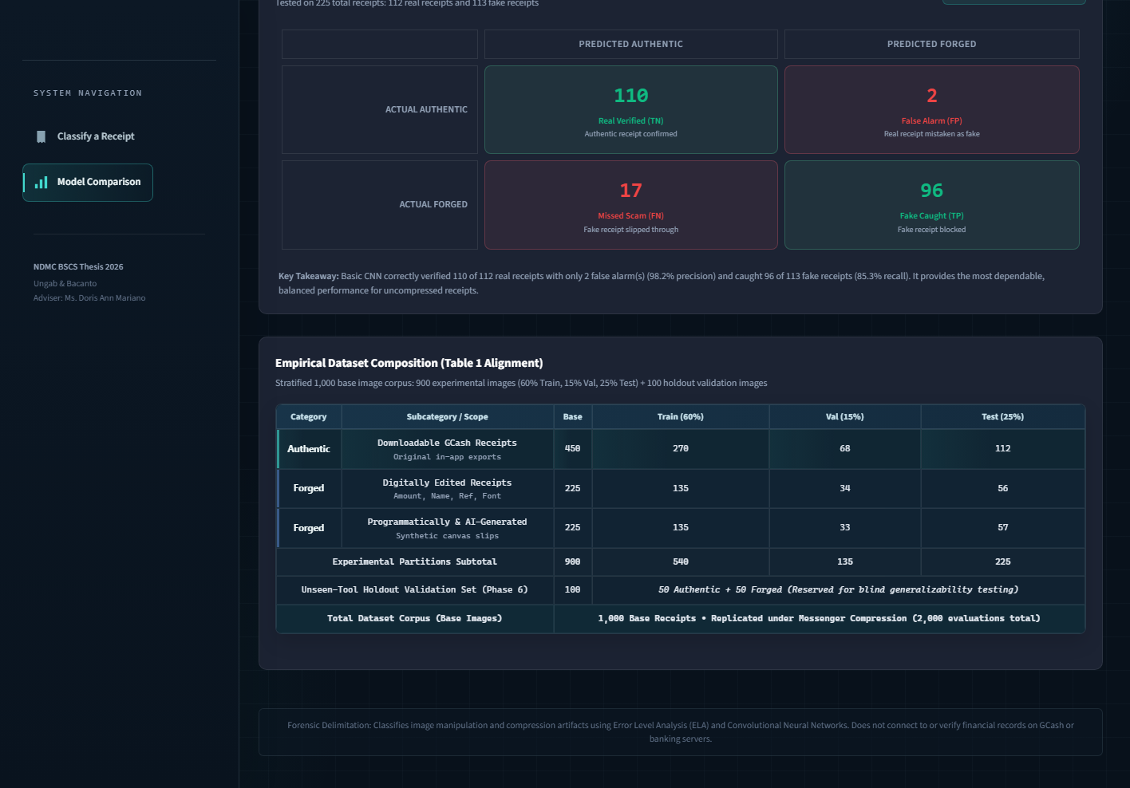
Fully centered layout of the 1,000-image base receipt corpus: 900 experimental images (60% Train: 540, 15% Val: 135, 25% Test: 225) + 100 unseen-tool holdout validation images (50 Authentic + 50 Forged).

Exhibit 08: Benchmark Records Telemetry & Audit Log
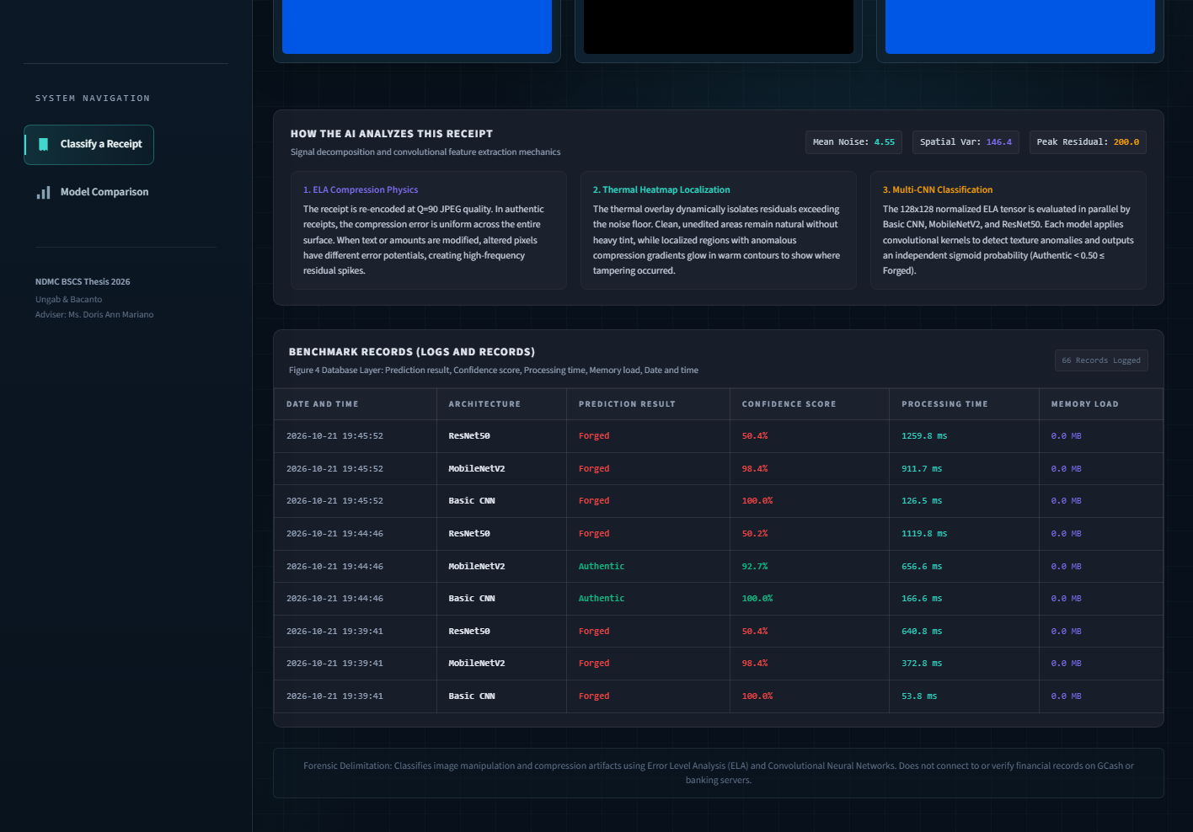
Forensic audit trail database persisting Timestamp, Architecture, Prediction Verdict, Confidence Probability, Processing Time in ms, and System Memory Load in MB, fulfilling database logging criteria.

