‘Receipt or Deceit?’: A Cross-Architecture Analysis of Convolutional Neural Network Models in Detecting Forged Digital Transaction Receipts



Daniela S. Ungab
Rogie P. Bacanto

Bachelor of Science in Computer Science

Notre Dame of Midsayap College
Midsayap, Cotabato

September 2026

Table of Contents
Chapter 1 6
Introduction 6
1.1 Background of the Study 6
1.2 Statement of the Problem 9
1.3 Significance of the Study 10
1.4 Scope and Delimitations of the Study 12
1.5 Definition of Terms 15
1.6 Review of Related Literature and Systems 18
1.6.1 Related Literature 19
1.6.2 Related Systems 31
1.7 Theoretical Framework 34
1.8 Conceptual Framework 36
1.9 Hypotheses 37
Chapter 2 39
Methodology 39
2.1 Research Design 39
2.2 Locale and Respondents of the Study 40
2.3 Sampling Technique 41
2.4 Data Gathering Procedure 44
2.5 System Architecture 47
2.5.1 Context Diagram 48
2.5.2 Use Case Diagram 49
2.5.3 Architecture Diagram 51
2.5.4 Image Preprocessing and Input Resolution 52
2.6 Software and Tools 53
2.7 Data Collection 55
2.8 Instrumentation 56
2.9 Validity and Reliability of the Instruments 59
2.10 Statistical Tools and Treatment of Data 61
2.11 Ethical Consideration 65
References 69

Chapter 1

Introduction

1.1 Background of the Study
A payment receipt can be downloaded, opened in a photo editor, and altered to show a different amount, reference number, or recipient. Digital payment channels now account for a substantial share of everyday retail transactions in the Philippines [1], and the downloadable receipt they issue has become the document merchants rely on to confirm that money has been sent. Fraudsters exploit this reliance by editing those details on a genuine receipt file and presenting it as convincing proof of a payment that was never made, walking away with goods no one paid for [2]. Digital image forgery, the alteration of an image’s visual and structural integrity, is easily achieved with modern photo-editing applications. The use of downloadable receipts as proof of payment therefore presents a serious security weakness, creating a need for automated image-forensic approaches that can assess the authenticity of transaction receipt images.
Globally, the spread of digital forgery has driven significant advances in image forensic architectures based on deep learning and Convolutional Neural Networks (CNNs). International benchmarks on image forensics have shown that CNNs can learn to extract latent manipulation artifacts, such as compression inconsistencies, noise variations, and edge-based aberrations left by digital tampering [3]. The deep residual network ResNet50 and similar architectures have achieved high performance in identifying splice forgeries and pixel-level manipulations by using residual learning to overcome the vanishing gradient problem and enable deep feature extraction [4]. In contrast, lightweight architectures such as MobileNetV2 offer efficient feature extraction at substantially lower computational cost, allowing deployment on mobile or edge devices without dedicated GPUs [5].
In the Philippines, the widespread use of mobile wallets such as GCash and Maya has democratized financial services but also increased opportunities for cyber fraud. As reported by the Bangko Sentral ng Pilipinas in its 2025 measurement report covering the 2024 calendar year, digital channels accounted for 57.4 percent of monthly retail payment transactions in 2024, up from 42.1 percent in 2022 [1], yet the adoption of robust real-time verification practices among MSMEs remains limited. Receipt fraud has consequently become a national concern. GCash has publicly warned that fabricated and artificially generated receipts are being circulated to claim payments that were never made, and has advised sellers not to release goods on the strength of a receipt image alone [2]. Because messaging apps heavily compress these images, visual inspection and simple Error Level Analysis (ELA) often fail to reveal subtle modifications, requiring models trained explicitly on heavily compressed data [6].
This vulnerability has been identified as a concern among small business owners, local online sellers, and student entrepreneurs in Midsayap, Cotabato. Merchants here accept mobile wallet payments but typically lack the technical infrastructure to cross-check transactions with banking servers during fast-paced exchanges. Informal accounts from student entrepreneurs, whose micro-businesses rely on peer-to-peer e-wallet transfers, suggest that forged proof-of-payment scams may be a recurring problem locally, although no formal incidence data for the municipality has yet been documented. Recent research documents the wider extent of the problem. Advances in image-editing tools have produced manipulated documents that are increasingly difficult to detect by visual means, prompting the construction of dedicated receipt forgery datasets for training automated detectors [7]. Yet no identified study has comparatively evaluated Basic CNN, ResNet50, and MobileNetV2 for classifying forged downloadable GCash transaction receipts, covering both digitally edited and programmatically generated forgeries under original and messaging-platform-compressed image conditions. Without that evidence, merchants have no accessible, lightweight basis for screening the receipts they are shown, which may leave them exposed to financial deception and erode trust in local digital commerce.
This study addresses the pressing need for accurate and efficient detection of forged transaction receipts, whether manually manipulated or programmatically generated. It conducts a comparative evaluation of Basic CNN, ResNet50, and MobileNetV2 in classifying GCash transaction receipt images as authentic or forged. Each model is assessed on classification accuracy, precision, recall, and F1-score using both original high-resolution downloadable receipts and heavily compressed images. Inference speed and memory load are also measured. The primary goal is to determine which of the three architectural approaches provides the most practical balance of classification accuracy and processing efficiency for real-world receipt authenticity screening on the limited hardware available to local merchants.

The research is well aligned with the CITE Research Agenda 2024-2030 under the Computer Science program focus areas “Emerging Technologies in Computer Science” and “Cybersecurity Threat Detection and Prevention”. It evaluates machine learning capabilities for real-time threat analysis and digital fraud prevention. The study contributes to SDG 9: Industry, Innovation and Infrastructure, which promotes advanced technologies that strengthen industrial systems. In addition, it contributes to SDG 8: Decent Work and Economic Growth through technologies that secure businesses and sustain economic growth and to SDG 16: Peace, Justice and Strong Institutions through the safe and ethical use of artificial intelligence to protect digital systems.

1.2 Statement of the Problem
The widespread integration of mobile wallets among local merchants and entrepreneurs in Midsayap presents a potential security vulnerability: receipt-based payment fraud. Fraudsters increasingly exploit digital image manipulation to fabricate or alter transaction receipts, deceiving sellers into releasing goods without actual fund transfers [2]. While deep learning architectures like Convolutional Neural Networks (CNNs) have proven highly effective in identifying pixel-level tampering and compression anomalies in image forensics [8], their practical application for small-scale local merchants remains an ongoing challenge. Deep architectures such as ResNet50 demonstrate exceptional accuracy in detecting splice-forgeries through residual learning frameworks [4], whereas lightweight models like MobileNetV2 are optimized specifically for fast, efficient inference on edge devices lacking high-end computing power [5]. The primary challenge lies in identifying an architectural approach that not only maintains high classification accuracy against sophisticated and heavily compressed forged images but also operates efficiently on resource-constrained hardware.
Therefore, this study seeks to comparatively evaluate the performance of a Basic CNN, ResNet50, and MobileNetV2 in classifying GCash transaction receipt images as authentic or forged. By assessing classification accuracy, processing efficiency, and practical deployability, the research aims to determine the most suitable architecture to support receipt authenticity screening for local online sellers.
Specifically, this study seeks to answer the following questions:
- What is the performance of the three models in classifying an image as authentic or forged using standard machine learning metrics in terms of:
1.1 Precision
1.2 Recall
1.3 F1-score
- What is the classification accuracy of the Basic CNN, ResNet50, and MobileNetV2 models in detecting:
2.1 Digitally edited transaction receipts
2.2 Programmatically generated fake transaction receipts
- Is there a significant difference in the inference speed and memory load of the three models?
- Is there a significant difference in classification accuracy among the three models when analyzing:
4.1 Original high-resolution downloadable receipts
4.2 Heavily compressed images
- Which of the three architectures offers the most practical balance of accuracy and efficiency for real-world receipt authenticity screening by local online sellers at Midsayap, Cotabato?

1.3 Significance of the Study
Mobile wallets are convenient, but their adoption has been accompanied by a rise in fraud committed through fabricated payment receipts. This research addresses that security gap by comparatively evaluating three convolutional neural network architectures to determine which detects forged digital transaction receipts most accurately and most efficiently on ordinary hardware. Its findings provide the following stakeholders with practical, evidence-based guidance:
Local Online Sellers. This study provides online sellers with comparative evidence of which CNN architecture is best suited to a future receipt-verification application that could be used before goods or services are released, informing the design of tools that would reduce their exposure to payment fraud.
Small Business Owners. This study also serves small business owners in Midsayap who accept mobile wallet payments in person rather than online, by identifying which architecture can deliver a verification decision quickly enough on modest hardware to be practical at the point of sale, and thereby establishing the technical basis on which such a tool could be built.
Student Entrepreneurs. This study identifies for student entrepreneurs the CNN architecture with the most feasible accuracy-efficiency trade-off, providing the evidence base for an accessible verification tool that could help secure their small-scale businesses against forged proof-of-payment scams.
Mobile Wallet Providers. The study contributes comparative findings that mobile wallet platforms may consider in selecting or reinforcing the underlying architecture of their own fraud detection and receipt verification features.
Software and Application Developers. This study helps developers build highly accurate, efficient fraud-detection tools for resource-constrained hardware. The comparative results may serve as a reference for designing lightweight verification applications suited to the constrained hardware of local merchants.
Local Government Units (LGUs) and Policymakers. This study equips Midsayap’s local government with insights to combat receipt-based fraud, protecting the economic stability of local businesses and driving sustainable economic growth.
Law Enforcement and Cybercrime Investigators. This research supports authorities working on image-based financial fraud by documenting how well convolutional neural networks of differing depth recover the latent manipulation artifacts left in forged receipts, and at what computational cost, which may inform the selection of tools used in examining pixel-level tampering and fabricated receipts.
Notre Dame of Midsayap College and the CITE Department. This study aligns directly with the CITE Research Agenda for 2024-2030, advancing the Computer Science program’s goals in cybersecurity and emerging technologies. It also supports the institution’s commitment to SDGs 8, 9, and 16 by promoting secure and ethical artificial intelligence.
Cybersecurity Researchers. This study adds to the growing body of work on image forensics and forgery detection, offering a domain-specific comparative benchmark of CNN architectures that future researchers may build upon.

1.4 Scope and Delimitations of the Study
This study is limited to the comparative evaluation of three Convolutional Neural Network (CNN) architectures, a Basic CNN, ResNet50 and MobileNetV2, in the detection of forged digital transaction receipts. The study focuses exclusively on the transaction receipts of the GCash mobile wallet because GCash is one of the most common e-wallet platforms used by local online sellers, small business owners, and student entrepreneurs in Midsayap, Cotabato. The dataset is a curated sample of six hundred base images, half of them legitimate GCash downloadable transaction receipts collected from consenting local users and half of them forged versions constructed by the researchers. Only receipts obtained through the application’s download function are included; screenshots are excluded, as they are produced by the device rather than issued by the platform and therefore carry a different artifact signature. Types of forged images include digitally edited receipts, where the text, amounts, or transaction details are altered with photo or graphic editing applications, and programmatically generated receipts, where script or template-based fabrication is used. The study also examines two image conditions: the original downloadable receipt as issued by the application, and a heavily compressed version produced by transmitting the image through Facebook Messenger at standard send quality and retaining the received file, so that the condition carries the recompression that messaging platforms actually apply when receipts are forwarded rather than an approximation of it.
The comparative evaluation of the three architectures is confined to the following performance measures: classification accuracy, precision, recall, and F1-score in distinguishing authentic from forged receipts, as well as inference speed and memory load in assessing practical deployability on limited hardware. All efficiency measurements are taken on a single fixed benchmarking machine of ordinary specification and without a dedicated graphics processing unit, representative of the hardware available to local merchants. This study is limited to the training, testing, and benchmarking of the three models using the curated dataset, together with a lightweight web interface built solely to demonstrate and test the trained models; the development of a production verification system for merchant use is not undertaken. The study is further delimited to image-level authenticity detection: the models classify a receipt image as authentic or forged based on its visual and structural characteristics, and do not query GCash servers or any transaction database. Determining whether a payment was in fact credited to the recipient's account lies outside the scope of this study.
This study is subject to the following delimitations. It does not cover other mobile wallet platforms such as Maya or bank-issued e-wallets, focusing solely on GCash receipts. This exclusion is deliberate: the widespread use of GCash among local merchants and student micro-businesses in Midsayap made it the only platform for which a sufficient volume of authentic receipts could feasibly be collected, and confining the dataset to a single receipt layout keeps the comparative evaluation free of confounding variation in template design. It does not address other forms of digital payment fraud, such as phishing, account takeover, or SIM-swapping, as these fall outside the scope of image-based forgery detection. The forged half of the dataset is produced by the researchers with a fixed toolchain, one image editor and one template renderer, so the study reports performance on a small unseen-tool holdout set as a check on toolchain dependence rather than claiming generalization to forgeries produced by arbitrary tools. The study is also delimited to the three selected architectures and does not include a comparative evaluation of other emerging models, such as Vision Transformers or generative adversarial network (GAN)-based detectors. It is likewise delimited to whole-image classification at a common input resolution of 224 × 224 pixels, which is what the ImageNet-pretrained weights of ResNet50 and MobileNetV2 require; patch-based classification at native resolution, which would retain the fine block-level compression evidence that downscaling discards, is not undertaken and is identified as the principal recommended extension of this work. Finally, the findings of this study are contextually anchored to the local setting of Midsayap, Cotabato, and are intended primarily to benefit local online sellers, small business owners, and student entrepreneurs; broader generalization to other regions or larger-scale commercial contexts is beyond the scope of this research.

1.5 Definition of Terms

The following terms are operationally defined as used in this study; the formulas by which the performance measures are computed are presented in the methodology:
Basic CNN. This refers to the baseline model built with standard convolutional, pooling and fully connected layers, trained and evaluated on the same dataset and measures as ResNet50 and MobileNetV2 for direct comparison.
Classification Accuracy. Refers to the overall correctness of a model on the test set, that is, the extent to which it assigns the authentic or forged label correctly across the images tested.
Convolutional Neural Network (CNN). Refers to the deep learning framework used to build, train, and test the Basic CNN, ResNet50, and MobileNetV2 models that classify receipt images as authentic or forged.
Copy-Move Forgery. A manipulation technique in which a region of an image is duplicated and pasted elsewhere within the same image, one of the editing methods represented among the digitally edited receipts in the dataset.
Dataset. Refers to the collection of GCash downloadable transaction receipt images compiled for this study, consisting of authentic and forged receipts, and partitioned into training, validation, and test sets.
Deep Learning. Refers to the branch of machine learning that uses multi-layered neural networks to learn features directly from image data, and is the approach applied to classify the receipt images as authentic or forged.
Digital Image Forgery. In this study, refers to a GCash downloadable transaction receipt in the dataset that was intentionally altered or fabricated, whether through manual editing or programmatic generation, to misrepresent a payment as successfully completed.
Digitally Edited Transaction Receipt. Refers to authentic GCash receipts whose text, amount, or other details were manually altered using photo or graphic-editing software, one of the two categories of forged images in the dataset.
E-wallet. Refers to a mobile-based electronic payment application, such as GCash, that stores funds digitally and issues downloadable transaction receipts as proof of payment.
F1-score. Refers to the single measure that balances a model's precision against its recall, used to summarize its overall classification performance on the test set.
Forgery Detection. Refers to the process of determining whether a GCash transaction receipt image has been altered or fabricated, performed by the three trained models.
GCash. Refers to the Philippine mobile e-wallet application whose downloadable transaction receipts form the dataset images, both authentic and forged.
Inference Speed. The time required for a trained model to process and classify a single receipt image, one of the two components of processing efficiency.
Machine Learning. Refers to the process by which the three models are fitted to the labeled receipt images in the training set so that they can assign labels to unseen receipt images in the test set.
Memory Load. The amount of memory a model consumes during inference on a single receipt image, the second component of processing efficiency.
MobileNetV2. Refers to the lightweight architecture implemented and trained on the dataset and compared against the Basic CNN and ResNet50 on the same performance and resource measures.
Mobile Wallet. Refers to the smartphone application, such as GCash, through which a user stores funds and completes transactions, and which issues the downloadable transaction receipt that serves as proof of payment in this study.
Optical Character Recognition (OCR). Refers to the technique that extracts machine-readable text from an image, cited as a text-based approach to receipt verification distinct from the image-based classification performed by the CNN models.
Precision. Refers to the reliability of a model's forged verdicts, that is, the degree to which the receipt images it flags as forged are in fact forged.
Processing Efficiency. Refers to the computational cost of processing one receipt image end to end, from the reading and decoding of the stored file through preprocessing to inference, comprising inference speed and memory load.
Programmatically Generated Fake Receipt. Refers to receipts in the dataset fabricated through scripts or receipt-generating templates rather than manual editing, one of the two categories of forged images.
Recall. Refers to the completeness of a model's detection, that is, the degree to which it succeeds in identifying the forged receipt images present in the test set.
Receipt-based Payment Fraud. Refers to the fraud scenario represented by the forged receipts in the dataset, wherein a fabricated or altered downloadable receipt is used to simulate proof of payment that was never actually made.
ResNet50. Refers to the 50-layer residual network implemented and trained on the dataset and compared against the Basic CNN and MobileNetV2 on the same performance and resource measures.
Splicing. Refers to the tampering method, present among the digitally edited images in the dataset, in which content taken from a different image is inserted into a receipt image.

1.6 Review of Related Literature and Systems

This section reviews the literature and systems most relevant to the study: digital payment fraud, digital image forgery, the effect of lossy compression on the forensic traces that detection depends on, convolutional neural networks and the characteristics of Basic CNN, ResNet50, and MobileNetV2, the metrics used to evaluate model performance, and existing receipt verification and fraud detection systems. Together, these related literature and systems establish the foundation for a comparative evaluation of CNN architectures in detecting forged GCash transaction receipts.

1.6.1 Related Literature

Digital Payment Fraud
The rapid growth of digital payment systems has transformed financial transactions by providing increased convenience, accessibility, and efficiency for consumers and businesses in general. However, this growth has also increased the risk of fraudulent activities and the digital payment fraud has become a growing concern across the globe. Recent studies have revealed that fraud techniques continue to evolve and exploit weaknesses in digital payment platforms, highlighting the need for advanced technologies such as artificial intelligence, machine learning, blockchain and electronic signatures to improve fraud detection and prevention. The study finds that promising research areas like digital forensics, neural networks, and image-based fraud detection are emerging to address the shortcomings of conventional fraud detection techniques, stressing the need for more intelligent and flexible security solutions in digital payment systems [9].
Two broad approaches dominate the literature that follows. Supervised classification learns fraud signatures from labeled historical transactions: one study integrated dynamic group selection and double error measurement into a machine learning classifier and demonstrated experimentally that such a model could identify fraudulent transactions reliably enough to improve customer protection and reduce financial loss [10], while another applied deep learning to credit card and banking data and reported improved detection accuracy over conventional machine learning baselines while maintaining latency suitable for time-sensitive banking applications [11]. Working from a different premise, a study of online payment fraud compared rule-based, statistical, and machine learning techniques and argued that no single detection model suffices on its own, recommending instead a layered risk management system in which unsupervised anomaly detection is combined with supervised classification so that previously unseen fraud patterns can be caught without inflating the false alarm rate [12].
Cutting across both approaches is the question of timing. A real-time fraud detection framework built on machine learning classifiers processed streaming transaction data as it arrived rather than in batches after the fact, and demonstrated that doing so substantially narrows the window between a fraudulent transaction and its identification [13]. The same concern for responsiveness appears in the deep learning detector discussed above, which was reported to meet the latency demands of point-of-sale and mobile payment verification without introducing unacceptable delay [11]. Taken together, these works treat detection speed as a requirement of standing equal to detection accuracy, a dual concern the present study similarly incorporates into its own evaluation.
Taken together, these studies establish that digital payment fraud is a recognized global problem and that machine learning has become the dominant countermeasure against it. However, all of the reviewed works detect fraud from transactional and behavioral signals such as transaction amounts, timing, and account histories [9]–[13], which presupposes access to the payment platform’s internal records. None of them examines the visual authenticity of the proof-of-payment image itself. This leaves unaddressed the situation faced by local online sellers and student entrepreneurs in Midsayap, who are shown only a receipt image and have no access to GCash transaction logs. The present study addresses this gap by shifting the unit of analysis from the transaction record to the receipt image.
Image Forgery Detection
Beyond payment fraud in general, a growing body of literature has focused specifically on detecting digital image forgery, the underlying technical problem this study addresses.
One study proposed a deep learning-based method using a pretrained AlexNet architecture to detect and localize both copy-move and spliced forgeries within a single image. The researchers generated binary masks using Sobel operators to pinpoint forged regions and extracted patch-wise feature vectors for classification. Their approach demonstrated that transfer learning from large pretrained networks could be adapted effectively to the comparatively narrow and specialized task of forgery localization, even with limited domain-specific training data [14].
A comprehensive survey examined deep learning-based approaches to image forgery detection published in recent years, organizing them into a taxonomy spanning convolutional, generative, and transformer-based detectors. The survey identified compression robustness as a persistent open challenge, noting that most existing detectors experience substantial accuracy degradation when evaluated on images that have undergone the heavy lossy compression typical of messaging and social media platforms. This finding directly parallels the compression conditions relevant to GCash receipts forwarded through chat applications [15].
Another study proposed transforming traditional handcrafted local descriptors into deep-derived features, combining the interpretability of classical image forensics techniques with the representational power of deep neural networks. The hybrid approach improved detection accuracy over purely handcrafted or purely deep baselines on standard forgery benchmarks. The authors argued that fusing classical and deep-learning features offers a practical middle ground for forgery detectors that must remain both accurate and computationally efficient [16].
A separate survey specifically reviewed recent deep-learning techniques for image forgery detection, comparing convolutional architectures, autoencoders, and hybrid detectors across splicing, copy-move, and inpainting forgery types. The survey concluded that architecture choice interacts strongly with the type of forgery being detected, meaning no single architecture consistently demonstrates superior performance across all forgery categories, which underscores the value of comparative, multi-architecture evaluations such as the one undertaken in this study [17].
To support the training of forgery detectors, one study introduced the Multiple Image Splicing Dataset (MISD), a curated benchmark specifically designed for evaluating detectors on images containing more than one spliced region. The dataset addressed a gap in earlier benchmarks, which typically contained only single-splice forgeries, and thereby provided a more realistic testbed for detectors intended for real-world deployment where multiple manipulations may coexist within a single altered document or image [18].
Collectively, this body of work confirms that manipulation leaves recoverable statistical traces and that deep learning can be trained to detect them, while also establishing that no single architecture dominates across all forgery types [17]. Two limitations are particularly relevant to the present study. First, the datasets and benchmarks used are composed of natural photographic scenes [18] rather than software-generated digital documents such as mobile wallet receipts, whose uniform templates and synthetic text present a different artifact profile. Second, programmatically generated fabrications, as opposed to edited authentic images, are rarely treated as a separate detection class. This study addresses both by constructing a receipt-specific dataset and by treating digitally edited and programmatically generated GCash receipts as distinct categories of forgery.
Compression and Forensic Detection
Because this study evaluates every architecture under both an original high-resolution condition and a heavily compressed condition, literature dealing specifically with JPEG compression and its forensic consequences was also reviewed.
Three related studies establish that JPEG recompression itself leaves a learnable signature. Convolutional detectors trained to identify aligned and non-aligned double JPEG compression achieved strong performance even on small image patches and outperformed earlier state-of-the-art solutions, including in the case widely regarded as most difficult, where the first compression quality factor is higher than the second [19]. A closely comparable result was obtained by classifying histograms of discrete cosine transform coefficients with a convolutional network, which separated single-compressed from double-compressed regions and used the classification to localize tampering, again performing best when the first quality factor exceeded the second [20]. The three works agree on the finding but differ in how the compressed data is presented to the network, and a comparison of pixel-domain against frequency-domain inputs showed that this choice materially affects detection performance, making input representation a design decision with measurable forensic consequences rather than an implementation detail [21].
Addressing the practical case most similar to this study, one work examined image forgery detection specifically for images transmitted over online social networks, noting that the lossy compression and resizing operations these platforms apply pose substantial obstacles to reliable detection. The authors modeled the noise introduced by such platforms and incorporated it into a robust training scheme, reporting marked improvements over competing detectors on forgeries that had actually been uploaded to and downloaded from four widely used platforms. This confirms both that platform recompression degrades detection performance and that training on compressed data can partially recover it [6].
A broader survey of media forensics on social media platforms reviewed source identification, integrity verification, and platform provenance analysis for content shared online, describing how the community has attempted to scale forensic analysis to real-world web-based systems. The survey documented the open challenges that remain when forensic traces must survive platform processing, reinforcing that compression robustness is an unresolved problem rather than a solved one [22].
This literature confirms the premise underlying the second image condition in this study: recompression both creates its own detectable artifacts and erodes the artifacts left by earlier manipulation, so detection accuracy cannot be assumed to transfer from original to compressed images. The gap, however, is one of domain and scale. These works address natural photographs circulated on social networks and pursue pixel-level localization using specialized or computationally heavy detectors [6], whereas the present study concerns template-based mobile wallet receipts forwarded through messaging applications and requires a binary authentic-or-forged decision that runs on ordinary merchant hardware. No reviewed study measures how much accuracy standard, deployable CNN architectures lose when receipt images are heavily compressed, which is precisely what the comparison of image conditions in this study was designed to quantify.

Convolutional Neural Networks
Given that this study relies on convolutional neural networks as its core classification technology, several foundational works on CNN-based image classification were also reviewed.
One study directly compared convolutional neural networks against recurrent neural networks for image classification tasks, evaluating both architectures, as well as a hybrid CNN-RNN model, on the ILSVRC dataset. The results confirmed that CNNs consistently outperformed RNNs on standard image classification benchmarks, reinforcing the architectural choice of convolution-based models, rather than sequence-based models, for image forensic tasks such as receipt forgery detection [23].
Another study implemented and reviewed convolutional neural networks for general-purpose image classification, examining how convolutional and pooling layers interact to extract hierarchical visual features. The study confirmed that properly tuned CNNs achieved strong classification accuracy even on relatively small and specialized image datasets, supporting the feasibility of training the Basic CNN architecture used in this study on a curated GCash receipt dataset of limited size [24].
A separate study proposed augmenting standard CNN inputs with wavelet-domain representations, arguing that combining spatial and frequency-domain information improves a network’s sensitivity to fine-grained image artifacts. The wavelet-augmented CNN outperformed a purely spatial-domain baseline on standard classification tasks, suggesting that frequency-domain cues, such as those introduced by JPEG compression, can meaningfully improve a CNN’s ability to detect subtle image manipulations [25].
A widely cited comprehensive review traced the development of deep convolutional neural networks for image classification from their early conceptual origins through the deep learning renaissance that began in the early 2010s. The review synthesized the architectural innovations, such as convolutional weight sharing and pooling-based downsampling, that allow CNNs to generalize well across diverse visual classification tasks, providing the theoretical grounding for the Basic CNN, ResNet50, and MobileNetV2 architectures compared in this study [26].
More recently, a review specifically examined the continued role of convolutional neural networks in computer vision amid the rise of transformer-based alternatives. The review concluded that CNNs remain the more computationally efficient choice for many practical deployment scenarios, particularly on resource-constrained hardware, reaffirming the relevance of CNN-based architectures for the local, hardware-limited deployment context this study targets [27].
These foundational works support the selection of convolutional architectures over competing model families and confirm that CNNs remain the efficient choice for constrained hardware [27]. They also establish that CNNs can perform well on small, specialized datasets [24], which supports the feasibility of the modest, curated dataset used here. What they do not provide is guidance on which specific convolutional architecture should be preferred when accuracy and computational cost must be weighed against each other for a particular deployment. This general literature treats efficiency as a broad architectural property rather than as a measured quantity for a given task, and the present study responds by measuring it directly for three named architectures on a single receipt dataset.
Comparison of CNN Architectures
In addition to foundational CNN literature, several studies have directly compared multiple CNN architectures against one another, a methodology closely mirrored in this study’s comparative design.
One study compared MobileNetV2, ResNet50, and VGG-16 for a binary image classification task involving the detection of helmet use in surveillance footage. ResNet50 achieved the highest classification accuracy at 97.81 percent, while MobileNetV2 achieved a slightly lower but still strong accuracy of 96.36 percent with a considerably smaller computational footprint. This finding is directly analogous to the accuracy-versus-efficiency trade-off this study investigates between ResNet50 and MobileNetV2 for GCash receipt classification [28].
Another study proposed lightweight edge-enhancement layers designed to improve the sensitivity of CNN-based detectors to the boundary-level artifacts common in document forgery. The proposed layers were tested across a Basic CNN, DenseNet121, ResNet50, and a Vision Transformer, evaluated specifically on a receipt forgery dataset alongside document and identity-card datasets. The study found consistent accuracy and F1-score improvements across all tested architectures, though at the cost of increased inference latency, illustrating the same accuracy-efficiency trade-off central to the comparative evaluation undertaken in this study [29].
A separate study benchmarked several lightweight convolutional neural network architectures for an image distortion classification task, systematically comparing their classification performance under differing algorithmic configurations. The study found that lightweight architectures could approach the accuracy of larger networks while requiring substantially fewer computational resources, supporting the inclusion of MobileNetV2 as a practical, resource-efficient alternative to deeper architectures such as ResNet50 in this study [30].
To address the scarcity of realistic receipt forgery data, one study introduced a dedicated receipt forgery detection dataset built from the Scanned Receipts OCR and Information Extraction (SROIE) dataset, comprising nearly one thousand scanned receipt images with a subset subjected to realistic fraudulent modifications. The study provided baseline detection results using both image- and text-based methods, offering a methodological precedent for constructing and annotating a curated, receipt-specific forgery dataset such as the GCash dataset compiled for this study [7].
A further comparative study evaluated a custom, resource-efficient CNN architecture against pretrained ResNet18 and VGG16 models for a medical image classification task. The custom CNN, despite its lower architectural complexity, achieved competitive accuracy relative to the larger pretrained models while requiring markedly fewer computational resources. This result parallels the expectation in the present study that a Basic CNN, though architecturally simpler than ResNet50 or MobileNetV2, may still achieve competitive classification performance on GCash receipt images [31].
These comparative studies supply the methodological template for the present research and consistently indicate that deeper architectures may improve representational capacity but generally involve greater computational cost [28], [31]. A remaining gap concerns the application domain. The three-way comparison has been carried out on helmet detection, brain tumor imaging, image distortion, and general document forgery, but no identified study applies it to GCash downloadable transaction receipts, and the one receipt-specific dataset located is built from scanned paper receipts [7] rather than the software-generated digital receipts issued by mobile wallets. Furthermore, none of these comparisons evaluates the same architectures across differing image quality conditions, nor across both digitally edited and programmatically generated forgeries within a single receipt domain. This study addresses these gaps by comparatively evaluating Basic CNN, ResNet50, and MobileNetV2 on downloadable GCash receipts spanning digitally edited and programmatically generated forgeries, under original and heavily compressed conditions alike.

Metrics and Model Efficiency
Finally, since this study evaluates the three CNN architectures using classification accuracy, precision, recall, F1-score, inference speed, and memory load, several studies concerning the appropriate selection and interpretation of these performance evaluation metrics were reviewed.
One study conducted a rigorous statistical evaluation of accuracy, precision, recall, F1-score, and the Matthews Correlation Coefficient across several classifiers applied to imbalanced business datasets. Using repeated-measures ANOVA and bootstrap confidence intervals, the study found that the F1-score consistently provided the most stable and balanced evaluation across varying conditions, while plain accuracy proved unreliable under class imbalance. This finding supports the decision in this study to rely primarily on precision, recall, and F1-score, rather than accuracy alone, when comparing the three CNN architectures [32].
Another study evaluated fourteen different classifiers for a binary classification task using precision, recall, F1-score, and accuracy, further examining the performance of soft-voting and hard-voting ensemble combinations. The study demonstrated that no single metric alone told the full story of classifier performance, and that F1-score in particular was necessary to reveal trade-offs between precision and recall that accuracy alone obscured, reinforcing the multi-metric evaluation strategy adopted in this study [33].
The lightweight CNN benchmarking study discussed earlier also incorporated accuracy alongside considerations of model complexity and computational demand when comparing architectures, reflecting the same dual concern for classification performance and deployability that motivates this study’s evaluation of inference speed and memory load alongside classification accuracy [30].
A separate study compared micro, macro, and weighted F1-score variants for multilabel classification under class imbalance, finding that each variant told a meaningfully different story about model performance depending on how heavily majority and minority classes were weighted. The study recommended reporting multiple F1-score variants rather than a single aggregate figure, a consideration relevant to this study’s use of F1-score across the Basic CNN, ResNet50, and MobileNetV2 architectures on a receipt dataset with potentially uneven authentic-to-forged image ratios [34].
The edge-focused document forgery detection study discussed earlier also measured single-image inference latency directly, in milliseconds, when comparing baseline and enhanced CNN architectures, reporting that added architectural complexity increased latency even as it improved accuracy and F1-score. This direct measurement of the accuracy-versus-latency trade-off closely mirrors the inference speed and memory load measures this study applies when comparing the Basic CNN, ResNet50, and MobileNetV2 architectures [29].
This literature establishes best practice for reporting classification performance under class imbalance and confirms that accuracy alone is an insufficient measure [32]–[34]. The gap is that classification metrics and efficiency metrics are largely treated in separate literatures: studies that rigorously analyze precision, recall, and F1-score seldom report inference speed or resource consumption, while those that measure latency do so as a secondary observation rather than as a criterion for selection [29]. Based on the studies reviewed, no study jointly evaluates both families of measures for receipt forgery detection in a manner tailored to the limited hardware available to local online sellers, small business owners, and student entrepreneurs in Midsayap, Cotabato. The present study treats accuracy and efficiency as equally weighted criteria and reports them together, so that the architecture recommended is the one offering the most practical balance under realistic local conditions.

1.6.2 Related Systems

Fraud Detection Systems
The most directly comparable existing systems are the fraud-detection mechanisms already deployed within mobile wallet platforms themselves. One such system implemented and benchmarked four machine learning models, namely Random Forest, Logistic Regression, Support Vector Machine, and an Artificial Neural Network, to detect fraudulent activity across four prominent mobile wallet platforms, evaluating each model using accuracy, precision, and recall [35]. While this system operates in the same mobile wallet domain as the present study and adopts a comparable multi-model benchmarking methodology, it detects fraud from structured transaction records and behavioral attributes rather than from the visual content of the proof-of-payment image. Consequently, such a system cannot assist a seller who has been shown only a receipt image and has no access to the platform’s internal transaction logs, which is precisely the situation faced by local online sellers and student entrepreneurs in Midsayap.
A closely related existing system is TrustBill AI, an invoice verification and fraud-detection platform that integrates dual-engine optical character recognition, an IsolationForest anomaly-detection model, perceptual-hash-based duplicate detection, and a lightweight CNN module to flag fraudulent Goods and Services Tax (GST) invoices in a corporate procurement setting. The system achieved a fraud-detection F1-score of 0.892 by combining OCR-extracted textual fields with vendor behavioral profiling and image-based template-similarity checks [36]. While TrustBill AI demonstrates that CNN-assisted visual analysis can be combined with OCR for financial document fraud detection, it targets structured, text-heavy corporate GST invoices rather than the simpler, template-based downloadable receipts issued by consumer mobile wallets, and it depends on a full multi-role backend with GST-registry API access that is not available or appropriate for individual local online sellers and student entrepreneurs in Midsayap.
Another existing system automates the extraction of key fields, such as item descriptions, totals, and dates, from invoice images using deep learning-based object detection and text recognition, enabling end-to-end digitization of paper and scanned invoices for business information systems [37]. This system, like several others reviewed in this section, is designed for information extraction and workflow automation rather than authenticity verification; it assumes that the invoice presented is genuine and focuses on correctly reading its contents, leaving the separate problem of detecting whether the document itself has been digitally altered unaddressed.
A further system applied document layout analysis and object detection models to automatically validate machine-written invoices against multiple criteria, including the presence of required signatures and stamps, using a manually annotated dataset of real-world invoices [38]. Although this validation pipeline improves the efficiency of confirming that an invoice is structurally complete, it checks for the presence of expected layout elements rather than for pixel-level manipulation artifacts, and therefore would not be able to identify a downloadable receipt whose amount or reference number had been digitally edited or programmatically fabricated.
An earlier industrial system used a double-check processing chain that combined deep convolutional neural networks with classical image and text processing to automatically extract the store brand, purchased products, and prices from sale receipts photographed with a smartphone [39]. This system illustrates that CNN-based processing of photographed receipt images is technically feasible even under uncontrolled scanning conditions, reinforcing the choice of CNN architectures in the present study; however, its objective was consumption-statistics extraction rather than forgery detection, and it was developed for physical paper till receipts rather than the software-generated, downloadable digital receipts issued by mobile wallets such as GCash.
Outside the receipt and invoice domain, a different class of system addresses image authenticity through cryptography rather than through learned visual features. PhotoProof is an image authentication system that attaches a succinct cryptographic proof of computational integrity to a signed source image, allowing any verifier to confirm that the image presented was derived from the original through an approved set of transformations such as cropping or compression [40]. Systems of this kind offer strong, mathematically grounded authenticity guarantees, but they require that the image be cryptographically signed at the point of origin. GCash downloadable receipts carry no such signature, so no trusted original exists against which a presented receipt can be verified. Establishing the authenticity of these images after the fact therefore requires a post-hoc, content-based forensic approach, such as the comparative CNN classification investigated in this study, rather than a provenance-signing system applied at the moment of creation.
Taken together, the systems reviewed above show that automated fraud-detection and document-validation platforms already exist for corporate invoices, that transaction-level machine learning systems already operate inside mobile wallet platforms, and that cryptographic provenance systems already exist for signed source images. However, no reviewed system performs post-hoc, CNN-based image-forensic classification of downloadable mobile-wallet transaction receipts of the kind issued by GCash, particularly under the heavily compressed conditions typical of messaging-app transmission, and none is deployable by an individual seller who possesses only the receipt image itself. This system-level gap, alongside the literature-level gap identified in the preceding section, is what the comparative evaluation of Basic CNN, ResNet50, and MobileNetV2 undertaken in this study is intended to address.

1.7 Theoretical Framework

This study is anchored in two established theories. Locard’s Exchange Principle explains why a forged receipt can be detected from the image alone, while the hierarchy model of visual processing proposed by Hubel and Wiesel explains why convolutional neural networks can recover that evidence and why architectural depth trades accuracy against efficiency.
Locard’s Exchange Principle, formulated by Edmond Locard, holds that every contact leaves a trace, and it is accepted as the foundational concept of digital forensics, where every interaction with a digital artifact leaves a recoverable trace [41]. Manipulating a receipt is such a contact. An image carries statistical regularities introduced by the process that produced it, and editing disturbs them measurably [42]. Because GCash receipts carry no watermark or signature, only the passive branch applies: edited regions recompress differently from their surroundings, and generated fakes fail to reproduce the artifact signature of a genuine receipt [3], [8]. Traces also degrade under later handling, so accuracy is expected to fall under the compressed condition [15]. Resizing to a common input resolution, as specified in Section 2.5.4, leaves the models the coarser expressions of these traces, which is a constraint of the pipeline rather than of the principle.
The hierarchy model, proposed by Hubel and Wiesel from recordings of the cat visual cortex, holds that simple cells responsive to oriented edges feed complex cells with larger receptive fields, so that abstract representations are built from local ones [43]. Fukushima realized this computationally in the Neocognitron [44], and LeCun and colleagues developed it into the trainable convolutional network [45]. A convolutional network is therefore expected to combine edge discontinuities and tonal irregularities in its early layers into representations that separate authentic from forged receipts in its deeper layers. Depth carries a cost: ResNet50 builds richer hierarchies through residual learning [4] while MobileNetV2 trades depth for efficiency [5], which is what makes the comparative evaluation undertaken in this study necessary [26], [30].
Together, the two accounts are complementary. Locard’s Exchange Principle establishes that evidence of forgery persists within the receipt image, while the hierarchy model explains how a convolutional architecture recovers that evidence and why architectures of differing depth do so with differing accuracy and cost. Their combination justifies the comparative evaluation of a Basic CNN, ResNet50, and MobileNetV2 on both original and heavily compressed GCash transaction receipts.

1.8 Conceptual Framework

This study uses an Independent Variable-Dependent Variable (IV-DV) framework. The independent variables are the CNN architecture, with three levels corresponding to the Basic CNN, ResNet50, and MobileNetV2, and the image condition, with two levels corresponding to the original high-resolution downloadable GCash receipts and the heavily compressed receipts obtained by transmitting the same receipts through a messaging platform, giving six architecture-image-condition combinations. The dependent variables are accuracy, precision, recall, and F1-score for classification performance, and inference speed and memory load for processing efficiency, measured for every combination. The curated GCash receipt dataset, the preprocessing procedure applied to every image, the training configuration, and the hardware on which inference is measured are controlled so that observed differences can be attributed to the architecture and image condition rather than to extraneous factors.
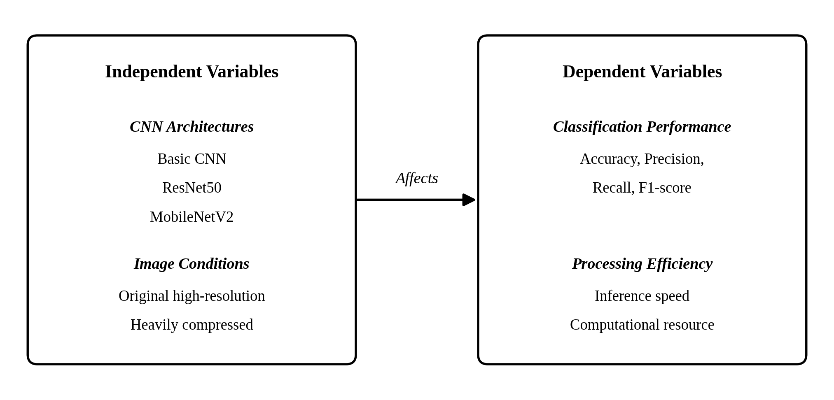
Figure 1. Conceptual Framework of the Study

1.9 Hypotheses

Hypothesis (HO₁): There is no significant difference in the classification accuracy of the Basic CNN, ResNet50, and MobileNetV2 models in detecting forged GCash transaction receipts.
Hypothesis (HO₂): There is no significant difference in classification accuracy between original and heavily compressed receipt images.
Hypothesis (HO₃): There is no significant difference in the processing efficiency of the Basic CNN, ResNet50, and MobileNetV2 models, measured by inference speed and memory load.

Chapter 2

Methodology
This chapter presents the methodology of the study. It describes the research design, the locale and the units of analysis, the sampling technique, the construction of the receipt dataset, the evaluation pipeline and the tools used to implement it, the instruments and measurements applied to the three architectures, and the statistical and ethical procedures observed.

2.1 Research Design
This study employs a quantitative, comparative-experimental research design. Because the objective is to determine which of three existing convolutional neural network architectures, the Basic CNN, ResNet50, and MobileNetV2, offers the most practical balance of accuracy and efficiency in detecting forged GCash transaction receipts rather than to build an original system, the design centers on comparing these architectures under identical conditions. Holding the dataset, preprocessing procedure, and training configuration constant isolates architecture as the variable of interest, so that any observed difference in performance can be attributed to the architecture itself.
The design follows a 3×2 factorial structure: CNN architecture (Basic CNN, ResNet50, MobileNetV2) crossed with image condition (original high-resolution receipts and heavily compressed receipts). Each of the six architecture-condition combinations is measured on accuracy, precision, recall, F1-score, inference speed, and computational resource requirement. These measures are compared descriptively to answer the first, second, and fifth research questions, while the third and fourth questions are tested inferentially through the null hypotheses H₀1, H₀2, and H₀3. Consistent with the factorial structure, the inferential analysis is conducted within a single two-way model that examines the main effect of CNN architecture, the main effect of image condition, and the architecture × image-condition interaction. The design implements the conceptual framework of the study and reflects the theories underlying it, which together predict both a degradation in accuracy under compression and a trade-off between network depth and computational cost.

2.2 Locale and Respondents of the Study
The study is conducted at Notre Dame of Midsayap College, situated on Quezon Avenue, Poblacion 5, Midsayap, Cotabato Province, during the first semester of the 2026–2027 academic year. Authentic GCash downloadable transaction receipts contributed by local online sellers, small business owners, and student entrepreneurs who transact within the municipality serve as the primary data source, and together with the forged samples generated from them they form the dataset on which the Basic CNN, ResNet50, and MobileNetV2 are comparatively evaluated. Dataset construction is carried out in the computer laboratory of the College of Information Technology Education (CITE) and on the researchers’ personal computers, and model training in Google Colaboratory; because processing efficiency is one of the dependent variables, however, every inference-speed and memory-load measurement is taken on a single fixed machine of ordinary specification without a dedicated graphics card, representative of the equipment available to local merchants, whose specifications are recorded and reported alongside the results.
The respondents are three faculty members of Notre Dame of Midsayap College with relevant expertise in image processing, machine learning, or digital forensics, who serve as the expert validators of the study by assessing the realism of the forged receipt samples and the appropriateness of the evaluation instruments. They are not asked to supply personal opinions or behavioral data, since the units of analysis are the receipt images rather than persons. Excluded from the study are transaction receipts issued by other digital wallet or banking platforms, photographed, scanned, printed, or handwritten receipts, and individuals who do not transact through GCash within Midsayap.

2.3 Sampling Technique
The study uses purposive sampling for both groups of participants. Receipt contributors are selected as active GCash users who buy or sell within Midsayap, Cotabato and who are willing to provide authentic downloadable receipts from their own completed transactions, and the three expert validators are selected for a demonstrated background in image processing, machine learning, or digital forensics. Prospective participants who do not meet these criteria are excluded.
At the image level, quota sampling fixes the dataset at six hundred base images, three hundred authentic and three hundred forged, the latter divided evenly between digitally edited and programmatically generated samples, so that accuracy is not distorted by class imbalance [32], [34]. Each base image is also rendered in a heavily compressed version, giving one thousand two hundred instances, with a further sixty base images reserved as the unseen-tool holdout set described in Phase 6. Stratified random sampling then divides the dataset into training, validation, and testing sets at sixty, fifteen, and twenty-five percent, grouped by source receipt so that no receipt, its derivatives, or its compressed counterparts appear in more than one partition. The resulting partition is generated once and applied identically to all three architectures. Table 1 presents the composition.
Category | Subcategory | Base Images | Training (60%) | Validation (15%) | Testing (25%)
Authentic | Downloadable GCash receipts | 300 | 180 | 45 | 75
Forged | Digitally edited receipts | 150 | 90 | 22 | 38
Forged | Programmatically generated receipts | 150 | 90 | 23 | 37
Total |  | 600 | 360 | 90 | 150

Table 1. Composition and Partitioning of the Dataset
The figures in Table 1 refer to base images; each architecture processes twice these totals once the compressed condition is included. The sixty holdout base images are excluded from the figures above.

2.4 Data Gathering Procedure
The image corpus is assembled in six phases, separately from the performance data generated once the models are running.
Phase 1. Permission and Consent. The thesis adviser and the CITE department approve the study before collection begins, and contributors are informed of its purpose, the images requested, and their right to withdraw. Consent is affirmed electronically on the submission form, so every submission carries a timestamped record as the Data Privacy Act of 2012 [46] allows.
Phase 2. Collection of Authentic Receipts. Contributors download receipts of their own completed transactions and submit them through a Google Form that preserves the original resolution and encoding. Screenshots are excluded because they are produced by the device rather than issued by the platform and so carry a different artifact signature. Submissions are logged and screened for duplicates.
Phase 3. Construction of the Forged Receipts. The researchers work offline, using splicing and copy-move to alter the amount, reference number, recipient’s name, and timestamp of authentic receipts, recording each source and donor receipt so that provenance can be enforced at partitioning. Editing is varied in care and save quality so that the models learn tampering in general rather than one editing signature. The remaining forgeries are rendered from templates reproducing the GCash layout with randomized fields.
Phase 4. Generation of the Compressed Condition. Every base image is transmitted through Facebook Messenger at standard send quality, the platform local buyers and sellers most commonly use to forward proof of payment, and the received file is kept as its compressed counterpart. The same path, devices, and send setting are used for both classes so that compression cannot itself become a class cue [6], [19]–[21].
Phase 5. Labeling, Organization, and Storage. Images receive coded filenames in a structure organized by class, forgery subtype, and image condition, with a label file recording the ground-truth class and provenance group. Ground truth is known by construction, labels are cross-checked by both researchers, and the dataset is stored encrypted.
Phase 6. Unseen-Tool Holdout Set. Sixty base images, half produced with a second image editor and an independently written template implementation and half authentic receipts withheld from the contributed pool, test whether the models generalize beyond the toolchain. They stay outside the partitioning, are never used for training or hyperparameter selection, and are opened once at the end.

2.5 System Architecture
This section presents the experimental pipeline within which the three architectures are trained and benchmarked under identical conditions, which is supported by three diagrams. The Context Diagram illustrates the interactions between the external entities and the pipeline; the Use Case Diagram highlights the functions performed within the evaluation environment; and the Architecture Diagram illustrates the internal components of the pipeline, showing how receipt images are preprocessed, classified as authentic or forged, and measured for processing efficiency. The study does not develop a production system for merchant deployment, although a lightweight web interface is built to demonstrate and test the trained models, and the components of the pipeline are held constant across the three architectures so that any difference in the measured outcomes can be attributed to architecture alone.

2.5.1 Context Diagram
Figure 2 illustrates the context diagram of the system. The diagram follows the Yourdon–DeMarco convention, presenting the Forged Receipt Detection System as a single process at the zero level and situating it in relation to the external entity that supplies its input and receives its output. The system boundary encloses the detection process alone; no internal component, data store, or model-specific step appears at this level, as these are presented in the architecture diagram in Figure 4. The user supplies a GCash downloadable receipt as the sole input to the system. The system returns three outputs to the user: processing feedback reporting the status of the preprocessing and inference stages, an authenticity verdict in which each of the three architectures independently classifies the submitted receipt as authentic or forged together with the confidence value on which that classification is based, and benchmark analytics reporting the accuracy and processing-efficiency measurements obtained for each architecture during evaluation. The three classifications are reported separately and are not combined into a single verdict, since the interface exists to demonstrate the behavior of each trained model rather than to adjudicate the authenticity of a receipt.
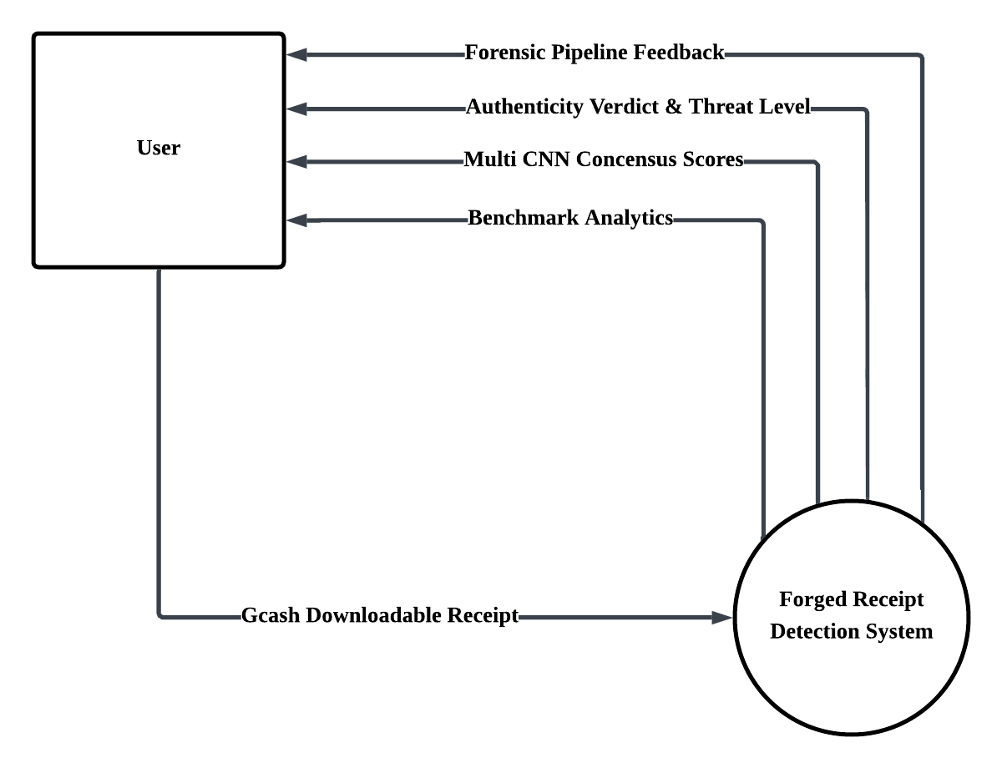
Figure 2. Context Diagram of the Forged Receipt Detection System

2.5.2 Use Case Diagram
Figure 3 illustrates the use case diagram of the Forged Digital Receipt Detection System. The diagram identifies the functions the system exposes and the actors who invoke them. Two actors interact with the system boundary: the User and the Researchers. The User is the primary actor and initiates the detection workflow by uploading a GCash transaction receipt, then views the authenticity verdict returned by each of the three architectures with its accompanying confidence value, and the benchmark analytics returned by the system. The Researchers act as secondary actors and are limited to deploying the trained CNN models, updating the trained CNN models, and viewing the benchmark analytics, which they share with the User for cross-architecture performance comparison. Dataset preparation, model training, and statistical evaluation are deliberately excluded from the diagram because they belong to the research procedure rather than to the operation of the deployed system. Internal processing steps such as image preprocessing, inference across the three CNN architectures, and benchmark logging are likewise not represented as separate use cases, since the system performs them automatically as part of the use cases invoked by the actors.
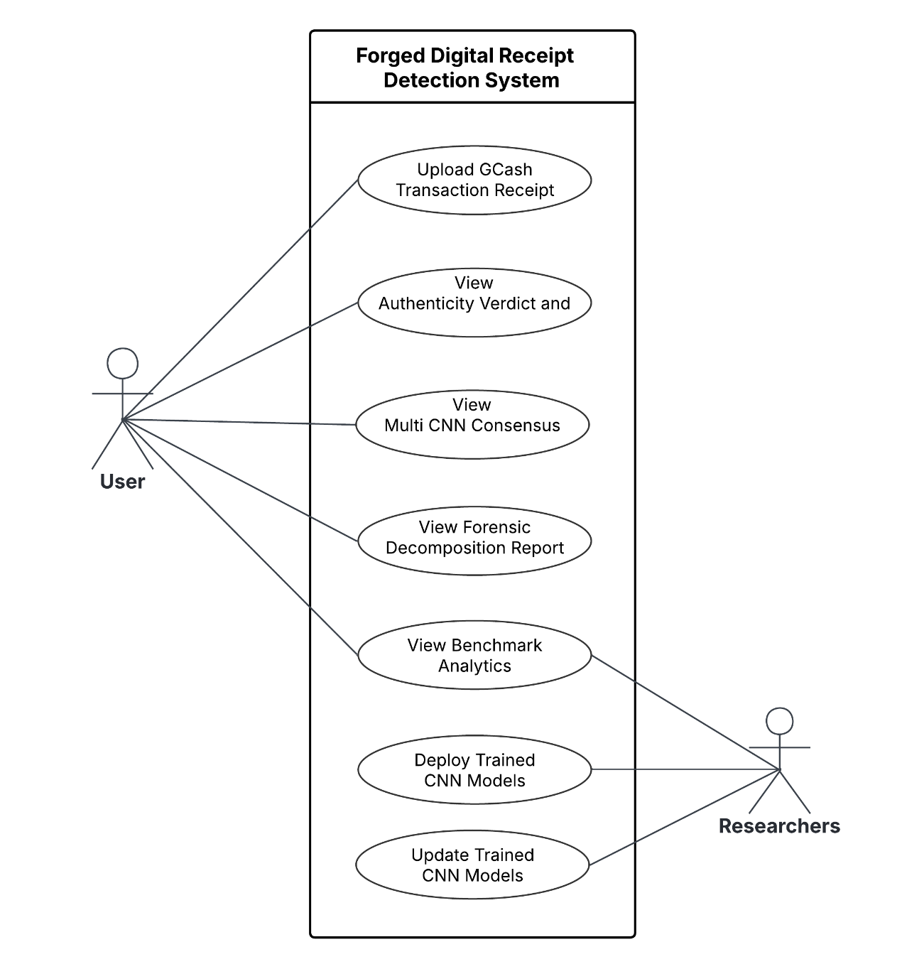
Figure 3. Use Case Diagram of the Forged Digital Receipt Detection System

2.5.3 Architecture Diagram
Figure 4 illustrates the architecture diagram of the evaluation pipeline. The diagram traces the flow of data through the five layers of the pipeline. The data layer holds the three image categories that compose the dataset, each of which is rendered under the original high-resolution condition and the heavily compressed condition. The preprocessing layer applies resizing to the common input resolution specified in Section 2.5.4, color conversion, normalization, and stratified partitioning; augmentation is deliberately not applied, for the reasons set out in Section 2.5.4. The model layer contains the three architectures under comparison, which receive identical data and identical training settings and differ only in their internal structure. ResNet50 and MobileNetV2 are initialized from weights pretrained on the ImageNet database [47], while the Basic CNN is trained from random initialization, and all three are optimized using the Adam algorithm [48] under the same learning rate, batch size, and epoch budget. The evaluation layer collects the two families of dependent variables, namely classification performance and processing efficiency. The analysis layer applies the descriptive and inferential treatments specified for the study, and the output is the identification of the architecture offering the most practical balance of accuracy and efficiency on merchant-grade hardware.
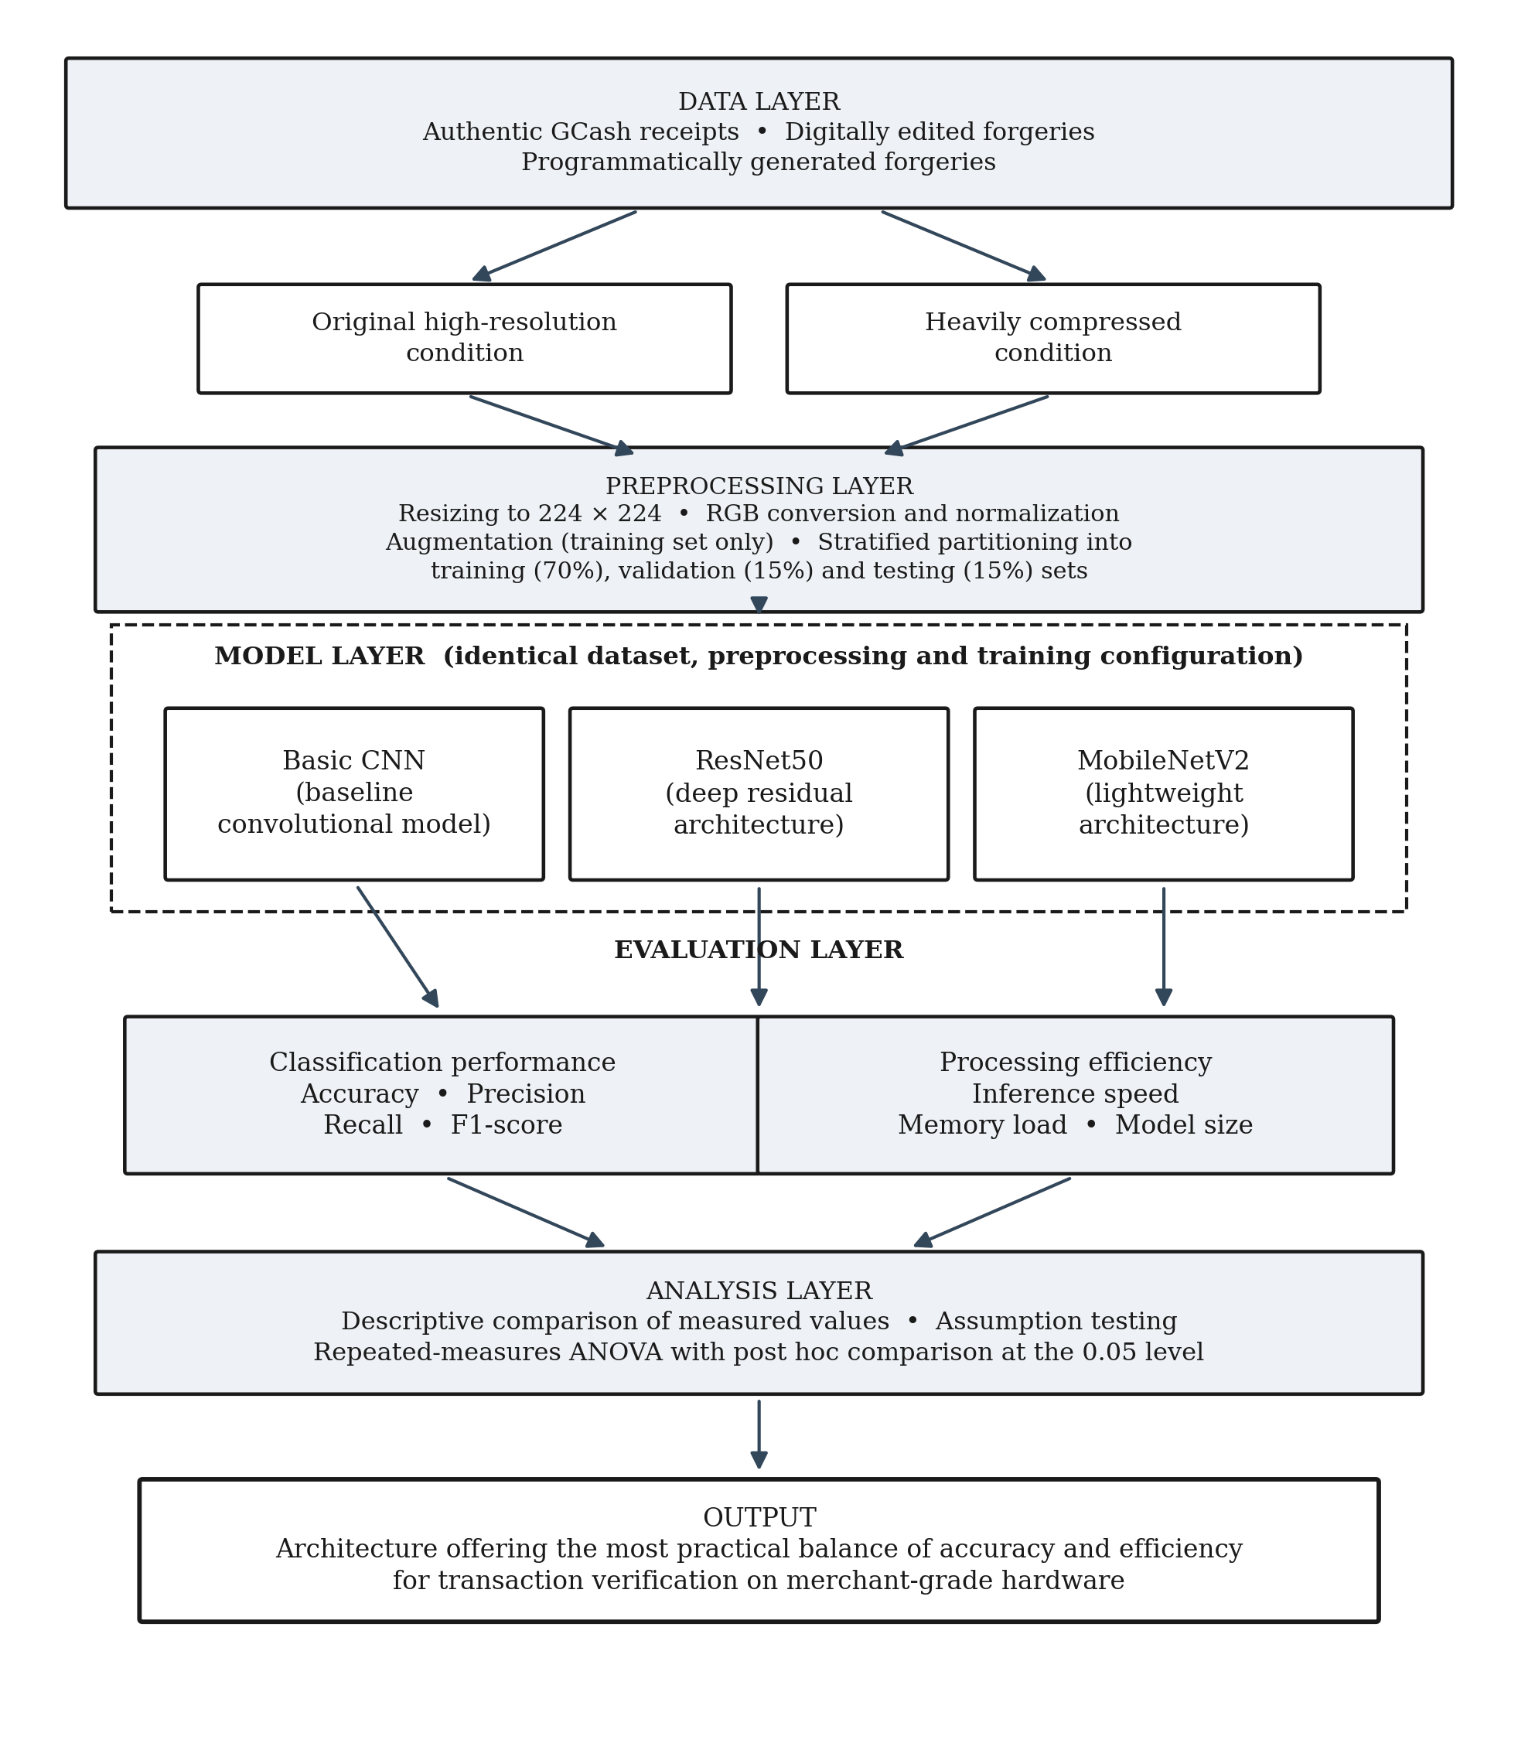
Figure 4. Architecture Diagram of the Evaluation Pipeline

2.6 Software and Tools
The study is implemented entirely in software, and the tools described in this section are those used to construct the dataset, build and train the models, take the performance measurements, and analyze the results. All versions are fixed at the outset and recorded, since a change of library version during experimentation would compromise the comparability of measurements taken before and after it.

The backend of the pipeline is implemented in Python, which serves as the primary programming language for the image processing and detection logic, covering preprocessing, model training, evaluation, and measurement. The three architectures under comparison, namely the Basic CNN, ResNet50, and MobileNetV2, are constructed and trained in TensorFlow using the Keras API, with model development and training carried out in Google Colaboratory notebooks using its graphics-accelerated runtime.
Dataset construction relies on Google Forms for the collection of authentic receipts from contributors, on OpenCV and Pillow for image reading, resizing, and format handling, on Facebook Messenger for the transmission that produces the compressed image condition, on consumer image editing applications such as Canva for the production of the digitally edited forged receipts, and on Python imaging and document rendering libraries for the production of the programmatically generated forged receipts. A second image editor, either GIMP or Photopea, and a second rendering implementation using a different imaging library and font stack are reserved exclusively for the unseen-tool holdout set described in Phase 6, and are used for no other part of the dataset. Stratified partitioning of the dataset into its training, validation, and test sets is performed with scikit-learn.
Measurement and analysis draw on the Python time module and psutil for end-to-end per-image latency and peak memory consumption, on NumPy and pandas for numerical computation and the tabulation of the recorded performance data, and on scikit-learn for the confusion matrices and the computation of precision, recall, and F1-score. The assumption tests, the analysis of variance, and the post hoc comparisons are carried out in SciPy and SPSS, with SciPy used for the Shapiro-Wilk test of normality and for the Friedman and Wilcoxon signed-rank tests where the non-parametric fallback is applied, and SPSS for the repeated-measures analysis of variance, Mauchly's test of sphericity, the Greenhouse-Geisser correction, and the Bonferroni post hoc comparisons, while Matplotlib and seaborn generate the training curves, confusion matrix plots, and comparative charts of the results.
The frontend is a lightweight web application built with Streamlit, which provides a simple interactive interface through which the trained models can be demonstrated and tested on individual receipt images. It communicates with the Python backend that performs the classification, and is not used to take any of the efficiency measurements reported in this study, which are recorded directly by the profiling harness described later in this chapter.
Supporting work is handled by Lucidchart for the preparation of the context, use case, and architecture diagrams, by Microsoft Word and a reference manager for the documentation of the manuscript and the management of the IEEE-style references, and by encrypted cloud and local storage for the secure storage and backup of the receipt dataset.
The same software environment is used for every training run and, more importantly, for every efficiency measurement, since inference latency and memory consumption are sensitive to the computational environment in which they are recorded.

2.7 Data Collection
This section describes how the performance measurements analyzed in this study are generated and recorded. The experimental unit of this study is the individual training run, and the unit of replication is the random seed. Five seeds are predetermined and fixed in advance of training, and the same five seeds are applied to each of the six architecture-condition combinations, so that every architecture is trained five independent times under each image condition and thirty runs are produced in total. Seeding is handled in this matched manner for two reasons. Weight initialization and batch shuffling introduce variation that a single run would conceal, and holding the seed set constant across combinations pairs the runs: the measurements obtained under a given seed for the Basic CNN, ResNet50, and MobileNetV2, under both the original and the compressed condition, share the same initialization and shuffling state and therefore constitute one matched set of observations rather than six unrelated ones. After each run the model is evaluated on the held-out testing partition, and the counts of true positives, true negatives, false positives, and false negatives are recorded in a confusion matrix from which accuracy, precision, recall, and F1-score are computed. Results are recorded separately for the two forgery subtypes and for the forged class as a whole, and every reported figure is a mean with its standard deviation rather than the outcome of one execution.
Efficiency data are collected on the fixed benchmarking machine specified earlier, with background applications closed and power settings held constant. Inference speed is measured on individual images rather than batches, with an initial warm-up series discarded, while peak memory consumption is sampled by the profiling utility and model file size and trainable parameter count are recorded as static indicators of computational cost. All measurements are entered into the performance recording matrix presented below, together with the training histories, confusion matrices, and configuration logs of every run, so that any reported result can be traced back to the run that produced it. Data collection at this stage involves no human participants.
The unseen-tool holdout set is evaluated last. After the five runs of every architecture-condition combination have been completed and every figure from the main testing partition has been recorded, each trained model is applied once to the holdout set, and the resulting confusion matrix, accuracy, precision, recall, and F1-score are recorded for each architecture under each image condition. The detection rate on the thirty unseen-tool forgeries is reported separately from the overall holdout figures, and the two forgery subtypes within the set are reported separately as well, since the programmatically generated subtype is the one most exposed to toolchain dependence. These results are reported descriptively alongside the main results and are not entered into any hypothesis test, as the set is too small to support inference and exists to characterize toolchain dependence rather than to compare the architectures.

2.8 Instrumentation
The instruments of this study are computational and documentary rather than survey-based, since the objects measured are models and images rather than persons. Four instruments are used.
The Curated Dataset and Labeling Protocol. The dataset described earlier functions as the test instrument through which the three architectures are examined. Its ground-truth labels are known by construction, its class composition is balanced by design, and its partitioning is fixed in advance, which together allow every model to be examined under identical conditions.
The Confusion Matrix and Classification Metric Suite. Classification performance is measured through the four-cell confusion matrix and the metrics derived from it. Consistent with the operational definitions of the study, the forged receipt is treated as the positive class throughout. A true positive (TP) is a forged receipt correctly identified as forged, a true negative (TN) an authentic receipt correctly identified as authentic, a false positive (FP) an authentic receipt incorrectly flagged as forged, and a false negative (FN) a forged receipt incorrectly accepted as authentic. The metrics are computed as follows:
Accuracy = (TP + TN) / (TP + TN + FP + FN)
Precision = TP / (TP + FP)
Recall = TP / (TP + FN)
F1-score = 2 × (Precision × Recall) / (Precision + Recall)
The false negative is the error of principal practical consequence in this domain, since it corresponds to a forged receipt accepted as genuine and to goods released without payment. Recall is therefore interpreted with particular attention, and the F1-score is used to summarize the balance between the two error types, following the evaluation literature reviewed earlier, which holds that accuracy alone is insufficient [32]–[34].
The Efficiency Measurement Instrument. Processing efficiency is measured by a timing and profiling harness written for this study. It records the end-to-end elapsed time required to process a single receipt image, timed from the reading of the stored file through decoding, preprocessing, and inference to the returned classification, and excluding a warm-up series. The interval is deliberately bounded at the stored file rather than at the input tensor, because the cost a merchant actually incurs in checking a receipt includes the decoding and preprocessing of whatever file arrives, and because the two image conditions differ in file size and encoding and therefore in the cost of those stages. Were timing to begin at the input tensor, every image would already have been resized to identical dimensions and the image condition could exert no effect on the measurement by construction. Memory consumption is sampled across the same interval to obtain a peak value, while model file size and trainable parameter count are read directly from the saved models. This instrument follows the practice of the edge-focused forgery detection work reviewed earlier, which measured single-image latency directly in milliseconds when comparing architectures [29].
The Forgery Realism Validation Rubric. A short rubric is provided to the expert validators for the assessment of a random sample of forged receipts. Each sampled image is rated on a four-point scale across four criteria: visual plausibility at a glance, fidelity to the layout of a genuine GCash receipt, internal consistency of the transaction details, and absence of conspicuous editing artifacts. The rubric establishes that the forged images represent a realistic fraud attempt rather than an implausibly crude one, and its use is described further below.
The measurements produced by these instruments are consolidated in the recording matrix shown in Table 2, which is completed for each of the six architecture-condition combinations.
Table 2
Performance Recording Matrix
Measure | Operational Definition | Unit
Classification accuracy | Correctly classified test images over all test images | Percentage
Precision | Correctly flagged forged images over all images flagged as forged | Percentage
Recall | Correctly flagged forged images over all actually forged images | Percentage
F1-score | Harmonic mean of precision and recall | Percentage
Inference speed | Mean end-to-end elapsed time to process one receipt image, from file read through decoding and preprocessing to classification | Milliseconds
Memory load | Peak memory consumption across decoding, preprocessing, and inference | Megabytes
Model size | Size of the saved model file and trainable parameter count | Megabytes, count

2.9 Validity and Reliability of the Instruments
Because the instruments are computational, validity and reliability are established through the design of the dataset and the measurement procedure rather than through the psychometric testing appropriate to questionnaires.
Validity. Content validity is established through expert review of the dataset. A random sample of forged receipts is submitted to the three expert validators identified earlier, who rate each image using the rubric described above. Images judged implausible or conspicuously crude are revised or replaced before the dataset is finalized, so that the models are tested against forgeries resembling those a merchant would actually encounter rather than against artificially easy examples. The degree of agreement among the three validators is quantified and reported, and a level of agreement below the substantial threshold prompts clarification of the rubric and a repeat of the rating.
Construct validity rests on the correspondence between the measures and the constructs of the study. Classification performance is measured through the four metrics standard in the forensic classification literature and endorsed by the evaluation studies reviewed earlier [32]–[34], while processing efficiency is measured directly as latency and memory consumption rather than inferred from parameter counts alone, following [29], [30]. Internal validity is protected by holding the controlled variables constant, that is, by using the same dataset, the same preprocessing sequence, the same training configuration, and the same benchmarking hardware for all three architectures, and by reserving the testing partition strictly for final evaluation. The balanced class composition described earlier further guards against the inflation of accuracy that class imbalance produces [32]. External validity is deliberately bounded by the delimitations of the study, and no claim is made beyond GCash downloadable receipts and the local setting to which the study is anchored.
The most consequential threat to the internal validity of this study is the single-source origin of its forged images. Every forgery is produced by the two researchers, the digitally edited receipts in one image editing application and the programmatically generated receipts from one template renderer, so the forged class carries the encoding, font rasterization, and file-writing signature of that particular toolchain. A model may therefore learn to recognize the tools of the researchers rather than forgery in general, and the programmatically generated subtype is the most exposed, since the distinction between the renderer of GCash and the renderer of this study is trivially learnable and near-ceiling accuracy on that subtype would demonstrate little. Provenance-constrained partitioning does not address this threat, because it separates source receipts across partitions while the generating toolchain remains common to both sides of every split. Two measures are taken in response. The editing of the digitally edited forgeries is deliberately varied in care, technique, and save quality, as described in Phase 3, so that no single editing signature runs uniformly through the class. More decisively, an unseen-tool holdout set is constructed and evaluated once at the end of the study, as described in Phase 6 and in the data collection procedure, so that the performance of each architecture on forgeries made with tools it has never encountered is reported alongside its performance on the main testing partition. A substantial gap between the two is interpreted as evidence of toolchain dependence and reported as such rather than omitted.
Reliability. Reliability is addressed as repeatability of measurement. Random seeds, library versions, hyperparameters, and hardware specifications are fixed and documented so that the pipeline can be re-executed and its results reproduced. Each architecture-condition combination is trained five times, and the dispersion of the resulting values is examined; a combination whose results vary widely across runs is re-examined before its mean is reported, since an unstable measurement cannot support a comparative conclusion.
The two evaluation procedures of the study serve distinct purposes and are not alternatives to one another. The fixed sixty-fifteen-twenty-five split is the sole basis of every result reported in this study: each architecture is trained five times on the training partition under each image condition, convergence is monitored on the validation partition, and every accuracy, precision, recall, F1-score, latency, and memory figure reported in Chapter 3 is a mean with its standard deviation computed over those runs on the held-out testing partition. Five-fold stratified cross-validation is performed once, in addition to and outside this procedure, purely as a check on the stability of measured performance across alternative data splits. It is conducted on the combined training and validation data with the testing partition excluded and untouched, the folds are constructed under the same provenance constraint that governs the main split so that no fold separates an authentic source receipt from a forgery derived from it, and each architecture is retrained from its initial state on every fold rather than carried over between folds. Its outcome is reported separately as evidence that measured performance is a property of the architecture rather than an artifact of one favorable split; no hypothesis test, comparative ranking, or reported performance figure is derived from it, and no model trained during cross-validation is used for the final evaluation. Reliability of the efficiency measurements is protected by taking every measurement on the same machine under the same conditions, by discarding the warm-up inferences that reflect initialization rather than steady-state performance, and by repeating each timing series so that the reported latency is an average rather than a single reading.

2.10 Statistical Tools and Treatment of Data
The data generated by the collection procedure are treated using both descriptive and inferential statistics. All inferential tests are conducted at the 0.05 level of significance.
Descriptive statistics are used to characterize the performance of each architecture. The mean and standard deviation of accuracy, precision, recall, F1-score, inference speed, and memory load are computed across the five runs of each architecture-condition combination and presented in comparative tables and charts, with confusion matrices reported alongside them. These descriptive results answer the first and second research questions and supply the values on which the remaining questions are decided.
Before any inferential test is applied, the assumptions underlying it are examined. Normality is assessed using the Shapiro-Wilk test, applied to the distributions of the paired differences rather than to the raw scores, since it is the differences that the repeated-measures model assumes to be normally distributed, and sphericity is assessed using Mauchly's test. Where Mauchly's test indicates a departure from sphericity, the Greenhouse-Geisser correction is applied to the degrees of freedom of the affected within-subject effect and the corrected F ratio and probability value are the ones reported. Homogeneity of variance is not tested, as it is an assumption of between-groups analysis of variance and has no bearing on a design in which every architecture-condition combination is observed under the same five seeds; sphericity is its counterpart in the repeated-measures model. Where the assumption of normality or homogeneity is violated, the corresponding non-parametric procedure for a matched, within-subjects design is used in place of the parametric test, and the substitution is reported with the result. Because the same five predetermined seeds are applied to every architecture-condition combination, the observations are matched rather than independent, and the fallback procedure must preserve that matching. The Friedman test is therefore used in place of the repeated-measures analysis of variance for the three-level architecture factor, applied separately within each image condition, with pairwise comparison by Wilcoxon signed-rank test under Bonferroni correction, or equivalently by the Nemenyi post hoc. For the two-level image-condition factor, the Wilcoxon signed-rank test is applied to the seed-matched pairs. The Kruskal-Wallis H test is not used, as it is the non-parametric analogue of a one-way between-groups analysis of variance and assumes independent samples, which would discard the seed matching on which the repeated-measures specification rests. No non-parametric equivalent of the factorial interaction term exists; where the parametric model cannot be sustained, the architecture × image-condition interaction is examined descriptively through the pattern of accuracy loss under compression rather than tested inferentially.
The third and fourth research questions are tested inferentially. For the fourth question, and thus for hypotheses H₀1 and H₀2, the primary analysis is a two-way (3×2) repeated-measures analysis of variance crossing architecture with image condition, applied to the accuracy values, with the random seed serving as the matching factor. Because the same five predetermined seeds are applied to every architecture-condition combination, the six accuracy values sharing a given seed form one matched set of observations; the seed is therefore entered into the model as the subject, or blocking, factor, while architecture and image condition are entered as the within-subject factors. The repeated-measures specification is justified by this matching rather than by the runs being replicates in the ordinary sense, and had the seeds been allowed to differ across architectures, the observations would have been independent and a between-groups factorial analysis of variance would have been the appropriate description. The main effect of architecture tests H₀1, the main effect of image condition tests H₀2, and the architecture × image-condition interaction term tests whether the loss of accuracy under compression differs in magnitude across architectures, a possibility anticipated by the theoretical framework of the study. A significant F ratio for architecture is followed by post hoc pairwise comparison with Bonferroni adjustment, which identifies which particular architectures differ rather than merely establishing that a difference exists. Where the interaction is significant, simple-effects tests of architecture within each image condition are reported to locate its source. For the third question, and thus for hypothesis H₀3, the same two-way procedure is applied to the end-to-end latency and peak memory measurements, so that any difference in processing efficiency among the three architectures is tested rather than assumed. The image condition is retained as a factor for these measurements because efficiency is timed from the stored file rather than from the input tensor, so that the decoding and preprocessing of the two conditions, which differ in file size and encoding, fall inside the measured interval. Had the interval begun at the resized input tensor, the two conditions would have been computationally identical and the main effect of condition would have been null by construction rather than by result.
The fifth research question is answered by joint interpretation rather than by a single test. The mean values of both families of dependent variables are normalized to a common scale and combined into a composite score in which classification performance and processing efficiency are weighted equally, consistent with the position that neither family is subordinate to the other. The composite ranking is interpreted alongside the descriptive and inferential results and against the practical requirements of the local setting, so that the architecture recommended is one that is both statistically defensible and deployable on the hardware available to local online sellers, small business owners, and student entrepreneurs. Table 4 summarizes the treatment applied to each research question.
Table 4
Statistical Treatment of Data by Research Question
Research Question | Data Required | Statistical Treatment
1. Classification accuracy per forgery type | Confusion matrices per architecture, per forgery subtype | Mean, standard deviation, percentage
2. Precision, recall, and F1-score | Confusion matrices per architecture and condition | Mean, standard deviation, percentage
3. Difference in inference speed and memory load (H₀3) | Latency and peak memory across seed-matched runs | Assumption tests; repeated-measures ANOVA with Bonferroni post hoc, or Friedman test with Wilcoxon signed-rank post hoc under Bonferroni correction
4. Difference in accuracy by image condition (H₀1, H₀2) | Accuracy across seed-matched runs under both conditions | Assumption tests; two-way (3×2) repeated-measures ANOVA testing architecture, image condition, and their interaction, with Bonferroni post hoc and simple-effects follow-up; Friedman test within each image condition and Wilcoxon signed-rank test across conditions as non-parametric fallback
5. Most practical balance of accuracy and efficiency | Mean values of both families of measures | Normalized composite scoring and comparative interpretation

2.11 Ethical Consideration
This study handles authentic financial documents and deliberately produces forged ones, so its ethical obligations extend beyond the treatment of participants to the handling of the data and the manner in which the findings are disseminated. The following safeguards are observed.
Institutional Approval. The study is conducted only after the endorsement of the thesis adviser and the approval of the CITE department have been secured, and it adheres throughout to the research policies of Notre Dame of Midsayap College.
Informed Consent and Voluntary Participation. Receipt contributors and expert validators participate voluntarily and record their consent electronically before participating, contributors through the submission form and validators through the validation instrument. Each is informed of the purpose of the study, the specific use to which the material will be put, the duration of storage, and the right to withdraw at any time without penalty and to have already-submitted material removed. No inducement is offered that might compromise the voluntariness of participation.
Privacy and Data Protection. GCash transaction receipts contain personal information, including names, partially masked mobile numbers, transaction amounts, and reference numbers, and are handled in accordance with the Data Privacy Act of 2012 [46]. Receipts are received through a Google Form whose responses are accessible only to the researchers, and uploaded files are moved to the study's encrypted storage and removed from the form's linked drive once logged. Contributor identities are replaced with codes in all records, the dataset is stored in encrypted form with access restricted to the researchers and the thesis adviser, and it is neither published nor shared with any third party. Personal details are not erased from the images used for training and testing, because altering pixels would introduce artifacts indistinguishable from tampering and would invalidate the classification task itself; confidentiality is therefore protected by restricting access to the dataset rather than by modifying it. A GCash receipt also carries the details of the counterparty to the transaction, ordinarily the recipient of the payment, who is not a participant in this study and whose consent cannot be obtained through the contributor. The researchers acknowledge this directly and address it through compensating controls rather than by treating the contributor's consent as covering both parties. No counterparty name, mobile number, transaction amount, or reference number is extracted, transcribed, indexed, aggregated, or analyzed as data at any stage of the study; each receipt enters the pipeline as an undifferentiated image whose pixel-level characteristics are the object of classification, and no receipt is searched, retrieved, or cross-referenced by the name or number of any person appearing in it. Access to the images remains restricted to the two researchers and the thesis adviser, no receipt is published or shared with any third party, any receipt displayed in the manuscript or presentation is redacted before display, and the dataset is destroyed on the schedule stated below. Contributors are further asked, where feasible, to submit receipts for transactions in which the recipient was a business or merchant rather than a private individual, so that the counterparty details unavoidably present in the image belong to a commercial establishment rather than to an identifiable private person. Any receipt reproduced in the manuscript, the presentation, or any public material is redacted before display, and that redacted copy is never used as training or testing data. The dataset is permanently deleted from all storage locations one year after the acceptance of the study.
Responsible Handling of Forged Material. The forged receipts created for this study are produced solely for training and testing. They are never sent to any merchant, used in any actual transaction, or presented as proof of payment. The forged images, the templates, and the scripts used to generate them are not published or distributed, and the manuscript reports the comparative performance of the architectures without providing instructions that would assist in producing convincing forgeries. The researchers acknowledge the dual-use character of this work and resolve it in favor of restricting the means of forgery while disseminating the means of detection.
Lawful Access. All authentic receipts are obtained through the ordinary and legitimate use of the GCash application by their rightful account holders. At no point do the researchers attempt to access the systems, servers, databases, or programming interfaces of the platform, and no security control of any application is circumvented in the course of the study.
Integrity in Reporting. All results are reported as obtained, including those unfavorable to the expectations set out in the theoretical framework. No measurement is fabricated, selectively omitted, or adjusted, and the limitations of the study are stated plainly. All sources are cited in IEEE format, the manuscript is submitted to the plagiarism check required by the institution, and any use of artificial-intelligence-assisted tools in the preparation of the manuscript is disclosed in accordance with institutional policy.

References
[1] Bangko Sentral ng Pilipinas, “2024 Report on the Status of Digital Payments in the Philippines,” Bangko Sentral ng Pilipinas, Manila, Philippines, 2025. [Online]. Available: https://www.bsp.gov.ph/PaymentAndSettlement/2024_Report_on_E-payments_Measurement.pdf
[2] G-Xchange, Inc., “GCash warns public on emerging AI-generated fake receipts scams, urges users to always check transactions tab,” Mynt Newsroom, Jul. 2025. [Online]. Available: https://mynt.com.ph/newsroom/gcash-warns-public-on-emerging-ai-generated-fake-receipts-scams-urges-users-to-always-check-transactions-tab
[3] J. H. Bappy, C. Simons, L. Nataraj, B. S. Manjunath, and A. K. Roy-Chowdhury, “Hybrid LSTM and Encoder-Decoder Architecture for Detection of Image Forgeries,” IEEE Transactions on Image Processing, vol. 28, no. 7, pp. 3286–3300, Jul. 2019, doi: 10.1109/TIP.2019.2895466.
[4] K. He, X. Zhang, S. Ren, and J. Sun, “Deep Residual Learning for Image Recognition,” 2016 IEEE Conference on Computer Vision and Pattern Recognition (CVPR), Las Vegas, NV, USA, 2016, pp. 770–778, doi: 10.1109/CVPR.2016.90.
[5] M. Sandler, A. Howard, M. Zhu, A. Zhmoginov, and L. Chen, “MobileNetV2: Inverted Residuals and Linear Bottlenecks,” 2018 IEEE/CVF Conference on Computer Vision and Pattern Recognition, Salt Lake City, UT, USA, 2018, pp. 4510–4520, doi: 10.1109/CVPR.2018.00474.
[6] H. Wu, J. Zhou, J. Tian, J. Liu, and Y. Qiao, “Robust Image Forgery Detection Against Transmission Over Online Social Networks,” IEEE Transactions on Information Forensics and Security, vol. 17, pp. 443–456, 2022, doi: 10.1109/TIFS.2022.3144878.
[7] B. M. Tornés et al., “Receipt Dataset for Document Forgery Detection,” in Document Analysis and Recognition – ICDAR 2023, Lecture Notes in Computer Science, vol. 14189, Springer, Cham, 2023, pp. 454–469, doi: 10.1007/978-3-031-41682-8_28.
[8] Y. Wu, W. AbdAlmageed, and P. Natarajan, “ManTra-Net: Manipulation Tracing Network for Detection and Localization of Image Forgeries With Anomalous Features,” 2019 IEEE/CVF Conference on Computer Vision and Pattern Recognition (CVPR), Long Beach, CA, USA, 2019, pp. 9535–9544, doi: 10.1109/CVPR.2019.00977.
[9] V. Laxman, N. Ramesh, S. K. Jaya Prakash, and R. Aluvala, “Emerging threats in digital payment and financial crime: A bibliometric review,” Journal of Digital Economy, vol. 3, pp. 205–222, Apr. 2025, doi: 10.1016/j.jdec.2025.04.002.
[10] J. Wang, “Fraud Detection in Digital Payment Technologies Using Machine Learning,” Journal of Economic Theory and Business Management, vol. 1, no. 2, pp. 1–6, Apr. 2024, doi: 10.5281/zenodo.10926495.
[11] M. I. Ayub, B. Bhattacharjee, A. K. Gharami, M. S. Rahman, and M. A. Hossain, “Deep Learning for Real-Time Fraud Detection: Enhancing Credit Card Security in Banking Systems,” The American Journal of Engineering and Technology, vol. 7, no. 4, pp. 141–150, 2025, doi: 10.37547/tajet/Volume07Issue04-19.
[12] P. Vanini, S. Rossi, E. Zvizdic, and T. Domenig, “Online payment fraud: From anomaly detection to risk management,” Financial Innovation, vol. 9, art. 66, pp. 1–25, 2023, doi: 10.1186/s40854-023-00470-w.
[13] B. Borketey, “Real-Time Fraud Detection Using Machine Learning,” Journal of Data Analysis and Information Processing, vol. 12, pp. 189–209, 2024, doi: 10.4236/jdaip.2024.122011.
[14] D. P. Timothy, and A. K. Santra, “Deep Learning-based Copy-Move and Spliced Image Forgery Detection,” International Journal on Recent and Innovation Trends in Computing and Communication, vol. 11, no. 10, pp. 854–861, 2023, doi: 10.17762/ijritcc.v11i10.8602.
[15] F. Z. Mehrjardi, A. M. Latif, M. S. Zarchi, and R. Sheikhpour, “A survey on deep learning-based image forgery detection,” Pattern Recognition, vol. 144, art. 109778, 2023, doi: 10.1016/j.patcog.2023.109778.
[16] M. A. Anwar, S. F. Tahir, L. G. Fahad, and K. Kifayat, “Image forgery detection by transforming local descriptors into deep-derived features,” Applied Soft Computing, vol. 147, art. 110730, 2023, doi: 10.1016/j.asoc.2023.110730.
[17] M. Zanardelli, F. Guerrini, R. Leonardi, and N. Adami, “Image Forgery Detection: A Survey of Recent Deep-Learning Approaches,” Multimedia Tools and Applications, vol. 82, pp. 17521–17566, 2023, doi: 10.1007/s11042-022-13797-w.
[18] K. D. Kadam, S. Ahirrao, and K. Kotecha, “Multiple Image Splicing Dataset (MISD): A Dataset for Multiple Splicing,” Data, vol. 6, no. 10, art. 102, 2021, doi: 10.3390/data6100102.
[19] M. Barni et al., “Aligned and non-aligned double JPEG detection using convolutional neural networks,” Journal of Visual Communication and Image Representation, vol. 49, pp. 153–163, Nov. 2017, doi: 10.1016/j.jvcir.2017.09.003.
[20] Q. Wang, and R. Zhang, “Double JPEG compression forensics based on a convolutional neural network,” EURASIP Journal on Information Security, vol. 2016, no. 1, art. 23, 2016, doi: 10.1186/s13635-016-0047-y.
[21] I. Amerini, T. Uricchio, L. Ballan, and R. Caldelli, “Localization of JPEG double compression through multi-domain convolutional neural networks,” in Proc. 2017 IEEE Conf. Computer Vision and Pattern Recognition Workshops (CVPRW), Honolulu, HI, USA, Jul. 2017, pp. 1865–1871.
[22] C. Pasquini, I. Amerini, and G. Boato, “Media forensics on social media platforms: a survey,” EURASIP Journal on Information Security, vol. 2021, no. 1, 2021, doi: 10.1186/s13635-021-00117-2.
[23] X. Qing, “A Comparison Study of Convolutional Neural Network and Recurrent Neural Network on Image Classification,” in Proc. 2022 10th Int. Conf. Information Technology: IoT and Smart City (ICIT 2022), Shanghai, China, Dec. 2022, doi: 10.1145/3582197.3582215.
[24] N. V. Gawali, K. Pagare, S. Daundkar, and D. Wagh, “Image Classification Using Convolutional Neural Networks,” International Journal for Research in Applied Science and Engineering Technology, vol. 11, no. 6, 2023, doi: 10.22214/ijraset.2023.52435.
[25] L. Wang, and Y. Sun, “Image classification using convolutional neural network with wavelet domain inputs,” IET Image Processing, vol. 16, no. 8, pp. 2037–2048, 2022, doi: 10.1049/ipr2.12466.
[26] W. Rawat, and Z. Wang, “Deep Convolutional Neural Networks for Image Classification: A Comprehensive Review,” Neural Computation, vol. 29, no. 9, pp. 2352–2449, 2017, doi: 10.1162/neco_a_00990.
[27] X. Zhao, L. Wang, Y. Zhang, X. Han, M. Deveci, and M. Parmar, “A review of convolutional neural networks in computer vision,” Artificial Intelligence Review, vol. 57, no. 4, art. 99, 2024, doi: 10.1007/s10462-024-10721-6.
[28] H. Hartatik, and M. K. Anam, “Comparison of Convolutional Neural Network Architecture on Detection of Helmet Use by Humans,” ELINVO (Electronics, Informatics, and Vocational Education), vol. 8, no. 1, pp. 44–54, 2023, doi: 10.21831/elinvo.v8i1.52104.
[29] Y.-Y. Bae, D.-J. Cho, and K.-H. Jung, “Enhancing Document Forgery Detection with Edge-Focused Deep Learning,” Symmetry, vol. 17, no. 8, art. 1208, 2025, doi: 10.3390/sym17081208.
[30] I. T. Ahmed, F. A. Abdulazeez, and B. T. Hammad, “Employing Different Algorithms of Lightweight Convolutional Neural Network Models in Image Distortion Classification,” Computers, vol. 13, no. 10, art. 268, 2024, doi: 10.3390/computers13100268.
[31] M. A. Khan, “Comparative Analysis of Resource-Efficient CNN Architectures for Brain Tumor Classification,” arXiv:2411.15596, 2024, doi: 10.48550/arXiv.2411.15596.
[32] K. M. Sujon, R. Hassan, K. Choi, and M. A. Samad, “Accuracy, precision, recall, f1-score, or MCC? Empirical evidence from advanced statistics, ML, and XAI for evaluating business predictive models,” Journal of Big Data, vol. 12, art. 268, 2025, doi: 10.1186/s40537-025-01313-4.
[33] A. Tasnim, M. Saiduzzaman, M. A. Rahman, J. Akhter, and A. S. M. M. Rahaman, “Performance Evaluation of Multiple Classifiers for Predicting Fake News,” Journal of Computer and Communications, vol. 10, pp. 1–21, 2022, doi: 10.4236/jcc.2022.109001.
[34] M. C. Hinojosa-Lee, J. Braet, and J. Springael, “Performance Metrics for Multilabel Emotion Classification: Comparing Micro, Macro, and Weighted F1-Scores,” Applied Sciences, vol. 14, no. 21, art. 9863, 2024, doi: 10.3390/app14219863.
[35] A. A. Abdirahman, A. O. Hashi, U. M. Dahir, M. A. Elmi, and O. E. R. Rodriguez, “Enhancing Security in Mobile Wallet Payments: Machine Learning-Based Fraud Detection Across Prominent Wallet Platforms,” International Journal of Electronics and Communication Engineering, vol. 11, no. 3, pp. 96–105, 2024, doi: 10.14445/23488549/IJECE-V11I3P110.
[36] A. M. Bhunje, R. Ghorpade, O. Dhumal, S. Chavan, and A. Khalate, “TrustBill AI: An Intelligent GST Invoice Fraud Detection and Verification System Using OCR, Machine Learning, and Deep Learning,” International Journal of Engineering Research & Technology, vol. 15, no. 5, pp. 1–15, May 2026, doi: 10.5281/zenodo.20445360.
[37] H. Arslan, “End to End Invoice Processing Application Based on Key Fields Extraction,” IEEE Access, vol. 10, pp. 78398–78413, 2022, doi: 10.1109/ACCESS.2022.3192828.
[38] A. Amari et al., “An Efficient Deep Learning-Based Approach to Automating Invoice Document Validation,” in Proc. 2024 IEEE/ACS 21st Int. Conf. Computer Systems and Applications (AICCSA), 2024, pp. 1–8, doi: 10.1109/AICCSA63423.2024.10912544.
[39] R. Raoui-Outach, C. Million-Rousseau, A. Benoit, and P. Lambert, “Deep Learning for Automatic Sale Receipt Understanding,” in Proc. 2017 Int. Conf. Image Processing Theory, Tools and Applications (IPTA), Montreal, QC, Canada, 2017, pp. 1–6, doi: 10.1109/IPTA.2017.8310088.
[40] A. Naveh, and E. Tromer, “PhotoProof: Cryptographic Image Authentication for Any Set of Permissible Transformations,” in Proc. 2016 IEEE Symposium on Security and Privacy (SP), San Jose, CA, USA, 2016, pp. 255–271, doi: 10.1109/SP.2016.23.
[41] E. Casey, Digital Evidence and Computer Crime: Forensic Science, Computers, and the Internet, 3rd ed. Waltham, MA, USA: Academic Press, 2011.
[42] H. Farid, “Image Forgery Detection,” IEEE Signal Processing Magazine, vol. 26, no. 2, pp. 16–25, Mar. 2009, doi: 10.1109/MSP.2008.931079.
[43] D. H. Hubel, and T. N. Wiesel, “Receptive fields, binocular interaction and functional architecture in the cat’s visual cortex,” The Journal of Physiology, vol. 160, no. 1, pp. 106–154, Jan. 1962, doi: 10.1113/jphysiol.1962.sp006837.
[44] K. Fukushima, “Neocognitron: A Self-Organizing Neural Network Model for a Mechanism of Pattern Recognition Unaffected by Shift in Position,” Biological Cybernetics, vol. 36, no. 4, pp. 193–202, Apr. 1980, doi: 10.1007/BF00344251.
[45] Y. LeCun, L. Bottou, Y. Bengio, and P. Haffner, “Gradient-Based Learning Applied to Document Recognition,” Proceedings of the IEEE, vol. 86, no. 11, pp. 2278–2324, Nov. 1998, doi: 10.1109/5.726791.
[46] Republic Act No. 10173, “An Act Protecting Individual Personal Information in Information and Communications Systems in the Government and the Private Sector, Creating for this Purpose a National Privacy Commission, and for Other Purposes (Data Privacy Act of 2012),” Congress of the Philippines, Manila, Philippines, Aug. 15, 2012.
[47] J. Deng, W. Dong, R. Socher, L.-J. Li, K. Li, and L. Fei-Fei, “ImageNet: A Large-Scale Hierarchical Image Database,” in Proc. 2009 IEEE Conf. Computer Vision and Pattern Recognition (CVPR), Miami, FL, USA, 2009, pp. 248–255, doi: 10.1109/CVPR.2009.5206848.
[48] D. P. Kingma, and J. Ba, “Adam: A Method for Stochastic Optimization,” in Proc. 3rd Int. Conf. Learning Representations (ICLR), San Diego, CA, USA, 2015, arXiv:1412.6980.
[49] C. Shorten, and T. M. Khoshgoftaar, “A survey on Image Data Augmentation for Deep Learning,” Journal of Big Data, vol. 6, art. 60, 2019, doi: 10.1186/s40537-019-0197-9.

