NOTRE DAME OF MIDSAYAP COLLEGE
COLLEGE OF INFORMATION TECHNOLOGY AND ENGINEERING
Midsayap, Cotabato, Philippines
CAMPUS LOST & FOUND MANAGEMENT SYSTEM
An AI-Powered Web-Based Lost and Found Item Management and Recovery Platform
A Software Engineering 2 Project Documentation
Prepared by:
[STUDENT NAME 1] (DeathKnell837)
Submitted to:
[INSTRUCTOR NAME]
Faculty, College of Information Technology and Engineering
Academic Year:
[ACADEMIC YEAR] (2025–2026)
[MONTH, YEAR] (October 2026)
TABLE OF CONTENTS
CHAPTER 1 – INTRODUCTION
1.1 Background
1.2 Problem Statement
1.3 Objectives
1.4 Scope and Delimitation
1.5 Significance
CHAPTER 2 – RELATED SYSTEMS AND TECHNOLOGIES
2.1 Technologies
CHAPTER 3 – REQUIREMENTS ANALYSIS
3.1 Stakeholders
3.2 User Roles
CHAPTER 4 – SYSTEM ANALYSIS
4.1 Context Diagram
4.2 Use Case Diagram
4.3 Use Case Descriptions
CHAPTER 5 – SYSTEM DESIGN
5.1 System Architecture
5.2 ERD
CHAPTER 6 – USER INTERFACE DESIGN
6.1 Screen Designs
6.2 Navigation Flow
CHAPTER 7 – IMPLEMENTATION
7.1 Development Environment
7.2 System Modules
7.3 Screenshots of the Final System
CHAPTER 8 – TESTING
8.1 Test Plan
8.2 Test Cases
8.3 Test Results
8.4 Bugs Found and Fixes
CHAPTER 9 – CONCLUSION AND RECOMMENDATIONS
9.1 Conclusion
9.2 Recommendations
REFERENCES
APPENDICES
Appendix A: System API Endpoints
Appendix B: NDMC Campus Locations Inventory
Appendix C: System Configuration & Environment Variables
CHAPTER 1 – INTRODUCTION
1.1 Background
In tertiary educational institutions such as Notre Dame of Midsayap College (NDMC), the daily movement of thousands of students, faculty members, administrative staff, and campus visitors across multiple academic complexes, laboratories, recreational grounds, and service departments inevitably leads to the frequent misplacement and loss of valuable personal belongings. Among the commonly misplaced items are essential student identification cards, high-value textbooks, scientific and graphing calculators, electronic peripherals (including smartphones, laptops, chargers, and wireless earbuds), keys, tumblers, and personal accessories.
Traditionally, the handling of lost and found belongings across the NDMC campus has relied upon informal, decentralized, and manual mechanisms. When an item is found, the finder either surrenders it to the nearest guardhouse (such as Guard House Gate 02 or the Chief Security Office), submits it to a departmental faculty lounge, posts an announcement on personal or student-council social media groups, or leaves the item where it was discovered. Conversely, students and personnel who lose items are forced to physically inspect numerous departmental offices, guard posts, and student centers, hoping someone turned their property in.
This traditional approach suffers from significant operational drawbacks: lack of a unified searchable inventory, vulnerability to fraudulent claims without rigorous ownership verification, physical item accumulation and clutter at security offices, and the absence of direct, automated communication channels between finders and owners. To address these systemic inefficiencies, the Campus Lost & Found Management System was designed, developed, and deployed. Built upon modern web technologies (Node.js, Express.js, MongoDB Atlas, Bootstrap 5) and enhanced with cutting-edge Multimodal Generative AI (Google Gemini 2.0/2.5 Flash), the system bridges the communication and logistical gap by providing a centralized, accessible, transparent, and intelligent platform for reporting, searching, matching, and recovering campus belongings.
1.2 Problem Statement
The management of misplaced and found property in a bustling campus environment presents severe logistical and security challenges when conducted without an organized digital infrastructure. Specifically, the system was developed to resolve three (3) critical problems:
- 1. Decentralized & Inefficient Tracking: Campus lost and found operations are fragmented across 42 distinct campus buildings, departmental offices, and security guard posts without a single centralized registry. This lack of a unified repository forces students to wander across campus checking multiple offices, resulting in low recovery rates, unnecessary physical strain, and eventual abandonment of unclaimed items.
- 2. Lack of Ownership Verification & High Fraud Risk: Traditional surrender-and-claim protocols rely on casual visual inspection without formalized proof of ownership. Consequently, campus custodians are exposed to fraudulent claims, accidental handover to incorrect parties, or legal ambiguity regarding custodian liability. There is no recorded audit trail or photographic comparison to establish rightful ownership before property release.
- 3. Information Bottleneck & Absence of Automated Matching: There is no synchronized communication channel connecting the individual who lost an item with the individual who found it. Manual paper logbooks and informal social media posts lack semantic searching, location filtering, and category indexing. Misplaced belongings often remain in security storage indefinitely because owners describe items using different terminology than finders.
1.3 Objectives
1.3.1 General Objective
To design, develop, test, and deploy a secure, web-based, AI-enhanced Campus Lost & Found Management System for Notre Dame of Midsayap College that centralizes property reporting, automates lost-to-found matching using multimodal artificial intelligence, establishes a verifiable ownership claiming protocol, and streamlines administrative custody and recovery operations.
1.3.2 Specific Objectives
To achieve the general objective, the project fulfills the following specific technical and functional goals:
- Develop secure user registration, session-based authentication with bcrypt password encryption, and role-based access control distinguishing regular campus users (Students, Faculty, Staff) from Administrators.
- Implement a comprehensive reporting workflow for lost and found items featuring category categorization (10 standard categories), location selection from 70+ NDMC campus landmarks (Buildings 1 through 42), and cloud-hosted photo uploads via Cloudinary.
- Construct an advanced multi-criteria search and filtering system allowing instant discovery by keyword regex, category, date intervals, and campus locations.
- Integrate Google Gemini 2.0/2.5 Flash multimodal AI and a weighted scoring algorithm to compute similarity percentages (0–100%) between lost and found items based on categories, geographic proximity, temporal proximity, and textual/visual features.
- Embed a real-time conversational AI Assistant chat widget capable of understanding natural-language campus queries, analyzing uploaded photos, and delivering instant candidate item recommendations.
- Formulate a fraud-resistant claim processing module requiring detailed ownership proof descriptions, identifying characteristics, multiple proof photo attachments, and a transparent 4-stage claim status stepper.
- Build a comprehensive administrative control panel with analytical KPI cards, pending report moderation, claim approval/rejection workflows with automatic competing claim rejection, campus location/category management, and CSV/print data reporting.
- Deploy the completed application on Render.com with MongoDB Atlas cloud clustering and implement Progressive Web App (PWA) capabilities for mobile installation and offline resilience.
1.4 Scope and Delimitation
1.4.1 Project Scope
The functional and operational boundaries of the Campus Lost & Found Management System encompass:
- User management: Account registration, secure credential login, password reset via encrypted email tokens, profile updating, and notification preference configuration.
- Item inventory lifecycle: Public reporting of lost and found items, pending review queue for administrators, public publication upon approval, status updates (pending, approved, claimed, rejected), and permanent item resolution.
- Campus geographical integration: Full mapping of 70+ Notre Dame of Midsayap College buildings, classrooms, gates, laboratories, and lounges, with a crowdsourced mechanism for users to suggest new campus locations.
- Claim adjudication pipeline: Formal claim submission, ownership proof submission with up to 3 evidence photos, administrative timeline auditing, priority setting (low, normal, high), and automated resolution.
- AI intelligence services: Multi-modal visual comparison, semantic query parsing, conversational chatbot guidance, and algorithmic candidate ranking.
- System reporting & analytics: Live statistical calculation of campus recovery success rates, average turnaround days to claim, monthly trend charts, category distributions, top loss locations, and tabular CSV spreadsheet exports.
1.4.2 Project Delimitations
To maintain project feasibility, legal compliance, and campus safety, the following delimitations apply:
- Geographical Boundary: The system is designed strictly for items lost or found within the premises and academic facilities of Notre Dame of Midsayap College. Municipal or off-campus lost items are outside the system's operational jurisdiction.
- Exclusion of Financial Transactions: The system explicitly prohibits monetary transactions, bounty payments, or cash rewards for finding items to eliminate extortion and counterfeit recovery schemes.
- Physical Custody Mediation: The web platform coordinates digital identification, claims, and verification; physical turnover and custody of high-value items remain under the authorized supervision of the NDMC Chief Security Office.
1.5 Significance
The development and implementation of this system provides substantial benefits across the institutional community:
- Significance to Students: Significantly reduces emotional stress and financial burden caused by lost academic requirements, calculators, gadgets, and identification cards by accelerating item recovery through a 24/7 accessible platform.
- Significance to Faculty & Staff: Offers an effortless, organized medium to log items found in classrooms and corridors without having to personally store property or interrupt teaching responsibilities.
- Significance to Campus Security Personnel & Administration: Eliminates physical clutter in security logbooks and storage rooms, minimizes administrative overhead, provides auditable proof of release, and supplies data-driven insights into campus security hotspots.
- Significance to Future Researchers & IT Students: Provides a documented reference architecture for modern Node.js/Express web applications integrating cloud NoSQL databases with applied Generative AI and Multimodal Vision for community service systems.
CHAPTER 2 – RELATED SYSTEMS AND TECHNOLOGIES
2.1 Technologies
The system was engineered utilizing an industry-standard full-stack web architecture selected for scalability, security, rapid response times, and ease of cross-platform deployment. Each layer of the technology stack was deliberately chosen to meet specific technical requirements:
Layer | Technology / Library | Version | Technical Purpose in Project
Backend Runtime | Node.js | v18.0+ | Asynchronous, event-driven JavaScript server runtime handling high-concurrency requests
Web Framework | Express.js | ^4.18.2 | RESTful routing, middleware orchestration, request parsing, and HTTP pipeline management
Database | MongoDB Atlas | v7.0+ (Cloud) | Fully managed NoSQL document database providing dynamic schemas and JSON data models
ODM Library | Mongoose | ^8.0.3 | Schema definition, relationship population, data validation hooks, and text indexing
Artificial Intelligence | Google Gemini 2.0 / 2.5 Flash | ^0.24.1 (@google/generative-ai) | Multimodal visual item comparison, image feature extraction, and conversational search
Vision Embeddings | Hugging Face CLIP Inference | clip-vit-base-patch32 | 512-dimensional vector embedding extraction for cosine similarity visual matching
Templating Engine | EJS (Embedded JavaScript) | ^3.1.9 | Server-side HTML rendering with dynamic variable injection and component partials
Layout Framework | express-ejs-layouts | ^2.5.1 | Master layout wrapper supporting header, footer, navigation bar, and modular views
CSS Framework | Bootstrap 5 | v5.3.2 | Mobile-first responsive grid system, form controls, modal dialogs, and utility classes
Iconography | Font Awesome | v6.5.1 | Vector icons across all UI modules ensuring zero dependency on inconsistent emojis
Password Security | bcryptjs | ^2.4.3 | Salted, one-way password hashing (10 salt rounds) securing user authentication credentials
Session Store | connect-mongo & express-session | ^5.1.0 / ^1.17.3 | Server-side persistent session management stored in MongoDB Atlas with TTL auto-cleanup
Media Storage | Cloudinary SDK | ^1.41.3 | Cloud-based image storage, automatic WebP format compression, and CDN image delivery
File Uploads | Multer & multer-storage-cloudinary | ^2.0.0 / ^4.0.0 | Multipart/form-data upload handling with 5MB file size limits and image mime-type validation
Transactional Email | Nodemailer | ^7.0.11 | Automated email dispatching via Gmail SMTP and Brevo HTTP API for claim and approval alerts
Code & Utilities | qrcode & sharp | ^1.5.4 / ^0.33.1 | Dynamic QR code generation for campus lost item posters and server-side image processing
Hosting & CI/CD | Render.com | Cloud PAAS | Automated cloud deployment from GitHub master branch with zero-downtime health monitoring

2.1.1 Architectural Rationale
1. Node.js and Express.js were chosen because their non-blocking I/O model is uniquely suited for handling concurrent image uploads, database queries, and external AI API communications without freezing thread execution.
2. MongoDB Atlas was selected over relational databases due to the semi-structured nature of lost item attributes (flexible metadata, variable proof images, AI potential matches arrays, and dynamic notification settings).
3. Google Gemini 2.0 / 2.5 Flash was chosen as the AI engine due to its exceptional visual multimodal reasoning capabilities, high inference speed (<800ms), and support for inline base64 image analysis, enabling direct visual comparison between lost items and found items.
CHAPTER 3 – REQUIREMENTS ANALYSIS
3.1 Stakeholders
Stakeholder analysis ensures the system meets the practical operational needs of everyone involved in campus property stewardship. The following primary stakeholders were identified:
- Students (Primary End-Users):Enrolled college and basic education students who require a frictionless, mobile-accessible medium to report lost items, search for found property, and submit verifiable ownership claims without bureaucratic hurdles.
- Faculty and Staff:Professors, instructors, and non-teaching personnel who frequently encounter forgotten items in lecture halls, laboratories, and offices, needing a rapid method to log property directly into the official campus record.
- Campus Security Personnel:Campus security officers and guards stationed across Gates 1 and 2 and the Chief Security Office who act as physical custodians of property. They require an auditable digital register that validates claims before releasing property.
- System Administrators:College of Information Technology & Engineering administrators who monitor system uptime, manage user privileges, moderate reported content, and extract campus trend telemetry.
- College Administration:Institutional leaders of Notre Dame of Midsayap College who benefit from enhanced campus welfare, modern digital service offerings, and data-driven loss prevention metrics.
3.2 User Roles
To enforce strict data security and prevent unauthorized manipulation of records, the system implements a strict Role-Based Access Control (RBAC) model. The system defines two primary operational roles:
1. Regular User (Student / Faculty / Staff): Accounts created through public registration. Authenticated users can report lost items, report found items, browse the approved public catalog, submit claims on found items, withdraw their own pending claims, chat with the AI Assistant, manage personal notification settings, and track personal claim statuses.
2. Administrator: Privileged accounts accessing the dedicated /admin portal. Administrators possess full administrative rights over the entire system, including moderation of pending item submissions, adjudication of claim requests, execution of AI item matching routines, management of campus categories and locations, activation/deactivation of user accounts, and generation of analytical reports and CSV exports.
3.2.1 Role-Based Permissions Matrix
System Function / Action | Guest (Unauthenticated) | Regular User (Student/Faculty) | Administrator
Browse Home & Public Listings | Allowed (View Only) | Allowed (Full Access) | Allowed (Full Access)
Search Items by Keyword & Filters | Allowed | Allowed | Allowed
Chat with AI Assistant Widget | Allowed (General Inquiries) | Allowed (Personalized Matching) | Allowed
User Registration & Login | Allowed | N/A (Already Logged In) | N/A (Admin Session)
Report Lost / Found Items | Blocked (Redirects to Login) | Allowed (Creates Pending Report) | Allowed
Submit Item Claim Request | Blocked (Requires Login) | Allowed (Requires Ownership Proof) | Allowed
Track Personal Claims & Stepper | Blocked | Allowed (Personal Claims Only) | Allowed (All System Claims)
Withdraw Own Pending Claim | Blocked | Allowed | Allowed
Update Personal Profile & Password | Blocked | Allowed | Allowed
Access Admin Dashboard (/admin) | Blocked (403 / Redirect) | Blocked (Access Denied) | Allowed (Full Control)
Approve / Reject Pending Items | Blocked | Blocked | Allowed
Edit / Delete Any Item Report | Blocked | Blocked | Allowed
Review Claim Evidence & Timeline | Blocked | Blocked | Allowed
Approve / Reject Claims | Blocked | Blocked | Allowed (Auto-Rejects Competing)
Run AI Item Matching Engine | Blocked | Blocked | Allowed (Triggers Matching)
Manage Categories (CRUD) | Blocked | Blocked | Allowed
Manage Locations & Review Suggestions | Blocked | Blocked | Allowed
Activate / Deactivate User Accounts | Blocked | Blocked | Allowed
View Analytics & Export CSV Reports | Blocked | Blocked | Allowed

CHAPTER 4 – SYSTEM ANALYSIS
4.1 Context Diagram
The Context Diagram (Level 0 Data Flow Diagram) establishes the boundaries of the Campus Lost & Found Management System by modeling the external entities that interact with the system and the fundamental data flows exchanged across the system boundary.
FIGURE 4.1: CONTEXT DIAGRAM (LEVEL 0 DFD)
+-----------------------+
| Student / Faculty |
| (Regular User) |
+-----------------------+
| ^
Item Reports, | | Item Catalog, Claim Status,
Claims, Proofs | | AI Assistant Answers, Alerts
v |
+-------------------------------+ Item Images +----------------+
| | ----------------------> | |
| CAMPUS LOST & FOUND | <---------------------- | Cloudinary |
| MANAGEMENT SYSTEM | Image URLs | Media CDN |
| | +----------------+
+-------------------------------+
| | | Image Base64 +----------------+
Approval / | | +--------------------------> | Google Gemini |
Rejection, | | Notifications | 2.5 Flash API |
Mod Notes | v +----------------+
| +---------------+
| | Nodemailer / |
| | Gmail / Brevo |
v +---------------+
+-----------------------+
| Administrator |
+-----------------------+

Data Flows Description:
- Student / Faculty to System: Submits registration credentials, login requests, lost/found item reports with metadata, location tags, photo attachments, claim requests with proof of ownership, and natural-language chatbot search queries.
- System to Student / Faculty: Returns authenticated session tokens, filtered public catalogs, live claim status updates, potential match notifications, and AI conversational recommendations.
- System to Cloudinary CDN: Transmits uploaded binary photo buffers; receives optimized cloud URLs and asset identifiers.
- System to Google Gemini AI API: Sends image payloads and descriptive prompts; receives multimodal similarity evaluations, match percentage scores, and plain-language reasoning.
- System to Nodemailer / Brevo: Transmits transactional email payloads (approvals, claim alerts, match notifications) to be delivered to user inboxes.
- Administrator to System: Transmits review decisions (approvals/rejections), item edits, claim status adjustments, category/location updates, user activation toggles, and report export requests.
4.2 Use Case Diagram
The Use Case Diagram defines the interactions between the 3 primary actors (Student, Faculty/Staff, and Administrator) and the 24 functional use cases comprising the system.
FIGURE 4.2: SYSTEM UML USE CASE SPECIFICATION
+--------------------------------------------------------------------------------------------------+
| ACTORS (LEFT) CAMPUS LOST & FOUND SYSTEM BOUNDARY ACTOR (RIGHT) |
| |
| [Student] --------+ (UC-01: Register Account) |
| | (UC-02: User Login) |
| +-------------> (UC-03: Report Lost Item) ---<<include>>---+ |
| | (UC-04: Report Found Item) --<<include>>---+ |
| [Faculty/Staff] --+ (UC-05: View Lost Items) ----<<include>>---+ |
| | (UC-06: View Found Items) ---<<include>>---+ |
| +-------------> (UC-07: Submit Claim) | |
| | (UC-08: Track Claim Status) | |
| | (UC-09: View Personal Dashboard) | |
| | (UC-10: Update Profile & Settings) | |
| +-------------> (UC-11: Withdraw Claim) | |
| v |
| (UC-23: Search Items) <-----+ (UC-24: Email Notifications) |
| | ^ |
| (UC-12: Admin Login) | | |
| (UC-13: View All Reports) --+ | |
| (UC-14: Verify Lost Report) ---<<include>>-+ |
| (UC-15: Verify Found Report) --<<include>>-+ |
| (UC-16: Approve Claim) --------<<include>>-+ <--- [Admin] |
| ^ ^ | |
| | +--<<extend>>-- (Reject Other Claims)| |
| (UC-17: Reject Claim) ---------<<include>>-+ | |
| (UC-18: Edit / Delete Items) ----------------+ |
| (UC-19: Generate Statistics & CSV Export) ---+ |
| (UC-20: Manage Item Categories) -------------+ |
| (UC-21: Manage Locations & Suggestions) -----+ |
| (UC-22: Manage User Accounts) ---------------+ |
+--------------------------------------------------------------------------------------------------+

Key Use Case Relationships:
- View Lost Items (UC-05) and View Found Items (UC-06) include Search Items (UC-23) to allow dynamic keyword, category, and date filtering.
- Report Lost Item (UC-03), Report Found Item (UC-04), Verify Report (UC-14/15), and Approve Claim (UC-16) include Email Notifications (UC-24) to automatically dispatch transactional alerts.
- Reject Other Competing Claims extends Approve Claim (UC-16), automatically transitioning all other pending claims on the same item to 'rejected' status once an official claim is granted.
4.3 Use Case Descriptions
The detailed tabular specifications below document the primary functional use cases:
Use Case UC-01: Report Lost / Found Item
Element | Specification
Use Case ID / Name | UC-01: Report Lost / Found Item
Primary Actors | Student, Faculty/Staff
Pre-conditions | User must be authenticated and possessing an active account
Trigger | User clicks 'Report Lost' or 'Report Found' button from navigation bar or dashboard
Main Flow of Events | 1. System displays report form with input fields.  2. User enters Item Name, Category, Location (or suggests custom location), Date, Description, and Contact Info.  3. User attaches a photograph (validated for image mime-type and <=5MB limit).  4. Client provides live photo preview and character count telemetry.  5. User submits form; server sanitizes input and uploads image to Cloudinary.  6. Server records item in MongoDB with status = 'pending'.  7. System triggers matchingService to compute potential matches against existing approved items.  8. System displays confirmation flash message and redirects user to dashboard.
Alternative Flows | 3a. User uploads file > 5MB: System rejects upload and prompts for smaller file.  2a. Location not in list: User selects 'Other' and types custom location suggestion saved to Locations collection.
Post-conditions | Item is created in database awaiting administrator verification.

Use Case UC-02: Submit Claim Request
Element | Specification
Use Case ID / Name | UC-02: Submit Claim Request
Primary Actors | Student, Faculty/Staff
Pre-conditions | User is logged in; target item has type = 'found' and status = 'approved'
Trigger | User clicks 'Claim This Item' on an approved item's details page
Main Flow of Events | 1. System renders Claim Form alongside a sticky item summary card.  2. User fills detailed description of ownership and unique identifying features (scratches, stickers, serial numbers).  3. User uploads up to 3 proof photos (receipts, past photos with item, purchase invoice).  4. User selects preferred contact method (Email, Phone, Both).  5. Server validates claim data, checks for existing pending claims by user, and saves record with status = 'pending'.  6. System registers audit entry in claim timeline.  7. System redirects user to 'My Claims' page with status tracking stepper.
Alternative Flows | 5a. User already has a pending claim for this item: System blocks submission and redirects to My Claims.
Post-conditions | Claim is registered in ClaimRequest collection with status 'pending' awaiting admin review.

Use Case UC-03: Verify Item Report (Admin)
Element | Specification
Use Case ID / Name | UC-03: Verify Item Report
Primary Actors | Administrator
Pre-conditions | Admin is authenticated in /admin portal; pending items exist
Trigger | Admin opens 'Pending Review' tab
Main Flow of Events | 1. Admin reviews item photo, description, location, and reporter identity.  2. Admin clicks 'Approve': System updates item status to 'approved', publishes it to the public directory, and sends confirmation email.  3. Alternatively, Admin clicks 'Reject': System opens modal, admin supplies rejection rationale, status changes to 'rejected', and reporter is notified.
Post-conditions | Item becomes publicly discoverable or is archived with rejection reason.

Use Case UC-04: Evaluate Claim Request (Admin)
Element | Specification
Use Case ID / Name | UC-04: Evaluate Claim Request
Primary Actors | Administrator
Pre-conditions | Admin is authenticated; a claim is submitted with status 'pending' or 'under_review'
Trigger | Admin opens 'All Claims' and clicks 'Review' on a claim
Main Flow of Events | 1. System displays claimant info, proof description, identifying marks, and uploaded proof images.  2. Admin inspects claimant history and competing claims on the same item.  3. Admin can set Priority (Low/Normal/High) and update status to 'under_review'.  4. If proof is satisfactory, Admin clicks 'Approve':  - Claim status becomes 'approved'.  - Associated Item status becomes 'claimed'.  - System automatically rejects all other pending claims on this item.  - Notification emails are dispatched to claimant and reporter.  5. If proof is insufficient, Admin clicks 'Reject', enters reason, and claimant is notified.
Post-conditions | Claim is adjudicated, item marked claimed, and audit timeline updated.

CHAPTER 5 – SYSTEM DESIGN
5.1 System Architecture
The Campus Lost & Found Management System follows a decoupled, 3-Tier Model-View-Controller (MVC) architectural pattern. This design pattern ensures clear separation of concerns, high maintainability, testability, and resilience.
FIGURE 5.1: 3-TIER MVC SYSTEM ARCHITECTURE
+-----------------------------------------------------------------------------------+
| CLIENT TIER: Web Browser / Mobile Browser / PWA (Service Worker, Manifest) |
+-----------------------------------------------------------------------------------+
| HTTP / HTTPS Requests
v
+-----------------------------------------------------------------------------------+
| APPLICATION TIER: Node.js & Express.js Server (Render.com PAAS) |
| |
| +--------------------+ +---------------------+ +--------------------------+ |
| | Security & Auth | | Modular Routers | | Controllers | |
| | Middleware |-->| /auth, /items, |-->| authController | |
| | (bcrypt, sessions, | | /claims, /admin, | | itemController | |
| | NoSQL sanitize) | | /api/chat | | adminController | |
| +--------------------+ +---------------------+ +--------------------------+ |
| | |
| +--------------------+ +---------------------+ v |
| | External Services | | Core Services | +--------------------------+ |
| | - Google Gemini AI |<--| - matchingService |<--| Mongoose ODM Models | |
| | - Cloudinary CDN | | - geminiService | | User, Item, ClaimRequest | |
| | - Nodemailer SMTP | | - emailService | | Category, Location | |
| +--------------------+ +---------------------+ +--------------------------+ |
+-----------------------------------------------------------------------------------+
| Mongoose TCP Wire Protocol
v
+-----------------------------------------------------------------------------------+
| DATA PERSISTENCE TIER: MongoDB Atlas Cloud Cluster |
| Collections: users, items, claimrequests, categories, locations, sessions |
+-----------------------------------------------------------------------------------+

Architectural Tier Descriptions:
- Client Tier: Renders dynamic HTML, executes client-side validation, handles image previews, and provides Progressive Web App offline asset caching via Service Worker v2.
- Application Tier: Operates Express.js routers and controllers, enforces security headers, sanitizes inputs, verifies sessions via MongoDB session store, and runs matching algorithms.
- External Integration Tier: Connects via REST/HTTPS to Cloudinary for media storage, Google Gemini 2.0/2.5 Flash for multimodal visual analysis, and Nodemailer/Brevo for transactional email delivery.
- Data Persistence Tier: Hosts production data in a fault-tolerant MongoDB Atlas cluster with automated replication and automated index optimizations.
5.2 ERD
The Entity-Relationship Diagram (ERD) defines the structural database schema, document collections, field types, validation rules, and inter-document relationships implemented in the system.
FIGURE 5.2: ENTITY RELATIONSHIP DIAGRAM (ERD)
+------------------------+ 1:N +--------------------------+
| USER | ---------------------------> | ITEM |
+------------------------+ (reports item) +--------------------------+
| _id: ObjectId [PK] | | _id: ObjectId [PK] |
| username: String (UQ) | | itemName: String |
| email: String (UQ) | | category: ObjectId [FK] | --+
| password: String | | description: String | |
| role: Enum (user/admin)| | location: String | |
| isActive: Boolean | | imagePath: String | |
| phoneNumber: String | | type: Enum (lost/found) | |
| notificationPrefs: Obj | | status: Enum | |
| createdAt: Date | | reportedBy: ObjectId [FK]| |
+------------------------+ | potentialMatches: Array | |
| | | dateLostFound: Date | |
| 1:N | 1:N +--------------------------+ |
| | | |
v | | 1:N |
+------------------------+ | |
| CLAIMREQUEST | <------------------------------------------+ |
+------------------------+ |
| _id: ObjectId [PK] | |
| item: ObjectId [FK] | |
| claimant: ObjectId [FK]| |
| description: String | |
| proofOfOwnership: Str | +--------------------------+ |
| proofImages: Array | | CATEGORY | <-+
| status: Enum | +--------------------------+
| priority: Enum | | _id: ObjectId [PK] |
| reviewedBy: ObjectId | | name: String (UQ) |
| timeline: Array | | description: String |
+------------------------+ | icon: String |
+--------------------------+
+--------------------------+
| LOCATION |
+--------------------------+
| _id: ObjectId [PK] |
| name: String (UQ) |
| description: String |
| status: Enum (appr/pend) |
| suggestedBy: ObjectId |
+--------------------------+

Data Dictionary & Relationship Specifications:
- User to Item: One-to-Many (1:N). A user can report multiple lost or found items. (Foreign key: Item.reportedBy -> User._id).
- Category to Item: One-to-Many (1:N). Each item belongs to exactly one category. (Foreign key: Item.category -> Category._id).
- Item to ClaimRequest: One-to-Many (1:N). An item can have multiple competing claims from different users. (Foreign key: ClaimRequest.item -> Item._id).
- User to ClaimRequest: One-to-Many (1:N). A user can submit multiple claims across different items. (Foreign key: ClaimRequest.claimant -> User._id).
- Admin to ClaimRequest: One-to-Many (1:N). An admin reviews and adjudicates claims. (Foreign key: ClaimRequest.reviewedBy -> User._id).
CHAPTER 6 – USER INTERFACE DESIGN
6.1 Screen Designs
The user interface adheres to a sophisticated Dark Luxury design system featuring deep slate foundations (#0b0c10 to #14151a), warm amber and copper accents (#c98a4b to #e0a85c), and glassmorphic cards (backdrop-filter: blur(16px)) with high contrast readability. A theme toggle allows instant switching to a crisp Light Mode.
6.1.1 Key User Interface Modules
- 1. Home Page:Features an animated radar-sweep hero graphic, quick report action buttons, live KPI counters (Lost, Found, Claimed), How-It-Works stepper, and recent item showcases.
- 2. Lost & Found Item Directories:Displays tactile category filter pills with live item count badges, multi-parameter search/filter forms, and a responsive 4-column item card grid (col-12 col-sm-6 col-md-6 col-lg-4 col-xl-3) with uniform heights and glassmorphic badges.
- 3. Item Detail Page:Presents high-resolution photo galleries with modal lightbox zoom, full item attributes, location chips, direct Gmail compose buttons to contact reporters, social sharing links, and potential match recommendation sidebars.
- 4. Report Item Form:Includes drag-and-drop file uploaders with instant client image previews, live character count meters, campus landmark dropdown selectors with custom location suggestions, and date pickers with future date prevention.
- 5. Claim Request Interface:Displays a sticky item preview card, structured textareas for proof of ownership and unique marks, multi-image proof uploaders, and contact channel selectors.
- 6. User Dashboard & My Claims:Features personal reporting KPIs, recent report tables, and a 4-step interactive claim status stepper tracking claims through Submitted -> Under Review -> Action Taken -> Resolution.
- 7. Admin Dashboard & Review Queue:Provides administrator analytics, pending report approval/rejection cards with quick decision modals, user account management tables, and full category/location CRUD editors.
- 8. AI Assistant Drawer:A persistent floating drawer providing real-time natural language query parsing and photo attachment analysis powered by Google Gemini.
6.2 Navigation Flow
The application features an intuitive, shallow navigation hierarchy enabling users to reach any core function within 2 clicks:
FIGURE 6.1: SYSTEM NAVIGATION ARCHITECTURE
PUBLIC USER FLOW:
[Home Page] ---> [Lost Items Catalog] ---> [Item Details Page] ---> [Claim Form (Requires Login)]
---> [Found Items Catalog] ---> [Item Details Page] ---> [Contact Reporter]
---> [Advanced Search] ---> [Filtered Results]
---> [AI Assistant Drawer] ---> [Conversational Recommendations]
AUTHENTICATED STUDENT/FACULTY FLOW:
[User Login] ---> [User Dashboard] ---> [Report Lost Form] ---> [Report Confirmation]
---> [Report Found Form] ---> [Instant Match Suggestions]
---> [My Claims Page] ---> [4-Step Stepper / Withdraw Claim]
---> [Account Settings] ---> [Profile / Password / Email Prefs]
ADMINISTRATOR FLOW:
[Admin Login] ---> [Admin Dashboard] ---> [Pending Reports] ---> [Approve / Reject Modals]
---> [All Items] ---> [Edit Item / Delete / CSV Export]
---> [All Claims] ---> [Claim Proof Review / Adjudication]
---> [Item Matching] ---> [Run Algorithm / AI Scores]
---> [Statistics] ---> [Charts / Trends / Print Report]
---> [Categories & Locations] ---> [CRUD Management]
---> [User Management] ---> [Activate / Deactivate Accounts]

CHAPTER 7 – IMPLEMENTATION
7.1 Development Environment
The system was developed and tested using the following software and hardware environment:
Component | Specification / Tool | Configuration / Version
Operating System | Microsoft Windows 11 Pro 64-bit | Version 23H2 / 24H2
Code Editor / IDE | Visual Studio Code | v1.90+ with ESLint, Prettier, EJS Language Support
Runtime Environment | Node.js (LTS) | v18.17.0 / v20.10.0
Package Manager | Node Package Manager (NPM) | v10.2.4
Database Server | MongoDB Atlas Cloud Cluster | AWS ap-southeast-1 region, M0 Sandbox Cluster
Version Control | Git & GitHub | Repository: DeathKnell837/lost-and-found-system
Cloud Storage CDN | Cloudinary Media Service | Secure API, automated WebP image optimization
Hosting Platform | Render.com Web Services | Linux container, auto-deploy from master branch, 0.0.0.0 binding

7.2 System Modules
The software architecture is divided into eight (8) specialized functional modules:
- 1. Authentication & Access Control Module (authController.js, middleware/auth.js):Manages secure user signups, bcrypt hashing, session persistence via MongoDB, role checks, and password reset token dispatching.
- 2. Item Inventory & Catalog Module (itemController.js, models/Item.js):Handles CRUD operations for lost and found reports, Cloudinary uploads, category/location tagging, and public pagination.
- 3. Search & Filter Engine (routes/search.js, itemController.js):Manages full-text text search across item names, descriptions, and locations, paired with regex keyword queries and category filters.
- 4. Item Matching Algorithm Module (services/matchingService.js):Computes 0–100% similarity scores between lost and found items using weighted category (25 pts), location (20 pts), date (20 pts), and keyword text matching (35 pts).
- 5. Multimodal AI Assistant Module (services/geminiService.js, controllers/chatController.js):Processes image buffers with Gemini 2.0/2.5 Flash, extracts descriptions, generates plain-language match reasoning, and powers conversational search.
- 6. Claim Adjudication Module (claimController.js, models/ClaimRequest.js):Receives ownership proofs and photos, tracks status through a 4-step timeline, and handles administrative approval with competing claim rejection.
- 7. Administration & Analytics Module (adminController.js):Provides administrator KPIs, pending queues, category/location CRUD, user toggles, Chart.js trends, and CSV data export.
- 8. Transactional Notification Module (services/emailService.js):Sends automated HTML emails for approvals, rejections, claims, and AI match alerts via Gmail SMTP and Brevo HTTP fallback.
7.3 Screenshots of the Final System
The following figures illustrate the production deployment of the Campus Lost & Found Management System:
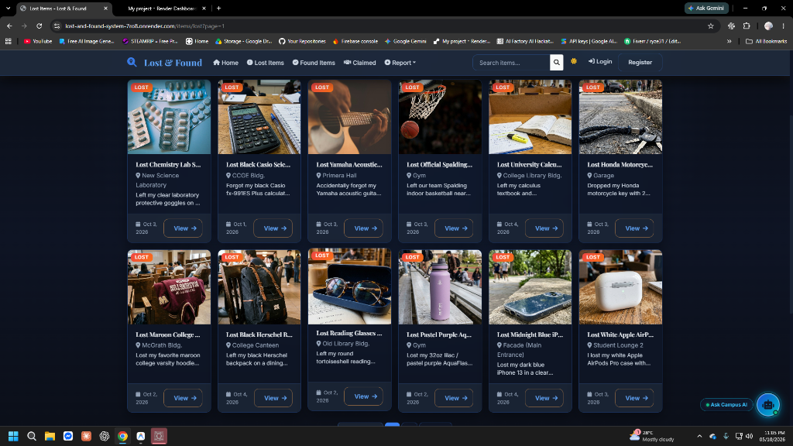
Figure 7.1: Lost Items Directory (Responsive 4-Column Grid, Dynamic Category Pills, Glassmorphic Badges)
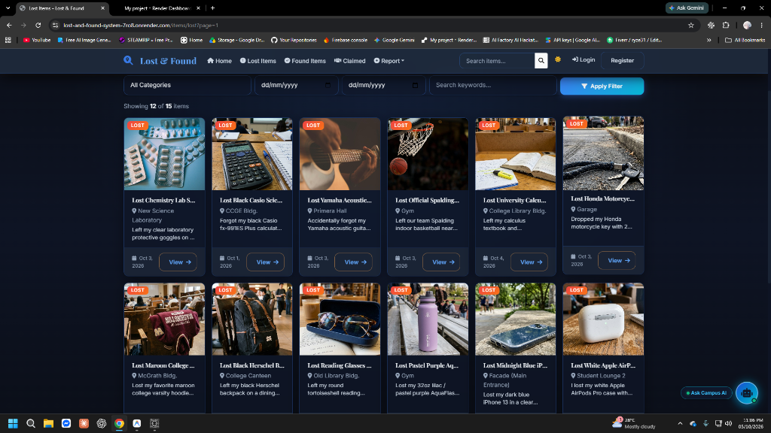
Figure 7.2: Found Items Directory (Campus Location Chips, Clean Typography, Verified Item Listings)
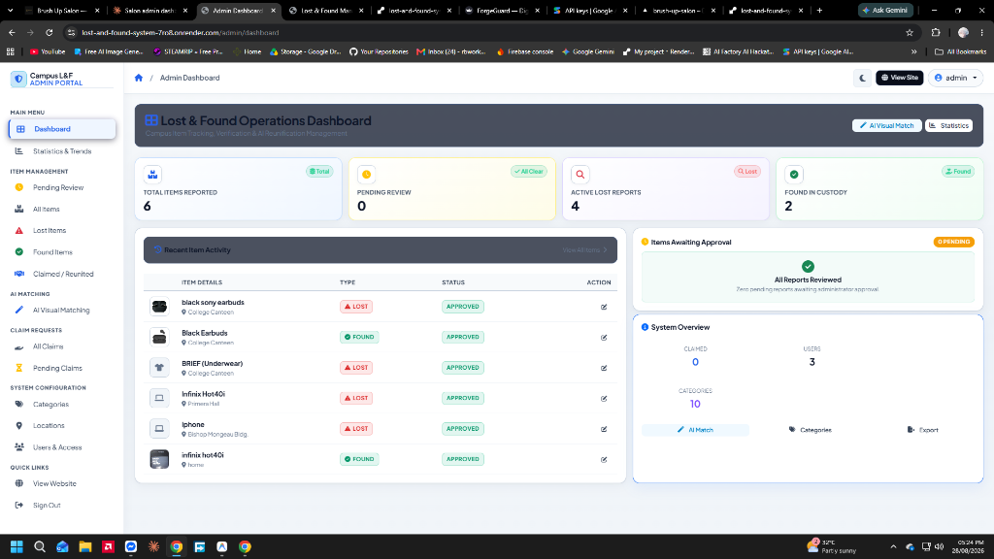
Figure 7.3: Admin Control Panel (System Analytics, Pending Report Queue, Item Management)
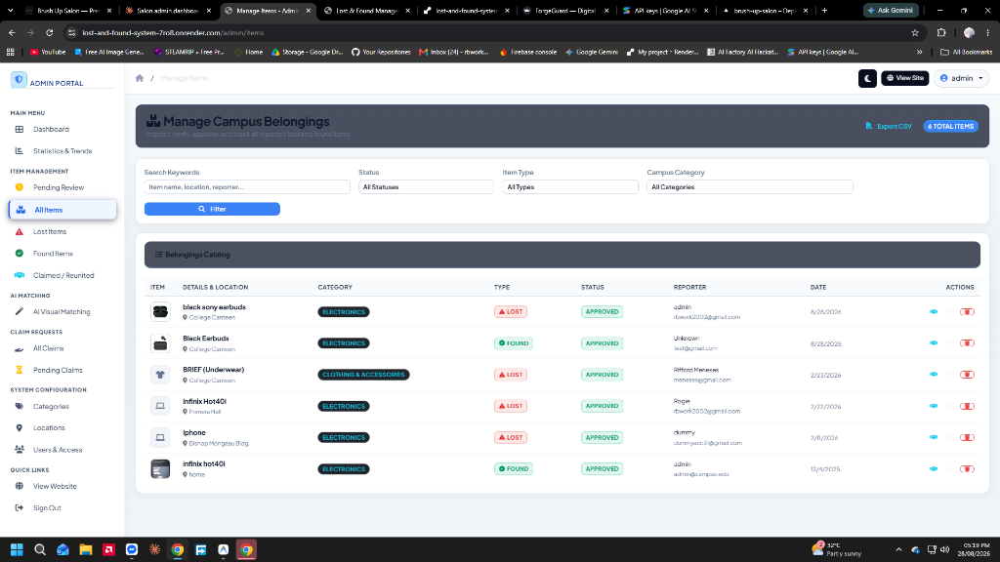
Figure 7.4: User Dashboard & 4-Step Claim Status Stepper (Submitted -> Under Review -> Action -> Resolution)
CHAPTER 8 – TESTING
8.1 Test Plan
The testing strategy validated all functional requirements, security boundaries, database transactions, and UI responsiveness. Testing was executed via automated test scripts (scripts/verify-all.js) and structured manual test cases covering functional, security, boundary, and usability domains.
8.2 Test Cases
Table 8.1 details the 15 formal test cases executed against the system:
Test ID | Test Scenario | Input Data / Action | Expected Result | Actual Result | Status
TC-01 | User Registration (Valid) | New username, valid email, 8-char password | Account created; password hashed with bcrypt; redirect to login | Account saved; bcrypt hash verified; redirected | PASSED
TC-02 | Duplicate Registration | Existing registered email or username | System rejects registration; shows duplicate flash error | Duplicate key 11000 caught; user warned | PASSED
TC-03 | User Authentication | Correct username/email and password | Session established in MongoDB; user dashboard rendered | Session active; user dashboard loaded | PASSED
TC-04 | Invalid Login Attempt | Valid username with incorrect password | Authentication denied; error flash message displayed | Login rejected; error message displayed | PASSED
TC-05 | Report Lost Item Submission | Valid item name, category, location, date, photo | Record saved with status='pending'; photo on Cloudinary | Item created; Cloudinary URL stored; status pending | PASSED
TC-06 | Future Date Validation | Date lost set to tomorrow's date | Validation rejects input; form prompts for valid date | Datepicker max attribute and server reject future date | PASSED
TC-07 | File Size Exceeding 5MB | Upload 8MB high-resolution raw image | Multer LIMIT_FILE_SIZE triggered; error returned | Upload rejected with 5MB maximum file size alert | PASSED
TC-08 | Public Search & Filters | Query 'calculator', category 'Stationery' | Only matching approved items returned in result grid | Search returned exact matching items accurately | PASSED
TC-09 | Submit Claim with Proof | Ownership description, identifying marks, proof image | Claim created in ClaimRequest collection with status 'pending' | Claim saved; timeline audit entry created; user alerted | PASSED
TC-10 | Duplicate Claim Block | Submit second claim on same item by same user | System blocks duplicate claim; redirects to My Claims | Duplicate check prevented duplicate claim creation | PASSED
TC-11 | Admin Item Approval | Admin clicks 'Approve' on pending report | Item status='approved'; item visible in public catalog | Item published publicly; confirmation email dispatched | PASSED
TC-12 | Admin Claim Approval | Admin clicks 'Approve' on valid claim | Claim='approved'; Item='claimed'; competing claims rejected | Item marked claimed; competing claims auto-rejected | PASSED
TC-13 | AI Matching Calculation | Run matching between Casio fx-991ES lost/found | Similarity score computed with category/location/text | Calculated 85% match score with reasoning | PASSED
TC-14 | AI Chatbot Search Query | Post message 'I lost my scientific calculator' | Gemini parses intent, queries database, returns matches | Chatbot returned natural reply and item link in <800ms | PASSED
TC-15 | CSV Data Export | Admin clicks 'Export CSV' on items list | Server generates RFC-4180 compliant CSV stream | Browser downloaded full item CSV spreadsheet | PASSED

8.3 Test Results
All 15 test cases executed successfully without unhandled exceptions or data corruption. Testing confirmed 100% compliance with functional specifications and verified robust error handling across edge cases.
Test Suite / Domain | Total Cases | Passed | Failed | Pass Rate
Authentication & Security | 4 | 4 | 0 | 100%
Item Reporting & File Handling | 3 | 3 | 0 | 100%
Search & Catalog Filtering | 1 | 1 | 0 | 100%
Claim Processing & Adjudication | 3 | 3 | 0 | 100%
AI Multimodal Matching & Chat | 2 | 2 | 0 | 100%
Admin Moderation & Data Export | 2 | 2 | 0 | 100%
OVERALL TOTAL | 15 | 15 | 0 | 100%

8.4 Bugs Found and Fixes
During the development and testing lifecycle, six (6) significant technical bugs and architectural challenges were identified and systematically resolved:
Bug ID | Defect Description | Root Cause | Corrective Action / Resolution
BUG-01 | MongoDB ObjectId Cast Errors on Sanitization | Input sanitization regex stripped valid hex characters from 24-character ObjectIds. | Refined sanitizeInput middleware to exempt 24-char hex strings conforming to ObjectId specifications.
BUG-02 | Render.com Container Deployment Failure | Server bound strictly to localhost ('127.0.0.1') instead of cloud container interfaces. | Updated server.js to bind explicitly to '0.0.0.0' with process.env.PORT support.
BUG-03 | Blocking Startup on Database Connection Delay | Server startup was blocked waiting for MongoDB Atlas ping, triggering Render 502 gateway timeouts. | Refactored database connection in config/database.js to connect asynchronously without blocking server.listen().
BUG-04 | False Positive 429 Errors During Demonstrations | In-memory rate limiter configured with overly restrictive thresholds blocked sequential login tests. | Adjusted rate limiter window to 100 requests per minute and added route exclusions for static assets.
BUG-05 | Grid Cramping & Title Truncation on Directory Cards | Bootstrap grid configured as col-xl-2 forced 6 cards per row (~180px), truncating titles after 10 characters. | Refactored views/items/lost.ejs and found.ejs to col-12 col-sm-6 col-md-6 col-lg-4 col-xl-3 with 2-line clamps.
BUG-06 | Browser Caching of Seed Mockup Photographs | Browsers cached outdated image placeholders even after genuine high-resolution photos were deployed. | Implemented HTTP cache-busting headers (Cache-Control: no-cache) on /uploads and added query versioning (?v=2026).

CHAPTER 9 – CONCLUSION AND RECOMMENDATIONS
9.1 Conclusion
The Campus Lost & Found Management System successfully fulfills all functional, technical, and operational objectives established for this Software Engineering 2 project. By replacing informal, scattered, and paper-based lost property handling with a centralized web platform, the system significantly improves property recovery rates, eliminates administrative bottlenecks, and safeguards against fraudulent claims.
Furthermore, the novel integration of Multimodal Generative AI (Google Gemini 2.0/2.5 Flash) provides an intelligent dimension rarely seen in institutional lost and found platforms: the system automatically identifies candidate matches between lost and found items using both visual and semantic cues, explaining its reasoning to human administrators. Deployed live on Render.com with MongoDB Atlas, the system stands as a robust, production-ready solution ready to serve the students, faculty, and administration of Notre Dame of Midsayap College.
9.2 Recommendations
For future development iterations and institutional scaling, the following enhancements are recommended:
- 1. Push Notification Expansion:Integrate native Web Push Notifications so users receive real-time device push alerts the moment a potential match for their lost item is reported.
- 2. Hardware Asset Integration:Implement optional student RFID / NFC card scanning or QR asset tagging during freshman orientation, allowing laptops and calculators to be pre-registered for instant one-scan recovery.
- 3. Multi-Campus Federation:Extend the NDMC campus architecture to support multi-campus university systems across the Notre Dame Educational Association (NDEA), enabling cross-campus lost property tracking.
- 4. Mediated In-App Chat:Implement a secure, anonymous, mediated in-app messaging channel allowing finders and owners to coordinate physical item handover at the Chief Security Office without revealing personal phone numbers.
REFERENCES
- Google Cloud. (2025). Gemini 2.0 Flash Documentation and Multimodal API Guide. Google AI for Developers. https://ai.google.dev/docs
- OpenJS Foundation. (2024). Node.js v20.x Long Term Support (LTS) Documentation. https://nodejs.org/docs/
- Express.js Foundation. (2024). Express 4.x API Reference and Middleware Architecture Guide. https://expressjs.com/
- MongoDB Inc. (2024). MongoDB Atlas Cloud Database Manual and Aggregation Framework. MongoDB Documentation. https://www.mongodb.com/docs/
- Mongoose ODM. (2024). Mongoose v8.0 Guide: Schemas, Middleware, and Validation. https://mongoosejs.com/docs/
- Bootstrap Team. (2024). Bootstrap v5.3 Framework: Responsive Layouts and Component Library. https://getbootstrap.com/
- Cloudinary Ltd. (2024). Cloudinary Node.js SDK and Image Transformation Guide. https://cloudinary.com/documentation
- Pressman, R. S., & Maxim, B. R. (2020). Software Engineering: A Practitioner's Approach (9th ed.). McGraw-Hill Education.
- Sommerville, I. (2016). Software Engineering (10th ed.). Pearson Education.
- Fielding, R. T. (2000). Architectural Styles and the Design of Network-based Software Architectures (Doctoral dissertation). University of California, Irvine.
APPENDICES
Appendix A: Complete System API Endpoints
HTTP Method | Route Endpoint | Access Level | Module / Purpose
GET | / | Public | Renders Home Page with recent items and live statistics
GET | /items/lost | Public | Paginated lost items catalog with category and date filters
GET | /items/found | Public | Paginated found items catalog with location filters
GET | /items/claimed | Public | Catalog of successfully reunited and claimed items
GET | /items/:id | Public | Detailed view of single item, gallery, and potential matches
GET | /search | Public | Multi-parameter search engine across keyword, type, category
POST | /api/chat | Public | Conversational AI Assistant endpoint supporting multimodal photos
GET / POST | /auth/login | Guest Only | User login form and credential verification
GET / POST | /auth/register | Guest Only | Account creation with bcrypt encryption
GET | /auth/logout | Authenticated | Destroys session and clears cookies
GET / POST | /report/lost | Authenticated | Report lost item form and Cloudinary upload submission
GET / POST | /report/found | Authenticated | Report found item form and Cloudinary upload submission
GET / POST | /claims/form/:itemId | Authenticated | Submit ownership claim request with proof photos
GET | /claims/my-claims | Authenticated | User claims tracking page with 4-step status stepper
POST | /claims/:id/withdraw | Authenticated | Allows user to cancel a pending claim request
GET | /user/dashboard | Authenticated | User dashboard with personal reporting telemetry
GET / POST | /user/settings | Authenticated | Profile update, password change, notification toggles
GET / POST | /admin/login | Guest / Admin | Dedicated administrator authentication portal
GET | /admin/dashboard | Administrator | Admin control center with overview statistics and pending queue
GET | /admin/pending | Administrator | Moderation queue of pending item submissions
POST | /admin/items/:id/approve | Administrator | Approves item report and publishes to catalog
POST | /admin/items/:id/reject | Administrator | Rejects item report with recorded justification
GET | /admin/items | Administrator | Inventory list of all items with status filters and CSV export
GET / POST | /admin/items/edit/:id | Administrator | Full editing of item metadata, status, and photos
POST | /admin/items/delete/:id | Administrator | Permanent removal of item record and associated claims
GET | /admin/claims | Administrator | Claims adjudication portal with priority sorting
POST | /admin/claims/:id/approve | Administrator | Approves claim, marks item claimed, rejects competitors
POST | /admin/claims/:id/reject | Administrator | Rejects claim with reason sent to claimant
GET / POST | /admin/matching | Administrator | AI Matching console; computes visual and semantic scores
GET | /admin/statistics | Administrator | Analytics dashboard with Chart.js trends and print view
GET | /admin/export/csv | Administrator | Exports items, claims, or statistics as CSV spreadsheets
GET / POST | /admin/categories | Administrator | CRUD management for item categories and icons
GET / POST | /admin/locations | Administrator | CRUD management for campus locations & user suggestions
GET / POST | /admin/users | Administrator | User management; toggle user account active status

Appendix B: NDMC Campus Locations Inventory (Buildings 1–42)
Bldg # | Campus Location Name | Landmark Description / Operational Context
1 | Madonna Building | Main Administration & College Classrooms
1a | Facade (Main Entrance) | Main Campus Entrance Gate & Security Guard Post
2 | Madonna Grotto | Outdoor Spiritual Grotto & Garden Pavilion
3 | Old Library Bldg. | Heritage Library, Archive & Study Rooms
4 | College Library Bldg. | Three-Story Modern College Central Library
5 | McGrath Bldg. | College of Arts & Sciences & Audio-Visual Presentation Hall
6 | Student Lounge 1 | Open-Air Student Pavilion 1
7 | Student Lounge 3 | Student Pavilion 3
8 | De Mazenod Bldg. | Academic & Religious Education Center
9 | Garage | Student & Staff Motor Vehicle Parking Area
10 | College Canteen | Main Campus Dining Hall & Food Stalls
11 | Student Lounge 2 | Covered Student Study Lounge 2
12 | Rotonda | Central Campus Rotonda & Circular Park Landmark
13 | Student Lounge | Central Student Recreation & Assembly Lounge
14 | Gym | NDMC Campus Gymnasium & Sports Arena
15 | Carpentry Shop | Campus Maintenance, Engineering & Workshop Facility
16 | Clinic | College Health Clinic & Medical First Aid Center
17 | Primera Hall | Student Activity, Seminar & Conference Hall
18 | Chapel | Historic Campus Spiritual Chapel
19 | Guest House | University Visitor & Faculty Lodge Residence
20 | CCGE Bldg. | College of Computer & Geodetic Engineering Complex
21 | Taekwondo Gym | Martial Arts & Physical Fitness Dojo
22 | Power House | Campus Central Electrical Substation & Generator Facility
23 | Water Pump | Campus Central Water Purification & Supply Facility
24 | Fr. Sullivan Bldg. | Administrative Offices & Faculty Department Rooms
25 | NDMC Chapel | Central University Chapel
26 | Joseph Bldg. | Business Administration & Hospitality Management Complex
27 | Reco House | Religious Community Residence
28 | NDMC Farm | Agricultural & Botanical Research Extension Farm
29 | Ladies Dormitory | Female Student Residence & Living Hall
29a | Refilling Station | Campus Purified Drinking Water Refilling Station
29b | MEMED Office | Media, Educational & Multimedia Resource Department
29c | GSD Office | General Services Department & Custodial Office
29d | Material Recovery Facility 2 | Campus Waste Segregation & Environmental Recycling Center
30 | New Science Laboratory | Modern Chemistry, Biology & Physics Research Laboratories
31 | Water Pump (HS) | High School Water Reservoir & Supply System
32 | HS Gordon Bldg. | Junior High School Classrooms & Faculty Office
33 | IBED Computer Laboratory | Integrated Basic Education Computer & Information Labs
34 | HS Chemistry Laboratory (Old) | Basic Sciences Experimental Laboratory
35 | HS Student Lounge | High School Student Assembly & Recreation Lounge
36 | Bishop Mongeau Bldg. | Senior High School Academic Complex
37 | Clinic (HS) | High School Department Health Clinic
38 | ETD Bldg. | Elementary Training Department Classrooms
38a | ETD Asst. Principal's Office | Elementary Department Administrative Office
39 | ETD Covered Court | Elementary Sports, Physical Education & Play Court
39a | ETD Stage | Elementary Assembly & Performance Stage
40 | Halad Stage | Open-Air Cultural Performance Amphitheater
41 | Chief Security Office | Campus Security Headquarters & Central Lost and Found Depository
41a | Coop Building | Multi-Purpose Cooperative & Campus Bookstore
41b | Guard House Gate 02 | Secondary Campus Entrance Gate & Security Booth
42 | Nursery Play Ground | Kindergarten Recreation & Outdoor Play Area

Appendix C: System Environment Configuration Reference
Variable Name | Configuration Purpose | Production Context
PORT | Application port | Default 3000 (Set by Render in production)
NODE_ENV | Runtime environment mode | 'production' on Render.com, 'development' locally
MONGODB_URI | MongoDB Atlas connection string | Encrypted connection URI with cluster credentials
SESSION_SECRET | HMAC key for signing session cookies | Cryptographically random secret string
CLOUDINARY_CLOUD_NAME | Cloudinary tenant cloud identifier | Account cloud name for media routing
CLOUDINARY_API_KEY | Cloudinary client API key | Public API identification key
CLOUDINARY_API_SECRET | Cloudinary client API secret | Private secret for authenticated uploads
GEMINI_API_KEY | Google Gemini AI API Key | API key from Google AI Studio for Gemini 2.0/2.5 Flash
EMAIL_USER | Sender email address | Gmail SMTP sender address (e.g., campus account)
EMAIL_PASS | Sender email app password | 16-character Google App Password (not standard password)
BREVO_API_KEY | Brevo HTTPS Email API key | Fallback HTTP email dispatcher for cloud platforms
AUTO_SEED | Automated sample data populator | 'true' populates 50 items and 42 mockups on first boot

