- Reseach Papers
  - OpenALex : j2LTOpMBSPXSXKIESkKnPQ
  - Corssref:
https://api.crossref.org
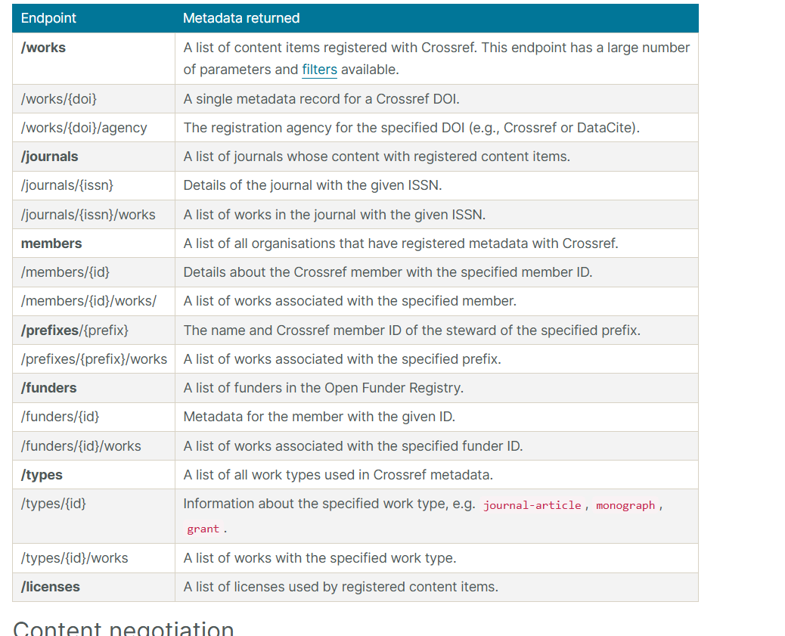
  - Arxiv: http://export.arxiv.org/api/query
- Jobs
  - USAJobs: FXQyCQCqMxH1sn4QnEXDbLpkPUBD5pfN7kJYEfW3etU=
- Skills
  - 5Wlci-sLYC0-pkxgL-XkOiy

