**Optimization Methods**  **Fall 2020** **Homework 3**

Instructor: Lijun Zhang Name: 左之睿, StudentId: 191300087

**Problem 1:**

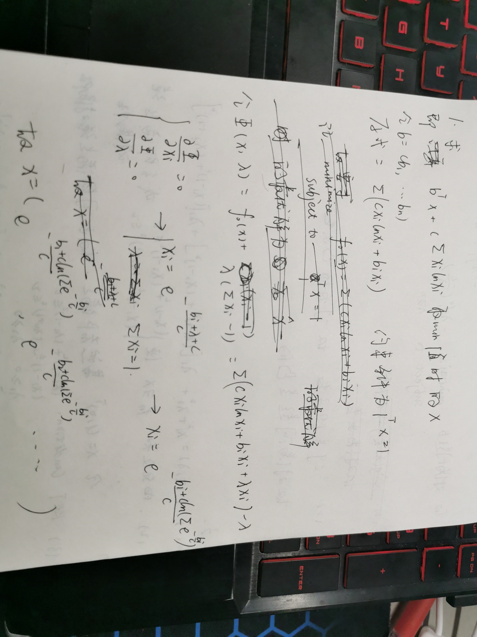

**Problem 2:**

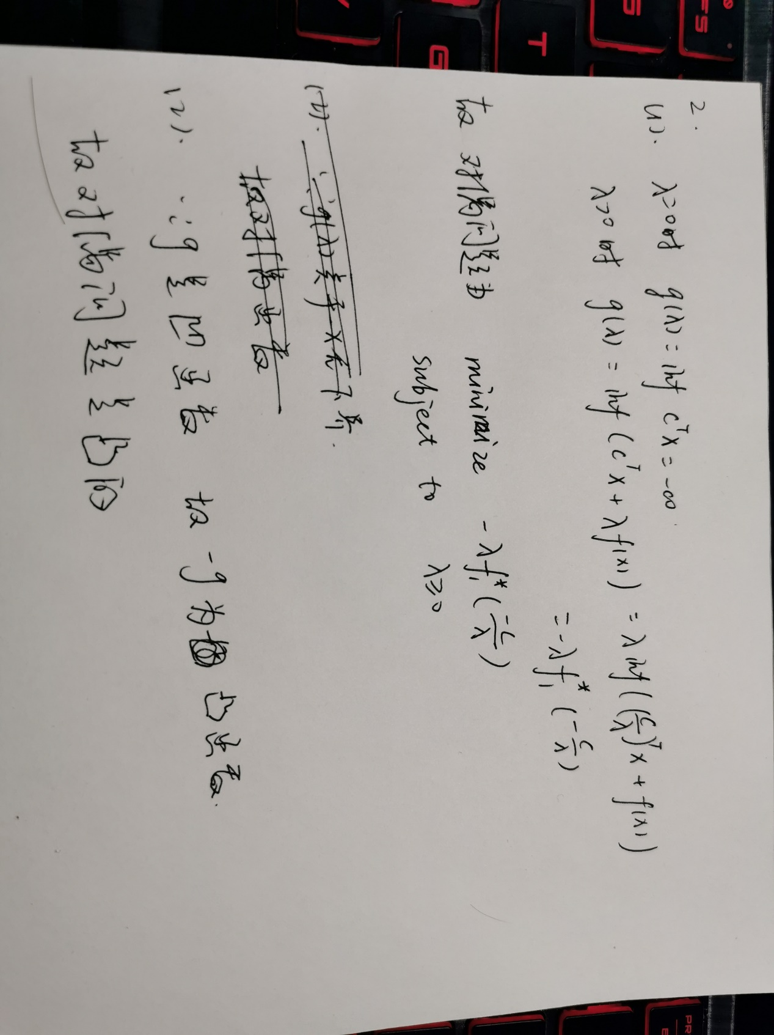

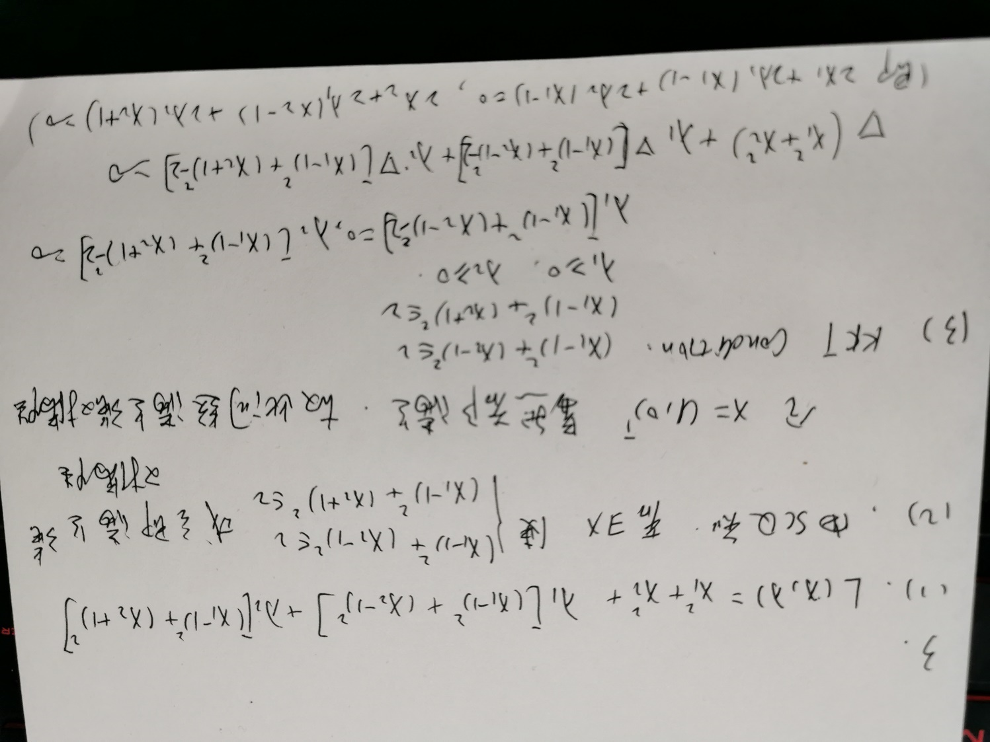**Problem 3:**

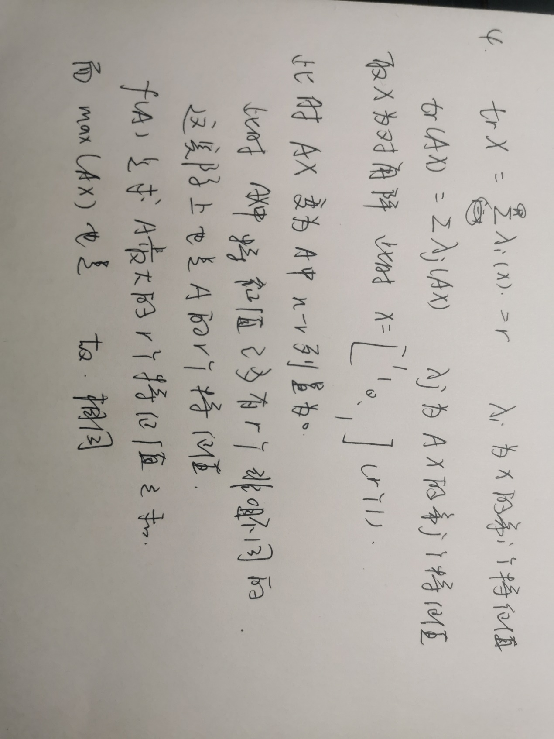**Problem 4:**

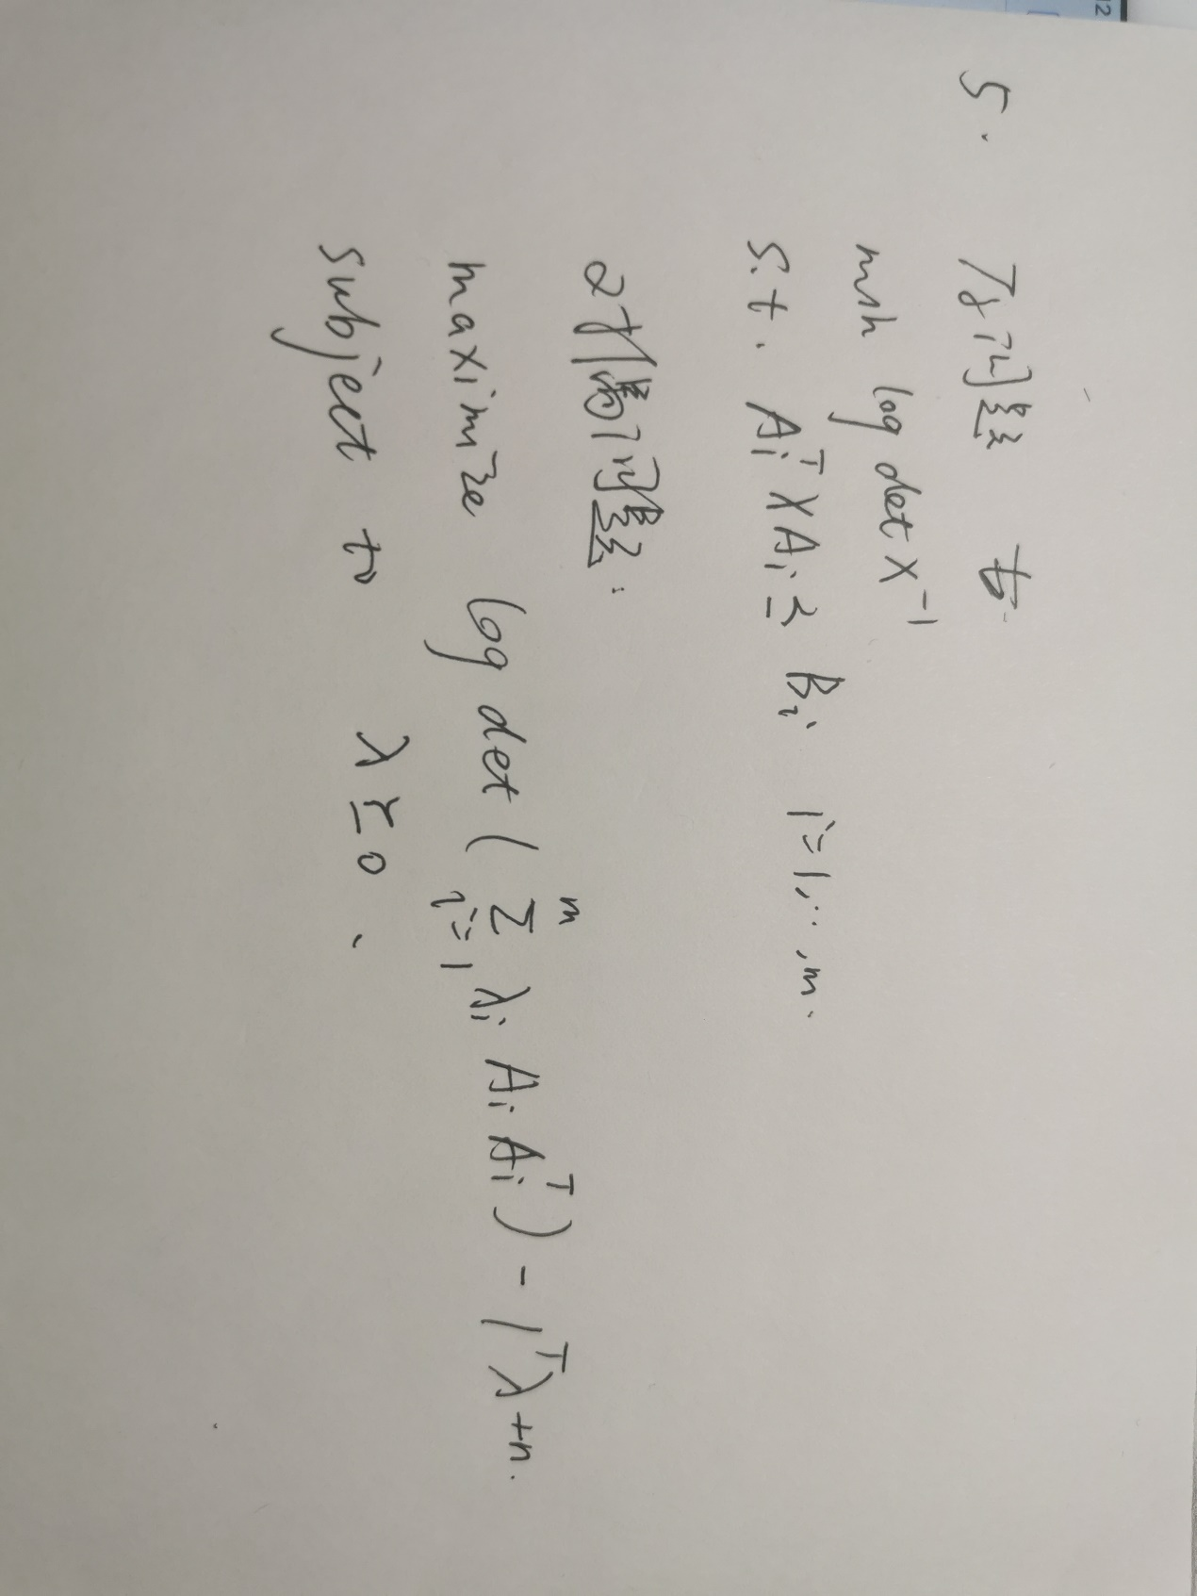**Problem 5:**