Agentic AI Course Assistant
Shahriyar Taufik
Roll No: 2330111

1. Project Overview
The Agentic Course Assistant is a Capstone Project designed to help 4th-year B.Tech students intelligently navigate their Agentic AI coursework. It acts as an autonomous tutor, utilizing a state-of-the-art intelligent agent architecture that goes beyond simple text generation to feature sophisticated routing, retrieval, evaluation, and tool-use capabilities.
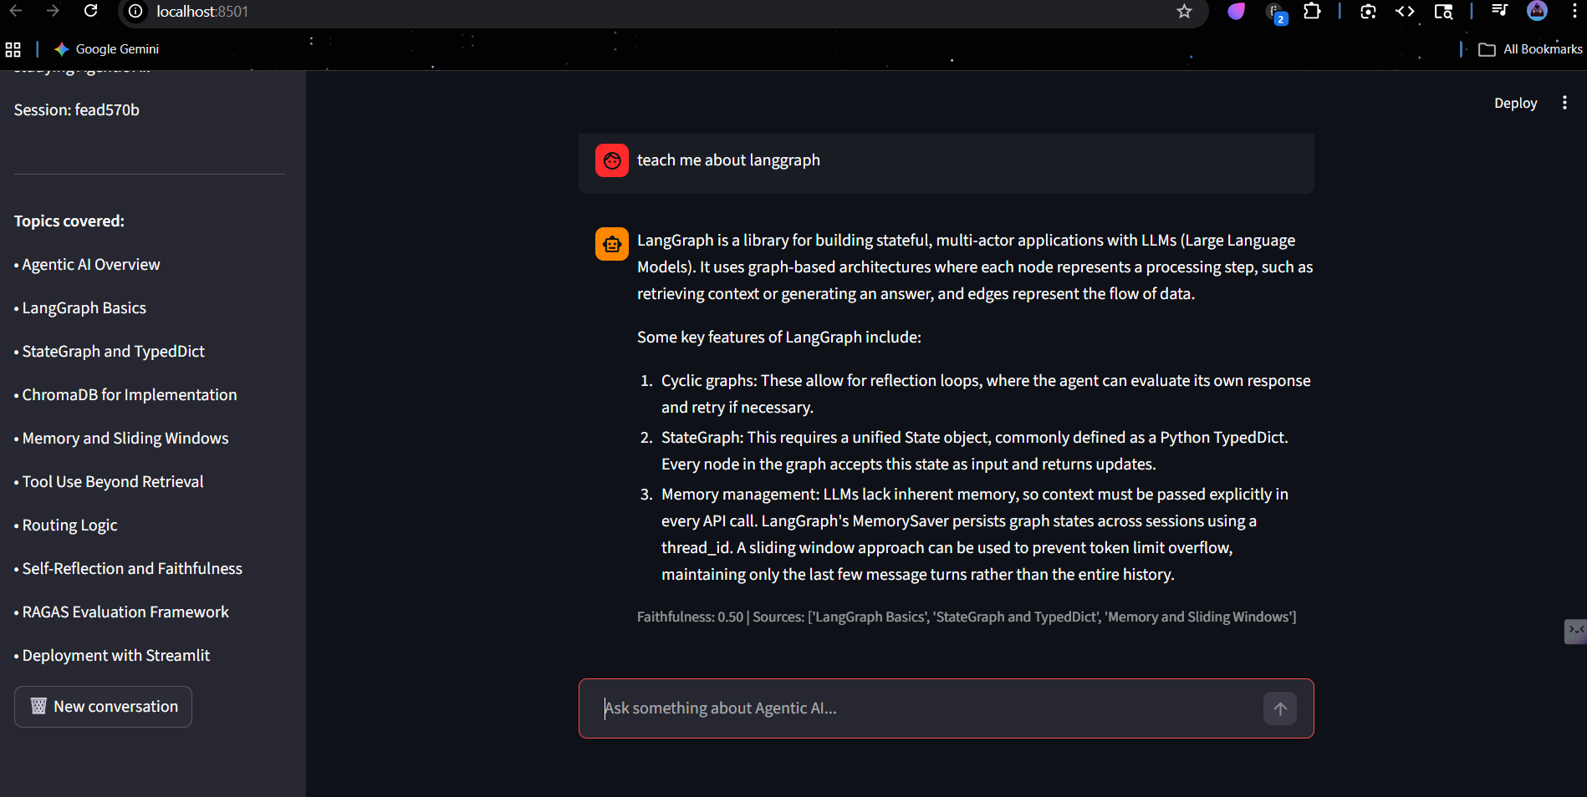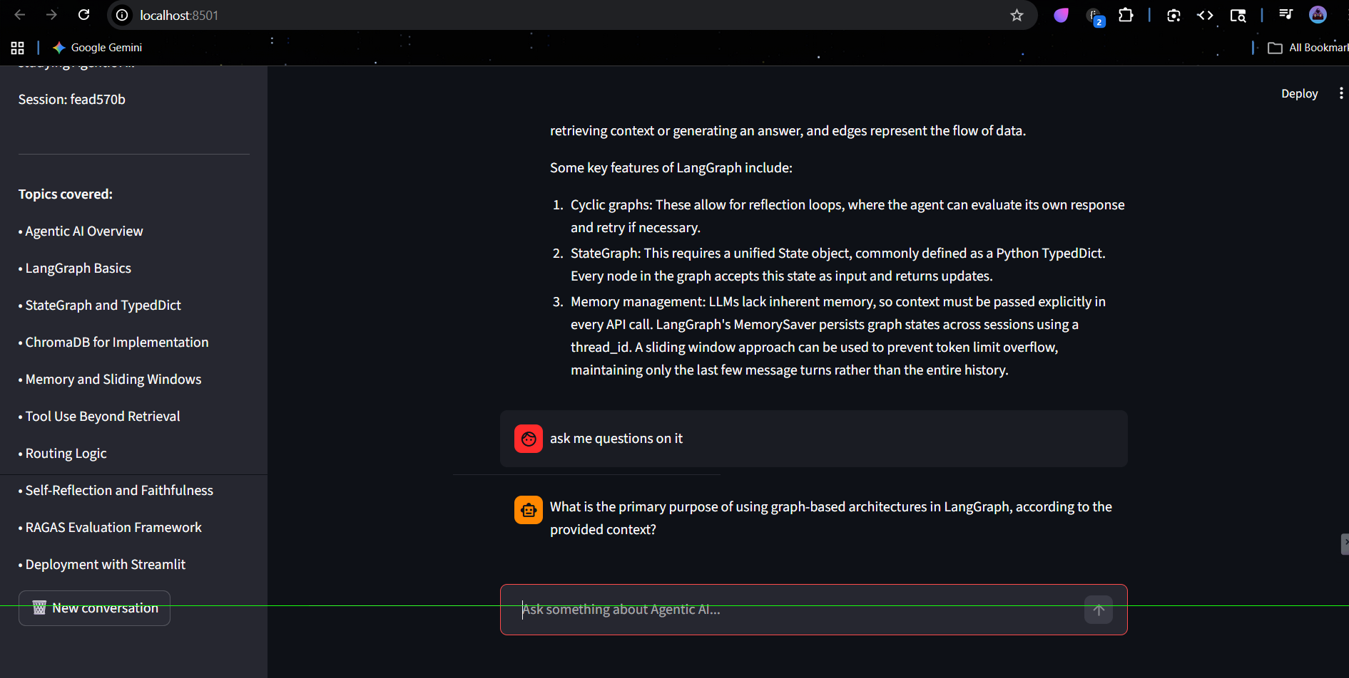

2. System Architecture
The project framework consists of two core components that establish a robust backend and an interactive frontend:
- agent.py: The core 'brain' of the AI containing LangGraph states, Retrieval-Augmented Generation (RAG) logic, and model interaction logic.
- capstone_streamlit.py: The interactive user interface built dynamically with Streamlit.

3. Core Agent Design (Backend)
The backend agent is orchestrated using LangGraph to create a cyclic, stateful flowchart (StateGraph). The agent determines the optimal course of action dynamically as questions arrive. Key elements of this architecture include:
- Knowledge Base Integration: A predefined domain expertise base containing essential syllabus topics like System Routing Logic, ChromaDB, RAGAS Evaluation, and LangGraph Basics.
- Vector Database (ChromaDB): The application encodes text snippets with 'SentenceTransformer' ('all-MiniLM-L6-v2') into a localized ChromaDB instance. When a student poses a query, the system retrieves the most semantically relevant chunks of information to use as context.
- Large Language Model: Powered by Groq's high-speed inference engine using the LLaMA 3.3 (70B parameter) model for highly capable semantic reasoning.
- Intelligent Router: Upon receiving a question, the routing node critically evaluates whether the agent should query the knowledge base ('retrieve' route), rely purely on conversation history ('memory_only' route), or execute external actions ('tool' route, such as retrieving the current date/time). This minimizes unnecessary database queries and reduces latency.
- Evaluation & Self-Reflection Loop: The generated answer undergoes a 'faithfulness' check by the eval_node. If the model hallucinated information not present in the retrieved texts (dropping below a 0.7 precision metric), the StateGraph forces the LLM to discard its answer and retry (up to 2 times), strictly adhering to factual data.
- Long-Term Memory Management: Utilizing LangGraph's 'MemorySaver', the agent accurately tracks conversational states using a thread_id, preventing token limit overflow by retaining historical context seamlessly.

4. Web Interface (Frontend)
The Streamlit UI provides a seamless user interaction layer directly tied to the AI infrastructure:
- Session Flow Management: Every unique web-tab instance or initialized 'New conversation' button correctly assigns a fresh UUID thread_id. This isolates conversational states, preventing test context leakage between consecutive sessions.
- Performance Caching: Time-consuming and memory-intensive initializations, like embedding models and vector clients, are decorated with '@st.cache_resource', guaranteeing swift latency during the lifespan of the server.
- Metadata Rendering: The Assistant actively prints out verification score tags (Faithfulness out of 1.0) and references the exact vector source topics beneath every response, giving users insight into its backend processes.
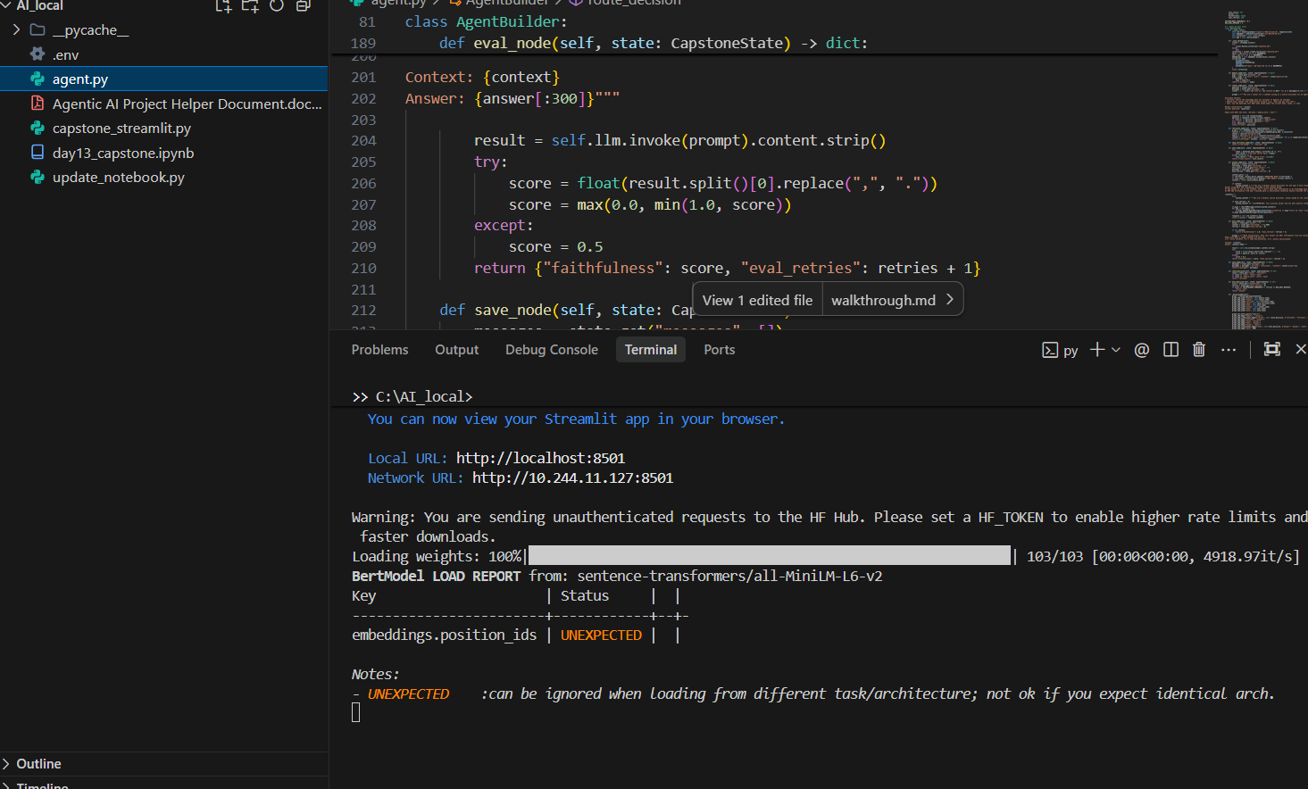

5. Validated Results & Conclusion
The Agentic Course Assistant codebase is fully completed and smoothly operational. Crucial dependencies encompassing LangChain, langgraph, Groq, ChromaDB, and Streamlit have been integrated successfully. The application server runs efficiently locally, resulting in highly responsive and robust academic guidance to assist students with their coursework.

