Roderick Rodelas

100978575

A simple 2D shooter game.

Gun Wing commander

GAME DEVELOPMENT CRN-13018-201601

Table of Contents

Game Mechanics 3

Control Description 3

Screen Descriptions 3

Start State 4

Gameplay State 4

End Game State 5

Enemies 5

Scoring 5

Sounds 6

Explosion Sound 6

Laser Sounds 6

Art/Multimedia 6

Missile 6

Player and Enemy Sprites 6

Explosion Sprite 7

Power-up and Shield Sprite 7

Background 7

Credits 7

Explosion Sound 7

Laser Sounds 7

Player and Enemy sprites 7

Missile Sprite 8

Explosion Sprite 8

# Game Mechanics

* + Earn points by destroying enemy space ships while avoiding the enemy missile or ship.
  + You will begin with 3 lives and would earn a bonus life if you reach 1000 points.
  + Every 500 points a powerup shield for you to collect and would protect you for two hits.

# Control Description

* + To control you ship, you can use either the arrow or AWSD keys.
  + To fire your missile, press spacebar.

# Screen Descriptions

Start State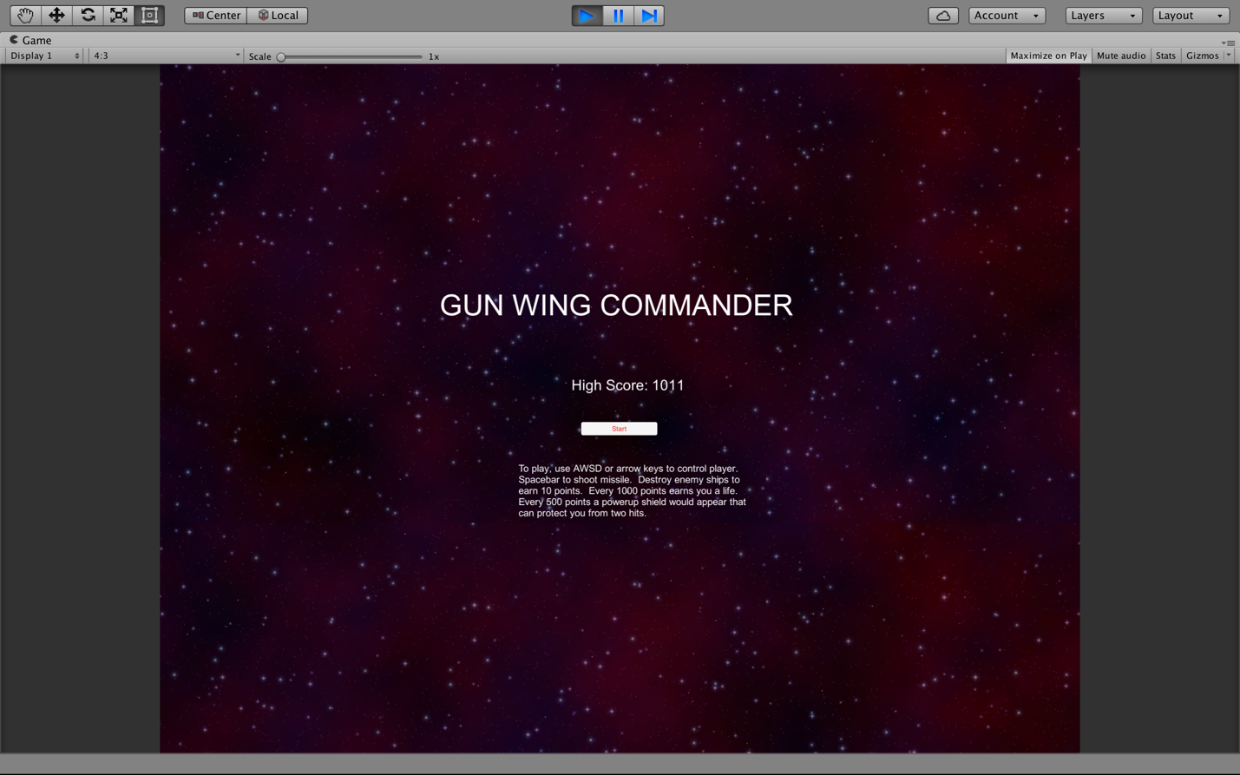

## Gameplay State

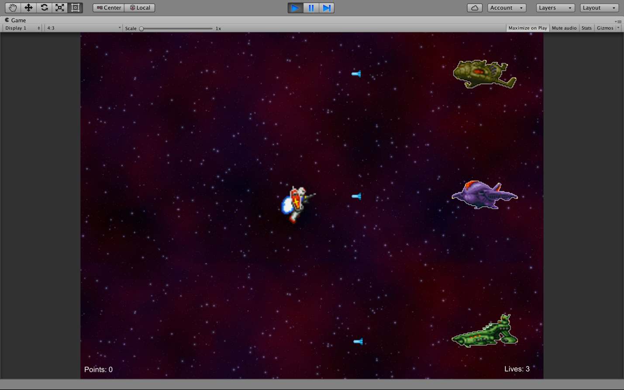

## End Game State

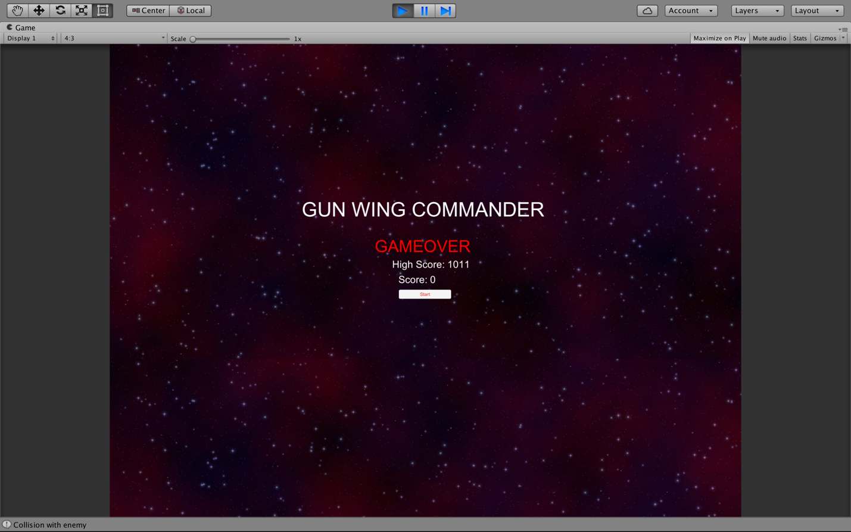

# Enemies

* Enemies would appear randomly and would fire their missiles at you.
* There are three enemies and each is worth 10 points.

# Scoring

* + Each enemy space ship you destroy is worth 10 points.
  + Every 500 points enables a power up.
  + Every 1000 points gives you one life.

# Sounds

The audio/sounds that I used can be found on the following sites:

## Explosion Sound

<https://www.freesoundeffects.com/free-sounds/explosion-10070/>

* + - Explosion

## Laser Sounds

<http://soundbible.com/tags-laser.html>

* + - Blaster
    - EnemyShoot

# Art/Multimedia

The sprites can be found on the following sites:

## Missile

<http://opengameart.org/content/bullet-collection-1-m484>

Player Missile 

Enemy Missile 

## Player and Enemy Sprites

<http://shrines.rpgclassics.com/snes/msgcd/downloads.shtml>

Player 

Enemy Ships   

## Explosion Sprite

<https://geeksretreat.files.wordpress.com/2013/12/explosion.png>

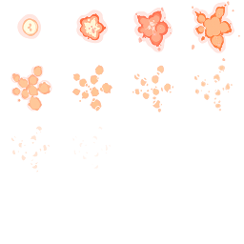

## Power-up and Shield Sprite

<http://www.deviantart.com/morelikethis/251892877>

Power-Up 

Shield 

## Background



# Credits

Credits to the following for their wonderful work of arts and sounds:

## Explosion Sound

<https://www.freesoundeffects.com/free-sounds/explosion-10070/>

## Laser Sounds

<http://soundbible.com/tags-laser.html>

## Player and Enemy sprites

<http://www.rpgclassics.com>

<http://shrines.rpgclassics.com/snes/msgcd/downloads.shtml>

## Missile Sprite

<http://opengameart.org/content/bullet-collection-1-m484>

## Explosion Sprite

<https://geeksretreat.files.wordpress.com/2013/12/explosion.png>