Da 102 Laboratory Assignment Week 7

**Question 1**

**Problem statement**

To create a histogram using libreoffice calc for the dataset given below

|  |
| --- |
| Data |
| 6 |
| 15 |
| 5 |
| 8 |
| 9 |
| 17 |
| 4 |
| 21 |
| 22 |
| 11 |

Note that libreoffice calc does not provide histogram chart in its chart menu.

Histogram chart has to be developed from scratch.

We know that a histogram is a graph that shows using rectangular blocks the frequency of numerical data falling within pre-defined bins.

To calculate the frequency, we will use libreoffice calc function FREQUENCY

(<https://wiki.documentfoundation.org/Documentation/Calc_Functions/FREQUENCY>)

**Detailed Solution**

We note that minimum value is 4 and maximum value is 22. We can consider bin values 5, 15 and 25

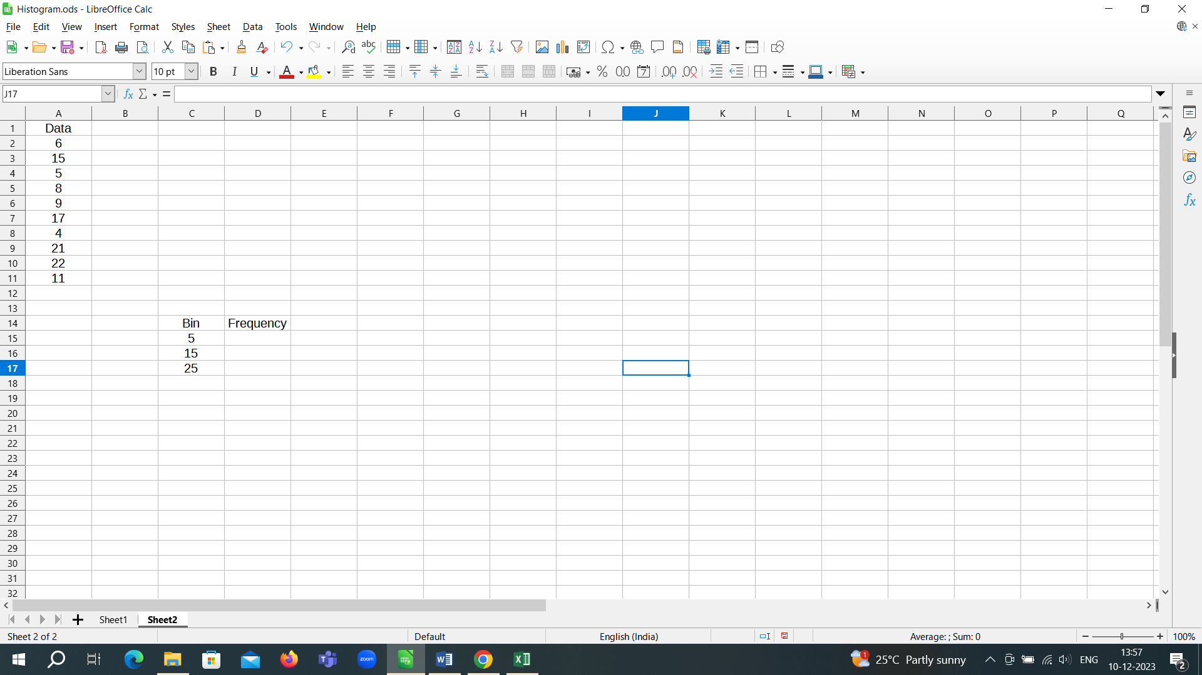

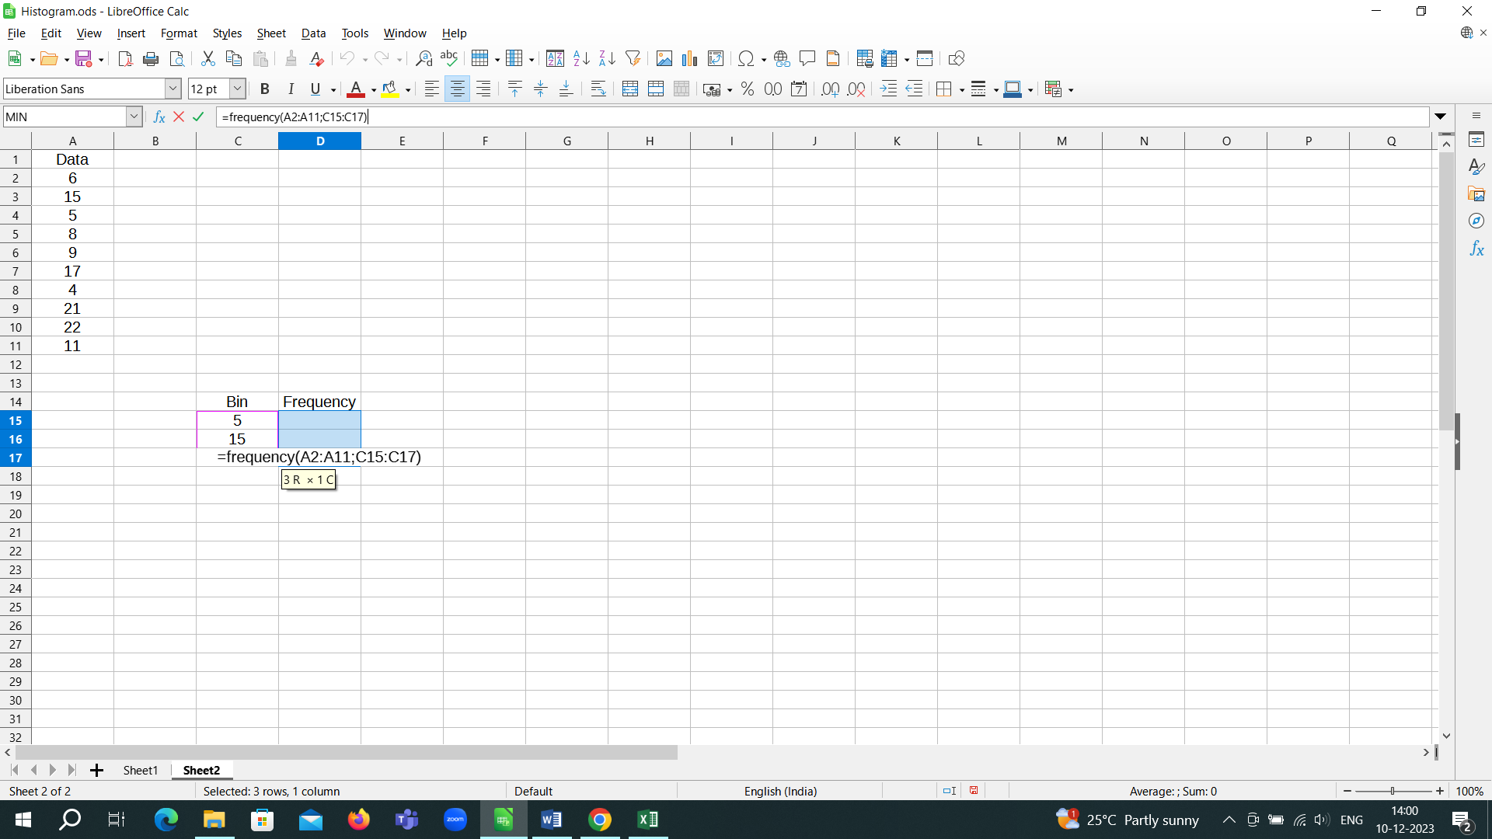

Ctrl+Shift+Enter

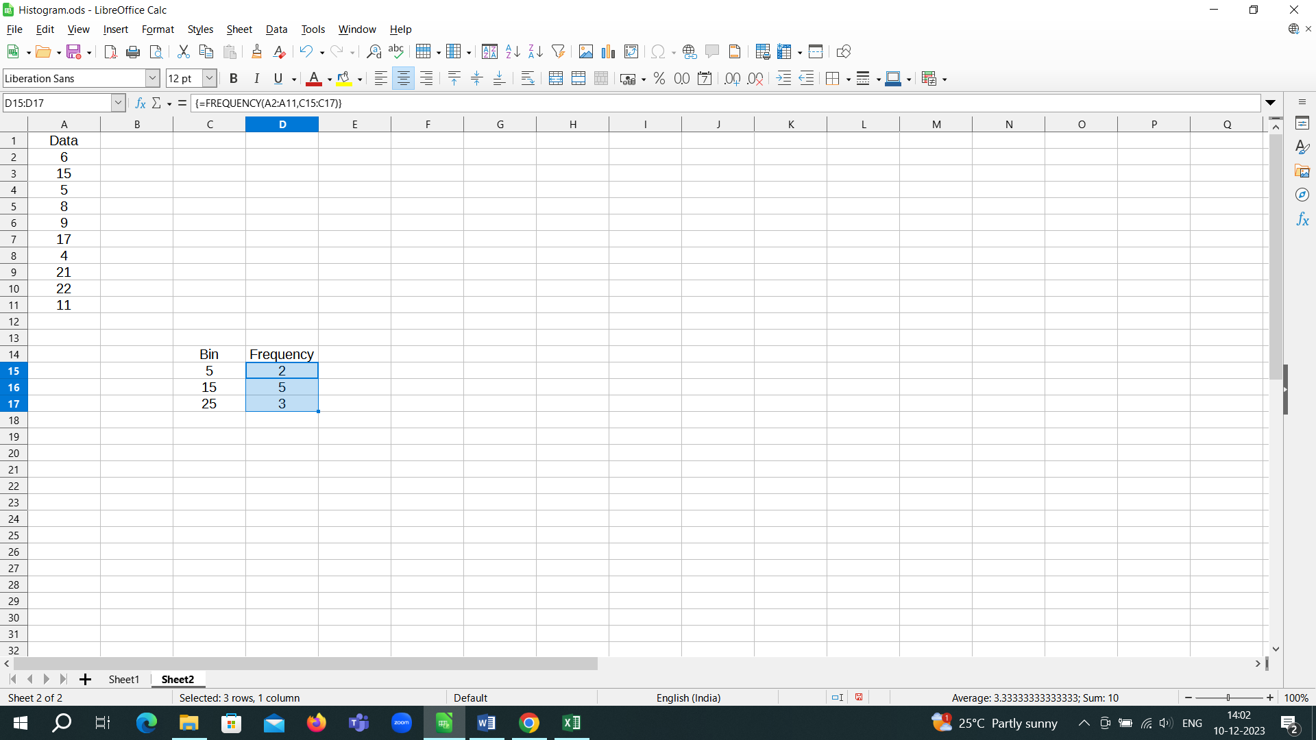

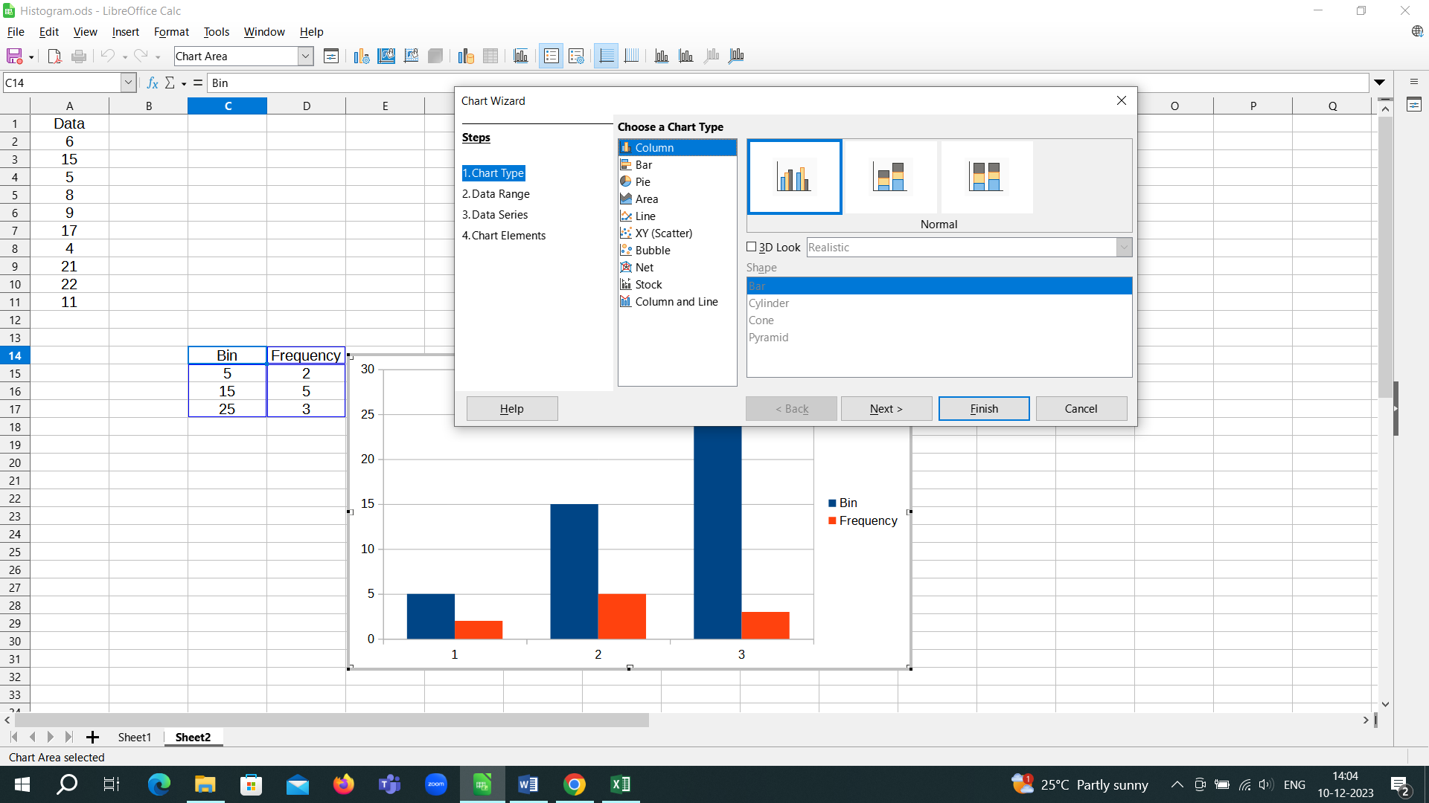

We want to have only the Frequency chart to create the histogram

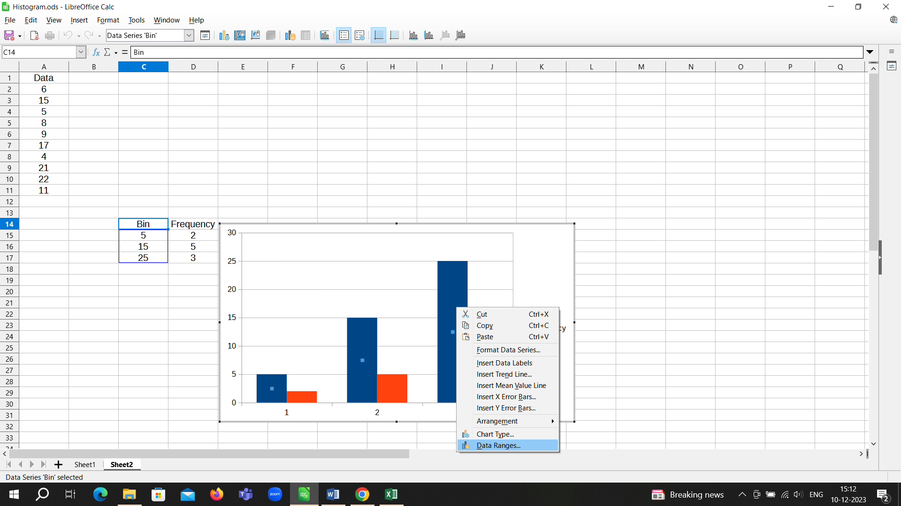

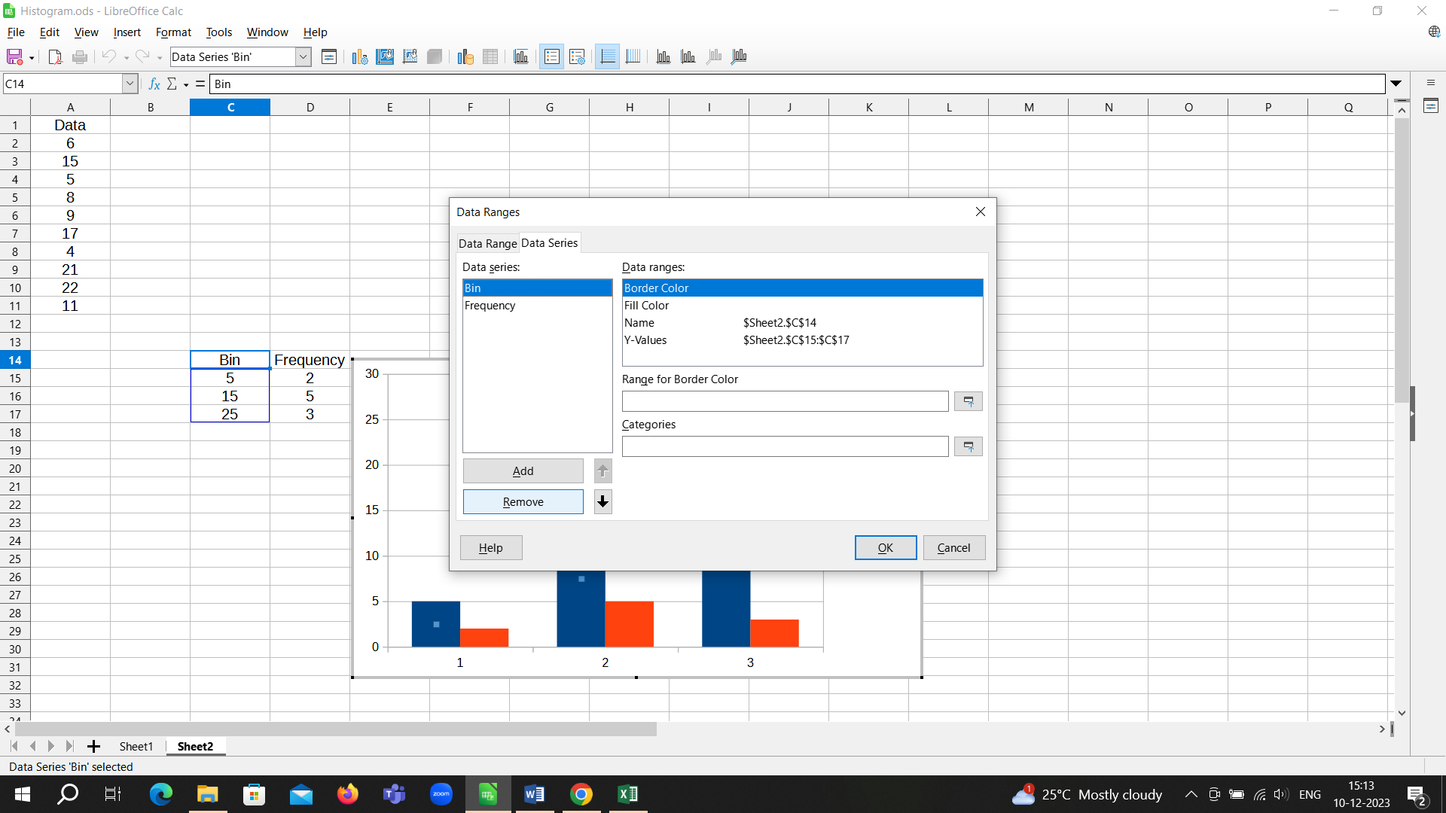

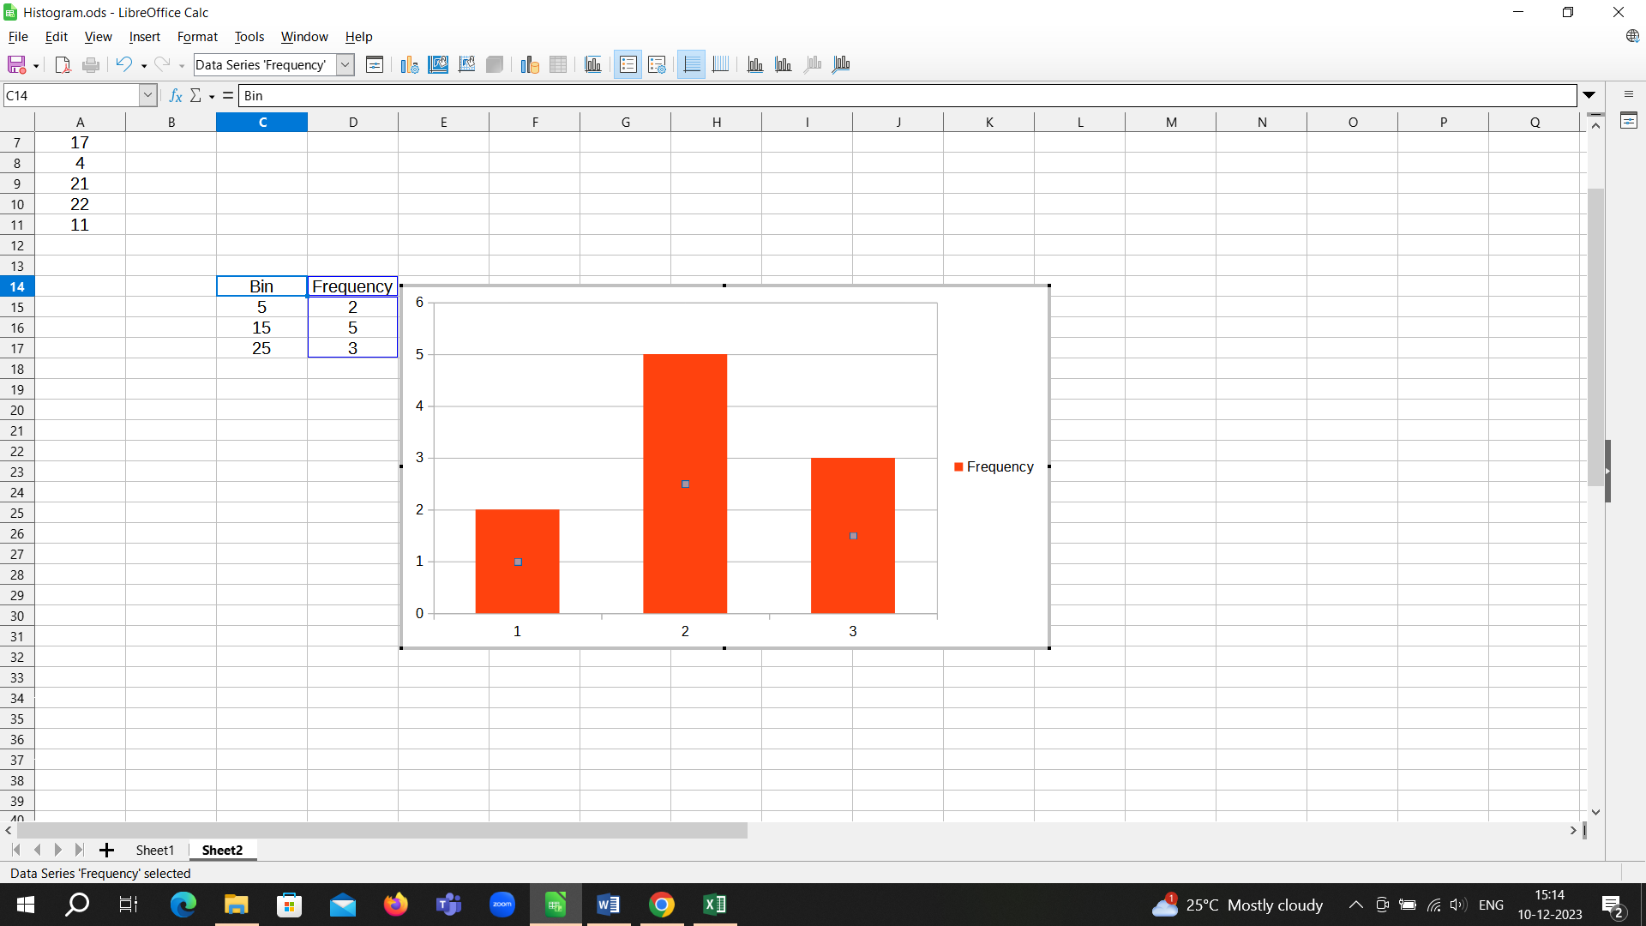

Next, we insert bins

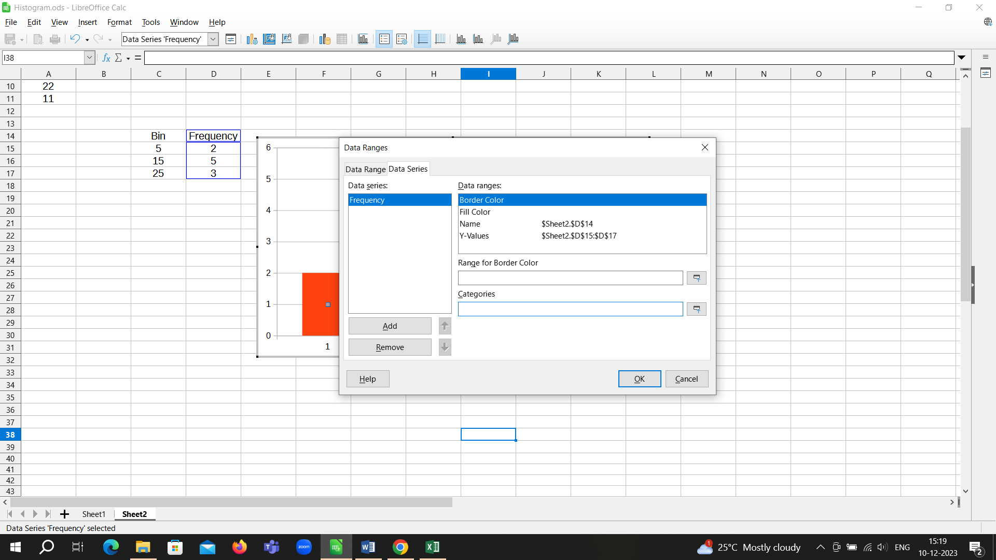

Add bin values under categories

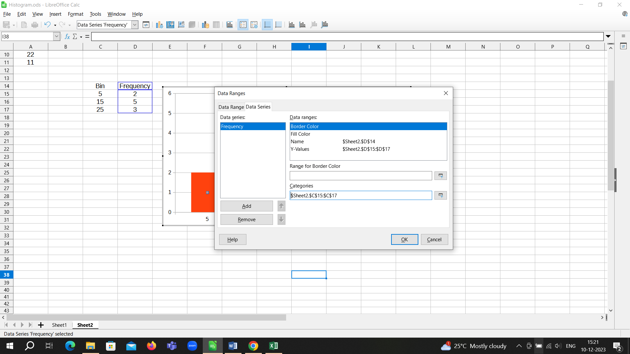

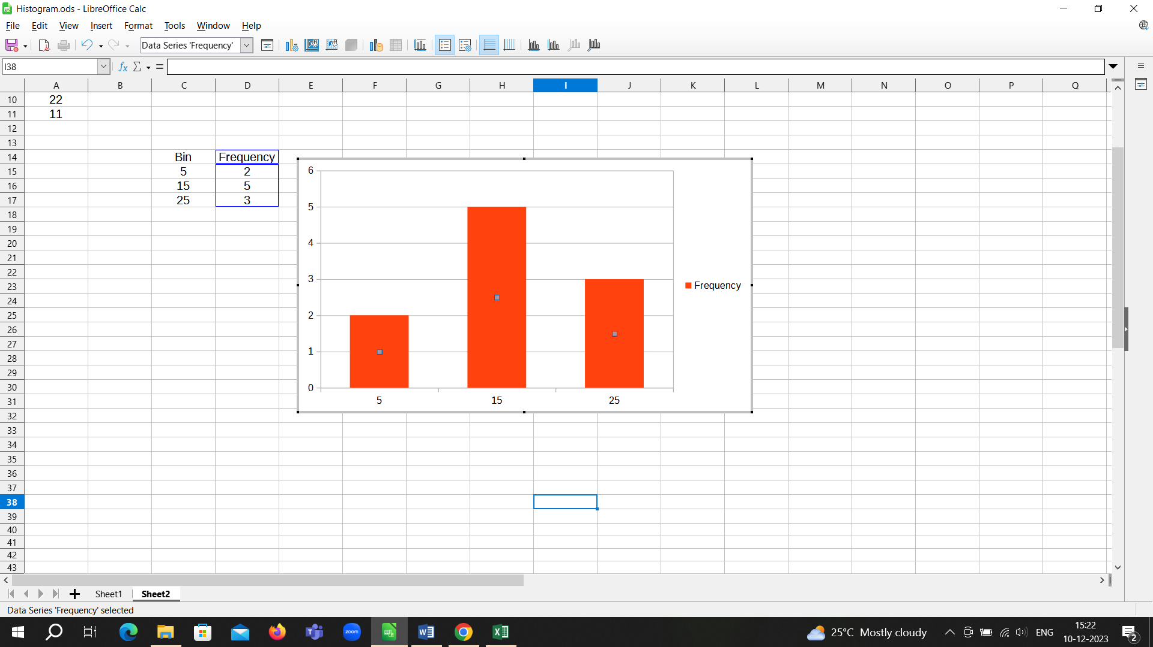

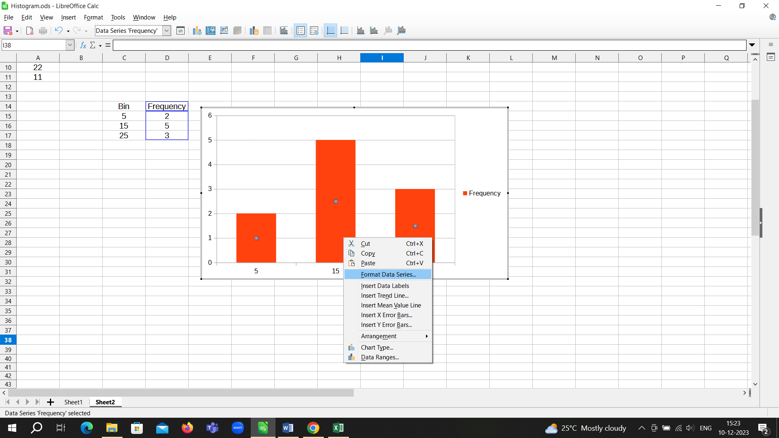

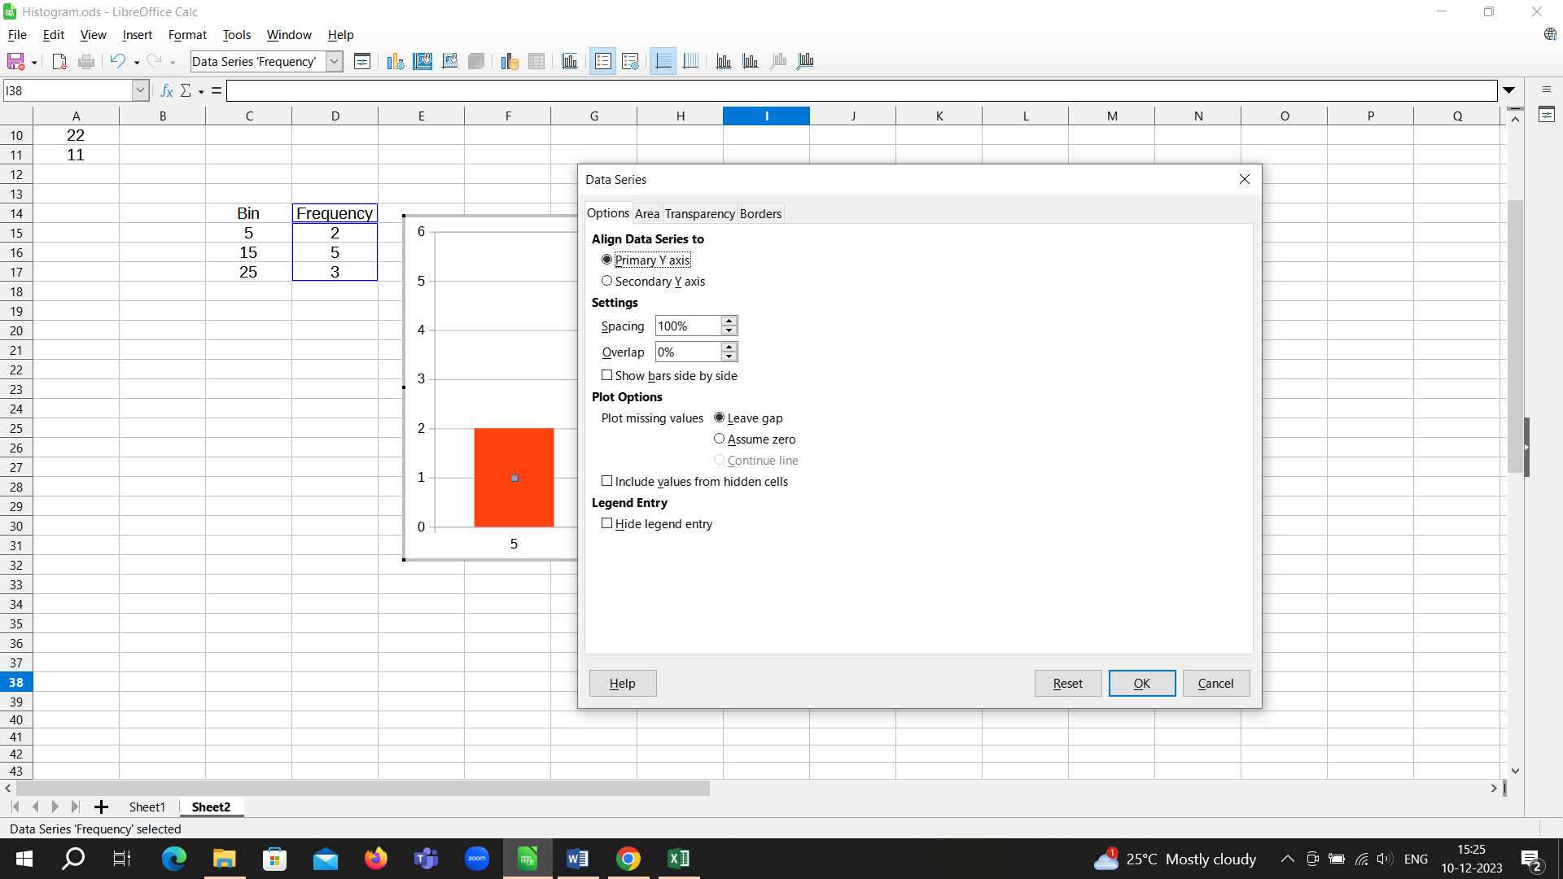

Set spacing to 0%

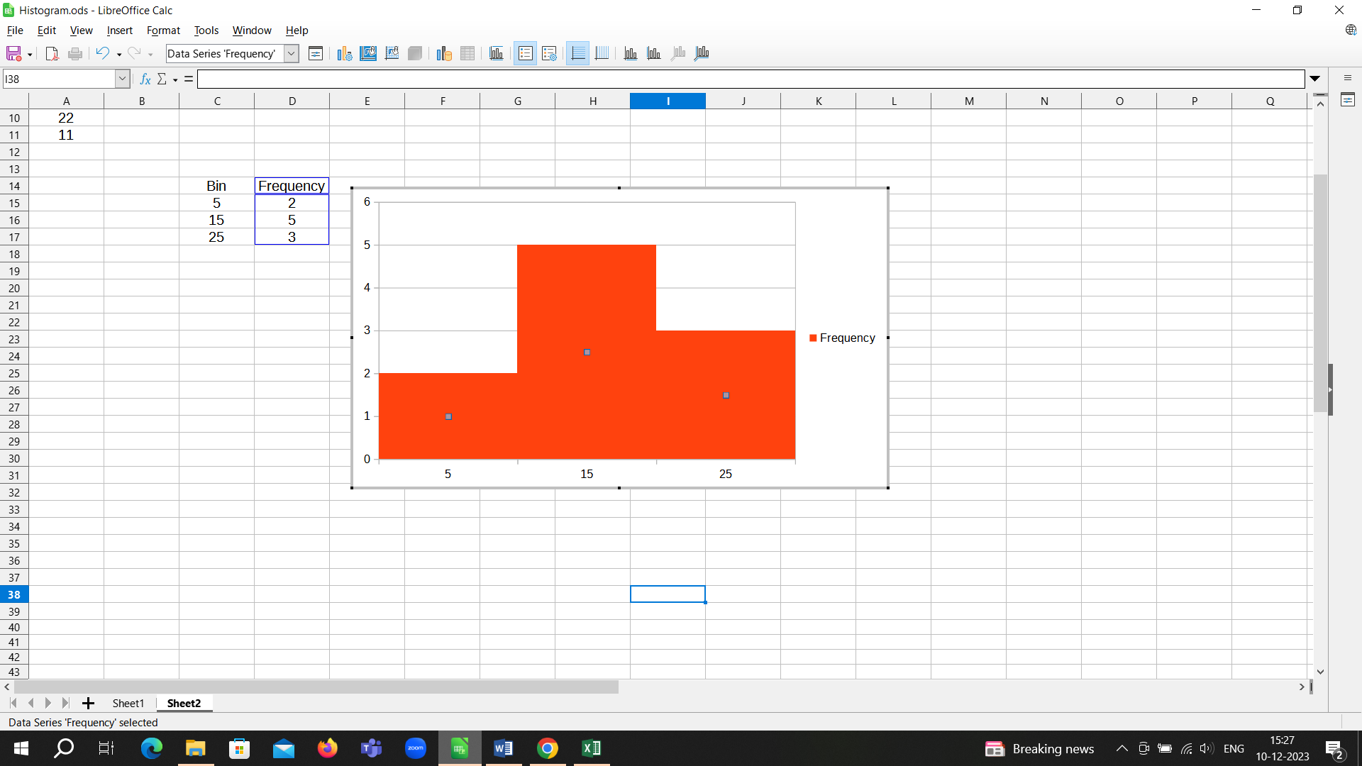

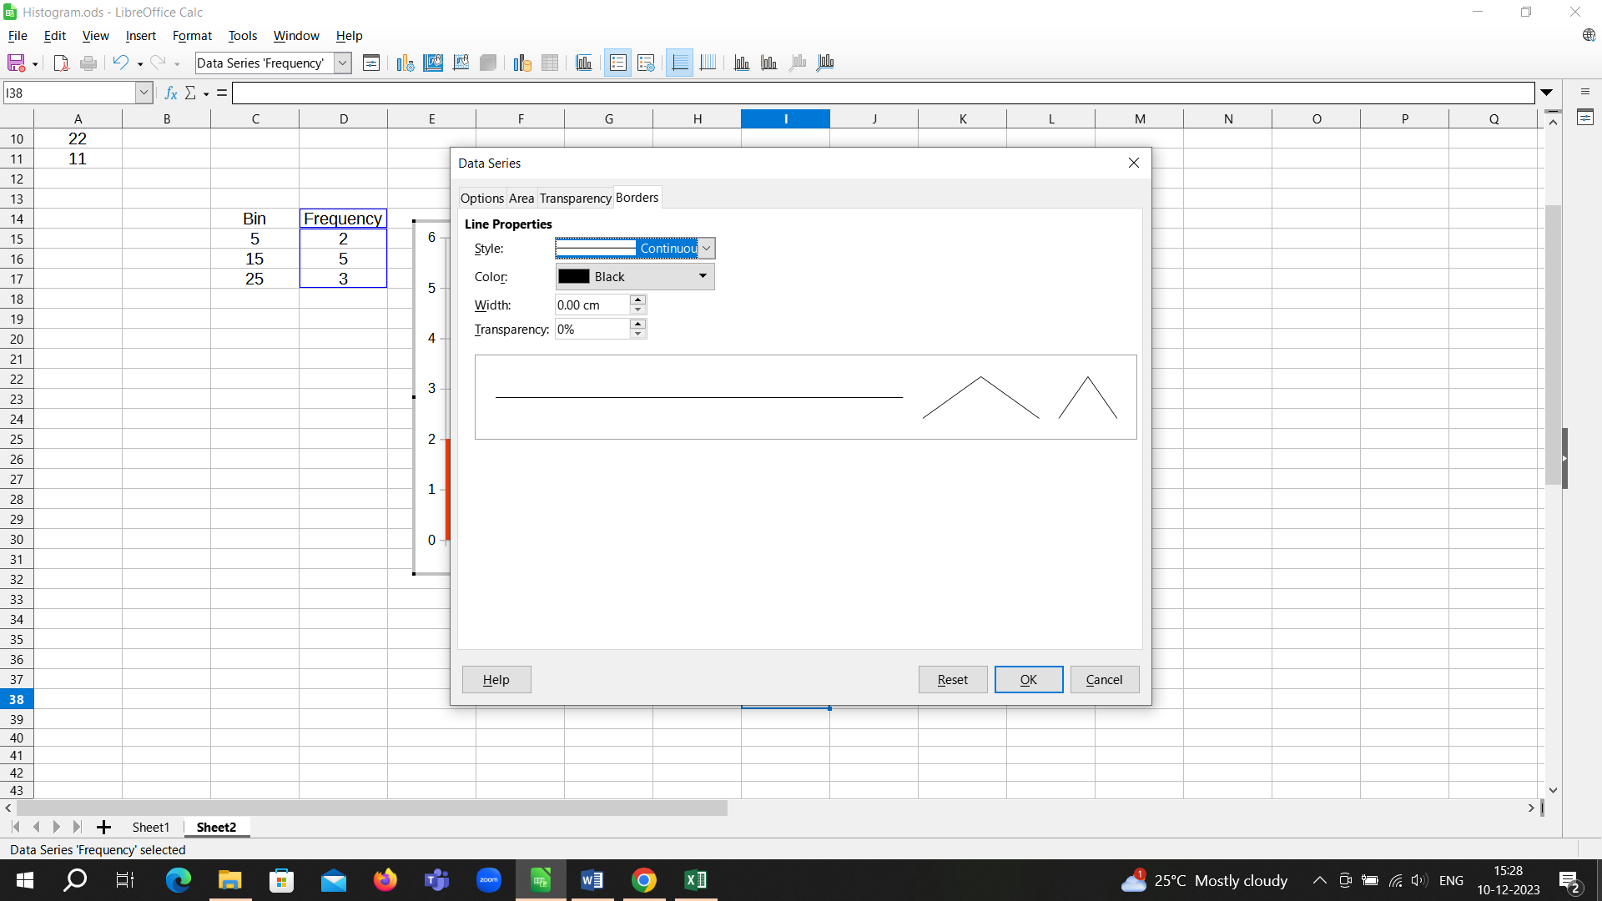

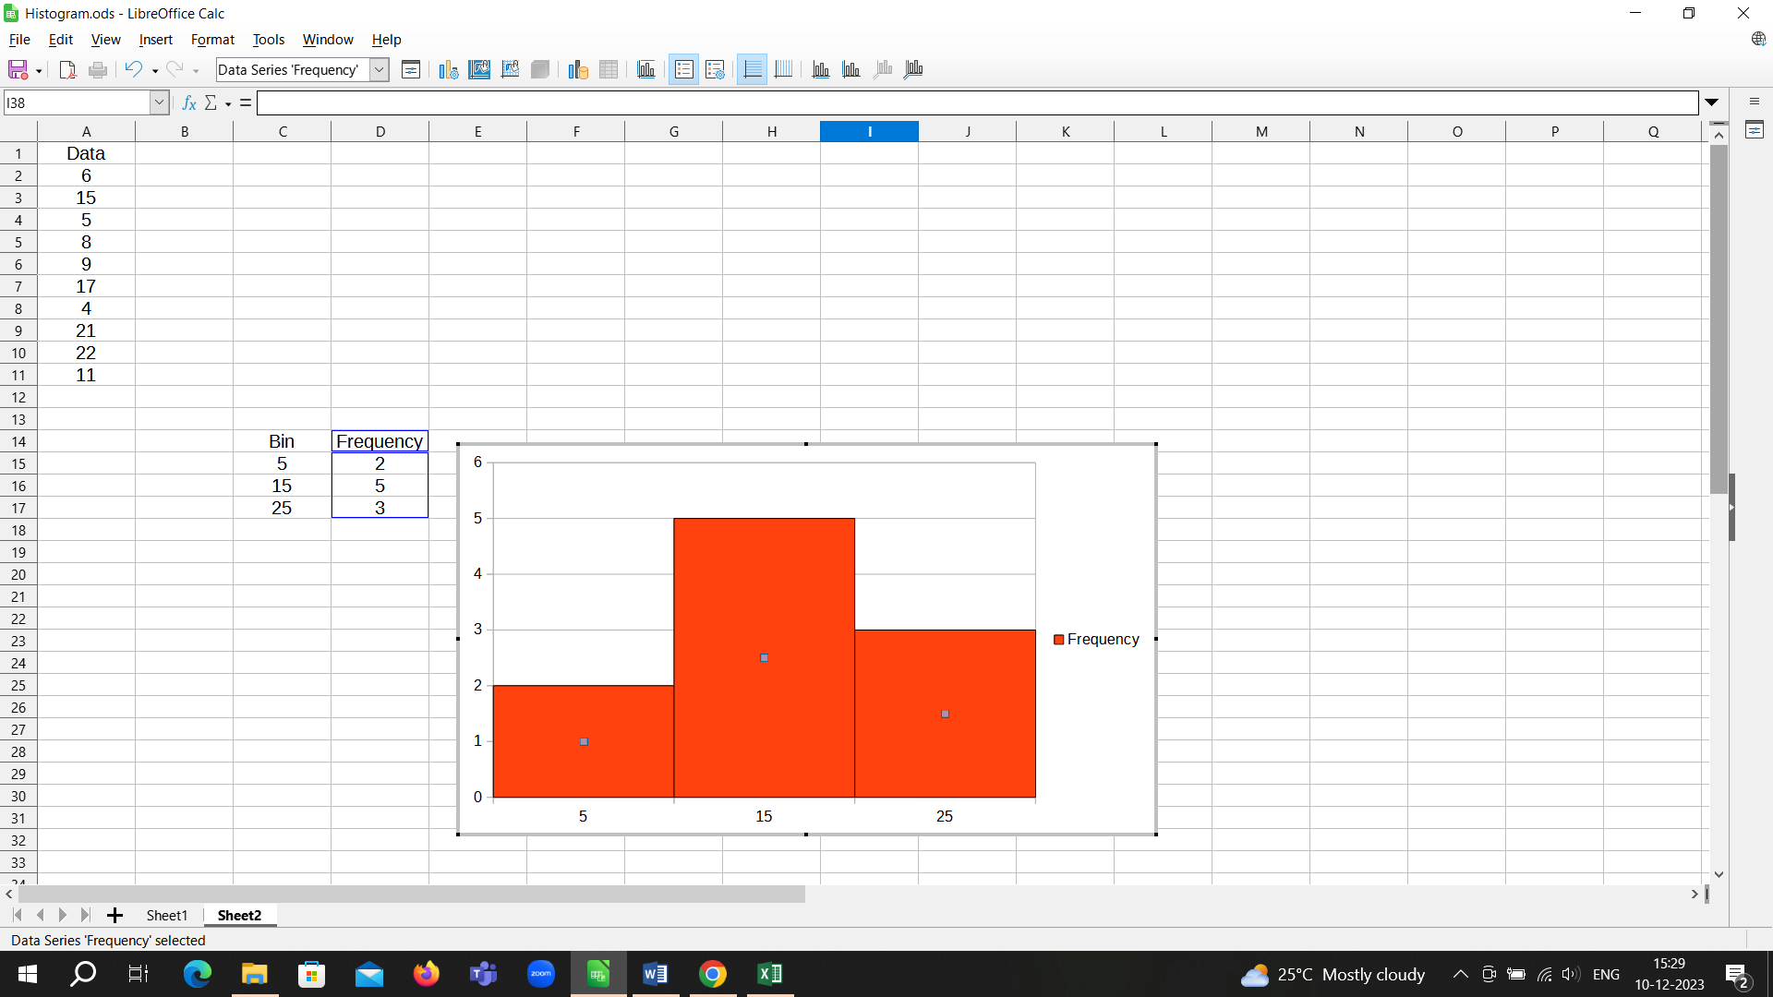

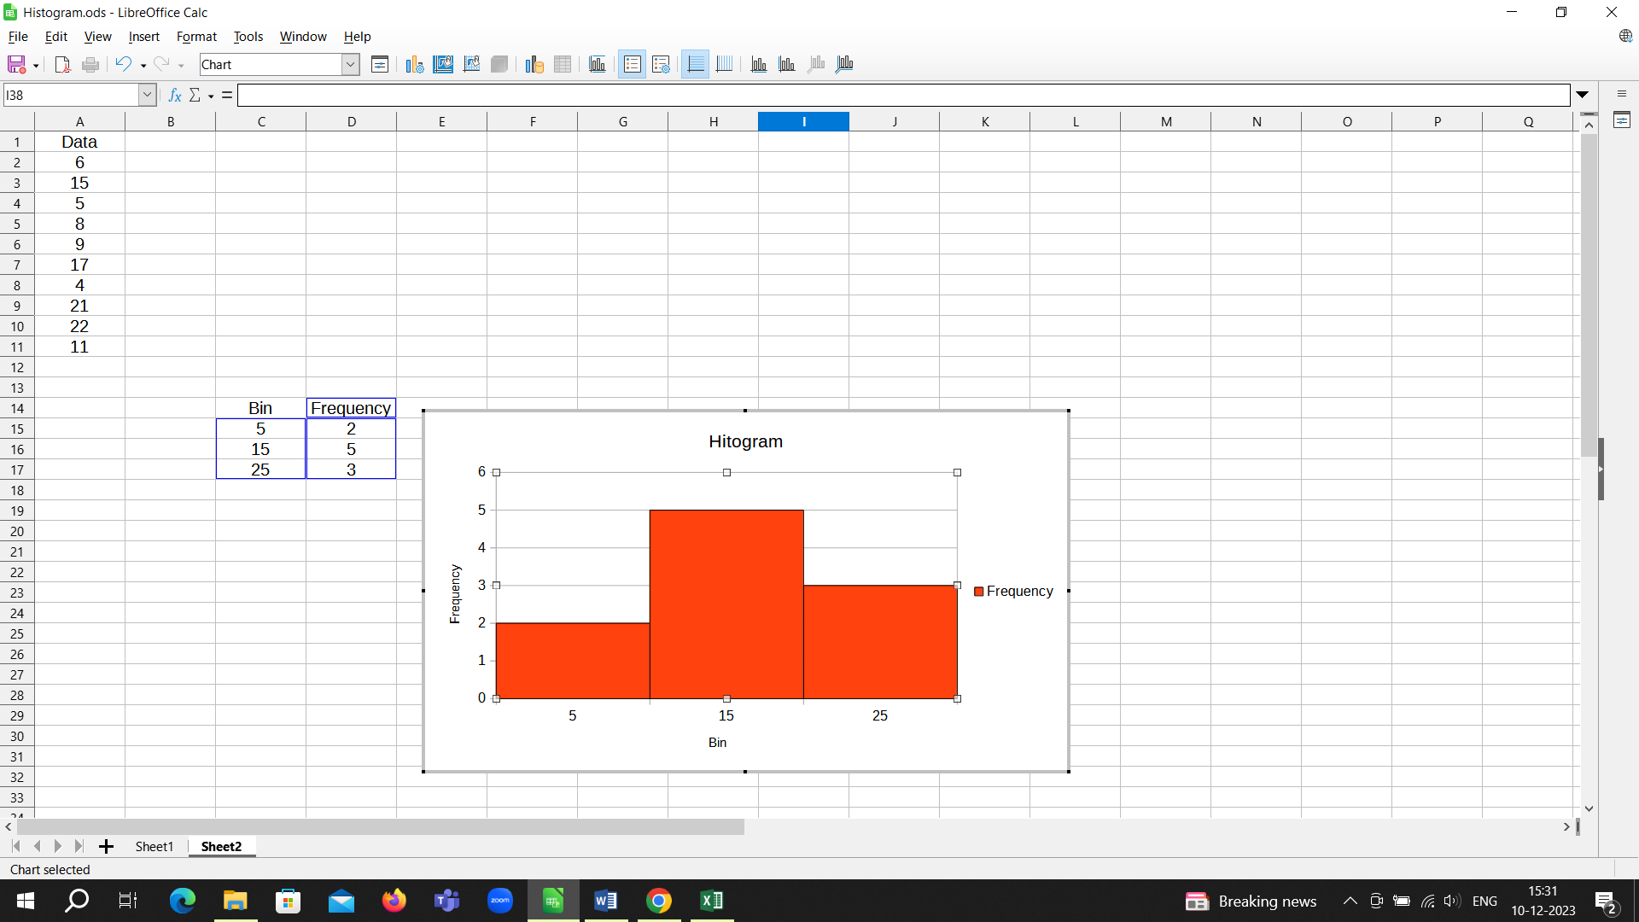

Remove the legend to get the histogram as shown below

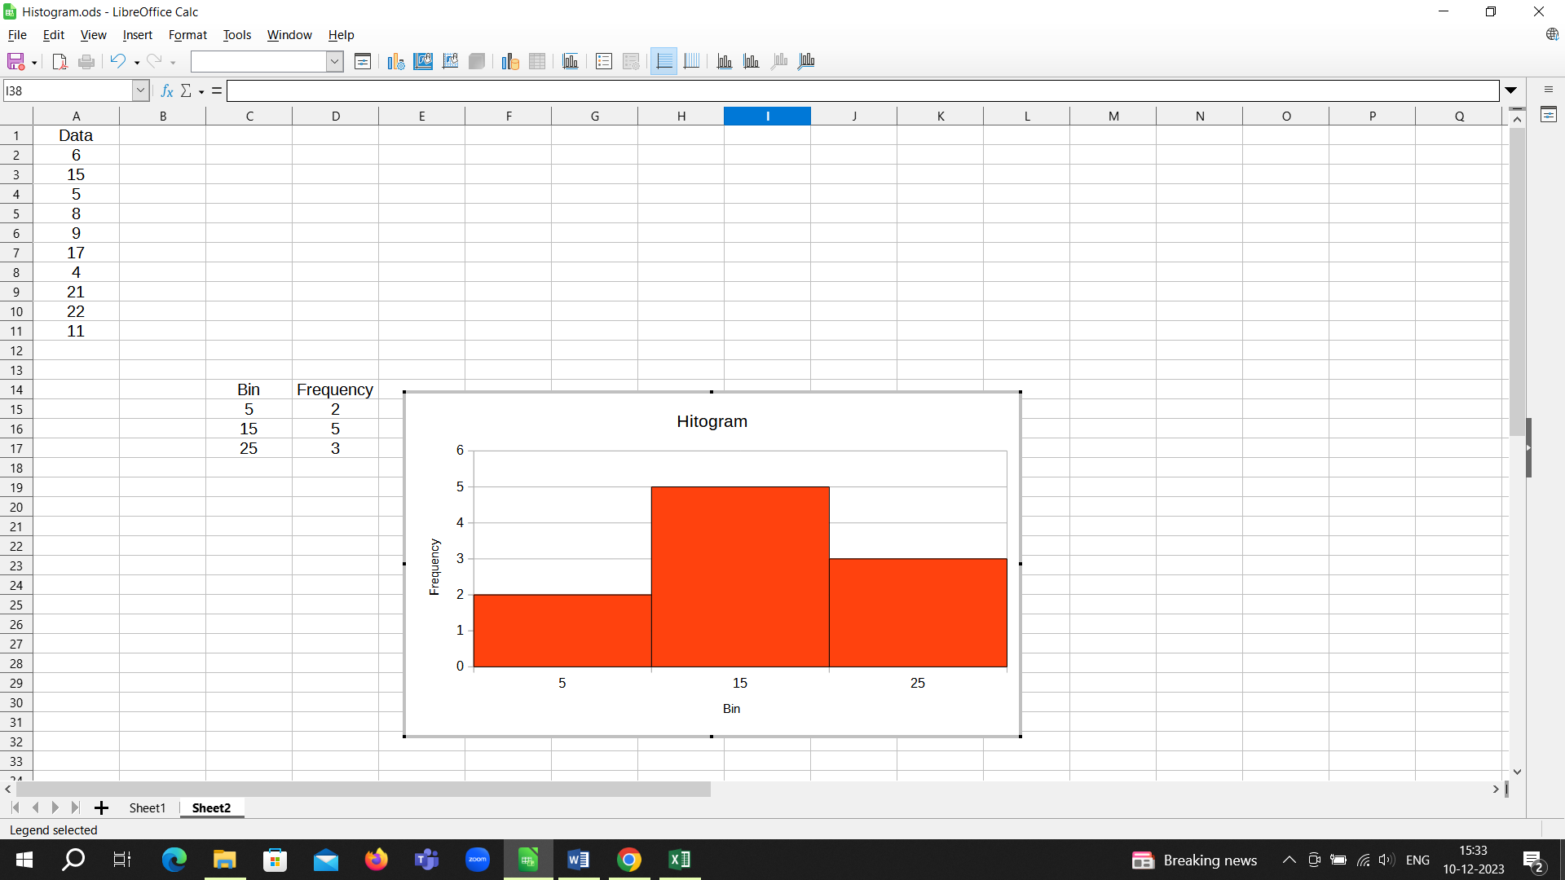

**Question 2**

Using the data given in Question 1, create a pareto chart.

Detailed Solution

Sort the data from Maximum to Minimum

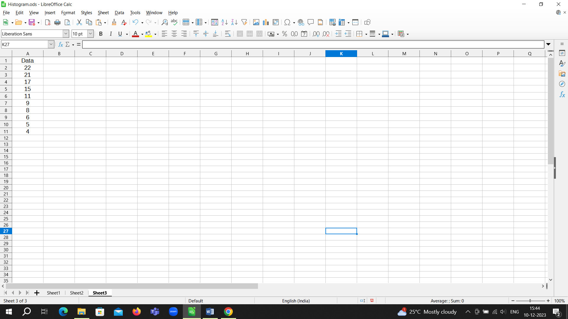

Add a column for cumulative values in % and calculate the same

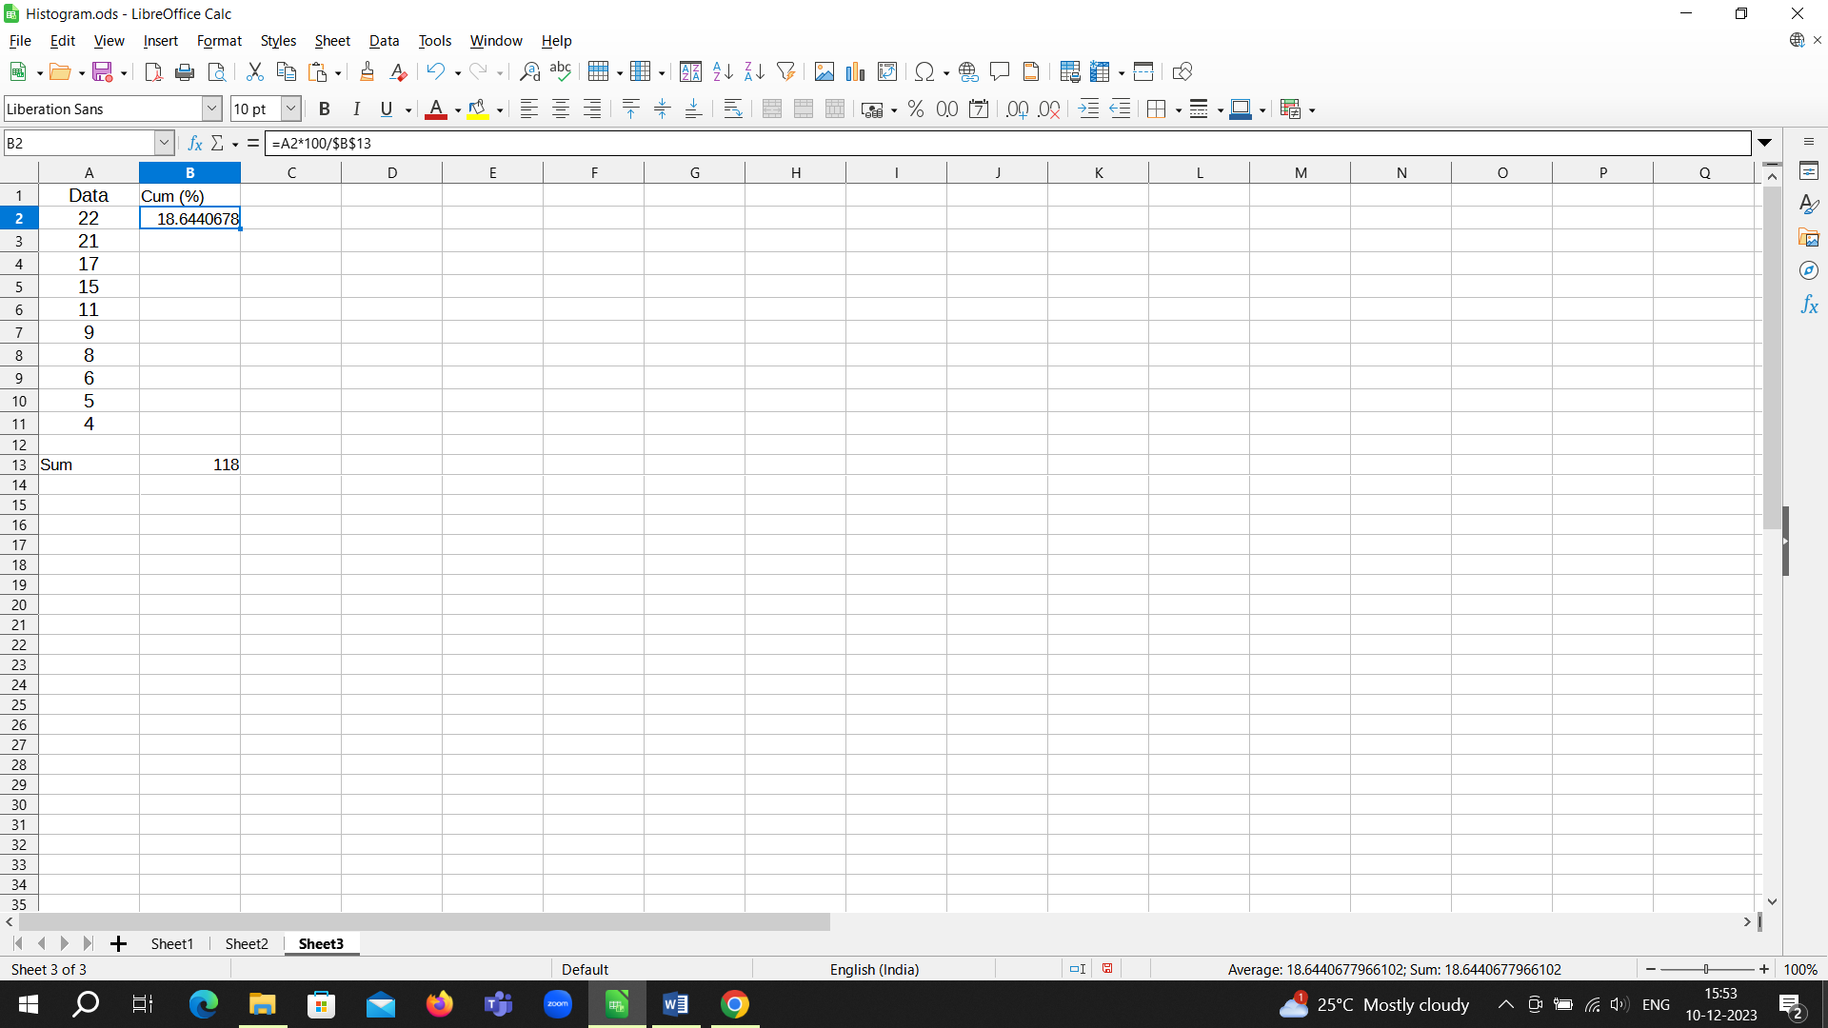

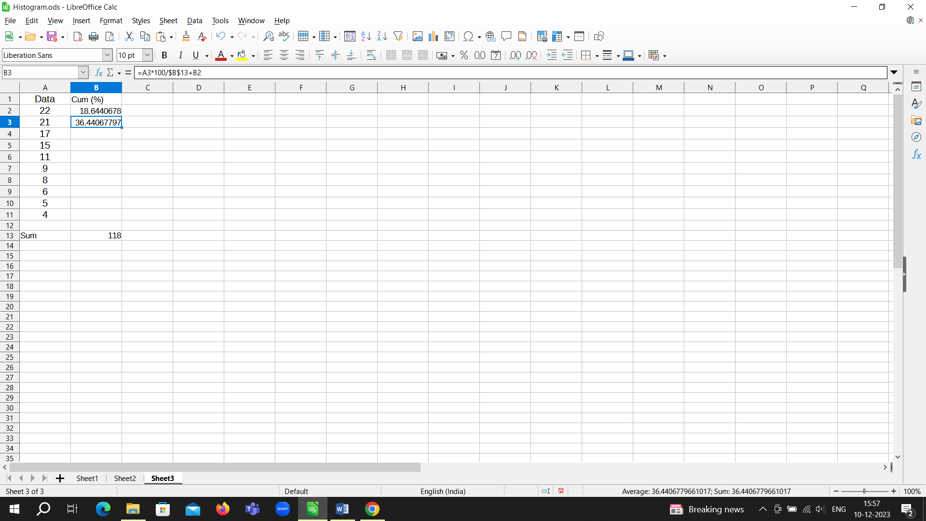

Applying the same to the rest of cells B4 to B11 we get

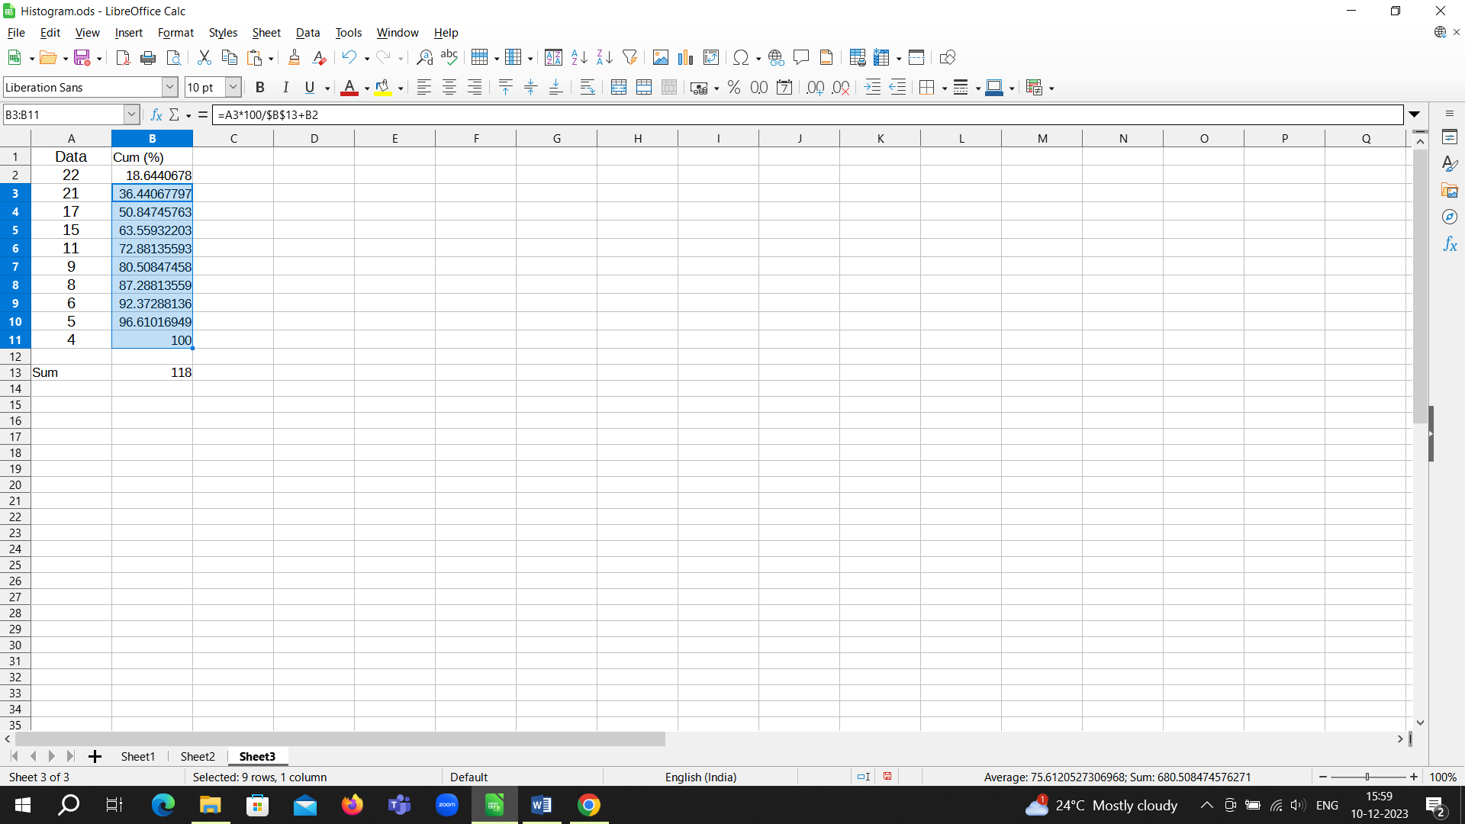

Insert Column charts

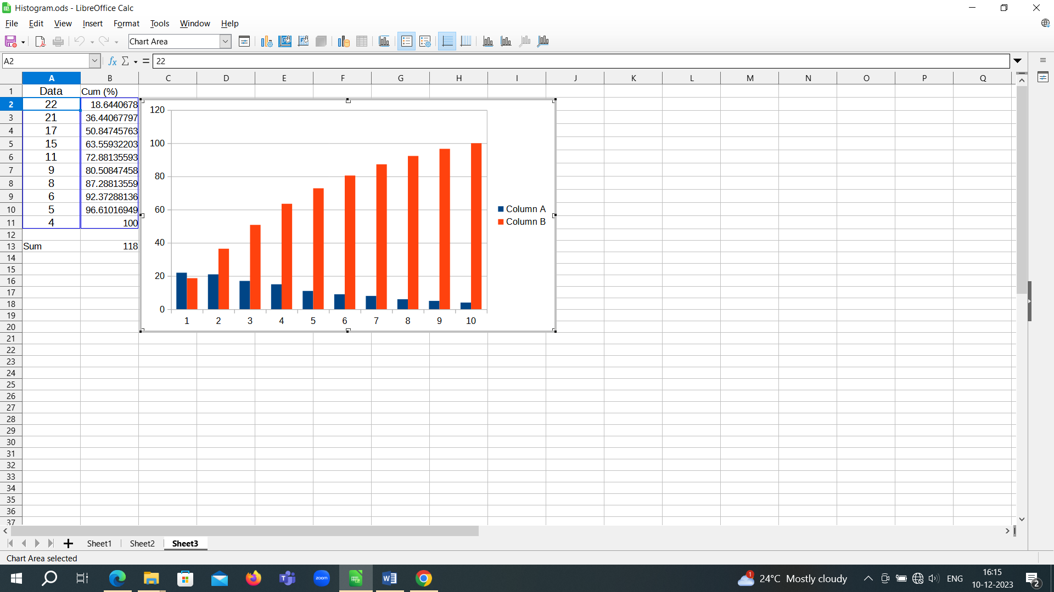

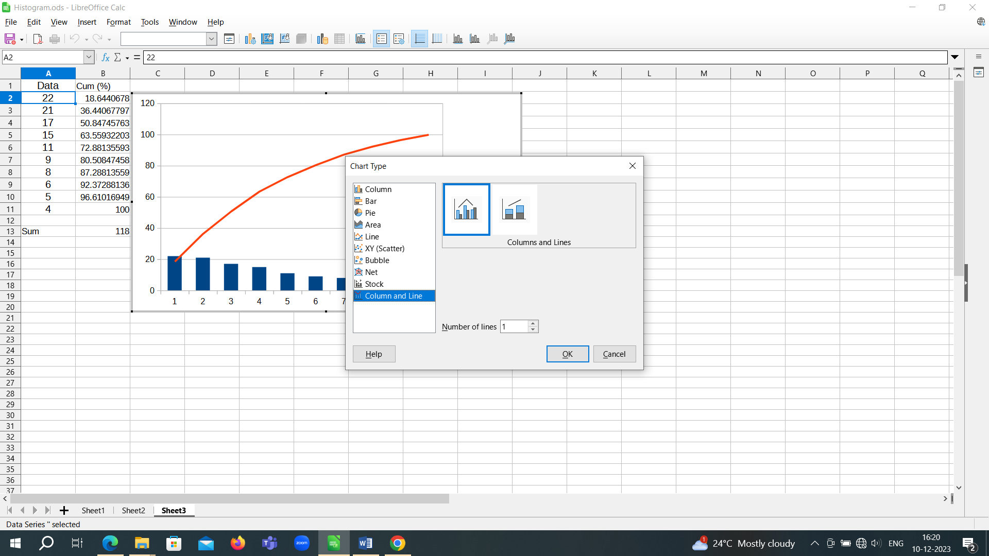

Pareto chart

(please note, axis range has been set from 0 to 100)

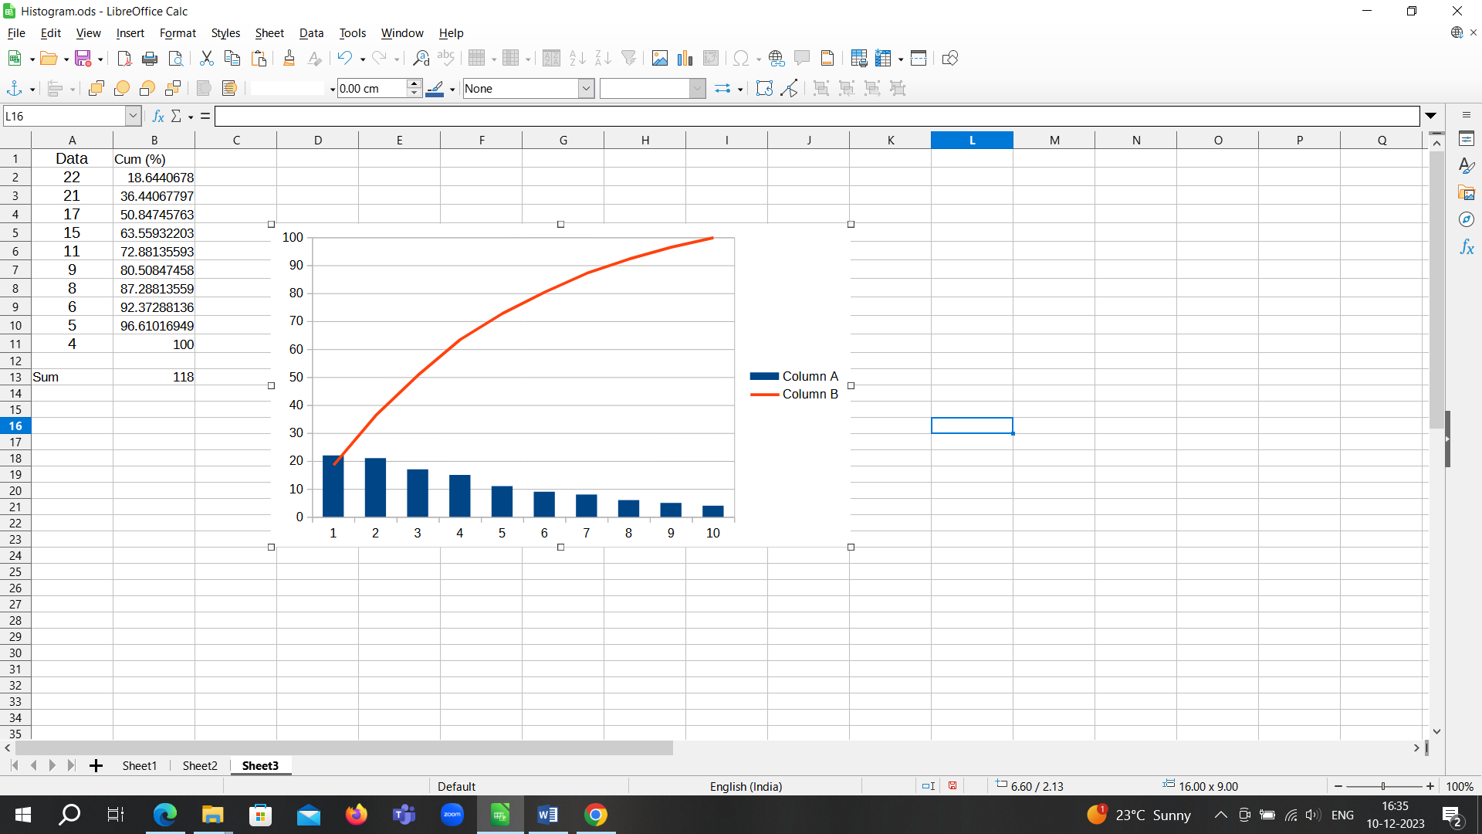

**Question 3**

Use the data set in Qn. 1 to find the descriptive statistics

**Detailed solution**

