Dear Sirs

Please see attached this incredibly large word document.

[](http://www.google.co.uk/url?sa=i&rct=j&q=&esrc=s&source=images&cd=&cad=rja&uact=8&ved=0ahUKEwjn1MudkuPJAhXIwBQKHT57DtUQjRwIBw&url=http://www.logospike.com/logo-image-1704/&psig=AFQjCNFgxs5KhXnj2NJSPbfGZHDdojS7cA&ust=1450450187539566)[](http://www.google.co.uk/url?sa=i&rct=j&q=&esrc=s&source=images&cd=&cad=rja&uact=8&ved=0ahUKEwj30K6ikuPJAhVKOBQKHQWEDy0QjRwIBw&url=http://www.webdesignerdepot.com/2009/05/50-excellent-circular-logos/&psig=AFQjCNFgxs5KhXnj2NJSPbfGZHDdojS7cA&ust=1450450187539566)[](https://www.google.co.uk/url?sa=i&rct=j&q=&esrc=s&source=images&cd=&cad=rja&uact=8&ved=0ahUKEwi9_uWkkuPJAhUBzRQKHXPZACoQjRwIBw&url=https://colorlib.com/wp/all-olympic-logos-1924-2016/&psig=AFQjCNFgxs5KhXnj2NJSPbfGZHDdojS7cA&ust=1450450187539566)[](http://www.google.co.uk/url?sa=i&rct=j&q=&esrc=s&source=images&cd=&cad=rja&uact=8&ved=0ahUKEwij0oiokuPJAhVMOhQKHSKKCdkQjRwIBw&url=http://www.businessinsider.com/ranked-the-best-new-tech-logos-2013-10&psig=AFQjCNFgxs5KhXnj2NJSPbfGZHDdojS7cA&ust=1450450187539566)[](https://www.google.co.uk/url?sa=i&rct=j&q=&esrc=s&source=images&cd=&cad=rja&uact=8&ved=0ahUKEwiOjauqkuPJAhWHvBQKHR-RAKoQjRwIBw&url=https://www.pinterest.com/muttybutt/logos-for-logo-class/&psig=AFQjCNFgxs5KhXnj2NJSPbfGZHDdojS7cA&ust=1450450187539566)

[](http://www.google.co.uk/url?sa=i&rct=j&q=&esrc=s&source=images&cd=&cad=rja&uact=8&ved=0ahUKEwjF_Ze1kuPJAhVMvBQKHRy5C_cQjRwIBw&url=http://www.complex.com/style/2013/03/the-50-most-iconic-brand-logos-of-all-time/target&psig=AFQjCNFgxs5KhXnj2NJSPbfGZHDdojS7cA&ust=1450450187539566)

[](http://www.google.co.uk/url?sa=i&rct=j&q=&esrc=s&source=images&cd=&cad=rja&uact=8&ved=0ahUKEwiYr_nBkuPJAhUI7RQKHcyhD2cQjRwIBw&url=http://lego.wikia.com/wiki/LEGO_logo&psig=AFQjCNFgxs5KhXnj2NJSPbfGZHDdojS7cA&ust=1450450187539566)

[](http://www.google.co.uk/url?sa=i&rct=j&q=&esrc=s&source=images&cd=&cad=rja&uact=8&ved=0ahUKEwjv7q_UkuPJAhWCvBQKHb-ZD1sQjRwIBw&url=http://www.beyondpixels.co.uk/blog/moustache-inspired-logos-movember&psig=AFQjCNFgxs5KhXnj2NJSPbfGZHDdojS7cA&ust=1450450187539566)[](http://www.google.co.uk/url?sa=i&rct=j&q=&esrc=s&source=images&cd=&cad=rja&uact=8&ved=0ahUKEwjTxbHXkuPJAhWENxQKHRw9DxgQjRwIBw&url=http://www.santabanta.com/photos/logos/15607014.htm&psig=AFQjCNFgxs5KhXnj2NJSPbfGZHDdojS7cA&ust=1450450187539566)

[](https://www.google.co.uk/url?sa=i&rct=j&q=&esrc=s&source=images&cd=&cad=rja&uact=8&ved=0ahUKEwiTsYrakuPJAhWLWhQKHWdUC6gQjRwIBw&url=https://gaurangdabhi.wordpress.com/2015/06/27/make-logos-vertically-centered/&psig=AFQjCNFgxs5KhXnj2NJSPbfGZHDdojS7cA&ust=1450450187539566)[](http://www.google.co.uk/url?sa=i&rct=j&q=&esrc=s&source=images&cd=&cad=rja&uact=8&ved=0ahUKEwj1sqrckuPJAhUDXRQKHZJyC-UQjRwIBw&url=http://logos.wikia.com/wiki/Google&psig=AFQjCNFgxs5KhXnj2NJSPbfGZHDdojS7cA&ust=1450450187539566)

[](http://www.google.co.uk/url?sa=i&rct=j&q=&esrc=s&source=images&cd=&cad=rja&uact=8&ved=0ahUKEwijnMbekuPJAhWBnhQKHaP_AgYQjRwIBw&url=http://forwallpapers.com/category/brands-logos/page/11&psig=AFQjCNFgxs5KhXnj2NJSPbfGZHDdojS7cA&ust=1450450187539566)

[](https://www.google.co.uk/url?sa=i&rct=j&q=&esrc=s&source=images&cd=&cad=rja&uact=8&ved=0ahUKEwjtruzikuPJAhWE6RQKHc5rAVYQjRwIBw&url=https://about.twitter.com/press/twitter-brand-policy&psig=AFQjCNFgxs5KhXnj2NJSPbfGZHDdojS7cA&ust=1450450187539566)[](http://www.google.co.uk/url?sa=i&rct=j&q=&esrc=s&source=images&cd=&cad=rja&uact=8&ved=0ahUKEwjqmonokuPJAhUGXRQKHRTxAsAQjRwIBw&url=http://brandongaille.com/list-famous-computer-software-company-logos/&psig=AFQjCNFgxs5KhXnj2NJSPbfGZHDdojS7cA&ust=1450450187539566)

[](http://www.google.co.uk/url?sa=i&rct=j&q=&esrc=s&source=images&cd=&cad=rja&uact=8&ved=0ahUKEwiK0PjrkuPJAhVIUBQKHZ31ADMQjRwIBw&url=http://crazy4images.com/items/different-superman-logos.htm&psig=AFQjCNFgxs5KhXnj2NJSPbfGZHDdojS7cA&ust=1450450187539566)

[](http://www.google.co.uk/url?sa=i&rct=j&q=&esrc=s&source=images&cd=&cad=rja&uact=8&ved=0ahUKEwjgqcPvkuPJAhXH7RQKHQshATwQjRwIBw&url=http://americanfootballfilms.com/nfl-logos/&psig=AFQjCNFgxs5KhXnj2NJSPbfGZHDdojS7cA&ust=1450450187539566)

[](http://www.google.co.uk/url?sa=i&rct=j&q=&esrc=s&source=images&cd=&cad=rja&uact=8&ved=0ahUKEwiko7j0kuPJAhVFshQKHegcB7kQjRwIBw&url=http://www.hongkiat.com/blog/logo-parodies/&psig=AFQjCNFgxs5KhXnj2NJSPbfGZHDdojS7cA&ust=1450450187539566)[](http://www.google.co.uk/url?sa=i&rct=j&q=&esrc=s&source=images&cd=&cad=rja&uact=8&ved=0ahUKEwjmy7D9kuPJAhXHtBQKHWn7Be0QjRwIBw&url=http://shieldtv.net/the-many-logos-of-s-h-i-e-l-d&psig=AFQjCNFgxs5KhXnj2NJSPbfGZHDdojS7cA&ust=1450450187539566)

[](http://www.google.co.uk/url?sa=i&rct=j&q=&esrc=s&source=images&cd=&cad=rja&uact=8&ved=0ahUKEwilvouCk-PJAhXJzxQKHeBBDAgQjRwIBw&url=http://webneel.com/webneel/blog/28-creative-cat-themed-logo-designs-your-inspiration&psig=AFQjCNFgxs5KhXnj2NJSPbfGZHDdojS7cA&ust=1450450187539566)

[](http://www.google.co.uk/url?sa=i&rct=j&q=&esrc=s&source=images&cd=&cad=rja&uact=8&ved=0ahUKEwj109aGk-PJAhXEThQKHR7pAKoQjRwIBw&url=http://voragine.net/diseno/logos-para-la-iniciativa-escudo-antimercados-del-15o&psig=AFQjCNFgxs5KhXnj2NJSPbfGZHDdojS7cA&ust=1450450187539566)

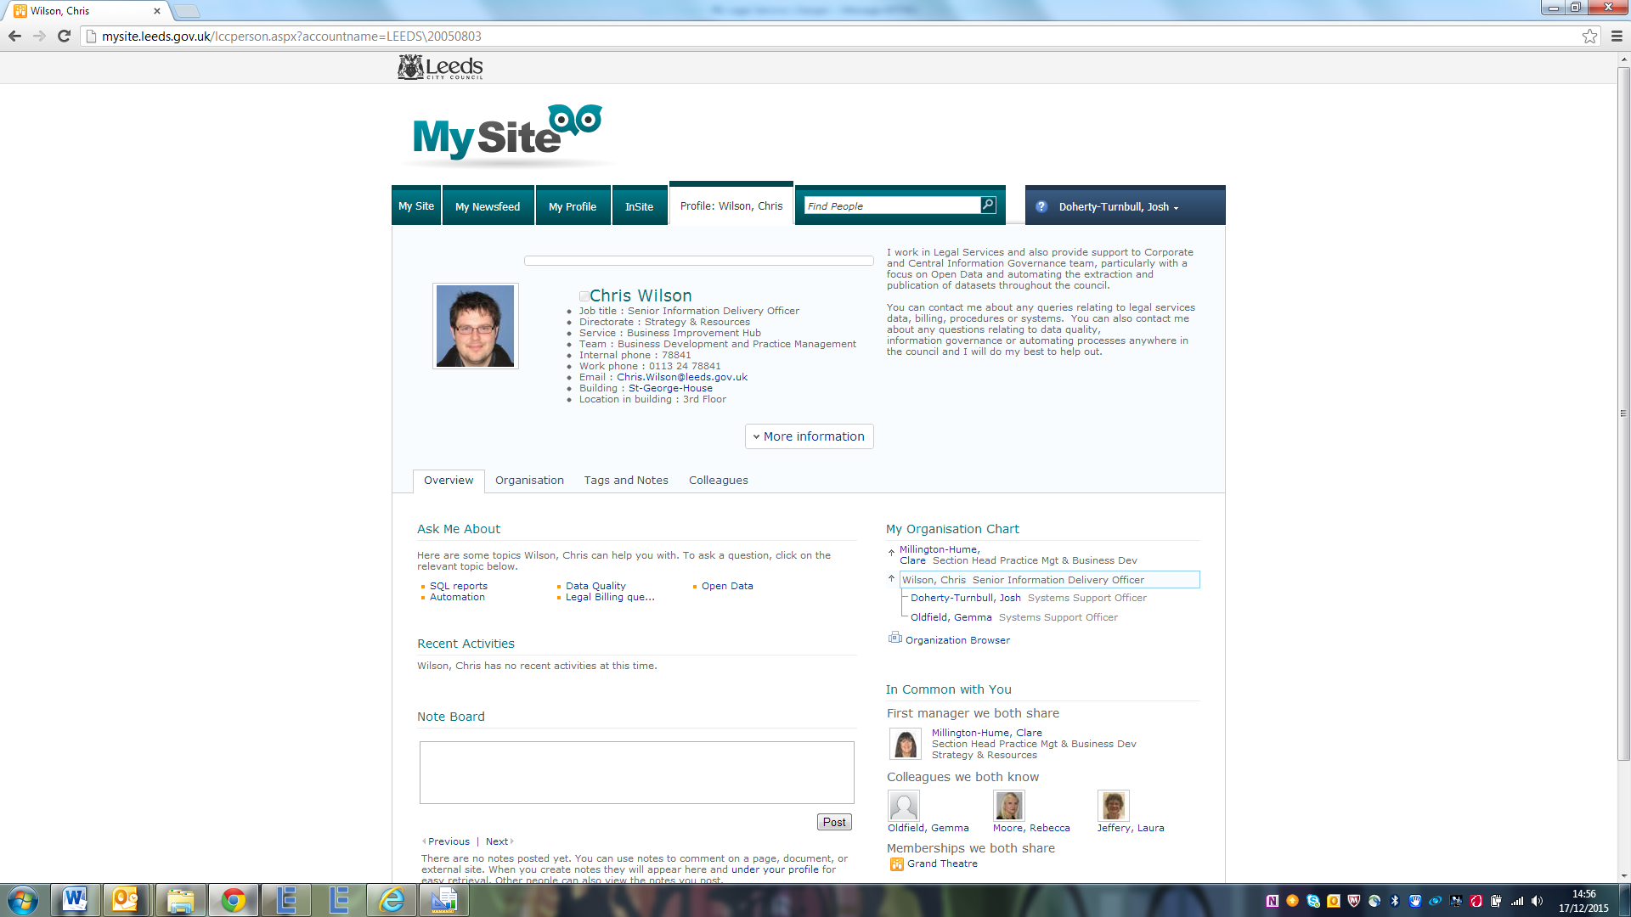



[](http://www.google.co.uk/url?sa=i&rct=j&q=&source=imgres&cd=&cad=rja&uact=8&ved=0ahUKEwiN-P-ymuPJAhXKPBQKHUtBDj4QjRwICTAA&url=http://www.classicfm.com/composers/beethoven/guides/reasons-love-beethoven/&psig=AFQjCNEfzTSRCb2Ao-Wno4nNpP-QUnOxoA&ust=1450452402609633)

Kind Regards

JDT

[](http://www.google.co.uk/url?sa=i&rct=j&q=&esrc=s&source=images&cd=&cad=rja&uact=8&ved=0ahUKEwiq96fjmuPJAhXFbhQKHaDAAhkQjRwIBw&url=http://www.eastcottvets.co.uk/77/Kitten_Vaccination_Prices/&bvm=bv.110151844,d.d24&psig=AFQjCNGRoM3ut9UbjxY_2NBbhstUdM7_zA&ust=1450452491277902)[](http://www.google.co.uk/url?sa=i&rct=j&q=&esrc=s&source=images&cd=&cad=rja&uact=8&ved=0ahUKEwjFwpnomuPJAhUEaRQKHYwQBJUQjRwIBw&url=http://adorablekittens.com/the-11-greatest-cosplay-cats-of-all-time/&bvm=bv.110151844,d.d24&psig=AFQjCNGRoM3ut9UbjxY_2NBbhstUdM7_zA&ust=1450452491277902)[](http://www.google.co.uk/url?sa=i&rct=j&q=&esrc=s&source=images&cd=&cad=rja&uact=8&ved=0ahUKEwisoPrqmuPJAhWISBQKHYNlDYcQjRwIBw&url=http://dreamatico.com/kitten.html&bvm=bv.110151844,d.d24&psig=AFQjCNGRoM3ut9UbjxY_2NBbhstUdM7_zA&ust=1450452491277902)[](http://www.google.co.uk/url?sa=i&rct=j&q=&esrc=s&source=images&cd=&cad=rja&uact=8&ved=0ahUKEwjSi9TwmuPJAhXL8RQKHbwqAo4QjRwIBw&url=http://www.petscorner.co.uk/petopedia/all-about-kittens/&bvm=bv.110151844,d.d24&psig=AFQjCNGRoM3ut9UbjxY_2NBbhstUdM7_zA&ust=1450452491277902)

Book One: 1805

CHAPTER I

WELL, PRINCE, so Genoa and Lucca are now

just family estates of the Buonapartes. But I

warn you, if you don't tell me that this means

war, if you still try to defend the infamies and

horrors perpetrated by that Antichrist I real-

ly believe he is Antichrist I will have nothing

more to do with you and you are no longer my

friend, no longer my 'faithful slave,' as you

call yourself! But how do you do? I see I have

frightened you sit down and tell me all the

news."

It was in July, 1805, and the speaker was the

well-known Anna Pdvlovna Sch^rer, maid of

honor and favorite of the Empress Marya Fe-

dorovna. With these words she greeted Prince

Vasili Kurdgin, a man of high rank and impor-

tance, who was the first to arrive at her recep-

tion