**Team Phoenix -**

**Login-based Coffee Machine using RazorPay API**

**Team Members :**

* Abhirup Mazumder
* Rohan Bhattacharjee
* Debjyoti Ghosh
* Suddhasatta Biswas

**Case Study :**

Infosys has bought a new login-based coffee machine for their Senior employees exclusively. The coffee machine is placed in their Cafeteria on the 3rd Floor. They are assigned a QR Code attached with their details that are being verified. After successful verification, the transaction is processed.

**Solution:**

Our model deals with the transaction of the new coffee machine in the office’s cafetaria, where a QR code assigned to the employees will get scanned and verified. After verification, the employee’s details as well as the payment details will be displayed and confirmed. It is then redirected to the payment portal, where the transaction is done using Razorpay API.

**Technologies We used :** Python , JSON, HTML, Tkinter

**Steps to Operate:**

**Step 1** The login screen opens as shown :   
 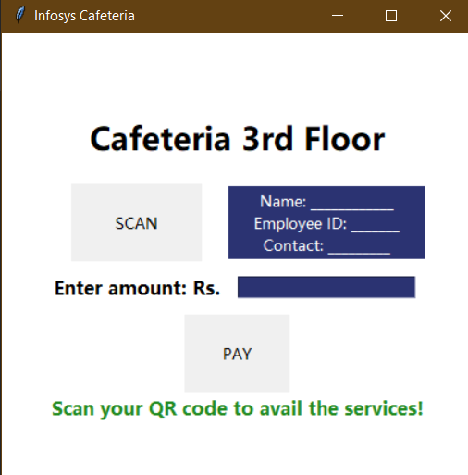

Press the SCAN button and scan your assigned QR Code.

* **Step 2**

Upon successful verification the screen appears as :  
  
 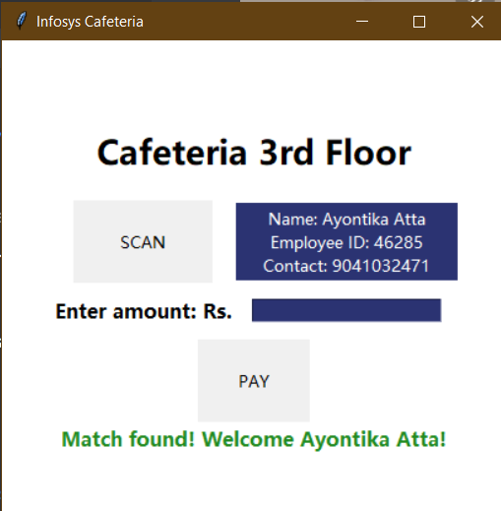

For unverified profiles, an error message is shown.  
 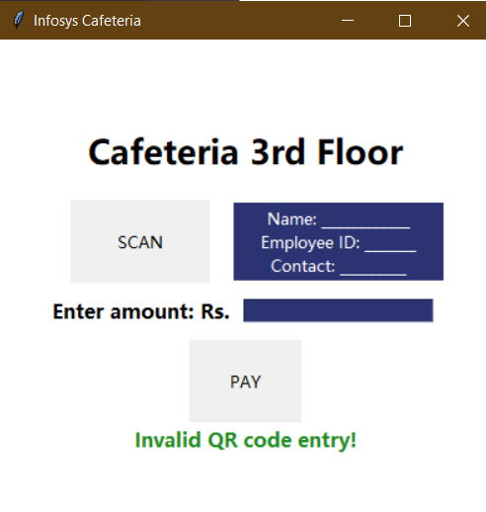

* **Step 3**

Enter the amount to be paid and press PAY

* **Step 4**

A Web Page opens with the details associated with the QR Code.

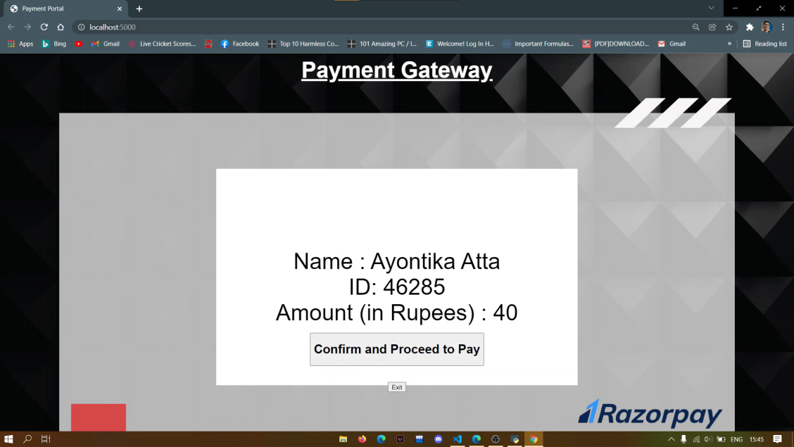

After confirming the details, press **Confirm and Proceed to Pay**

* **Step 5**

The Payment Portal appears.

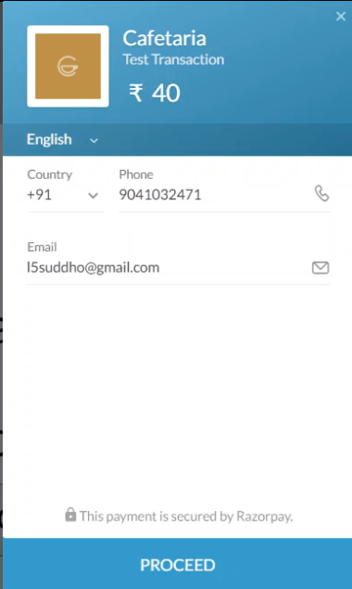

Press **Proceed** and continue the transaction with your preferred payment method.

* **Step 6**

After successful transaction, press **Exit** and return to the main screen