**Paper 6**

**Author Name:** Malay Kishore Dutta , Ashish Issac , Navroj Minhas, Biplab Sarkar

**Title:** Image processing based method to assess fish quality and freshness

**Reference Number:** http://dx.doi.org/10.1016/j.jfoodeng.2015.12.018

**Method used:** Image processing

* Gill colour used as freshness indicator
* Rohu gill
* Segmentation of the gills from the fish image:

RGB -> XYZ -> Lab colour space

K-means clustering algorithm works in 2 steps:

Assignment: total observations are divided into clusters such that the within cluster sum of squares is minimized

Update: a new mean is calculated for every cluster formed.

3 clusters are formed

* Feature extraction from red channel in the wavelet transformation domain using Haar filter.

First, second and third level decomposition * in the wavelet domain is performed.

The colour of the gill being reddish brown colour has maximum information stored in the red channel

Spatial domain: limited to pixel intensity values

Wavelet transform domain: spatial + frequency

Haar filter to decompose image to coefficients.

* Feature analysis:

The statistical features of coefficients (mean and standard deviation) obtained at each level.

The features extracted from horizontal coefficient at level 3 for all days of observation are analysed for the variation pattern.

* **

Freshness Range 1, FR1 = FL0 - FL1; Most fresh

Freshness Range 2, FR2 = FL1 - FL2; Moderate fresh

Freshness Range 3, FR3 = FL2 - FL3; Least Fresh

where,

FL0 = Lowest value of the statistical parameter of all the samples at day 1.

FL1 = Lowest value of the statistical parameter of all the samples at day 2.

FL2 = Lowest value of the statistical parameter of all the samples at day 4

FL3 = Lowest value of the statistical parameter of all the samples at day 6.

* A reference level is calculated in each freshness range, which can be considered as tolerance for each range:

Ref level for FR1, R1 = (FL0 + FL1)/2;

Ref level for FR2, R2 = (FL1 + FL2)/2;

Ref level for FR3, R3 = (FL2 + FL3)/2;

* When a new sample is fed to system:

M and SD in same range: Range defines

M and SD in different range: for both the statistical parameters the distance from the reference level is considered to decide.

**Accuracy:** 95.833%

**Time complexity:**

**Structural/model complexity:**

**Conclusion:**

**Improvements possible:**

Apply to type, genetical status, resistance to environmental stress, gill colour pattern of fish.

Consider toxicant residue, pathogenic load and habitat quality within a single fish for analysis.

A bar code based optical device can be designed using this gill imaging analysis tool. It will be handy and time bound.

**Paper 7**

**Author Name:** S Agustin, R Dijaya

**Title:** Beef Image Classification using K-Nearest Neighbour Algorithm for Identification Quality and Freshness

**Reference Number:** 10.1088/1742-6596/1179/1/012184

**Method used:**

* Pre-processing:

Convert RGB to HSI (more suitable for image processing):

Separate RGB channels

Normalize RGB to produce mean value of RGB normalization

Convert to HSI: Hue Saturation Intensity

HSI -> Grayscale image -> Binary image

* Feature extraction:

Thresholding process: the separation of pixels based on the grey level owned.

Image segmentation/edge detection: to increase the appearance between the boundary line of an area or object in the image.

Find GLCM

GLCM: Gray Level Co-Occurrence Matrix

Matrix for storing the frequency value of the difference in brightness between one pixel

and the surrounding pixels that occur in an image.

Stores information about grey intensity between two pixels separated by

q (angle) as direction

d as distance.

* Classification: KNN algorithm

The proximity or distance of the neighbour is usually calculated based on Euclidian distance

**Accuracy:** 91.0667%

**Time complexity:**

**Structural/model complexity:**

**Conclusion:**

**Improvements possible:**

Other pre-processing approach and other feature extraction methods are needed.

Other classification algorithms based on neurons, genetics or evolution can be tried to optimize the classification results of these features.

**Paper 8**

**Author Name:** Calvin , Ghiri Basuki Putra, Esa Prakasa

**Title:** Classification of Chicken Meat Freshness using Convolutional Neural Network Algorithms

**Reference Number:**

**Method used:** Convolutional Neural Networks

* Image acquisition

Chicken breast image

Fresh image: 6-8 hours

Stored in room in covered container (has air holes)

Rotten image: 21-23 hours

* Image pre-processing

OpenCV library used

RGB to Grayscale

Grayscale to Binary with a thresholding process using the Otsu method:

Calculate threshold T

T is expressed in the range 1 to 255

Binary image used only to find coordinate points that have a pixel value area with a value of 255

From the obtained coordinates, the RGB image was cropped and saved to be used as a dataset in this study

Normalization process: each chicken meat image has a pixel value with a value range of 0 to 1 to obtain a stable dynamic value range

Augmentation process: rotating the chicken meat image in the dataset by 30◦

* Image classification using CNN

4 CNN architectures are used: AlexNet, VGGNet, GoogLeNet and Ayam6Net.Ayam6Net gives the best accuracy

Ayam6Net:

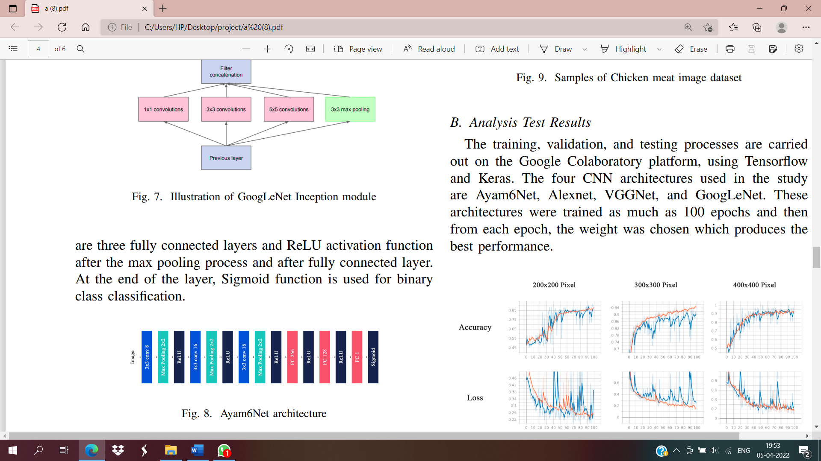

Self-made

3 CNN layers -> max pooling -> ReLU activation function

-> Sigmoid function for binary class classification

* Analysis

80% for training data, 10% for validation data, and 10% for testing data.

The training, validation, and testing processes are carried out on the Google Colaboratory platform, using Tensorflow and Keras.

The 4 CNN architectures were trained as much as 100 epochs and then from each epoch, the weight was chosen which produces the best performance.

**Accuracy:**

Ayam6Net: 92.9%

AlexNet: 50.5%

VGGNet: 50.5%

This probably happens cause AlexNet and VGGNet are suitable for complex and numerous image datasets, but not for simple and few image datasets.

GoogLeNet: 91.5% (300 x 300 pixel)

**Time complexity:**

**Structural/model complexity:**

**Conclusion:**

**Improvements possible:**

**Paper 9**

**Author Name:** Jun JIAO, Wenzhou WANG, Jinbo Hou, Pei SUN, Yutong HE, Lichuan GU

**Title:** Freshness Identification of Iberico Pork Based on Improved Residual Network and Transfer Learning

**Reference Number:**

**Method used:**

* The pork images were classified into fresh, secondary fresh grade I, secondary fresh grade II, secondary fresh grade III, deteriorated grade I, deteriorated grade II and deteriorated grade III, a total of 7 grades, according to the aerobic plate count, coliform bacteria and pH value of pork combined with national pork food standards.
* Image acquisition:

224 x 224 , 11 KB

* Augmentation:

Affine transformation, perspective transformation and image rotation

Increase the diversity of data, avoiding over-fitting

* Deep Residual Neural Network (ResNet):

Resnet-50 deep residual network was used as the feature extractor of the images to learn the abstract features of the images.

* Transfer Learning:
* When we don’t have enough data to train deep neural networks, we use transfer learning.
* AAUSet (big dataset) was used for the pre-training of ResNet-50 network to make it have the ability to extract image features.
* The trained network parameters were used as the initial parameters for our network model.
* ResNet-50 network was improved based on the ideas of model transfer and model fine tuning.

Replace the full connection layers and classification layers of the Resenet-50 model with a 3-layer adaptive network

initialize the improved Resenet-50 model weights using the network parameters trained on the AAUSet

Use LReLU as the activation function of the adaptive network.

* The images of 7 grades of pork were used for the fine-tuning of the improved ResNet-50, so that it can automatically classify the freshness images of pork.

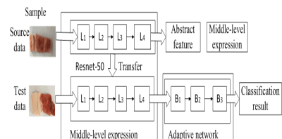

* + B1: 1000 neurons

B2: 256 neurons and Dropout=0.8

B3: 7 neurons

Activation function of each layer of neurons adopted LReLU, which realized the nonlinear mapping of features

**Accuracy:** 94.5%

**Time complexity:**

**Structural/model complexity:**

**Conclusion:**

**Improvements possible:**

**Paper 10**

**Author Name:** Danika Trientin, Bambang Hidayat, Sjafril Darana

**Title:** Beef Freshness Classification by Using Color Analysis, Multi-wavelet Transformation, and Artificial Neural Network

**Reference Number:**

**Method used:**

* Pre-processing:

RGB -> HSV colour space (Hue, Saturation, Value) to see the difference of its brightness.

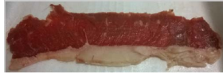 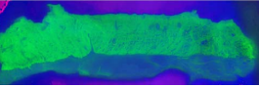

Thresholding to separate the background and the beef image to distinguish the beef from the background itself.

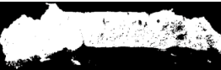

The next step is matrix multiplying from HSV image and the image resulted from thresholding process.

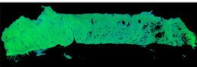

* Feature extraction:

Method used: GHM Multi-wavelet Transformation. But this can only process a square matrix of pixels. Hence normalization is done. Image is segmented to small square block size.

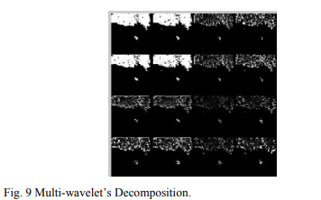

* Make an array from all square blocks, and we get the feature of multi-wavelet process
* Histogram can show the red-colour differences.
* All parameters resulted from multi-wavelet and histogram feature extraction will be used to classify beef freshness into 3 classes.

Class 1: day 1, 2, 3

Class 2: day 4, 5

Class 3: day 6, 7

* Classification: Nearest Neighbour Classification and Back-propagation Neural Network Classification.

**Accuracy:** 75% accuracy by using NN classification with computation time in 10.683 second.

71.4286% using backpropagation with the computation time 15.800086 second.

**Time complexity:**

**Structural/model complexity:**

**Conclusion:**

**Improvements possible:**

Color analysis for the next time should be more sensitive.

The size of pixels should be bigger to get the more sensitive system.

Try another feature extraction process to improve the feature quality.