**Paper - 11**

**Author Name:** Nachiketa Hebbar

**Title:** Freshness of Food Detection using IoT and Machine

Learning

**Reference Number:** https://ieeexplore.ieee.org/abstract/document/9077712/

**Method Used:** IOT and Machine Learning (Logistic Regression)

**Summary:**

* Principle

The detection of whether or not a food item is spoilt or not is made using the following two principle:

i) Oxygen Level Detection: The underlying theory is that if food item ,say fruits or meat , is inhabited by germs ,the oxygen levels in the immediate surrounding is going to be lower than it normally is.

ii) Ammonia Gas: Meat items like fish, are known to release ammonia gases when they go stale.

* Methodology

i) Sensor monitors the food quality.

ii) Machine learning model uses trained model to predict if the given food item is spoilt or not

iii) Node Mcu (microcontroller) sounds a buzzer when it encounters a spoilt food item.

iv) Number of spoilt food occurrences can be monitored and machine learning model can be deployed again to predict average shelf life.

* Learning Algorithm

i) Logistic Regression is used as it performs best in the given dataset with mean squared error = 0.0.

ii) The output class are binary: ‘Spoilt’, ‘Not Spoilt’.

iii) We obtain the given food item probabilities of being spoilt for different days.

**Accuracy**: 100% (MSE = 0.0 as mentioned in the paper)

**Time Complexity:** (As per Logistic Regression)

Training - O( N * D )

Runtime - O(D)

Where, N = Number of Data Points and D = Number of Features

**Space Complexity:** (As per Logistic Regression)

Runtime - O(D)

**Further Improvements:**

The machine learning model is highly dependent upon the dataset the author is using as mentioned in the paper conclusion so there could be a chance of overfitting. More datas need to be gathered for further improvements.

**Paper - 12**

**Author Name:** Cheng-Ta Chiang and Lian-Teng Lin

**Title:** A CMOS Fish Freshness to Continuous-Time Incremental Sigma-Delta Modulator for Monitoring Fish Freshness in Fish Markets

**Reference Number:** https://ieeexplore.ieee.org/document/8816201

**Method Used:** IOT with Continuous-Time Incremental Sigma-Delta Modulator (CT-ISDM)

**Summary:**

* Principle

i) A CMOS fish freshness to continuous-time incremental sigma-delta modulator for monitoring fish freshness in fish markets is proposed.

ii) The chip is fabricated in the TSMC 0.35 m 2P4M CMOS technology with 3.0 V power supply.

iii) By using MATLAB and SPICE programs, all the performance and functions of the proposed fish freshness to continuous-time incremental sigma-delta modulator have been correctly verified and proven in simulations.

iv) The chip size is 1.26 × 2.69 mm2. The proposed chip is aimed to be applied in detecting fish freshness in fish markets.

**Accuracy**: Not Given

**Time Complexity:** Not GIven

**Space Complexity:** Not GIven

**Further Improvements:** Not Given

**Paper - 13**

**Author Name:** Assia Arsalane, Abdessamad Klilou, Noureddine El Barbri, Abdelmoumen Tabyaoui

**Title:** Artificial vision and embedded systems as alternative tools for evaluating beef meat freshness

**Reference Number:** https://www.semanticscholar.org/paper/Artificial-vision-and-embedded-systems-as-tools-for-Arsalane-Klilou/5db516d1044b04cffa8e950359d8151ad3ba72e0

**Method Used:** Artificial Vision, SVM and Neural Network

**Summary:**

* Principle

i) This paper reports a synthesis of recent research about beef meat freshness based on color and texture features using the artificial vision technique.

ii) This technique is based on a computer system for data processing, it can easily be affected by processor speed and computer stability.

iii) It was necessary to develop a portable device that can be rapid, reproductive, inexpensive and easy to use for beef meat freshness evaluation.

* Methodology

i) Meat samples preparation - Fresh cut beef were placed in plastic boxes and kept under cold storage at 4 ± 1°C for nine days.

ii) Embedded system description - The proposed embedded system contains four principal systems: the illumination system, the processing system, the image acquisition system and the display system.

iii) Image processing using color features - In order to measure changes of color in beef meat surface, parameters of beef meat HSI images captured during nine days were used to build the classification models.

iv) Image processing using texture features.

v) Principal Component Analysis (PCA) - Technique for reducing the dimensionality of datasets, increasing interpretability but at the same time minimizing information loss.

vi) Classification techniques applied.

* Learning Algorithm -

i) Support Vector Machines (SVM) - SVMs were originally designed for binary classification. Since in this application meat freshness classification and identification is a multi-class problem, a combination of binary classifiers is required.

ii) Probabilistic Neural Network (PNN) - PNN is presented as an implementation of the Bayes decision rule as a neural network, based on maximum probability classifiers. A typical PNN is composed of an input layer, a layer of patterns or target classes (hidden layer) and an output layer.

iii) Linear Discriminant Analysis (LDA) - LDA as a supervised pattern recognition method utilized for predictive technical analysis. It aims for explaining and predicting the membership of an individual to a predefined class (group) based on his indicators measured using predictive variables.

* Results

i) Using SVM and PCA - Classification Rate is 100% and Accuracy Rate is 98.81%.

ii) Using PNN and PCA - Classification Rate is 93.83% and Accuracy Rate is 87.65%.

iii) Using LDA and PCA - Classification Rate is 82.72% and Accuracy Rate is 80.25%.

**Accuracy**:

SVM - Accuracy Rate is 98.81%

PNN - Accuracy Rate is 87.65%

LDA - Accuracy Rate is 80.25%

**Time Complexity:**

i) PCA

ii) SVM -

* Training = O( N^2 ) [ N = #Train Data Points ]
* Runtime = O( K x D ) [ K = #Support Vectors, D = #Features ]

iii) PNN -

* Training = O(n^2 + nEW^3 ) [ N = #Test Data Points, W = #adaptive parameters in the ANN, E = #training epochs]
* Runtime = O( W + N ) [ N = #Runtime Data Points, W = #adaptive parameters in the ANN ]

ii) LDA -

**Space Complexity:**

**Further Improvements:**

The model permits detecting external features, but not internal characteristics. Also, for embedded systems, there are still some challenges in the optimization of the existing processing algorithms and the development of novel ones suitable for processors. This is highly required in order to permit the material miniaturization and the real time assessment of meat quality.

**Paper - 14**

**Author Name:** Erika Carlos Medeiros, Leandro Maciel Almeida and José Gilson de Almeida Teixeira Filho

**Title:** Computer Vision and Machine Learning for Tuna and Salmon

Meat Classification

**Reference Number:** https://www.mdpi.com/2227-9709/8/4/70/pdf

**Method Used:** Computer Vision

**Summary:**

* Principle

i) This paper presents a solution to inspect tuna and salmon meat from digital images. The solution proposes hardware and a protocol for preprocessing images and extracting parameters from the RGB, HSV, HSI, and L*a*b* spaces of the collected images to generate the datasets.

ii) We evaluated the AutoML models to classify the freshness levels of tuna and salmon samples through the metrics of: accuracy, receiver operating characteristic curve, precision, recall, f1-score, and confusion matrix (CM).

iii) Computer vision and machine learning, as a nondestructive method, were viable for external quality detection of tuna and salmon meat products through its efficiency, objectiveness, consistency, and reliability due to the experiments’ high accuracy.

* Background

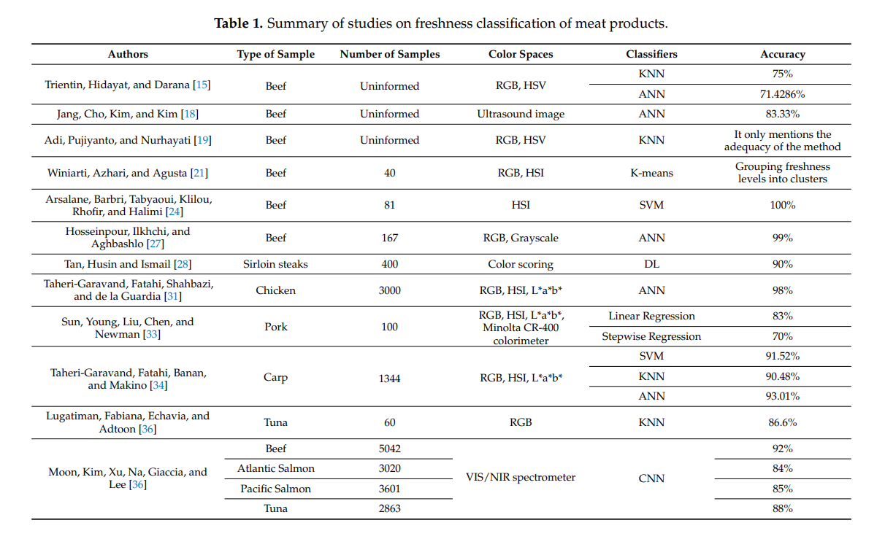

* Methodology

i) Meat samples preparation - Extraction of samples from frozen body fish at minus 2 ◦C.

ii) Computer Vision System - The CVS for capturing images consisted of a studio with thirty-six white and circularly LED lights at the top, with 6500 K.

iii) Preprocessing of Images are done.

v) Color Features and AutoML applied

vi) To analyze freshness levels, we used the PipelineProfiler, which enables the interactive exploration of pipelines generated by AutoML systems.

* Learning Algorithm -

i) AutoML - This model is used to classify the freshness levels of tuna and salmon samples through the metrics: accuracy, receiver operating characteristic (ROC) curve, precision, recall, f1-score, and confusion matrix (CM).

**Accuracy**: 100%

**Time Complexity:** Not Given

**Space Complexity:** Not Given

**Further Improvements:**

Limitations were the low amount of tuna and salmon meat samples, emphasizing this in a recent study. Data collection is dependent on the availability of fish and the access that the industry and restaurant allow us. For future assignments, we suggest tests with more samples and with models not covered by AutoML. DL approaches will be considered as soon as a dataset containing a larger volume of samples is available.

**Paper - 15**

**Author Name:** Miroljub Mladenov, Martin Dejanov, Stanislav Penchev

**Title:** Evaluation of the Freshness of Food Products by Predictive Models and Neural Networks – a Comparative Analysis

**Reference Number:** https://ieeexplore.ieee.org/document/7737446

**Method Used:** Neural Network and Predictive Regression Model

**Summary:**

* Principle

i) The aim of this paper is to present a comparative analysis of the possibilities for evaluating the freshness of the investigated products using two approaches - regression predictive models and neural networks

ii) The features are extracted from the spectral characteristics (SH) of the overall measuring range of the spectrophotometer and from the selected frequency band of the hyperspectral characteristics (HSC).

iii) Three types of Artificial Neural Networks (ANN) are used for assessment of time of storage: Multilayer Perceptron (MLP), Network architecture with radial basis elements (NRBE) and Network architecture with kernels (NNK).

* Methodology

i) *Assessment of quality and freshness using predictive models* - Predictive models for presence of colonies of fungi, yeasts and molds, microbial spoilage and bacterial strains, water content, active acidity, acid degree °T and others as well as for the change of these features during the time of storage

ii) *Assessment of quality and freshness using neural networks* - The artificial neural networks are applied for QF assessment of foodstuffs, for example for identification of meat spoilage [7], for prediction of features related to the quality and freshness of eggs [15], meat and fish [3], for identification of microbiological contamination of foods

iii) *Evaluation Of The Freshness Using Predictive Models* - The separability is determined by Linear Discriminant Analysis (LDA) and Kernel SVM (K-SVM) classifiers. The Principal Component Analysis (PCA) method is used to extract the features from spectral characteristics and to reduce the dimensionality of the spectral data

iv) *Evaluation Of The Freshness Using Neural Networks* - The following three types of neural networks are used for assessment of the time of storage:

1. Multilayer Perceptron
2. Network architecture with spherical radial basis elements.
3. Network architecture with kernels

v) *Analysis Of The Results From The Investigation.*

* Learning Algorithm -

i) Neural Network

ii) Predictive Regression Model

**Accuracy**: Depends on the type of meat used

**Time Complexity:** Not Given

**Space Complexity:** Not Given

**Further Improvements:**

* The creation of predictive models is relatively complex, expensive and slow procedure. It requires investigations in a reference laboratory and usually lasts more than 7 days. The predictive models can be created in advance and can be used as available data, as is made in the study.
* There is no opportunity for direct assessment of the expiry date of the product.