Topic 7 | Assessment Evidence
  - Advanced Planning, Reasoning, and Self-Correction
Workflow: Topic_7_AI_Self_Correction_Agent | Platform: n8n | Date: 13 November 2026

Test summary
Validation checkpoint | Observed result
First validator call | Failed as expected - invalid unquoted JSON keys
Second validator call | Passed - corrected JSON accepted
Final reflection_loops | 2
Final validation_status | Passed
Maximum iterations | 4

Evidence 1 - Workflow execution
The chat-triggered AI Agent completed successfully with the Gemini model, validator, and Structured Output Parser connected.
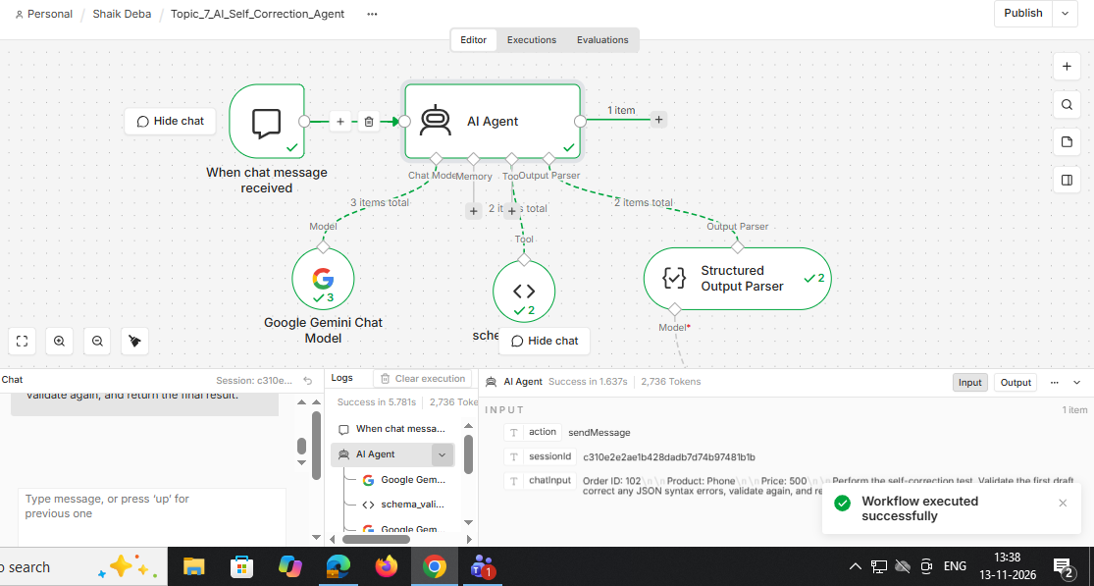
Source: n8n execution screenshot supplied during the Topic 7 hands-on exercise.

Evidence 2 - First validation failed
Run 1 of 2: malformed JSON with unquoted keys was rejected with a JSON syntax error.
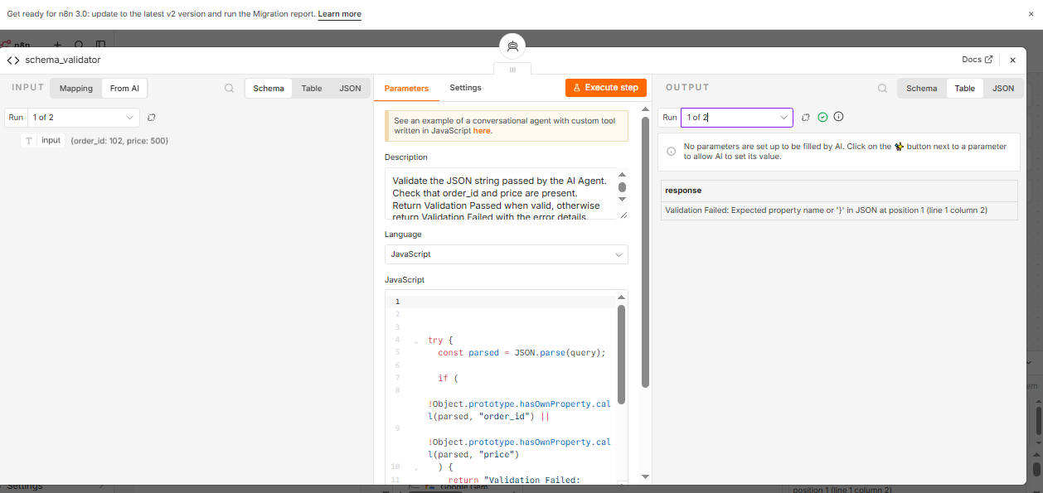
Source: n8n execution screenshot supplied during the Topic 7 hands-on exercise.

Evidence 3 - Corrected validation passed
Run 2 of 2: corrected JSON passed the JavaScript schema validator.
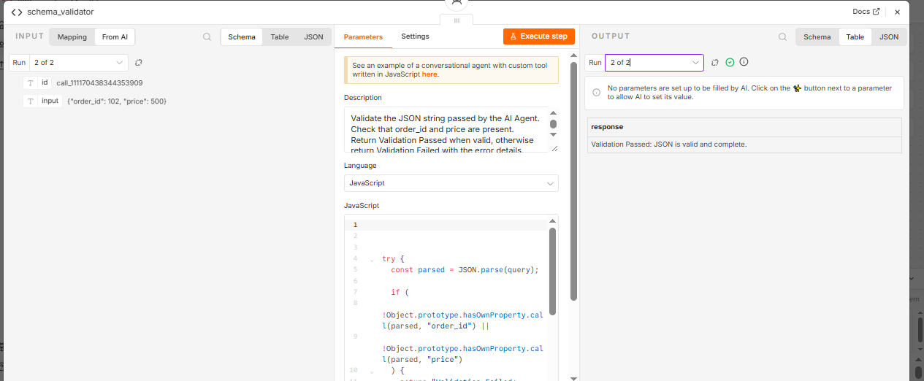
Source: n8n execution screenshot supplied during the Topic 7 hands-on exercise.

Evidence 4 - Final output and iteration setting
AI Agent output includes order 102, price 500, reflection_loops = 2, validation_status = Passed, and Max Iterations = 4.
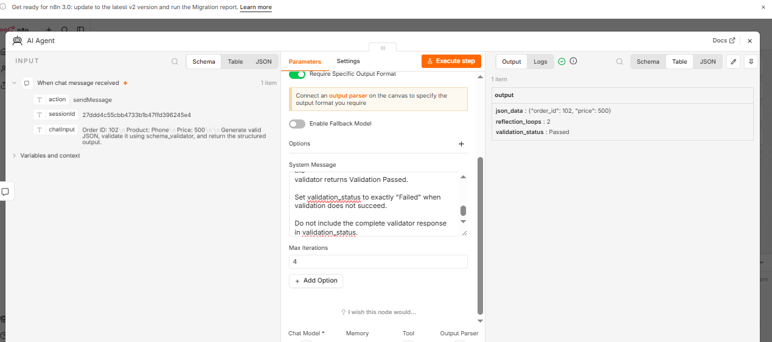
Source: n8n execution screenshot supplied during the Topic 7 hands-on exercise.

Conclusion
The controlled test demonstrates validation failure followed by correction and successful revalidation. The final response records two validator calls and reports Passed. The intentional malformed-draft instruction should be removed for ordinary workflow operation.

