1. Project Modules
We will define the main modules:
- Authentication & User Management
- Product Management
- Category Management
- Supplier Management
- Inventory Management
- Purchase Order Management
- Dashboard & Reports
The sprint requires the project to be divided into logical modules.
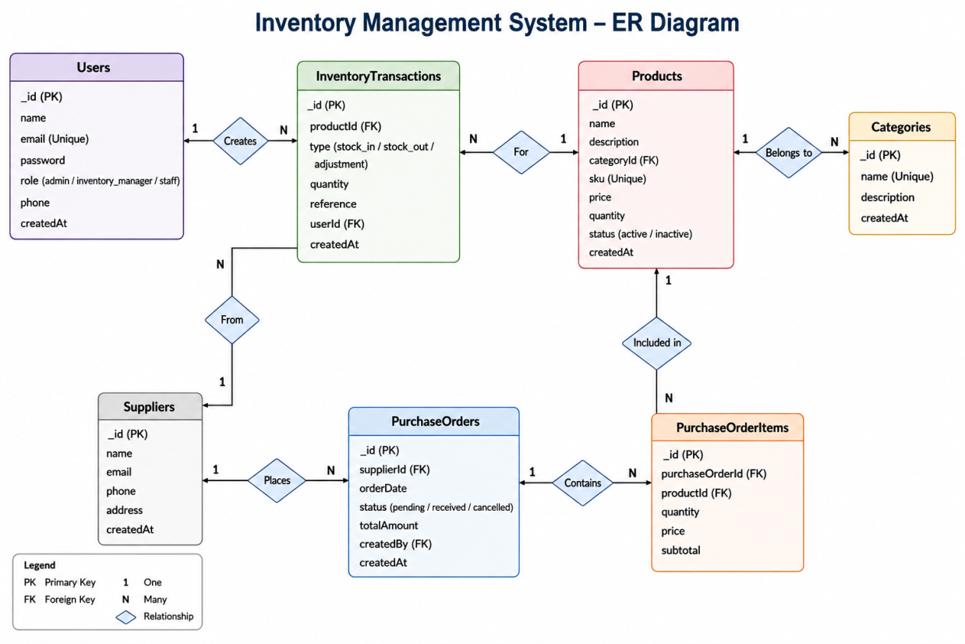
2. ER Diagram (ERD)

3. MongoDB Collection Design
We need to document each collection and its important fields.
For example:
Users
_id
name
email
password
role
createdAt
Categories
_id
name
description
createdAt
Products
_id
name
description
categoryId
price
quantity
status
createdAt
Suppliers
_id
name
email
phone
address
createdAt
InventoryTransactions
_id
productId
type
quantity
reason
userId
createdAt
PurchaseOrders
_id
supplierId
orderDate
status
totalAmount
createdBy
PurchaseOrderItems
_id
purchaseOrderId
productId
quantity
price

4. Application Navigation
We need separate navigation for each role.
Administrator
Login
↓
Dashboard
├── Users
├── Products
├── Categories
├── Suppliers
├── Inventory
├── Purchase Orders
├── Reports
└── Logout
Inventory Manager
Login
↓
Dashboard
├── Products
├── Categories
├── Suppliers
├── Inventory
├── Purchase Orders
├── Reports
└── Logout
Staff
Login
↓
Dashboard
├── View Products
├── View Inventory
├── Inventory Transactions
├── Profile
└── Logout
Sprint 3 requires navigation flows to be prepared according to user roles.

5. Application Workflow
A basic workflow for your system:
Login
↓
Dashboard
↓
Select Module
↓
Perform Operation
↓
Validate Data
↓
Save Data
↓
MongoDB Database Updated
↓
Display Success Message

6. Wireframes
