Assignment V: Goal-Based Portfolio Optimisation — Summary Report
NSE Indian Equities 2014–2023 | 5 Stocks | 70 Portfolios | 5,000 Monte Carlo Paths | 20 Year Horizon | Target: Rs 1.5 Crore
Goal Sequences Tested  Goal Seq A Year Seq A Target Seq B Year Seq B Target  G1 Yr 3 Rs 15 L Yr 8 Rs 10 L  G2 Yr 7 Rs 25 L Yr 12 Rs 20 L  G3 Yr 12 Rs 30 L Yr 16 Rs 40 L  Retire Yr 20 Rs 1.5 Cr Yr 20 Rs 1.5 Cr | Optimal Portfolio Results  Sequence A Sequence B  Best Portfolio 100% ITC 75% ITC + 25% HDFC Bank  Success Rate 0.04% 89.7%  Borrowing needed? Yes, from Year 3 Minimal to none  Early withdrawals Rs 70 L by Yr 12 Rs 30 L by Yr 12

Stock Universe
Stock | Sector | Annual Return | Annual Risk | Optimal Weight
TCS | IT | 18.3% | 23.3% | 0% in both
HDFC Bank | Banking | 19.3% | 26.6% | 25% in Seq B
Reliance | Energy | 9.0% | 28.0% | 0% in both
Sun Pharma | Healthcare | 1.9% | 24.0% | 0% in both
ITC | FMCG | 23.1% | 21.5% | 100% Seq A / 75% Seq B

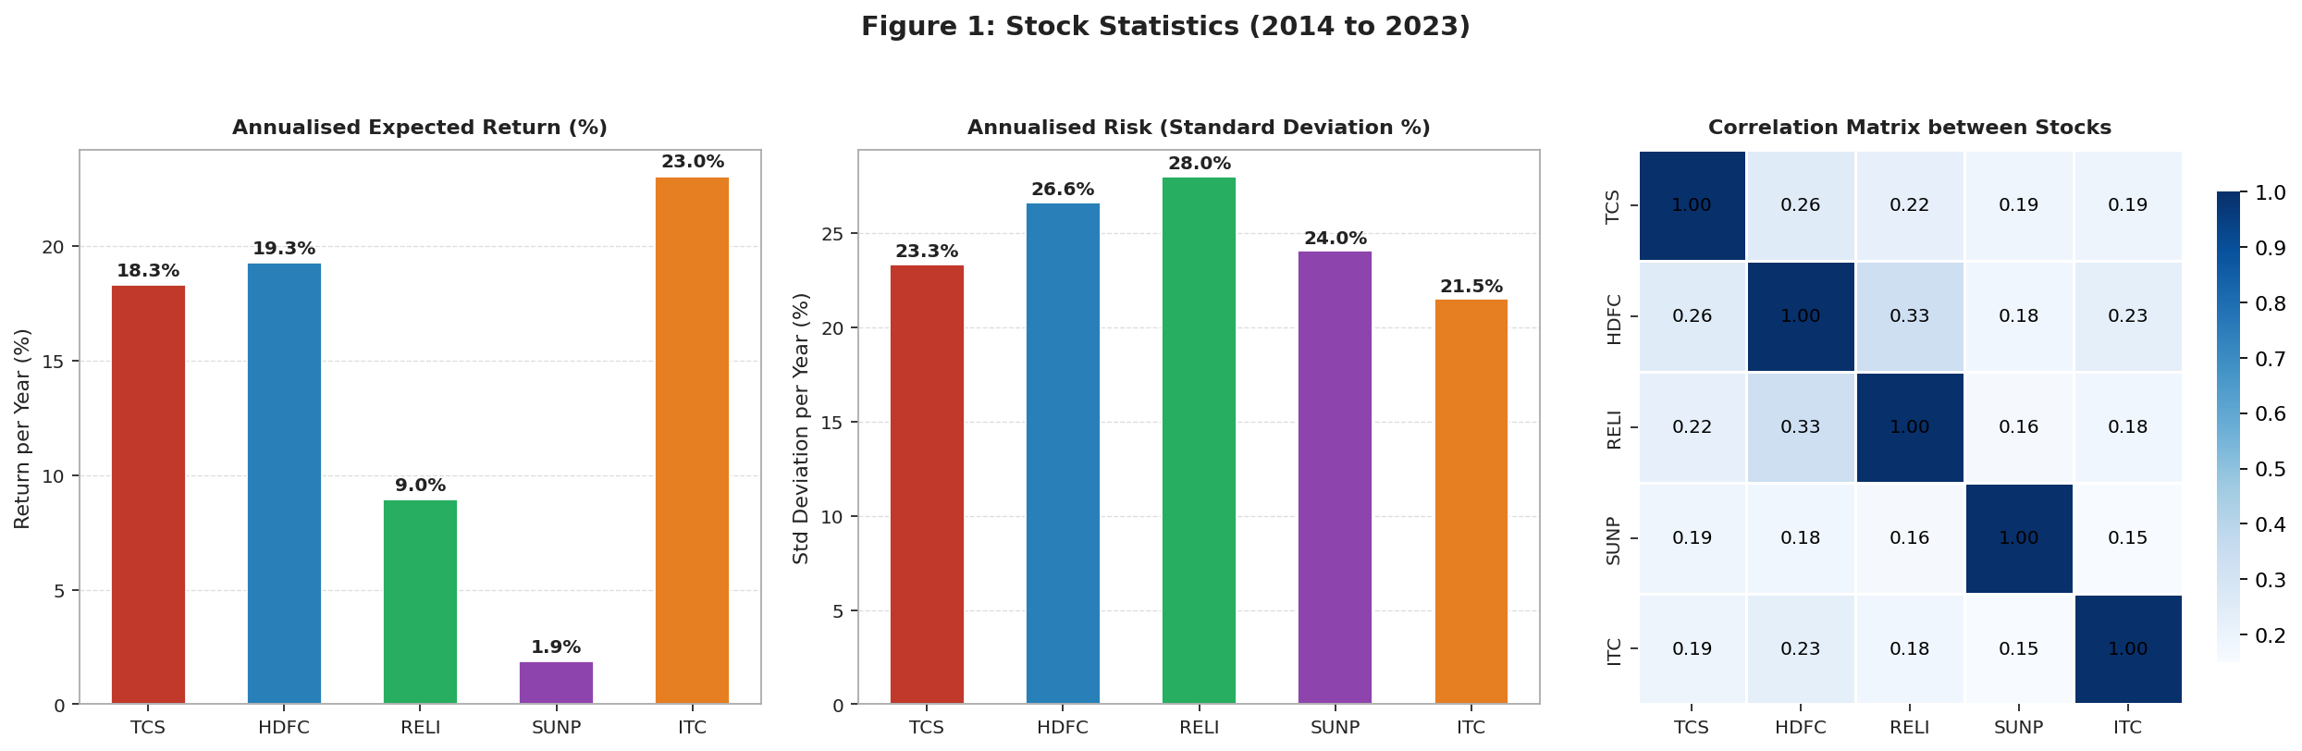  Fig 1: Annual return, risk and correlation for all 5 stocks. | 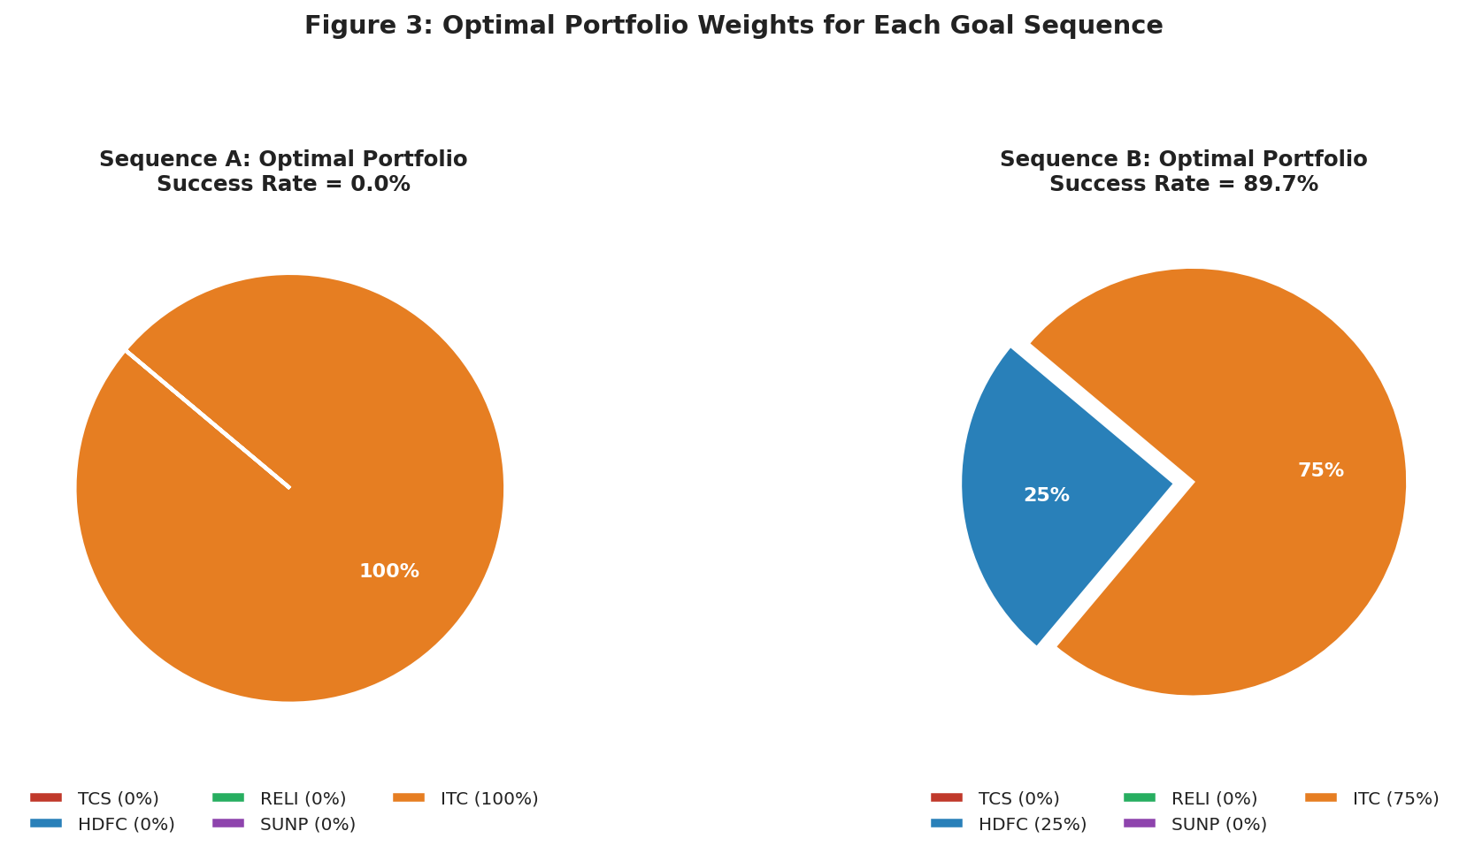  Fig 2: Optimal weights — Seq A (100% ITC) vs Seq B (75% ITC + 25% HDFC).

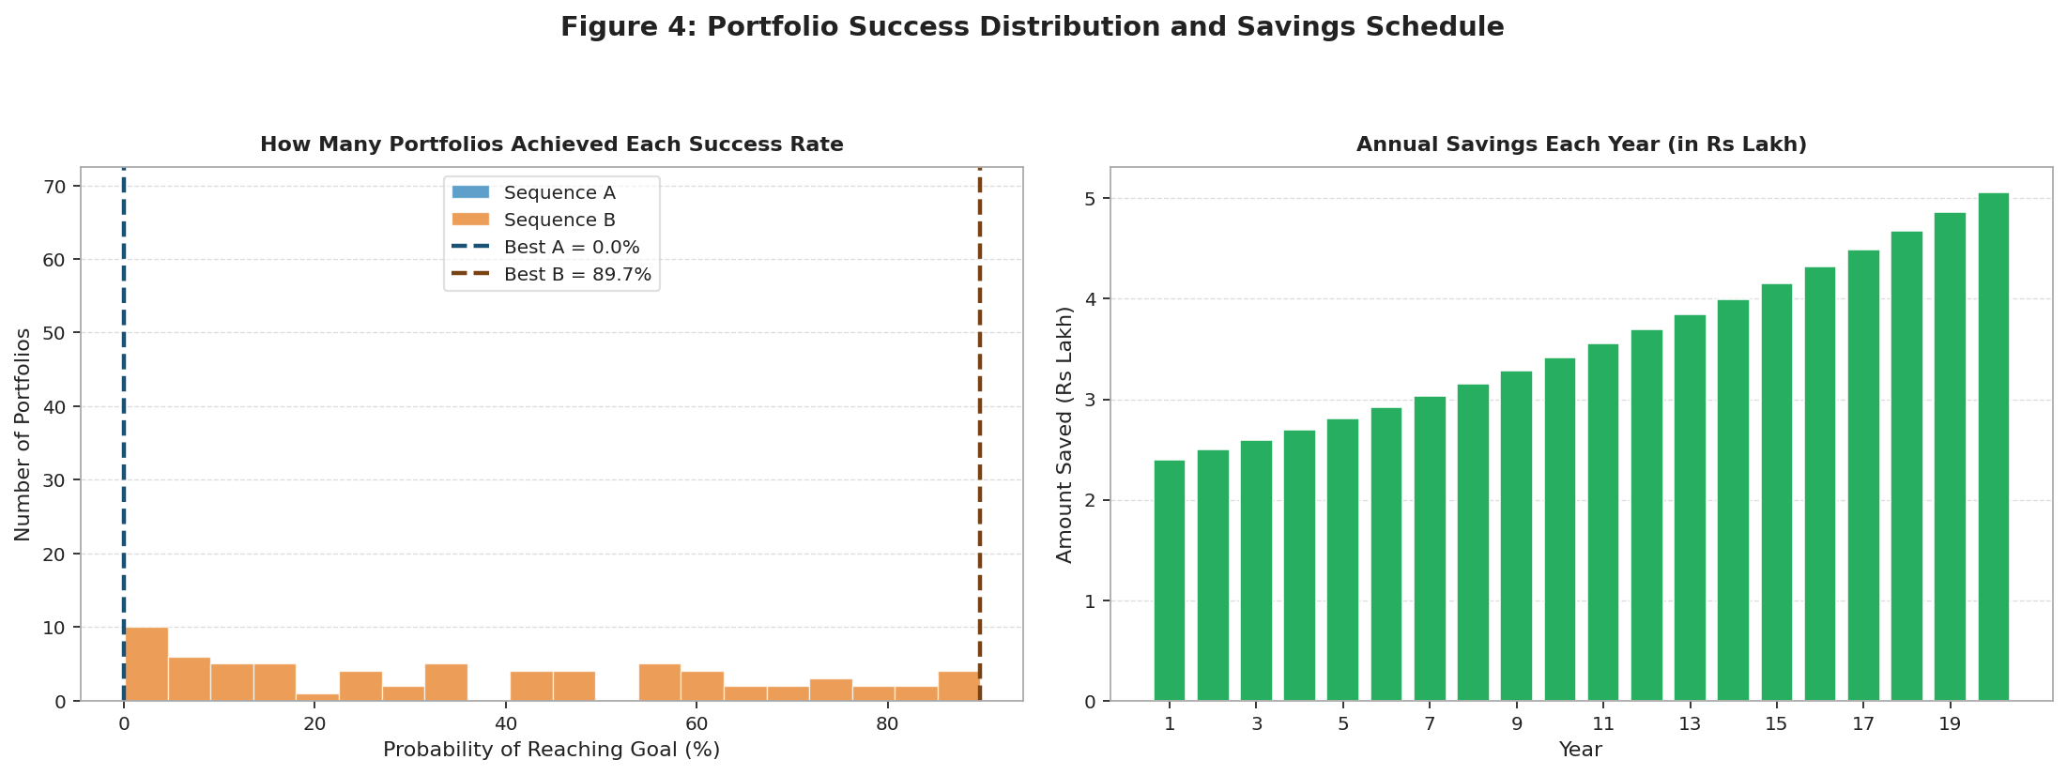
Fig 3: (Left) Success rate distribution across all 70 portfolios. (Right) Annual savings growing at 4% per year.

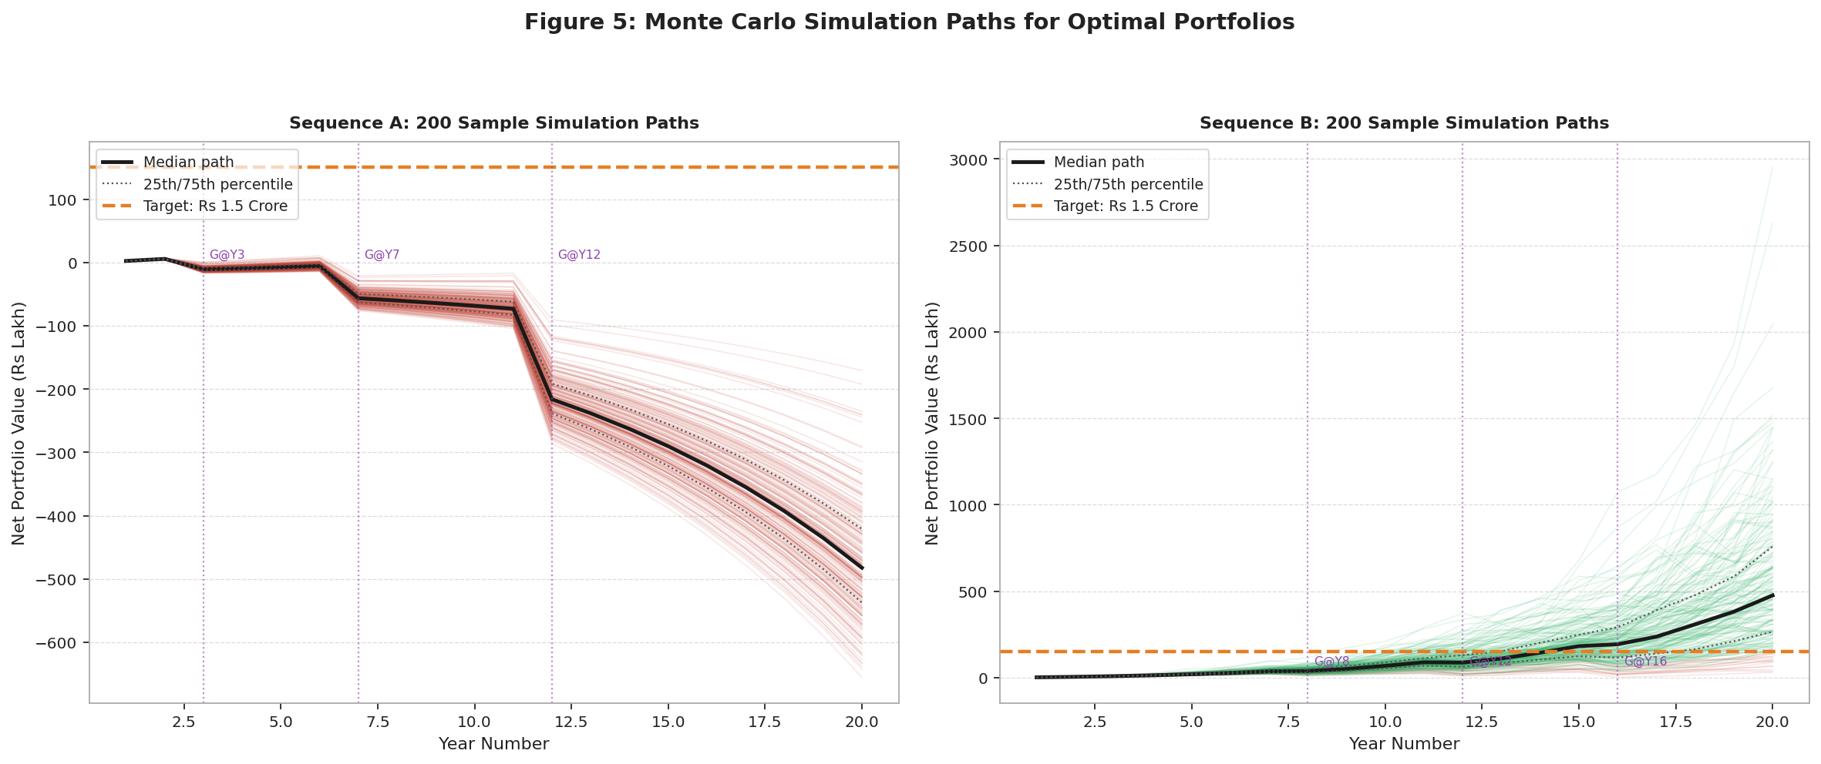
Fig 4: Monte Carlo simulation paths. Green = reached Rs 1.5 Cr. Red = fell short. Black = median. Purple lines = goal years.

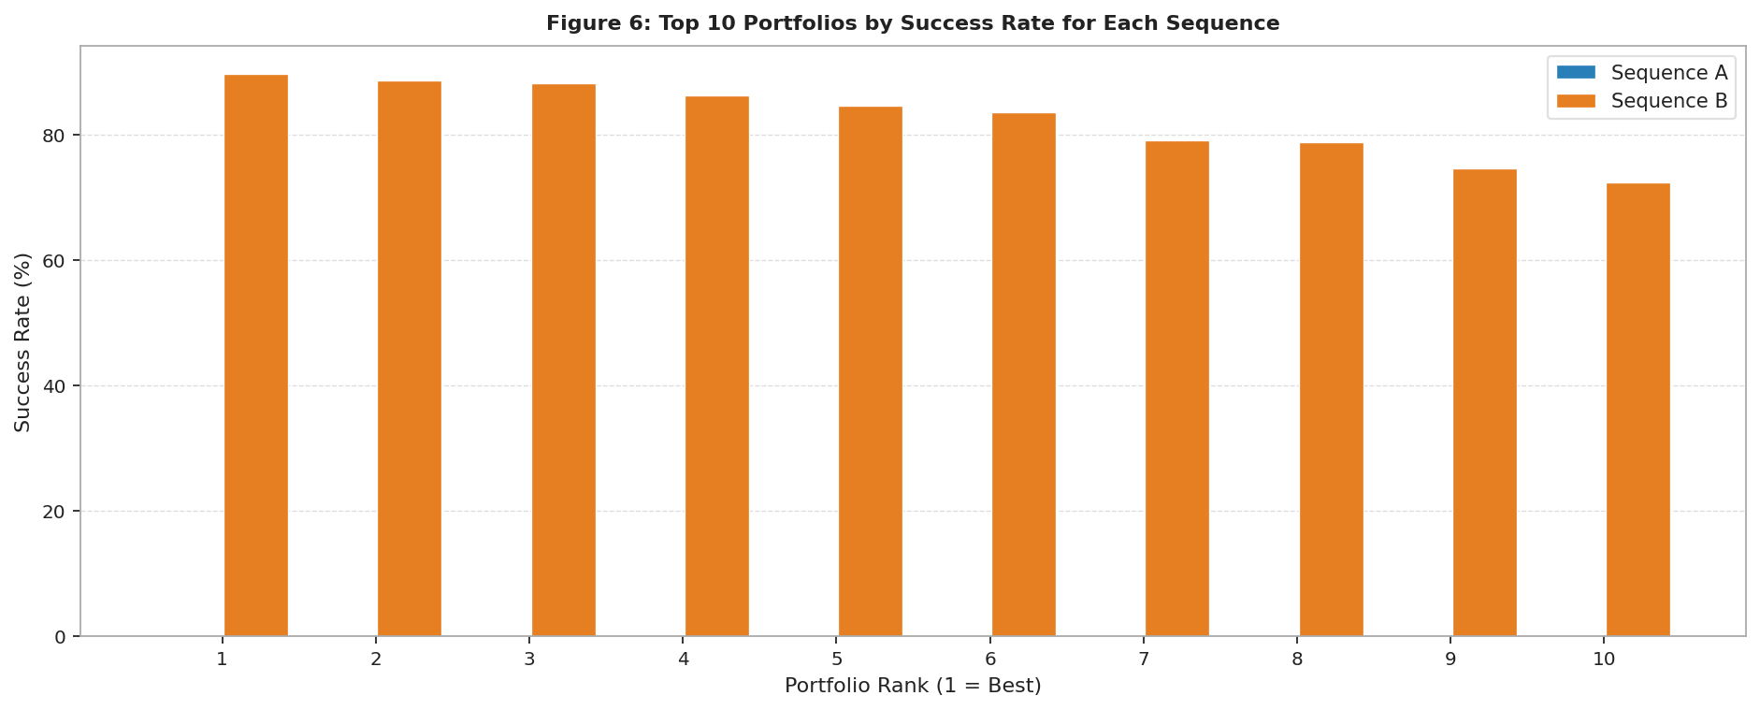
Fig 5: Top 10 portfolios by success rate. Seq A bars are near zero; Seq B top portfolios cluster around 85 to 90%.

Why the Two Plans Give Such Different Results
Compounding needs time.  Seq A pulls out Rs 70 L in the first 12 years, robbing the portfolio of compounding. Seq B leaves money invested for 8 full years before the first withdrawal, building a strong base.  12% borrowing creates a debt spiral.  Rs 7.5 L borrowed at Year 3 grows to over Rs 48 L by Year 20 at 12% per year. Seq A triggers this at multiple checkpoints. Seq B needs no borrowing because savings cover the Year 8 goal. | Stock choice cannot fix bad timing.  No portfolio, not even the best one, can overcome structurally impossible early withdrawals. This proves goal timing matters more than asset selection.  Why ITC and HDFC Bank?  ITC gives the best return per unit of risk (23.1% at 21.5% risk). HDFC Bank adds banking sector diversification. Together they maximise growth while protecting against sector-specific downturns.

Final Comparison
 | Sequence A: Aggressive Early Goals | Sequence B: Backloaded Goals
Optimal Portfolio | 100% ITC | 75% ITC + 25% HDFC Bank
Success Rate | 0.04% | 89.7%
Borrowing from | Year 3 (12% p.a.) | None
Core Lesson | Early withdrawals + compounding debt make retirement unreachable | 8 years of compounding + backloaded goals = 90% success

Key Takeaway: Give investments time to compound before withdrawing. A sensibly timed plan with ITC and HDFC Bank achieves 89.7% success. The same stocks in a poorly timed plan fail completely. Goal timing matters far more than stock selection.

