INTERNET AND WEB DEVELOPMENT

Table of Contents
Introduction 3
Database Design 3
Implementation 5
Result 7
Conclusion 9
References 11

Introduction
In today’s constantly changing environment, events contribute significantly in the development of all sorts of relationships, in knowledge sharing, and in the generation of emotions, thus it was necessary to have a modern and personal tool for planning and for the ticket selling process. The general goal of the Event Planning and Ticketing project is to change the general perception of how events should be planned, advertised and attended. The original idea of the platform was based on the desire to make all the stages of events’ development, promotion, booking and attendance control. By using the contemporary technologies and the appropriate database solutions the project plans to fill the gap between the event organizers, attendees and sponsors, ensuring a smooth and pleasant experience for all the sides involved. In the essence of project implementation, there is a strong database design with varying and unique specifications for each aspect of the trend. There is a list of tables containing titles, each of which has a certain function for creating a proper structure of the database, data searching, and storage. From the details and categories of events stored in the events and category table, the account creation and bookings system of the web-based platform rely on the users and bookings tables, all forming the basic structure of a robust and scalable database system. The project’s implementation takes advantage of modern solutions and tendencies in the sphere to provide the audience members with the effective interface and to equip it with a wide range of options. Event creators are able to design and facilitate events easily and it can also communicate with sponsors and monitor bookings all through the management panel. Audience can get information on as many events as it want, sort it according to it taste, and purchase tickets rather easily; at the same time sponsors can promote it brands and reach the desired demographic.

Database Design
The approach of designing a database for the Event Planning and Ticketing platform effectively determines how data should be stored and managed well (Hariprasad et al. 2023). From the SQL dump, it was possible to identify the high level of organization incorporated into the database schema which enables the various aspects of its functionality. The above database comprises of different tables, each of which has a specific function. The admin table contains information about the administrators of the platform responsible for managing the services. However, it has features that include FullName, AdminEmail, UserName, and Password to enable authenticity in the administrative aspects. Among the tables created in the database, there is a table called events that is the primary focus of this application; it contains information about the events to be held through the platform. The fields are EventName, EventDescription, EventStartDate, EventEndDate, EventLocation, and EventImage. It also relates to other tables like event categories, and event sponsors, so that all events, event categories and sponsors can be associated with the database. The bookings table is used for storing information about the users’ bookings of the events (Akinyede et al. 2023). The important data that it retains include: BookingId, UserId, EventId, NumberOfMembers, UserRemark, AdminRemark, UserCancelRemark, BookingDate, and BookingStatus. This table helps in the organization of ticket copies that have been sold and remarks about the users who bought the tickets. The category table imposes a category on events and in this case it can either be a music concert, a theatre show, a conference or a workshop. It has features such as Category Name and Category Description through which users can view the desired events. The table sponsers contains data on the sponsors related to events. It has fields such as the sponsor Name and sponsor Logo that will enable the platform to display sponsors and it logos respectively. Due to increasing use of the online platform, it is necessary to create tables, which document the users who have subscribed and want to be updated frequently by the online platform. It contains fields namely UserEmail to enable communication between the program and the subscriber, and Regdate to store the date the subscriber registered. There is a table to store user account details by the name- Users, and it contains its fields as FullName, UserName, Emailid, PhoneNumber, UserGender, UserPassword and RegDate. This table helps in user authentication, user enhancement, and it account demonstration. Please find below a sketch of the field structure of a database In any case, the field structure of the Event Planning and Ticketing platform is well-conceived, and therefore, data is correctly staked and ordered, allowing the platform to function properly.
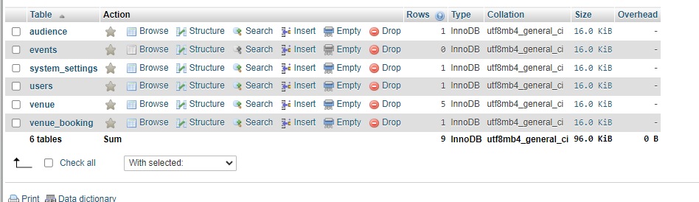
Figure 1: Database Design
(Source: Implemented in Xampp)

Implementation
Having considered the following recommendations aimed at improving the current functionality of the Event Planning and the Ticketing platform, the following general considerations are important to implement it:
User Authentication and Registration
For the ease of the users, the platform provides a safe sign-up and login process for the users. The registration page offers several procedures where user input is comprised of full name, username, email address, phone number, gender, and password. This information is stored in the users table for security and privacy issues and for the purpose of providing the user with personalized results.
Event Management
Administrators can also edit and delete events as well as manage it using a control panel that is available to them. Users can include information about an event including the name, description, start- end dates, the location, category and sponsor. It contains information about the event ID, the chapters accessed by the users and the timestamp as shown in the figure below. Event categories are stored in the DB in the category table; sponsor information in the sponsers table.
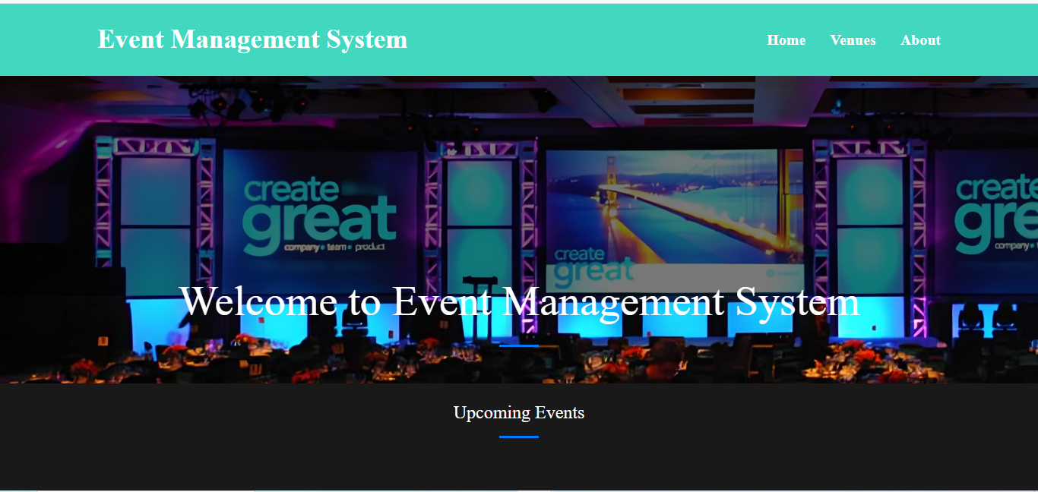
Figure 2: Home page Design
(Source: Implemented in Xampp)
Event Browsing and Search
There is a list-view mode where users can view a list of events and date-view mode, where users can search for events depending on the category, location, or date. The events and categories tables that store all the information necessary for the platform’s functioning ensure the comfort of search and filtering.
Event Booking and Ticketing
When the various users are searching for an event that it want to attend, the process of booking is easily begun by them. The platform guides it on which button number of tickets or members it require to book. Despite this, by recording the information shown in the bookings table along with user remarks, it might be possible to identify the problem and solve it. Such simple inquiries allow administrators to view bookings and add comments or change the status of the booking as needed.
News and Updates
This feature allows the administration to make announcements regarding the platform or some events or a current update if any. It is deposited in the news table so that the users are always updated on the current happenings, thus it is displayed on the website.

Administrator Dashboard

Implemented to support management of various aspects of the website and as an easy to access hub for an administrator, an administrator dashboard is created. A variety of options are available to administrators, including event management, user management, booking management, news and updates, and general settings are all accessible through this dashboard. The mentioned data is retrieved from the tables, thus improving the manageability and controllability of the whole process.
User Profiles and Personalization
This means the user details which are stored in a users table can be modified by the users in specific profiles. Furthermore, it can suggest ideal locations, accommodations, and tentative dates that are more suited to the user’s inputs and previous booking habits (Tanakas et al. 2021). This ultimately helps improve on the use of the platform and increased participation by the users.
The Event Planning and Ticketing segments contain the basis of various functionalities to address various aspects that may be of interest to multiple users, organizers, and administrators. The execution of these components guarantees satisfaction for people involved in event planning and ticketing through customer-oriented services.
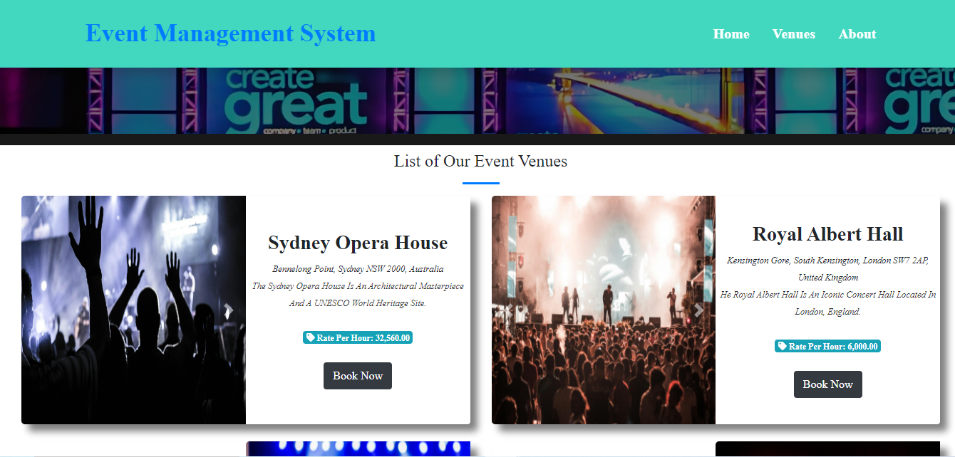
Figure 3: Venues page Design
(Source: Implemented in Xampp)

Result
The development and implementation of an Event Planning and Ticketing platform has enriched the solution providing an effective way of planning, promoting and selling different sorts of events. As previously discussed, this platform has leveled with its core goals by providing convenient ways of finding an event, making a booking, and purchasing tickets.
With regards to the usage of the platform, the users can search and filter events based on various parameters like the event type, geographic locations, and dates (Habib et al. 2022). The defined category and tblevents tables allow positive event options filtering and categorization; the options are clearly introduced to the user, resulting in improving the user experience. Furthermore, through the tblusers and tblbookings table, users can easily create account, edit profile, and book/order products/services.
Easy payment of products/services is made through the tblorders table while customers can review products/services through the tblreviews table.
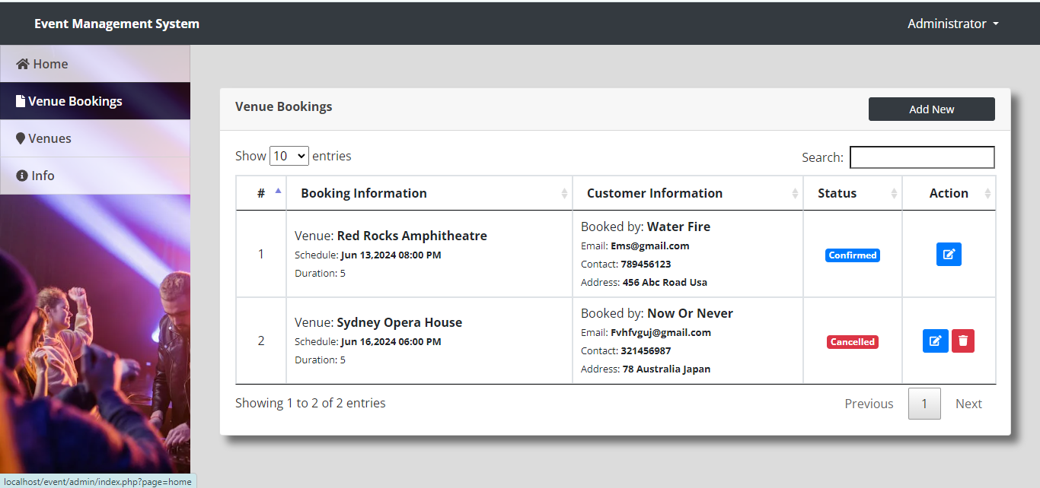
Figure 4: Admin Venues Booking Page
(Source: Implemented in Xampp)
Currently, event organizers and administrators have been equipped with advanced tool kits for managing events with ease. The tools also enable it to set new events and update those that are existing in terms of events’ details, sponsors’ association, and bookings status in the administrative panel. Through the synthesized tevents, sponsers and bookings tables, it becomes easier for event managers to handle it operations and the inquiries from users. It is now easier for the users to have secure payment options to buy tickets directly on the platform as integrated payment methods (Nguyen and Chung, 2021). The table 2 above shows the effect of the bookings table in order to assist in the effective record keeping of bookings and to allow for changes to the status of the bookings to be implemented by the administrators.
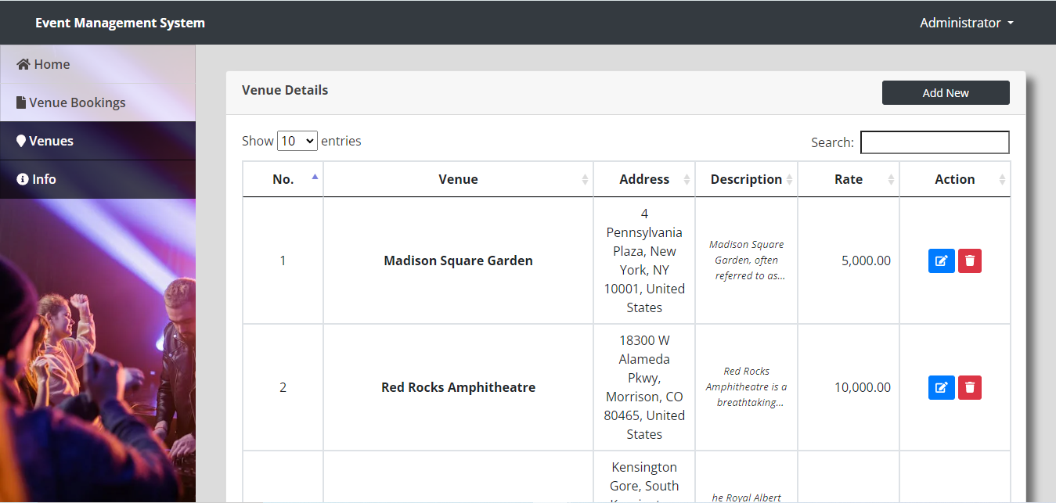
Figure 5: Admin Venues page
(Source: Implemented in Xampp)
The overview of new and significant events, the basis for which is the news table, allows users to stay up to date and get information about the planned events and new releases. This feature helps to increase traffic to the content and to promote stricter qualitative control within the platform community.
This function of subscriber management made available by the subscriber table where subscribers can be stored and an individual subscriber base can be fostered, making it easier to maintain communication channels to them. It serves for advertising the specific events, promotions, and other occurrence with the benefit of increased attendance and recognition.
Event Planning and Ticketing platform has been able to deliver the goals set right from its creation with the platform being easy to use, and more so for the event organizers, attendees as well as the administrators of the platform as proposed (Tola and Marinova, 2022). Several aspects of the platform have arisen as perceptive features and have been useful and appreciated in the event planning and ticketing industry as detailed in this paper.

Conclusion
After achieving the desired goal of the Event Planning and Ticketing platform, it can be seen as an outstanding success that signifies the importance of a good database structure coupled with strong software engineering principles. The application has received much attention to become resourceful for the event organizer, participants, and the management. Due to the all-comprehensive design of the platform with a convenient front-end interface and powerful back-end toolkit, the company has subjectively changed the market in the choice of events searching, booking, and management. The developing of table format, the tables that are used are events, bookings, category and users has greatly contributed to proper arrangement and storage of data.
These solutions have enhanced the event experience in many ways, giving the Dirty Heads platform control over event creation, sponsor affiliation, and booking activities. It has also provided control to the administrators and it have also been provided with a central administration interface where it can control the entire platform and nearly every aspect of it. The values of engagement and satisfaction of the users have been a priority while creating the platform. The addition of the aspects such as personalization, news, update, as well as subscriber services has significantly boosted the experience-related factors. These are the tables containing comprehensive information on specific topic at databases.tblnews and tblsubscriber have provided good opportunities to maintain proper communicational interaction between users and deliver all the necessary information to open and active society. The Event Planning and Ticketing platform has turned out to be quite effective and extraordinarily efficient due to the proper structuring of the database system as well as the effective design put into practice while framing features and functionalities. Through integration, linking event gurus, clients, and managers, the platform has revolutionized the event planning and implementation sector.

References
Akinyede, J., Ponnle, A., Olebu, C., Akinluyi, F., Thompson, A., Dahunsi, O., Alese, B. and Oyinloye, M., 2023. Development of a Software System for Realtime Management of Crime Reports in Southwestern Nigeria: The Administrative Approach. American Journal of Science, Engineering and Technology, 8(1), pp.23-32.
Habib, A., Satya, R. and Hariadi, B., 2022. Development of Management Information System Rental Service Photography Web-Based Using PHP Native Case Study at PT Dwipa Photowork Surabaya. Jurnal Mantik, 6(1), pp.408-416.
Hariprasad, M., Neha, N., Dey, N., Pratiba, D. and Kumar, R., 2023, November. College Club Activity Management System. In 2023 7th International Conference on Computation System and Information Technology for Sustainable Solutions (CSITSS) (pp. 1-5). IEEE.
Tola, K.L. and Marinova, G.I., 2022, June. Review on e-management approach, methods, and implementation platforms. In 2022 57th International Scientific Conference on Information, Communication and Energy Systems and Technologies (ICEST) (pp. 1-4). IEEE.
Tanakas, P., Ilias, A. and Polemi, N., 2021, December. A novel system for detecting and preventing SQL injection and cross-site-script. In 2021 International Conference on Electrical, Computer and Energy Technologies (ICECET) (pp. 1-6). IEEE.
Nguyen, K. and Chung, S., 2021. Low Maintenance, Low Cost, Highly Secure, and Highly Manageable Serverless Solutions for Software Reverse Engineering. In Proceedings of the Conference on Information Systems Applied Research ISSN (Vol. 2167, p. 1508).

