INTERNET AND WEB DEVELOPMENT

Slide 1: Title
Slide 2: Introduction
· The development of the interactive web application involves creating an online venue to host events and conduct ticketing with the help of within HTML, CSS, JavaScript, and PHP.
· The first is the improvement of the web development competencies and the acquisition of the practical usage of these technologies (Karami et al. 2024).
· The project helps evaluate the student’s knowledge about the concepts of database systems, design of the user interface, logic and functionality integration, testing of the application, and presentation abilities.
· Since the assignment is based on a team, enhanced teamwork and good communication within the team is achieved.
Speaker Note: The primary aim is to improve their level in these technologies and evaluate their knowledge of the database systems, user interface design, logic and functionality application, testing, and presentation.

Slide 3: Database Design
· Set up an online database that will enable to store and process user accounts, their passwords, and other options preferred by users concerning the customized web pages.
· Connect this website and the database using an SQL database and PHP (Arwan and Rusdianto, 2020).
· Draw out the relationships between tables and the general concept of the table and the columns that are to be used and their respective data types.
· Use SQL and PHP for querying the databases for purpose of creating, reading, updating and deleting content.
Speaker Note: The database design, thus, requires formulating a system that will manage users’ profiles, administration of authorization credentials, and customization of web pages; this will be realized through using an SQL database and PHP to enable the connection between the site and the database.

Slide 4: Implementation - User Interaction and Database Design
· Develop a set of new views for the management of user accounts including user registration and login and user’s personal information account views to enable efficient user account creation, login, and personal details management.
· The user authentication and authorization should be done using PHP to ensure that only authorized users are given access to resources and to also check the identity of a user wherever he or she is in the application.
· Adopt page customization to meet the client’s expectations where the page will be modified according to the choice of clients (Kirsan et al. 2024).
· Maintain the consistency and confidentiality of data by using proper regulations for access rights and standardize entered data to avoid contamination with incorrect information.
Speaker Note: The implementation details include the aspects on how the user interface for the registration and login pages will be developed, design of the profile pages, user login authentication and authorization using PHP.
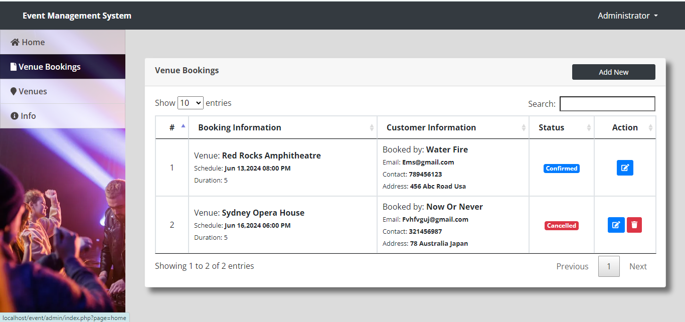
Slide 5: Result
· A fully cushtised event planning and online ticketing solution.
· A reliable and expandable database solution for users’ accounts, authorization, and individualization of the website.
· The integration of an easy to use and accessible web application with the support of the responsive design.
· Strong logic and options integration, which would make for comfortable work.
Speaker Note: observed that most of the web application’s logic and functionality will be implemented using JavaScript and PHP and also pointed out that form validation will be done using both JavaScript and PHP.
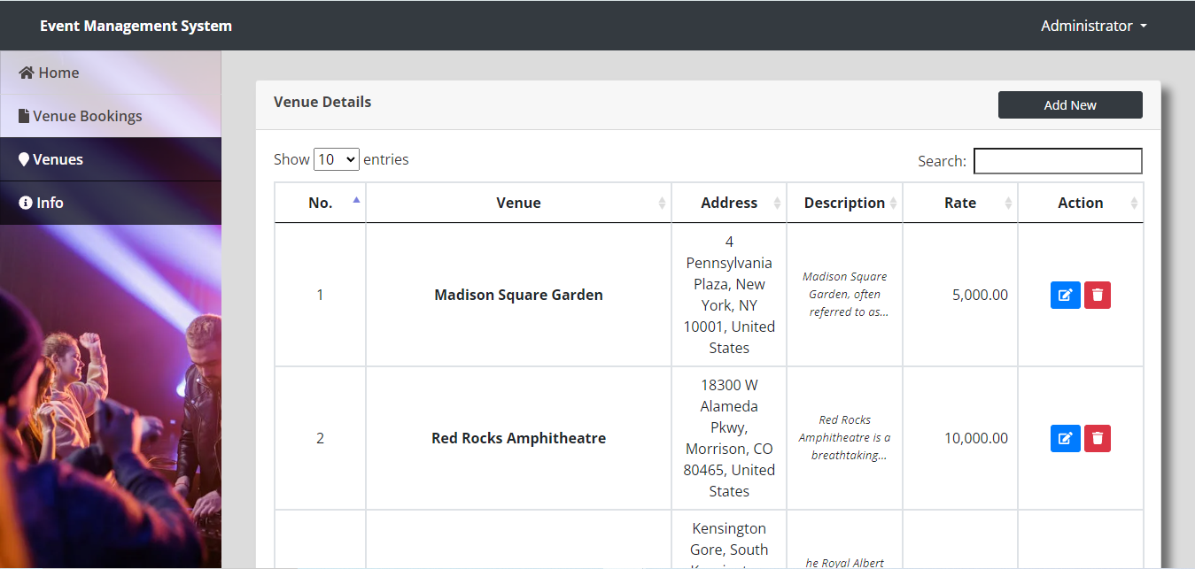
Slide 6: Conclusion
· The practical component of the project reflects students’ capacity to plan and implement a web application with the help of HTML, CSS, JavaScript, PHP.
· It enables the assessment of students’ comprehension of the various components of database systems, aspects of user-interface designing, implementing necessary logic and functions, testing, and presenting the outcomes (Hidayat et al. 2023).
· The format of the team-based assignment stimulates coordination and efficient aspect in communication among the members.
Speaker Note: The findings assessing the project aims underpin the students’ capacity to implement a complex web application utilising the majority of programming languages. It also illustrates the students’ ability in the deduction of database systems, user interface, and aspects of logics.
Slide 7: References
- Karami, M., Hafizi, N., Nickfarjam, A.M. and Refahi, S., 2024. Development of minimum data set and dashboard for monitoring adverse events in radiology departments. Heliyon, 10(9).
- Arwan, A. and Rusdianto, D.S., 2020. Maintenance Web Based Applications Using Feature Location. Journal of Information Technology and Computer Science, 5(2), pp.115-122.
- Kirsan, A.S., Takano, K. and Mansurina, S.T.Z., 2024. EksPy: a new Python framework for developing graphical user interface based PyQt5. International Journal of Electrical & Computer Engineering (2088-8708), 14(1).
- Hidayat, R.A., Agustin, N., Detrias, F. and Zein, M.T.A.A., 2023, December. WEB-GIS FOR SCHOOL DATA MANAGEMENT AND ASSESSMENT IN KLATEN REGENCY. In PROCEEDING AL GHAZALI International Conference (Vol. 1, pp. 161-172).
Slide 8: Thank You

