📘 PROJECT REPORT: SHOWHUB (Online Movie Booking System)

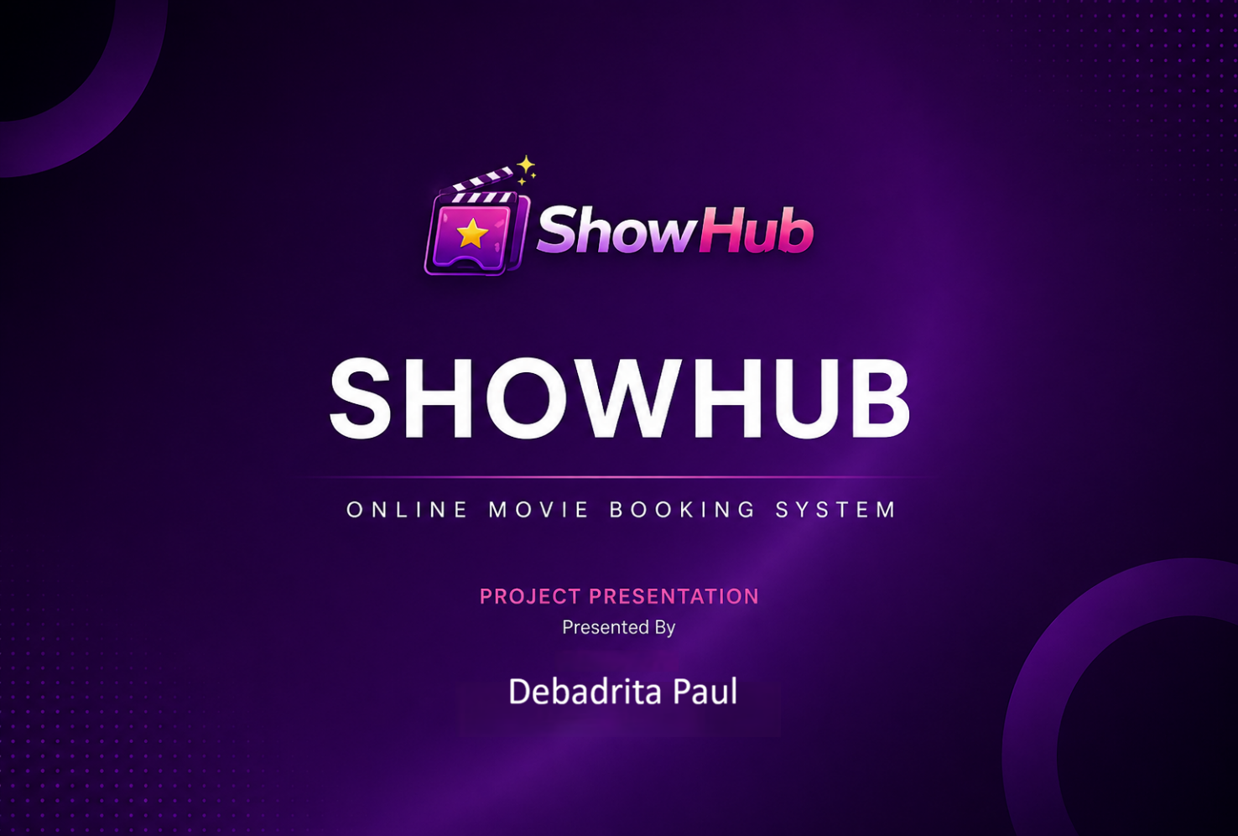

INDEX
Contents
1. Introduction 3
2. Objectives 4
3. Technology Stack 5
4. System Architecture 6
5. Features 7
6. Key Functional Modules 8
7. Database Design 9
8. Advanced Features and Enterprise-Level Enhancements 13
8.1 Google Signup with Email OTP Verification 13
8.2 Automated Booking Confirmation Email with Invoice 14
8.3 Partial Cancellation with Email Notification 14
8.4 Google Calendar Integration 15
8.5 Post-Show Rating System 15
8.6 Dynamic Banner Management 16
8.7 User Management System 16
8.8 Scalable Genre and Language Filtering 17
8.9 Secure YouTube Trailer Embedding 17
8.10 Payment Gateway Integration 18
8.11 Concurrency-Safe Seat Reservation 19
8.12 Advanced Analytics Dashboard 19
8.13 Updated System Highlights 20
9. Security Measures Implemented 21
10. Future Scope (Updated) 22
11. Conclusion 23

1. Introduction
ShowHub is a full-stack web application designed to simplify the process of browsing movies, selecting shows, booking seats, and managing bookings online. The system provides a seamless experience for users to explore available movies, view show timings, and reserve seats in real time.
The project focuses on solving common issues in traditional booking systems such as manual seat allocation, lack of real-time updates, and poor user experience.

2. Objectives

- To develop a user-friendly platform for booking movie tickets online
- To implement real-time seat selection and locking mechanism
- To provide admin control over movies, shows, and bookings
- To ensure secure authentication and booking management
- To build a scalable full-stack application using modern technologies

3. Technology Stack

Frontend
- React.js
- Axios (API communication)
- CSS / Tailwind / Bootstrap (UI styling)
Backend
- Node.js
- Express.js
Database
- MongoDB (Mongoose ORM)
Authentication
- JWT (JSON Web Token)

4. System Architecture

The application follows a client-server architecture:
- Frontend (React) handles UI and user interaction
- Backend (Node + Express) processes requests and business logic
- Database (MongoDB) stores users, movies, bookings, and seat locks
Flow:
- User sends request from frontend
- Backend validates and processes request
- Database performs CRUD operations
- Response sent back to frontend

5. Features

User Features
- User registration and login
- Browse movies and shows
- View available seats
- Select and lock seats temporarily
- Confirm booking
- View booking history
- Payment integration
Admin Features
- Add/update/delete movies
- Manage movies and timings using locationwisemovie
- Monitor bookings
- Add/update/delete theater
- Control seat section in theater for movies
- Add/update/delete show
- Add/update/delete language, banner,

6. Key Functional Modules

1. Authentication Module
- Secure login/signup using JWT
- Protected routes for users and admin
2. Movie Management
- Add movie details (title, category, duration, etc.)
- Fetch and display movies
3. Show Management
- Create shows with timings and screen details
- Link shows to movies
4. Seat Selection & Locking
- Users can select seats
- Seats are temporarily locked using a Seat Lock System.
- Lock expires after a fixed time to prevent conflicts
5. Booking System
- Confirm booking after seat selection
- Store booking details in database
- Prevent double booking

7. Database Design

Collection | Fields
Users | Name, Email, Password, Role
Movies | Title, Category, MovieImage, BackgroundURL, Language, TotalTiming, ReleasedDate, MovieDescription, Format, Crew, CreatedAt, IsRecommended, Casting, IsActive, Rating, TrailerLink
Shows | ShowName, Media, Gallery, Category, IsActive, SubCategory, IsMultipleLocation, IsRecommended, Locations, Languages, AgeLimit, Description, Artists, StartDate, EndDate, CreatedAt, UpdatedAt
Bookings | UserId, MovieId, MovieTitle, TheaterId, HallName, ShowDate, ShowTime, Seats, TicketPrice, FoodItems, FoodTotal, ConvenienceFee, CGST, SGST, TotalAmount, PaymentId, BookingStatus, PaymentStatus, RefundAmount, RefundStatus, FoodRefundAmount, CreatedAt, UpdatedAt
Categories | Name, Image, Type, CreatedAt, isActive, SubCategories
Subcategories | Title
Languages | Title, CreatedAt, isActive
Theaters | LocationName, TheaterName, isMultiple, Halls, FoodItems, ParkingFacility, FoodCourt, WheelChairFacility, isActive
Halls | HallName, SeatCategories
SeatCategories | SeatName, TotalRows, SeatsPerRow, Price
LocationWiseMovieSelection | Movie, Location, Language, Theater, HallName, Shows, StartDate, EndDate
SeatLocks | MovieId, TheaterId, ShowDate, ShowTime, Seats, UserId, ExpiresAt, LockedBy, LockStatus
RefundPayments | UserId, BookingId, MovieId, PaymentId, Seats, FoodItems, RefundAmount, RefundType, RefundStatus
Reviews | MovieId, ShowId, UserId, Type, Rating, ReviewText, CreatedAt

8. Advanced Features and Enterprise-Level Enhancements

8.1 Google Signup with Email OTP Verification
The system provides secure authentication by integrating Google OAuth with email OTP verification.
Functionality
- Users can sign up/login using Google authentication
- OTP is sent to registered email
- OTP validation confirms account authenticity
Implementation Details
- Google Identity Services integration
- Backend-generated OTP with expiry validation
- SendGrid email delivery service
- OTP validation API for secure activation
Benefits
- Prevents fake registrations
- Enhances account security
- Improves onboarding experience

8.2 Automated Booking Confirmation Email with Invoice
After successful booking, ShowHub sends confirmation email automatically.
Includes
- Movie / Show name
- Theater name
- Show timing
- Seat numbers
- Total amount
- Booking ID
- Payment ID
Implementation Details
- SendGrid integration
- PDF invoice generation using PDFKit
- Background queue processing
- Retry mechanism for failed deliveries
Benefits
- Professional booking workflow
- Proof of purchase
- Reliable record keeping

8.3 Partial Cancellation with Email Notification
Users can partially cancel seats or food items.
Functionality
- Cancel selected seats
- Cancel food items separately
- Updated refund invoice sent automatically
Implementation Details
- Modified booking schema
- Dynamic seat recalculation
- Automated refund notification emails
Benefits
- Flexible cancellation system
- Better user convenience
- Real-world cinema functionality

8.4 Google Calendar Integration
Users can directly save bookings to Google Calendar.
Features
- “Add to Calendar” button
- Saves:
  - Movie / Show name
  - Date & Time
  - Theater location
Implementation
- Google Calendar API integration
- OAuth permission-based event creation
Benefits
- Improves engagement
- Prevents missed bookings

8.5 Post-Show Rating System
Users can submit ratings only after show completion.
Implementation
- Date validation on backend
- Review schema linked to booking and movie
- Duplicate rating prevention
Benefits
- Genuine user reviews
- Supports recommendation systems

8.6 Dynamic Banner Management
Admins control banners dynamically across pages.
Pages Covered
- Home
- Movies
- Contact
- Feedback
Features
- Add / Update / Delete banners
- Upload images and links
Benefits
- Easy content updates
- Improved user interface management

8.7 User Management System
Admins can monitor platform users.
Features
- View user details
- Track booking history
- Monitor activity logs
Benefits
- Improved customer support
- Better monitoring

8.8 Scalable Genre and Language Filtering
The system supports large-scale filtering optimization.
Implementation
- Multi-select filters
- MongoDB indexed queries
- Pagination + sorting
- Dynamic filter count updates
Optimization Strategy
Indexed fields:
- Genre
- Language
- Release Date
- Rating
Benefits
- Handles 5000+ movie entries efficiently

8.9 Secure YouTube Trailer Embedding
Movie trailers are embedded securely.
Security Controls
- URL validation
- XSS prevention
- CSP restrictions
Performance Optimization
- Lazy loading
- Thumbnail placeholders
- Deferred loading
Fallback
Displays “Trailer Unavailable” when unavailable.

8.10 Payment Gateway Integration
Secure ticket payments using Razorpay.
Payment Flow
- Seat selection
- Payment order creation
- Razorpay checkout
- Payment verification
- Booking confirmation
Security
- Signature verification
- Duplicate transaction prevention
- Webhook validation
Benefits
- Secure payments
- Fraud protection

8.11 Concurrency-Safe Seat Reservation
Seats are locked for 2 minutes during payment.
Features
- Atomic database locking
- Auto-release scheduler
- Prevents simultaneous booking conflicts
Handles
- Browser closure
- Network interruption
- Device switching
Consistency
Strong transactional consistency using MongoDB transactions.

8.12 Advanced Analytics Dashboard
Admin dashboard provides real-time insights.
Metrics
- Daily / Weekly / Monthly bookings
- Revenue reports
- Peak booking hours
- Busiest theaters
- Cancellation trends
- Average ratings
Optimization
- MongoDB aggregation pipelines
- Indexed analytics queries
- Redis caching
- Server-side pagination
Security
- Role-based authentication
- Bcrypt password hashing
- Session validation
Benefits
- Business intelligence
- Performance monitoring
- Data-driven decision making

8.13 Updated System Highlights
ShowHub now supports:
- Google OAuth + OTP
- Automated invoices
- Partial cancellations
- Google Calendar integration
- Ratings and reviews
- Dynamic banners
- Secure payments
- Scalable filtering
- Concurrency-safe booking
- Admin analytics dashboard

12. Security Measures Implemented

ShowHub ensures enterprise-grade security through:
- JWT authentication
- Password hashing
- OTP verification
- Input sanitization
- Role-based authorization
- Secure webhook validation
- SMTP encryption
- Protected API routes

13. Future Scope

- AI-based movie recommendation system
- Real-time seat updates using WebSockets
- Mobile app (React Native)
- Loyalty rewards system
- Multi-language support
- Coupon System

14. Conclusion

ShowHub successfully demonstrates a scalable and efficient online movie booking system. It provides a smooth user experience, secure booking process, and robust backend logic to handle real-world challenges like concurrent bookings.
The project showcases strong full-stack development skills, including frontend design, backend architecture, database management, and API integration.

