


SVM Model Trained with Time and Frequency Domain Features

By Team 7
Rithika Ravichandran [23177041]
Debadrita Mukherjee [23174700]
Utkarsha Shukla [23171986]

Mind Move: Real-Time Decoding of Neural Signals into Movement Intent
Professor - Alessandro Del Vecchio



CONTENTS

- Abstract
- Introduction
  - EMG & Application
  - Related Work (Literature review)
- Methodology
  - Understanding Data Structure
  - Filtering
  - SVM Model
  - Feature Extraction
  - Data Preprocessing for SVM Model
  - Hyper-parameter Training & Evaluation
  - Confusion Matrix
  - Model Performance
  - Performance Metrics
- Conclusion and Results
- References

Name | Contribution to the Report
Debadrita Mukherjee | 1, 3.6, 3.7, 3.8, 3.9,5
Utkarsha Shukla | 2, 2.1, 2.2, 3, 3.1, 3.2
Rithika Ravichandran | 3.3, 3.4, 3.5, 4 and compiled & edited the  report together.

1. ABSTRACT

This report presents a pioneering approach that leverages Support Vector Machine (SVM) models for the decoding of hand gestures from non-invasive Electromyography (EMG) signals. Through the utilization of both time domain and frequency domain features, the SVM model achieves a commendable level of accuracy in classifying gestures, particularly evident in the analysis of Day 1 EMG dataset. By incorporating hyperparameter optimization techniques, the model's performance is further elevated, showcasing resilience against noise while attaining elevated levels of precision, recall, and F1-score when applied to real-world EMG data.
The model's capacity to generalize is clearly demonstrated, as it effectively predicts two out of four distinct movements when tested on previously unseen EMG data from Day 2. This methodology not only holds great potential for the advancement of mind-controlled prosthetic limbs but also presents a pathway towards seamless human-computer interaction, particularly in the context of real-time online datasets.
In summary, this research introduces an innovative and effective approach that harnesses SVM models to decode hand gestures from non-invasive EMG signals. The utilization of advanced features, coupled with meticulous hyperparameter optimization, underscores the model's robustness and its ability to yield high-precision results in real-world scenarios. The model's successful predictions on unseen data further emphasize its practical applicability in diverse fields, positioning it as a pivotal development for enhancing both prosthetic technology and the interaction between humans and computers.

For decades, Electromyograms (EMGs) have been used to control the prosthetic limbs. The “Mind-Move” seminar aims at decoding the neural signals into real-time movement intent. For the EMG data provided, we presented our approach of using Support Vector Machine (SVM) Model to classify the different Hand Movements. Our approach focused on feature extraction predominantly focusing on the time and frequency domain. To validate our results, we considered confusion matrix, accuracy, precision, F1-score and recall as performance metrics.

Electromyography (EMG) and it’s applications:
The Electromyography (EMG) signals originate from the electrical impulses generated by muscle fibres during their contractions and relaxations. These signals emerge because of the intricate interplay between the nervous system, muscle tissue, and the complex processes underlying muscle contraction. In recent advancements in the technology, the process of measuring and recording the action potential has been becoming more non-invasive. The most common non-invasive technique is Surface Electromyography (sEMG), that involves placing electrodes on the skin overlying the muscle of interest.

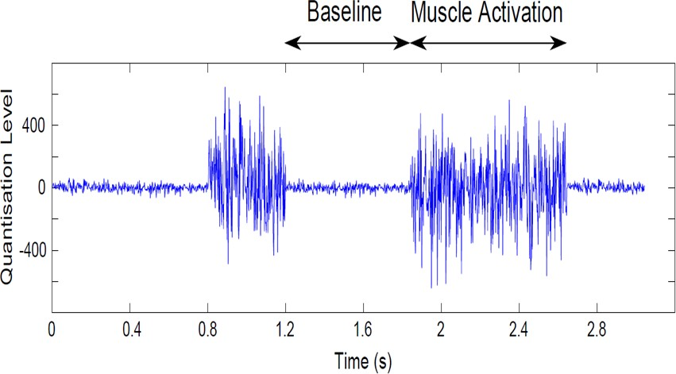
Figure2.1.1 EMG Signal
Surface electromyography (sEMG) finds diverse applications across various sectors due to its non-invasive ability to measure and analyse muscle activity. Here are several areas where sEMG is utilized.
    - Medical Assessments: sEMG aids in the diagnosis and monitoring of neuromuscular conditions such as muscular dystrophy and myasthenia gravis by examining irregular muscle activation patterns. Also, EMG offers real-time feedback on muscle activity during exercises, enabling therapists to tailor recovery programs for patients recuperating from surgeries or injuries.
    - Prosthetics: sEMG is used to develop intuitive control strategies for prosthetic limbs and assistive devices, allowing users to control devices using their residual muscle activity. The signals recorded by the electrodes act as input signals for the algorithm which in-turn controls the prosthetic limb.

and interfaces.
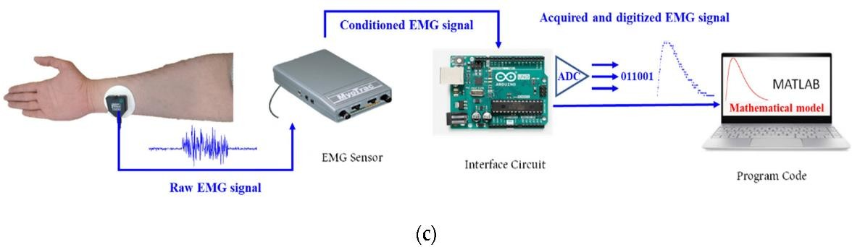
Figure 2.1.2 Human- Computer Interface

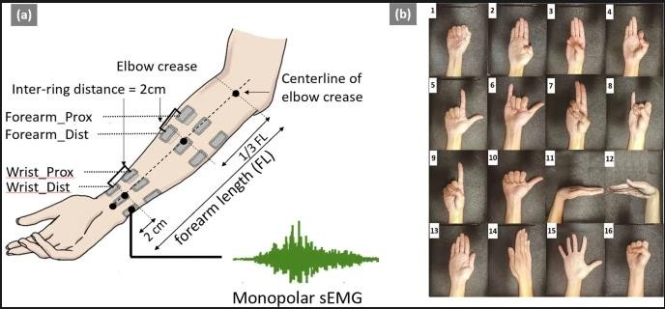

Related work
Figure 2.1.3 Hand-Gesture Recognition

In the related work published, the following inferences were drawn:
    - SVM models showed high classification accuracy, ranging from 86.67%- 98.9%. SVM models even though being a machine learning model, it performs at par with MLP.
    - In related work, the focus was on feature extraction rather than directly combining algorithms with SVM. Mean Absolute Value (MAV), Slope Sign Changes (SSC), Zero Crossings (ZC), and Waveform Length (WL) were frequently utilized for high accuracy results.
    - If appropriate number of channels are used to record the EMG signals, the classification accuracy increases. Also, for more complex task’s accuracy increases with the available number of channels.
    - To improve the classification accuracy, SVM parameters such as penalty factor ‘C’ and kernel function ‘δ’ are used in addition to the default parameters.

Understanding Data Structure:
The dataset comprised of 720 segments, each with 64 samples recorded from 320 channels across 5 set of electrodes. These segments were labelled to corresponding hand gestures namely first_slow, index_slow, rest_slow and twoFPinch_slow.
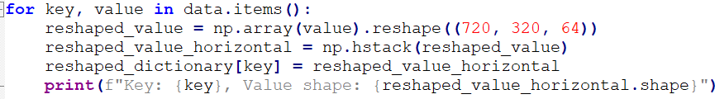

Filtering:
To remove unwanted noise and artifacts from the raw EMG signal, Butterworth filter is used as a bandpass filter with lower cut-off frequency as 20Hz and higher cut-off frequency as 500Hz. The sampling frequency is maintained at 2048 Hz. In addition to bandpass filtering, Notch filter is used to remove 50 Hz power interference. The power spectrum is plotted to see differences between original and filtered signals.
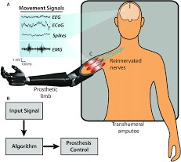

Figure 3.2.1 Prosthetics

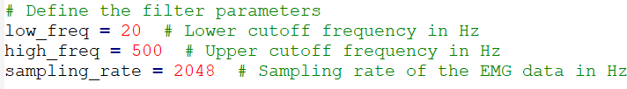

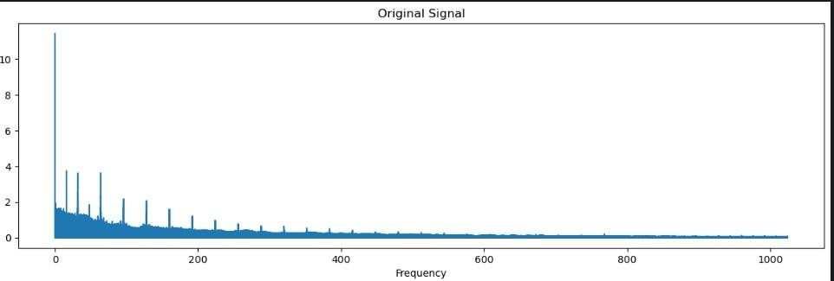
7

Figure 3.2.2 Orginal EMG Signal before filteration

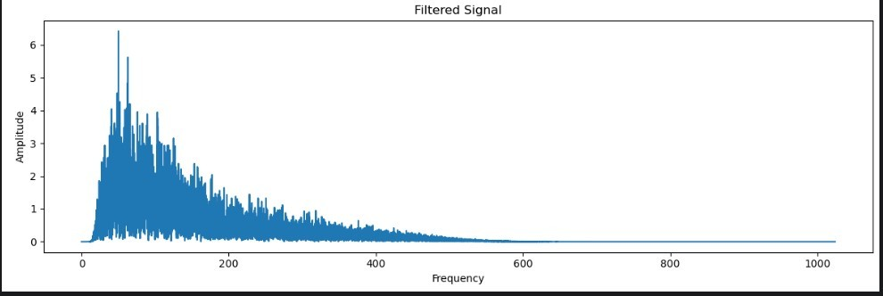

Figure 3.2.3 Filtered EMG Signal

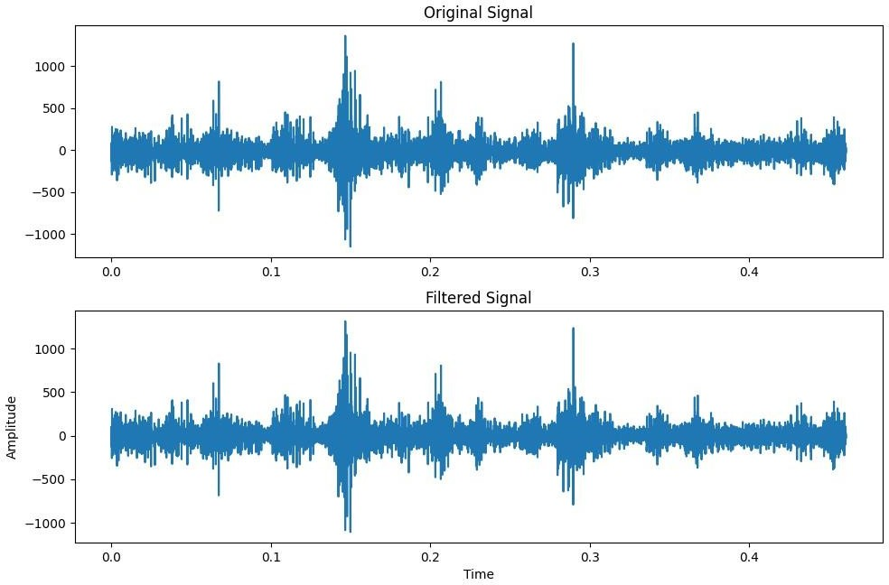

Figure 3.2.4 Power Spectrum of filtered and orginal EMG signal

8

SVM Model
Support Vector Machines (SVMs) offer a potent tool for effectively capturing intricate and non- linear patterns inherent in Electromyography (EMG) signals through the utilization of kernel functions.
One of the standout advantages of SVMs lies in their robustness when dealing with high- dimensional data. In the context of EMG signal analysis, where the feature spaces can become quite intricate, SVMs exhibit the ability to navigate these complex dimensions without succumbing to overfitting issues.
SVMs further demonstrate their prowess in achieving robust generalization even when presented with scant training data. This attribute proves particularly valuable in scenarios where the availability of training samples is limited, as SVMs can still attain remarkable accuracy.
In the realm of EMG signal processing, noise and artifacts frequently pose challenges. Here, SVMs showcase their robustness by remaining resilient against the presence of noise and artifacts, factors that often plague EMG signals. This resilience translates into dependable classification performance.
In conclusion, Support Vector Machines excel in capturing intricate non-linear patterns within EMG signals through kernel functions. Their robustness to high-dimensional data, aptitude for generalization with limited samples, resistance to noise and artifacts, and capacity to deliver interpretable results collectively underscore their suitability for EMG signal classification tasks.

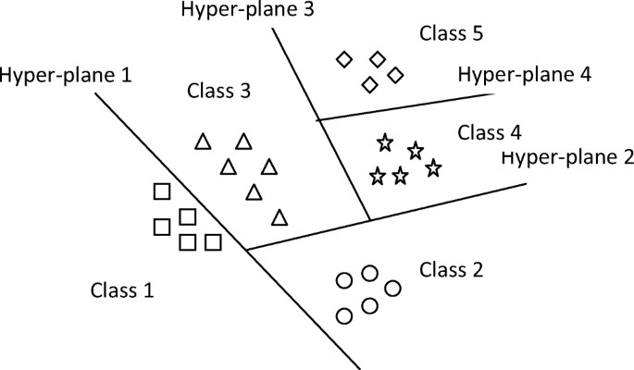
Figure 3.3.1 SVM model with one to many approach

9

Feature Extraction
The process of feature extraction from Electromyography (EMG) signals encompasses a wide array of techniques, each aimed at revealing distinct aspects of the underlying signal. This section delves into the multifaceted feature extraction methods, including time domain, frequency domain, autoregressive modelling, and wavelet transform, applied to EMG signal analysis.

Time Domain Features:
- Mean Absolute Value (MAV): Calculates the average absolute value, offering insights into signal magnitude and activity.
- Root Mean Square (RMS): Computes the square root of the average of squared values, characterizing energy distribution.
- Zero Crossing Rate (ZCR): Represents the rate of sign changes, providing information about signal dynamics.
- Waveform Length (WL): Cumulative length of the EMG signal, offering insights into signal complexity.
- Slope Sign Changes (SSC): Measures the count of slope sign changes, revealing signal curvature and transitions.

Frequency Domain Features:
- Power Spectrum: Distribution of power across frequency bands, aiding in identifying frequency-specific patterns.
- Median Frequency (MDF): Frequency where median power occurs, indicating central frequency distribution.
- Mean Frequency: Average frequency weighted by power spectrum, providing an overview of dominant frequencies.

Advanced Features:
- Autoregressive (AR) Modelling Features: Extracted 16 features with 8 real and 8 imaginary parts where the imaginary parts do not contribute to feature classification.
- AR Coefficients: Capture relationships between current and past EMG signal samples, revealing temporal dependencies.
- Wavelet Transform Features: Extracted 10 features.
- Wavelet Coefficients: Magnitudes of coefficients across different scales and positions, dissecting signal frequency content into sub-bands.

Individual Movement Features: For each of the movement categories "fist_slow," "twoPinch_slow," "index_slow," and "rest_slow," a set of 35 features has been derived, encompassing aspects from time domain, frequency domain, AR coefficients, and wavelet transform magnitudes.

10

By amalgamating time and frequency domain features with advanced techniques such as autoregressive modelling and wavelet transform, a comprehensive picture of the EMG signals emerges. Each feature type contributes a unique facet, ranging from signal magnitude and dynamics to frequency-specific attributes and temporal dependencies. Tailoring the feature extraction process to individual movement categories enriches our understanding of gesture- specific nuances.

Data Preprocessing for SVM Model
Before constructing a Support Vector Machine (SVM) model for accurate classification of movement categories using Electromyography (EMG) signals, an essential step is data preprocessing. This process involves transforming the raw features into a suitable format for training, testing, and validation.
Here it has the code snipet and the explanation
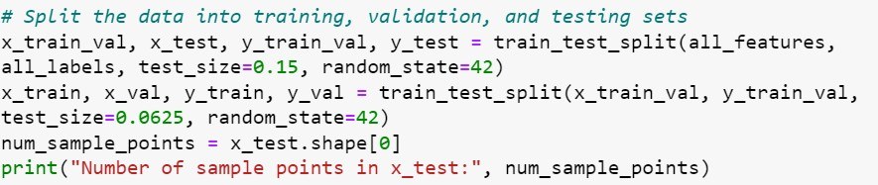
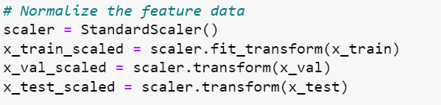

Feature Extraction and Dictionary Formation:
- all_features: A list containing a total of 35 features derived from both time and frequency domains.
- feature_matrix[movement]: The list of features for each specific movement category is converted into an array. These arrays constitute the values of a new dictionary, where each movement category corresponds to a unique key.
- all_labels: Corresponding movement labels are assigned to the keys of the dictionary. These labels will serve as the predicted output labels during model evaluation.

Standard Normalization: Data Split: The dataset is divided into distinct subsets for training, testing, and validation purposes.
New Dataset Creation: The all_features arrays become the input features (X values) for the SVM model, while the all_labels associated with each movement category are used as the target output labels (Y values).
By following this data preprocessing pipeline, we ensure that the extracted features are organized and prepared in a way that facilitates the training and evaluation of the SVM model.

11

Standard normalization guarantees that the data is appropriately scaled, preventing any undue influence of features with larger magnitudes on the model's performance. The division of the dataset into training, testing, and validation subsets is crucial for robust model evaluation and generalization.

Hyperparameter, Training & Evaluation
GridSearchCV is a technique for hyperparameter tuning, which is the process of finding the best combination of hyperparameters for a machine learning model.
Hyperparameters are parameters that are set before the learning process begins and are not learned from the data. They control the behaviour of the learning algorithm.
Our dataset is split into training, testing, and validation sets.
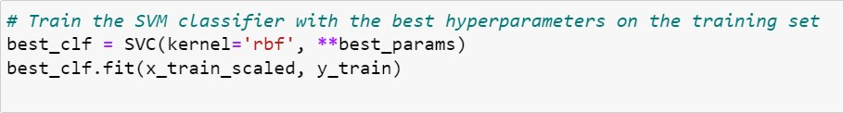

GridSearchCV performs an exhaustive search over a specified parameter grid to find the best hyperparameters with Validation data set. It uses cross-validation to evaluate the performance of different hyperparameter combinations and selects the best combination based on a specified evaluation metric. After the grid search is complete, these best hyperparameters represent the combination that yielded the highest performance during cross-validation.
SVM classifier with the RBF kernel, the parameter grid values with C and gamma, and the number of cross-validation folds (cv=5) has been used. Hyperparameters (C and gamma) are optimized using GridSearchCV.
1.Trained the SVM classifier with the best hyperparameters on the Training set. 2.Evaluated the Model on Testing Dataset.

Confusion Matrix
Confusion matrices visually represent model performance, showing the accuracy of classification across different movement intents.
For Our model, we have computed the confusion matrix and calculated below table for True positives, True Negatives, False Positives, False negatives. This indicates Our classifier has properly classified the four movements with True positives being quite high and False Positives or False Negatives shows quite low values.

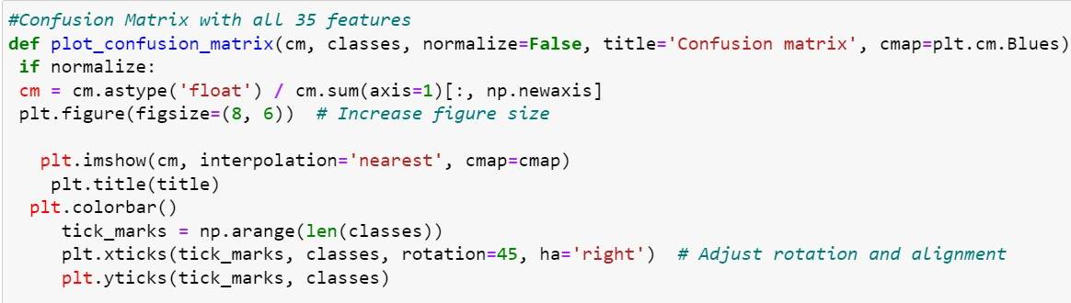
12

fist_slow index_slow
True Labels
rest_slow twoFPinch_slow

Normalised Confusion Matrix
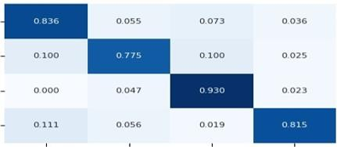
fist_slow index_slow rest_slow twoFPinch_slow
Predicted Labels

Labels | TP | TN | FP | FN
fist_slow | 0.836 | 2.309 | 0.182 | 0.164
index_slow | 0.775 | 3.6 | 0.2 | 0.225
rest_slow | 0.93 | 3.256 | 0.209 | 0.07
twoFPinch_sloW | 0.815 | 2.481 | 0.074 | 0.185

Figure 3.7.1 Confusion Matrix and Truth table with all 35 features

Comparing Time Domain & Frequency Domain Features
For better understanding and comparing the results we have computed the confusion matrix for only time domain features and only frequency domain features.

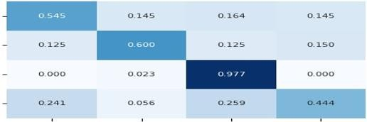
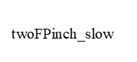
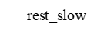
13
fist_slow index_slow

Normalised Confusion Matrix
True Labels

fist_slow index_slow rest_slow twoFPinch_slow
Predicted Labels

Labels | TP | TN | FP | FN
fist_slow | 0.545 | 2.164 | 0.327 | 0.455
index_slow | 0.6 | 3.5 | 0.3 | 0.4
rest_slow | 0.977 | 2.814 | 0.651 | 0.023
twoFPinch_sloW | 0.44 | 2.296 | 0.259 | 0.556

Figure 3.7.1.1 Confusion matrix and truth table with only the time domain features.

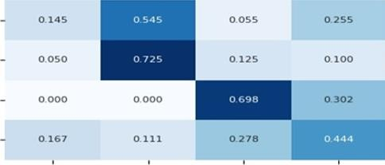
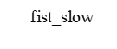
Normalised Confusion Matrix
index_slow
True Labels
fist_slow index_slow rest_slow twoFPinch_slow
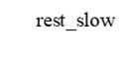
Predicted Labels

Labels | TP | TN | FP | FN
fist_slow | 0.145 | 2.291 | 0.2 | 0.855
index_slow | 0.725 | 2.9 | 0.9 | 0.275
rest_slow | 0.698 | 2.93 | 0.535 | 0.302
twoFPinch_sloW | 0.44 | 1.981 | 0.574 | 0.556

Figure 3.7.1.2 Confusion matrix and truth table with only the frequency domain features.

model, to visualize important features which is driving our model towards good performance achieving high scores. In this graphical representation we can clearly understand which of 35 features have maximum contribution to the classification model.
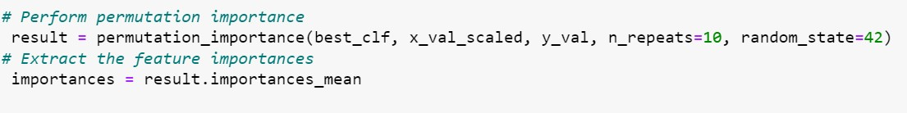

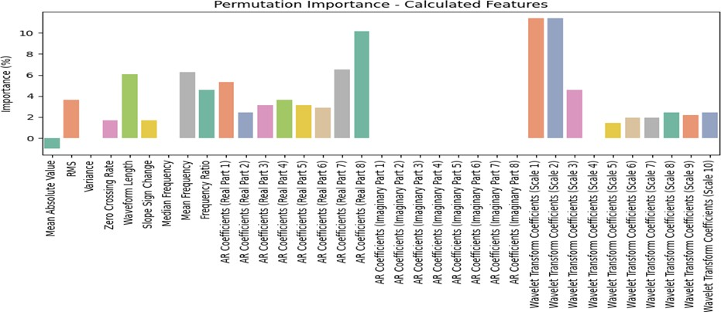

Figure 3.7.2.1 Feature Importance for classification

training, validation, and testing data are all relatively high and close to each other, it indicates that the model has learned well, is generalizing to new data, and is performing consistently on Day 1 EMG data.Examining Day 2 EMG data and laboratory test data highlights average performance for our model.
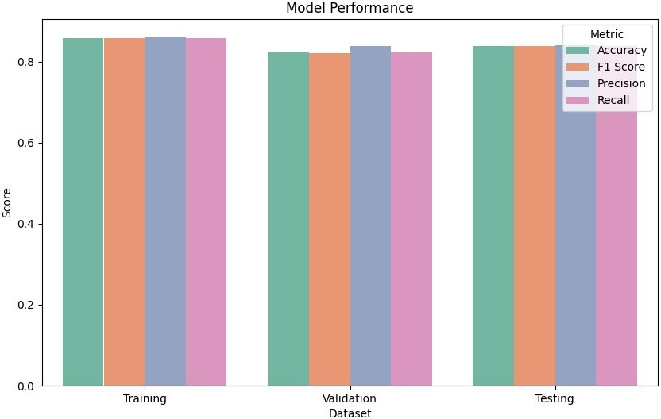

Figure 3.8.1 Model performance for day 1 EMG data
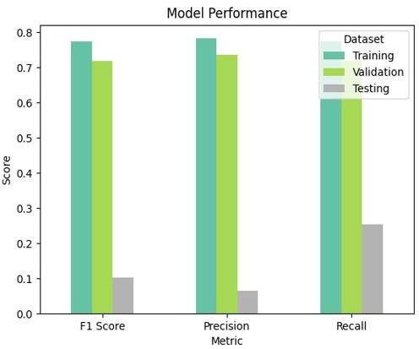

Figure 3.8.2 Model performance for Laboratory data

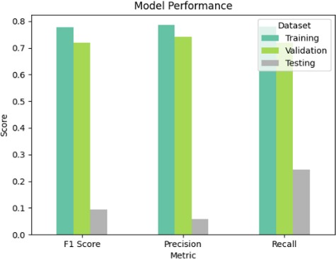

Figure 3.8.3 Model performance for day 2 EMG data

16

3.10 Performance Metrics
Performance metrics provide a comprehensive evaluation of the SVM model's accuracy and predictive capability across various scenarios. These metrics provide insights into how well the model is performing in terms of classification accuracy and its ability to correctly identify positive and negative instances. For our model, we have achieved high precision score, high recall as well high F1 score on Day 1 EMG data set. This indicates that our model is accurately identifying positive instances while minimizing false positives and false negatives. It's performing well in both classifying positives and negatives and finding a good balance between them.
- Accuracy = (True Positives + True Negatives) / Total Predictions
- Precision - It helps assess how well the model performs when it predicts a positive class.
  - Precision = True Positives / (True Positives + False Positives)
- Recall - It indicates the model's ability to correctly identify positive instances.
  - Recall = True Positives / (True Positives + False Negatives)
- F1-Score- It's a metric that considers both false positives and false negatives and is particularly useful when dealing with imbalanced datasets.
a. F1-Score = 2 * (Precision * Recall) / (Precision + Recall)

Class | Precision | Recall | F1-Score | Accuracy
fist_slow | 0.821428571 | 0.836363636 | 0.828828890 | 0.8385416666
index_slow | 0.794871794 | 0.775 | 0.784810126 | 0.8385416666
rest_slow | 0.816326530 | 0.93023255 | 0.869565217 | 0.8385416666
twoFPinch_slow | 0.916666666 | 0.81481481 | 0.862745098 | 0.8385416666

Figure 3.10.1 Performance of our Model with EMG Day 1 data.

4. Results
For Day1 EMG dataset, after analyzing all the features along with computing Feature Importance where we could identify some dominant features, Finally we got best F1,Recall, Precision and Accuracy Score when considered all the 35 features together.
Day 2 EMG data and laboratory test data highlights average performance for our model paving the path for model enhancement and adaptation given if more refined EMG signal analysis and decoding.
Realtime Implementation-
- Chunk of Data-(100:200,50:100,20:40)
- Feature Extracted
- SVM Model
- Predicted Labels
- Metrics Calculated on Test Data
Performance evaluated-
- Accuracy-0.845
- F1 Score-0.844
- Precision-0.849
- Recall-0.843

- Conclusion
In conclusion, the integration of Support Vector Machine (SVM) models with advanced feature extraction techniques has proven to be highly effective in accurately decoding hand gestures from EMG signals. The remarkable overall accuracy of 83.53% achieved by the SVM model across all 35 features showcases its robust classification capability. Moreover, the precision of 83.8% and recall of 84.25% highlight the model's proficiency in minimizing false positives and reliably identifying positive samples.
The impressive F1-score of 83.77% further emphasizes the model's consistency in distinguishing between the four labels while also mitigating misclassifications. Notably, the model's performance remained consistent when tested on Day 2 EMG data and laboratory test data, demonstrating its adaptability and reliability in real-world scenarios.

- Abougarair, A.J., Shashoa, N.A.A., Elmelhi, A.M., & Gnan, H.M. (2022). Real Time Classification for Robotic Arm Control Based Electromyographic Signal. In 2022 IEEE 2nd International Maghreb Meeting of the Conference on Sciences and Techniques of Automatic Control and Computer Engineering (MI-STA) (pp. 155-160). Sabratha, Libya. DOI: 10.1109/MI-STA54861.2022.9837703.
- Basak, H., Roy, A., Lahiri, J.B., Bose, S., & Patra, S. (2021). SVM and ANN based Classification of EMG signals by using PCA and LDA. ArXiv. Retrieved from https://arxiv.org/abs/2110.15279
- Cai, S., Chen, Y., Huang, S., Wu, Y., Zheng, H., Li, X., & Xie, L. (2019). SVM-Based Classification of sEMG Signals for Upper-Limb Self-Rehabilitation Training. Frontiers in Neurorobotics, 13, 453955. https://doi.org/10.3389/fnbot.2019.00031
- Toledo-Pérez, D.C., Rodríguez-Reséndiz, J., Gómez-Loenzo, R.A., & Jauregui-Correa, J.C. (2019). Support Vector Machine-Based EMG Signal Classification Techniques: A Review. Applied Sciences, 9(20), 4402. https://doi.org/10.3390/app9204402
- https://towardsdatascience.com/support-vector-machines-svms-important- derivations-4f50d1e3d4d2
- https://towardsdatascience.com/a-three-level-sentiment-classification-task- using-svm-with-an-imbalanced-twitter-dataset-ab88dcd1fb13

