

Debagnik Kar (1804373) (ETC-06)

School of electronics engineering,  KIIT Deemed to be University

**Laboratory record Communication engineering lab (ec 2094) AUTUMN 2020**

**Index Page**

|  |  |  |  |  |
| --- | --- | --- | --- | --- |
| Experiment No. | Aim of the Experiment | Date of Experiment | Date of Submission | Faculty Remarks |
| 01 | Generation and detection of Amplitude Modulation and Demodulation, DSBSC and SSB-SC modulation. | 03/08/2020 | 17/08/2020 |  |
| 02 | Study of Frequency modulation and Demodulation Techniques. |  |  |  |
| 03 | Generation and detection of PAM, PWM and PPM techniques |  |  |  |
| 04 | Study of Pulse Code Modulation (PCM) and demodulation. Multiplexing of signal using Time Division Multiplexing (TDM) technique. |  |  |  |
| 05 | Generation and detection of Delta modulation Technique |  |  |  |
| 06 | (i) Study of different Data formatting techniques.  (ii)Generation and Detection of Amplitude Shift Keying (ASK) |  |  |  |
| 07 | (i) Generation and Detection of Frequency Shift Keying (FSK).  (ii)Generation and Detection of Binary Phase Shift Keying (BPSK) |  |  |  |
| 08 | Generation and Detection of Quadrature Phase Shift Keying (QPSK). |  |  |  |
| 09 | Open Ended Experiment-1 |  |  |  |
| 10 | Open Ended Experiment-2 |  |  |  |

|  |  |
| --- | --- |
| **Experiment Number** | 01 |
| **Date of Experiment** | 03/08/2020 |
| **Date of Submission** | 17/08/2020 |
| **Name of the student** | Debagnik Kar |
| **Roll Number** | 1804373 |
| **Section** | ETC-06 |

**Aim of The Experiment :-**

Generation and detection of Amplitude Modulation and Demodulation, DSBSC and SSB-SC modulation.

**Equipment / Software Required:-**

* Matlab R2018a

**Theory:**

Amplitude modulation: AM is a modulating technique which is generally used to transmit Radio signals over a carrier signal, where the amplitude of the modulated changes in response of the signal.

Mathematically,

If the carrier signal is,

And the message signal is,

Then the equation of the modulated signal is,

If we solve this equation further, we get,

,

Modulating Index(µ), also known as modulation depth, of a modulation scheme describes by how much the modulated variable of the carrier signal varies around its unmodulated level. It is defined differently in each modulation scheme.

DSBSC: The transmission of a signal, which contains a carrier along with two sidebands can be termed as Double Sideband Full Carrier system or simply DSBSC.

Mathematically,

If the carrier Signal is,

And the message signal is,

Then the modulating signal will be,

**SSBSC:** The process of suppressing one of the sidebands along with the carrier and transmitting a single sideband is called as Single Sideband Suppressed Carrier system or simply SSBSC.

Mathematically,

If the carrier Signal is,

And the message signal is,

Then the modulating signal will be,

**Code:-**

<<<File: GenerateAM.m Comment: This code will amplitude modulate and then demodulate a sine wave.>>>

%generating user defined AM Signals

%Written By Debagnik Kar 1804373

clc;

clear all;

close all;

t = linspace(0,1,1000) %Time of 1 secs divided by 1000 times

%Carrier wave

fc = input('Enter fc = ')

ac = input('Enter ac = ')

xc= cos(2*pi*fc*t)

%Message signal

fm = input('Enter fm = ');

am = input('enter am = ');

xm = cos(2*pi*fm*t);

%AMplitude modulation

y = [ac + am*xm].*xc;

%plot AM

subplot(4,1,1)

plot(t,xc);

xlabel("Time -->")

ylabel("Amplitude -->")

title("Carrier Wave")

subplot(4,1,2)

plot(t,xm)

xlabel("Time -->")

ylabel("Amplitude -->")

title("Message Wave")

subplot(4,1,3)

plot(t,y)

xlabel("Time -->")

ylabel("Amplitude -->")

title("Modulated Wave")

%if else statement

mu = am/ac;

if mu==1

disp('Critical modulation');

elseif mu>1

disp('Over modulated signal');

elseif mu<1

disp('under modulated signal');

end

%Demodutating The wave

dm = y.^2;

[b,a] = butter(10,0.1);

xd = filter(b,a,dm);

subplot(4,1,4)

plot(t,xd);

xlabel("Time -->")

ylabel("amplitude")

title("Demodulated Wave")

<<<File:DSBSC.m Comment: This code will generate a DSBCS Modulated signal>>>

%DSBCS Generation

%Written by Debagnik Kar 1804373

clc;

clear all;

close all;

t = linspace(0,4,1000);

fc = input('Enter the carrier frequency: ')

ac = input('Enter the carrier amplitude: ')

fm = input('Enter the message frequency: ')

am = input('Enter the message amplitude: ')

y = am*cos(2*pi*fm*t) %message signal

z = ac*cos(2*pi*fc*t) %carrier signal

w = ((am*ac)/2).*(cos(2*pi*(fc+fm)*t)+cos(2*pi*(fc-fm)*t)) %DSBSC Modulation

subplot(3,1,1)

plot(t,z)

xlabel("time -->")

ylabel("magnitude -->")

title("Carrier Signal")

subplot(3,1,2)

plot(t,y)

xlabel("time -->")

ylabel("magnitude -->")

title("Message Signal")

subplot(3,1,3)

plot(t,w)

xlabel("time -->")

ylabel("magnitude -->")

title("DSBSC Signal")

<<<File: SSBSC.m Comment: Generates an upper sideband, a lower side band SSBSC>>>

% Generation of SSB-SC Signal

% Written by Debagnik Kar

clear all

close all

clc

fc = input('Enter the frequency of Carrier: ')

ac = input('Enter the amplitude of Carrier: ')

fm = input('Enter the frequency of Message: ')

am = input('Enter the amplitude of Message: ')

t = linspace(0,1,1000)

m = am*cos(2*pi*fm*t) %Message signal

c = ac*cos(2*pi*fc*t) %carrier Signal

Susb = ((am*ac)/2).*cos(2*pi*(fc+fm)*t) %upper Sideband

Slsb = ((am*ac)/2).*cos(2*pi*(fc-fm)*t) %lower Sideband

subplot(4,1,1)

plot(t,c,'r')

xlabel("Time -->")

ylabel("Amplitude-->")

title("Carrier Wave")

subplot(4,1,2)

plot(t,m,'g')

xlabel("Time -->")

ylabel("Amplitude-->")

title("Message Wave")

subplot(4,1,3)

plot(t,Susb,'b')

xlabel("Time -->")

ylabel("Amplitude-->")

title("Upper Sideband SSB-SC Signal")

subplot(4,1,4)

plot(t,Slsb,'k')

xlabel("Time -->")

ylabel("Amplitude-->")

title("Lower Sideband SSB-SC Signal")

**Output/Graph:-**

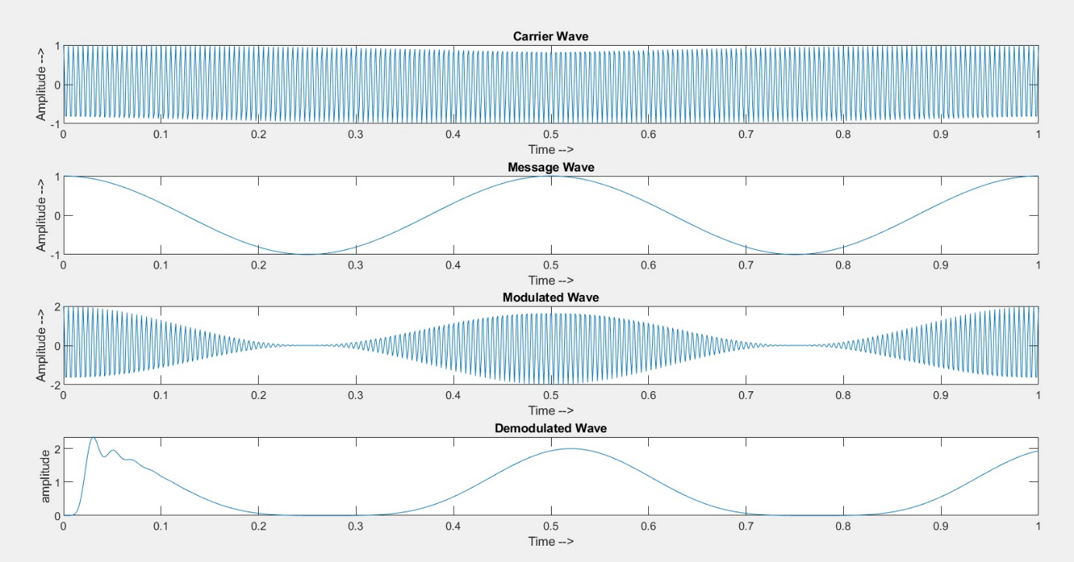

*Fig 1 : Amplitude modulating and Demodulating a Sine wave of 2Hz*

*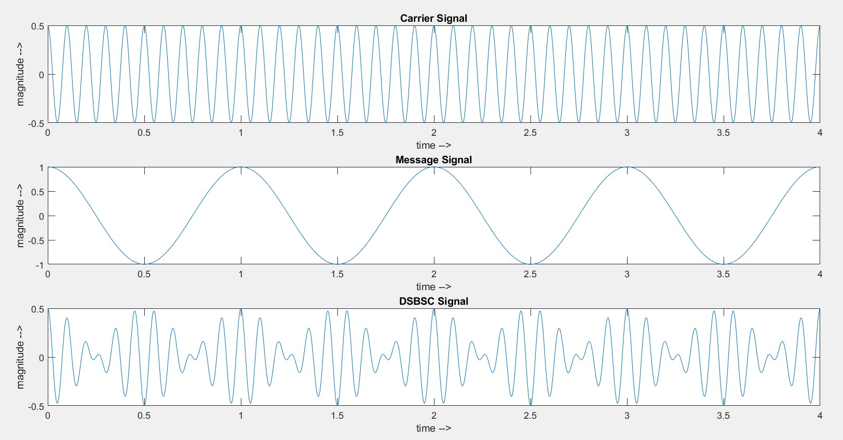Fig 2: Generation of DSBSC Signal*

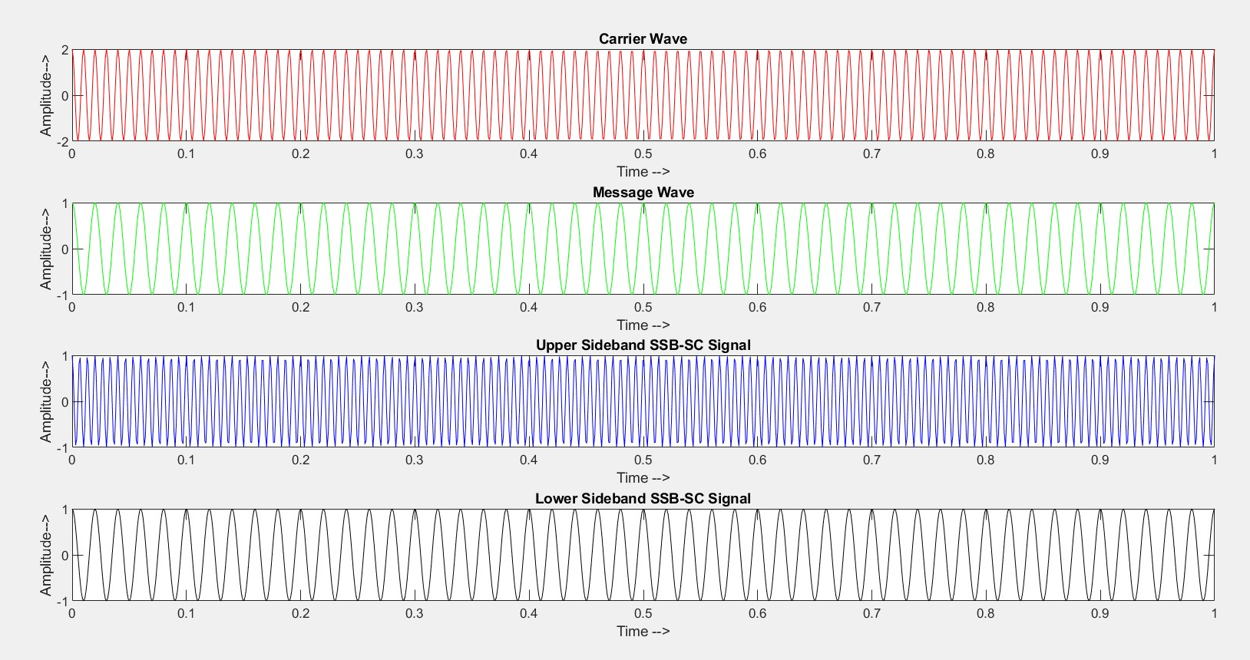

*Fig 3: Generation of SSBSC Signal*

**Discussion or Inference of the experiment**

This experiment taught me about different kind of amplitude modulation and demodulation techniques that is practiced in analog radio communication technology. It also helped me visualize the difference between the different techniques of transmission

**Conclusion:-**

The simulation of experiment is done successfully using MATLAB Software.