**. Install Ansible in any server or jenkins server.**

**. Need to install Ansible plugin from Manage Plugin.**

# Manage Jenkins --> Manage Plugins

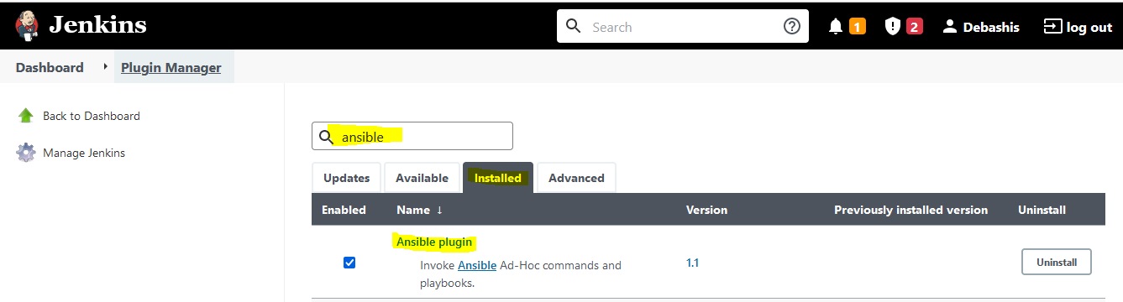

**. Need to configure Ansible into Global Tool Configuration**

# Manage Jenkins --> Global Tool Configuration

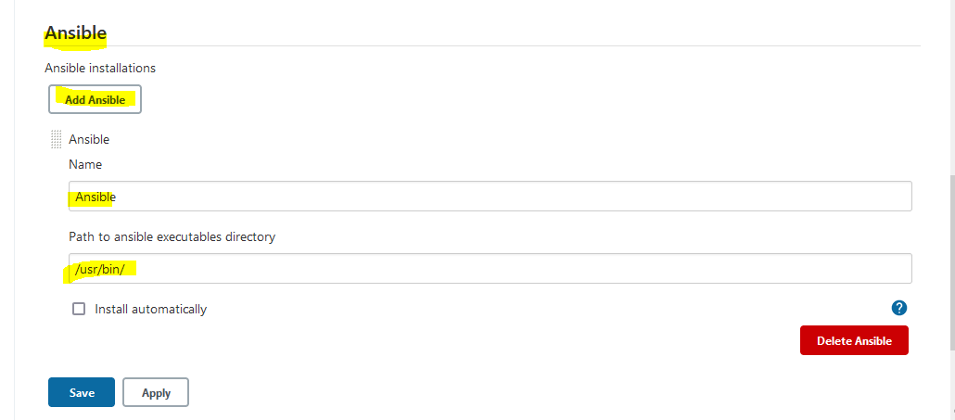

** For Path to ansible executables directory go to ansible server and run the command:

**# which ansible**



**. Create a task using pipeline**

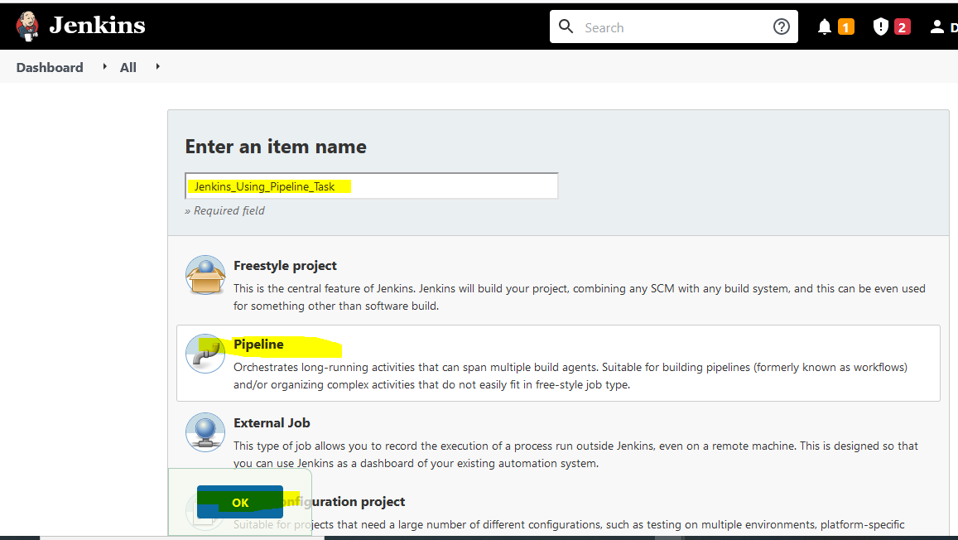

**. Go to [Pipeline Syntax](http://192.168.56.106:8080/job/Jenkins_Using_Pipeline/pipeline-syntax" \t "http://192.168.56.106:8080/job/Jenkins_Using_Pipeline/_blank) and generate pipeline script**

***Ansible tool***

--> Ansible

***Playbook file path in workspace***

--> /opt/httpd.yaml

***Inventory file path in workspace***

--> /etc/ansible/hosts

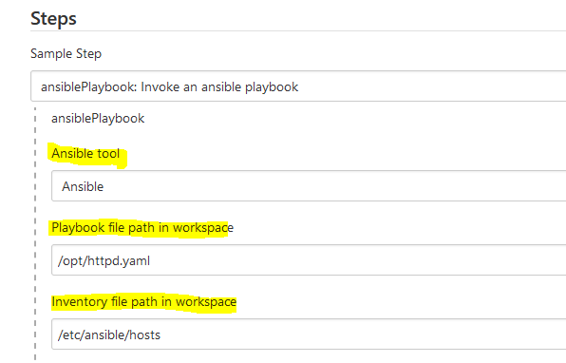

***SSH connection credentials***

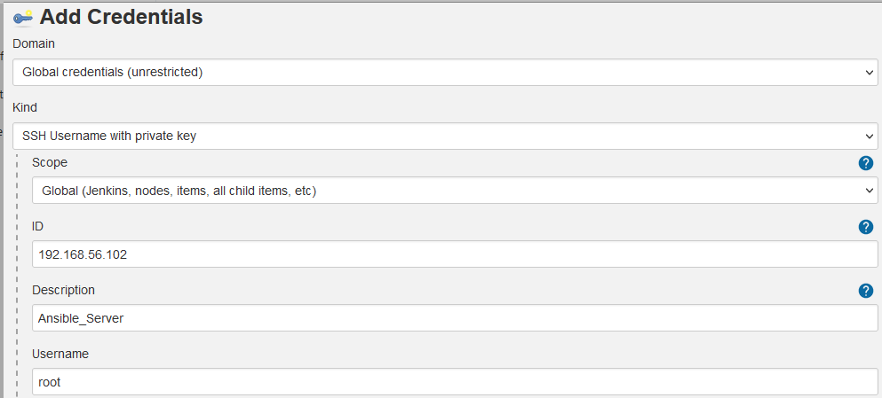

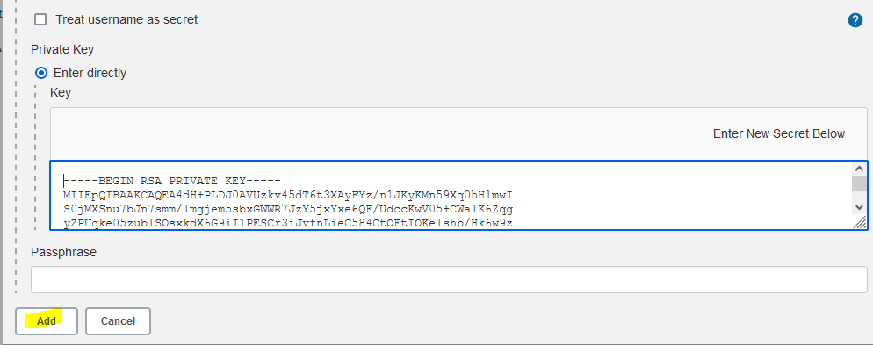

** For private key, go to the root home directory and copied id_rsa value from /root/.ssh

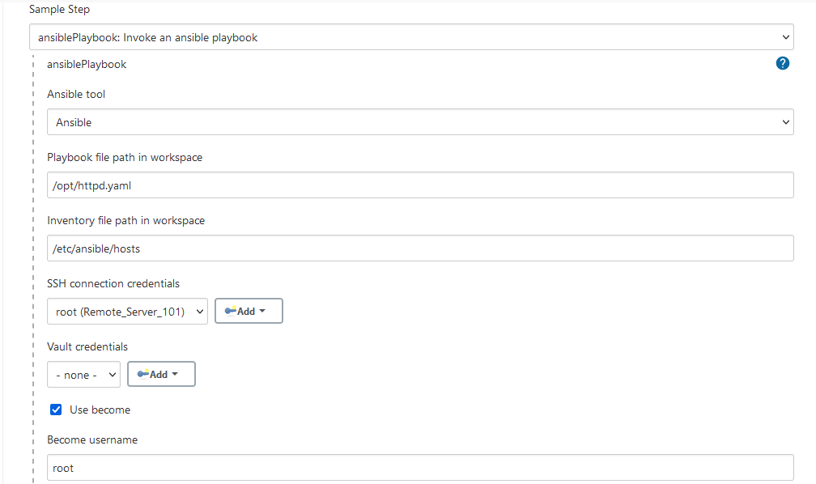

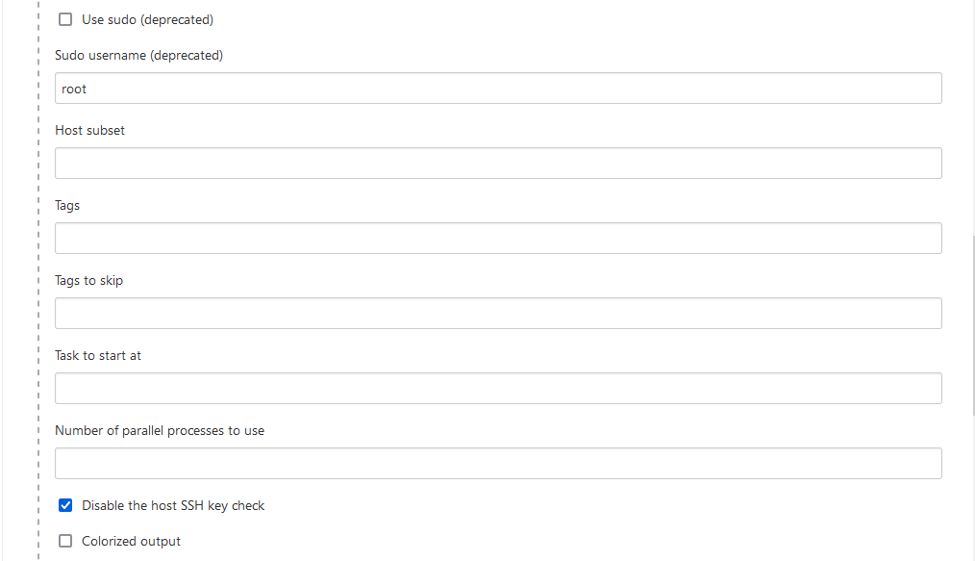

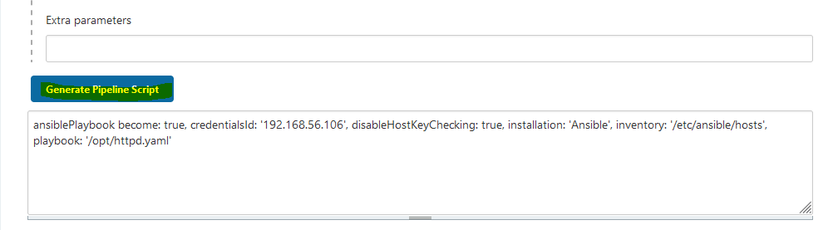

**. Now need to create pipeline script for the task**

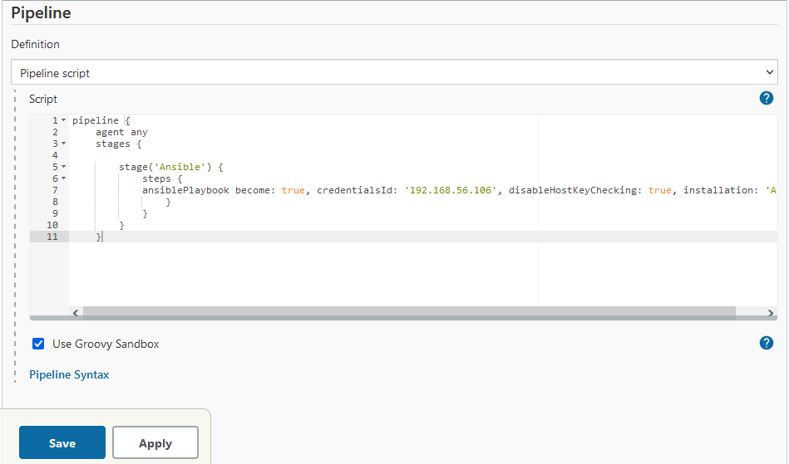

pipeline {

agent any

stages {

stage('Ansible') {

steps {

ansiblePlaybook become: true, credentialsId: '192.168.56.106', disableHostKeyChecking: true, installation: 'Ansible', inventory: '/etc/ansible/hosts', playbook: '/opt/httpd.yaml'

}

}

}

}

**. Now click on Build now**

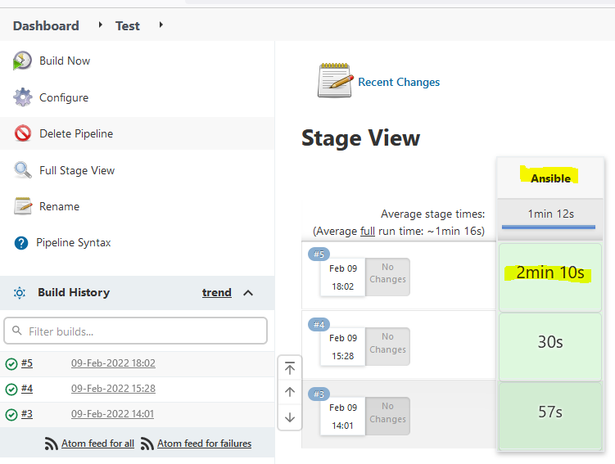

**. Console Output**

