Customer Segmentation using K-Means Clustering – Project Report & Business Insights

Group-B

Team Member Contribution
Team Member UID No. Contribution
- Koustab Ghosh | TNU2024021100001 | Implemented the machine learning model, data preprocessing, and code development.
- Rebangshu DUBEY | TNUR20251053039 | Assisted in machine learning implementation, data analysis, and code validation.
- Debajyoti Sardar | TNU2024021100005 | Prepared the project report, documentation, and business analysis.
- Rahul Mondal | TNU2024021100016 | Designed and prepared the project presentation (PPT).

Introduction
Customer segmentation is a powerful marketing analytics technique that enables businesses to group customers based on similar characteristics such as age, annual income, spending behavior, and membership duration. Instead of treating every customer the same, organizations can use these segments to develop personalized marketing strategies, improve customer satisfaction, increase customer retention, and optimize business performance.
In this project, K-Means Clustering, an Unsupervised Machine Learning algorithm, is used to identify meaningful customer groups without the need for a target variable. The project involves data preprocessing, exploratory data analysis (EDA), feature scaling using StandardScaler, determining the optimal number of clusters through the Elbow Method, and building a K-Means clustering model to segment customers effectively. Finally, the identified clusters are analyzed to generate business insights and recommend targeted marketing strategies, demonstrating how machine learning can support data-driven decision-making in modern retail businesses.

Business Problem
In today's competitive retail market, businesses collect large volumes of customer data but often fail to utilize it effectively. As a result, many companies apply the same marketing strategies to all customers, regardless of their purchasing behavior, income level, or loyalty. This generic approach leads to low customer engagement, reduced marketing efficiency, unnecessary promotional costs, and missed revenue opportunities.
The primary business challenge is to identify customers with similar characteristics so that personalized marketing campaigns can be developed. By analyzing customer demographics, annual income, spending patterns, and membership duration, the company can better understand different customer groups and tailor its products, services, and promotional offers accordingly.
To address this problem, this project uses the K-Means Clustering algorithm to segment customers into meaningful groups. The identified customer segments enable the business to implement targeted marketing strategies, improve customer satisfaction, increase customer retention, optimize marketing return on investment (ROI), and support data-driven decision-making.
Proposed Solution
To address the identified business problem, the following approach was implemented:
- Collect and preprocess the customer dataset by handling missing values, removing duplicates, and encoding categorical variables.
- Perform Exploratory Data Analysis (EDA) to understand customer demographics, spending patterns, and relationships between features.
- Apply StandardScaler to normalize numerical features, ensuring accurate distance-based clustering.
- Use the Elbow Method to determine the optimal number of customer clusters for the K-Means algorithm.
- Build the K-Means Clustering model to group customers with similar characteristics into meaningful segments.
- Analyze each customer segment based on age, annual income, spending score, and membership duration to understand customer behavior.
Project Objectives
The primary objectives of this project are to:
- Understand the concept and importance of Customer Segmentation in marketing analytics.
- Apply K-Means Clustering, an Unsupervised Machine Learning algorithm, to group customers with similar characteristics.
- Perform data preprocessing, including data cleaning, handling missing values, and encoding categorical variables.
- Conduct Exploratory Data Analysis (EDA) to identify customer behavior and data patterns.
- Apply feature scaling using StandardScaler to improve clustering accuracy.
- Determine the optimal number of clusters using the Elbow Method.
- Analyze and interpret the characteristics of each customer segment.
- Generate business insights and recommend targeted marketing strategies based on the identified customer groups.
Technology Stack
- Programming Language: Python
- Development Environment: Jupyter Notebook
Libraries Used
- NumPy – Numerical computations
- Pandas – Data manipulation and analysis
- Matplotlib – Data visualization
- Seaborn – Statistical data visualization
- Scikit-learn (sklearn) – Machine Learning algorithms and preprocessing
  - StandardScaler – Feature scaling
  - LabelEncoder – Categorical data encoding
  - KMeans – Customer segmentation using clustering
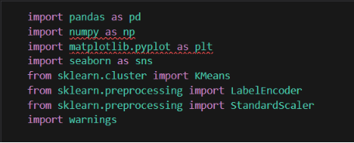

Dataset Description
The dataset used in this project contains customer demographic and purchasing information collected by a retail company. It is designed to analyze customer behavior and identify meaningful customer segments using the K-Means Clustering algorithm. Since this is an Unsupervised Machine Learning project, the dataset does not contain a target variable or class label.
Dataset Features
Feature | Description
Customer ID | Unique identifier assigned to each customer.
Age | Age of the customer (in years).
Gender | Gender of the customer (Male/Female).
Annual Income | Annual income of the customer.
Spending Score | Score (1–100) assigned based on the customer's spending behavior.
Membership Years | Number of years the customer has been associated with the company.
City | Customer's city of residence.
Preferred Category | Product category most frequently purchased by the customer.

Load the Dataset
Loaded the customer dataset into a Pandas DataFrame using read_csv() to begin the analysis.
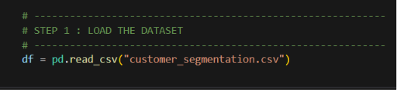

We perform these operations with this dataset
- Display the first five rows.
- Display the last five rows.
- Check dataset dimensions.
- Display column names.
- Understand data types.
- Generate descriptive statistics.

Answers the Questions
- How many customers are in the dataset?
  - 476500
- Which columns are numerical?
  - 'Customer ID', 'Age', 'Annual Income', 'Spending Score', 'Membership Years'.
- Which columns are categorical?
  - 'Gender', 'City', 'Preferred Category'
- Which features will be used for clustering?
  - 'Age', 'Annual Income', 'Spending Score', 'Membership Years'
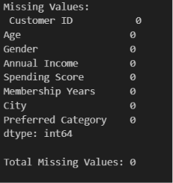
Data Cleaning
Step 1: Handle Missing Values
- Identify missing values.
- Count missing records.
- Fill or remove missing values using appropriate techniques.
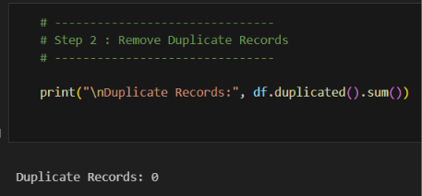
Step 2: Remove Duplicate Records
- Check for duplicate customer records.
- Remove duplicates if found.

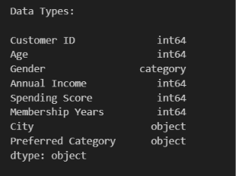
Step 3: Check Data Types
Ensured that:
- Age is numeric.
- Annual Income is numeric.
- Spending Score is numeric.
- Membership Years is numeric.
- Gender is categorical.
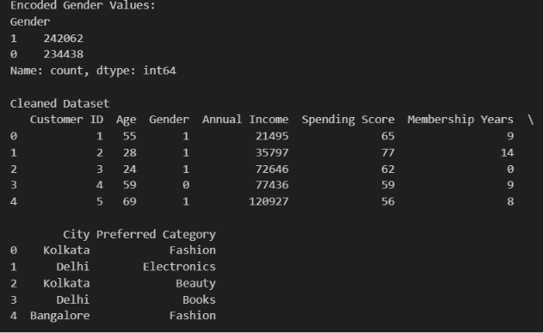
Step 4: Encode Categorical Variables
Convert categorical variables into numerical values using:
- Label Encoding
- One-Hot Encoding (optional)

EDA (Exploratory Data Analysis)
Exploratory Data Analysis (EDA) is the process of examining and visualizing data to understand its characteristics, identify patterns, and prepare it for machine learning.
Visualization 1: Customer Age Distribution
Questions
- Which age group has the highest number of customers?
  - 70
- Is the customer base mostly young or older adults?
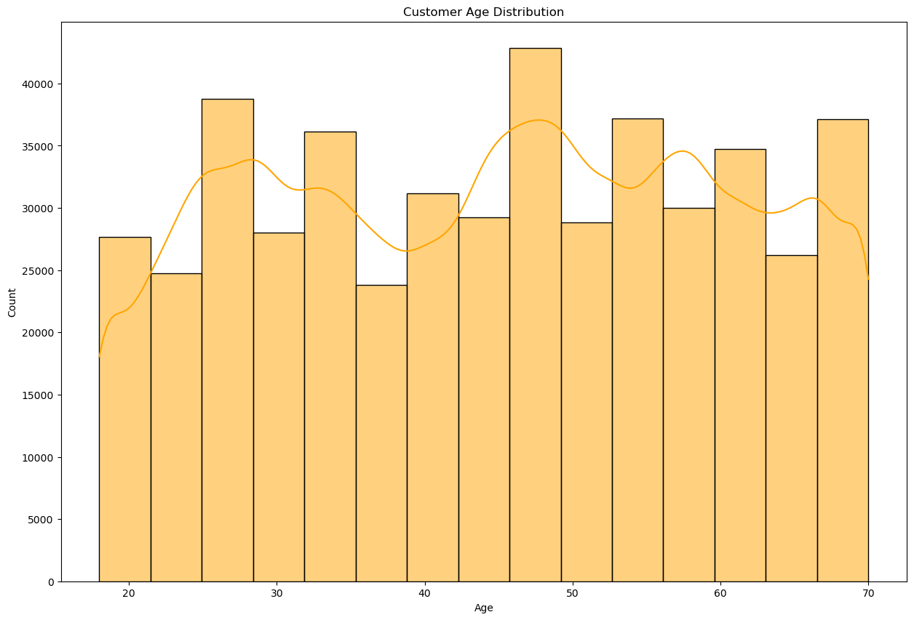
  - 44.7

Visualization 2: Annual Income Distribution
Questions
  - What income range is most common?
  - 83091
  - Are there high-income outliers?
  - 171026
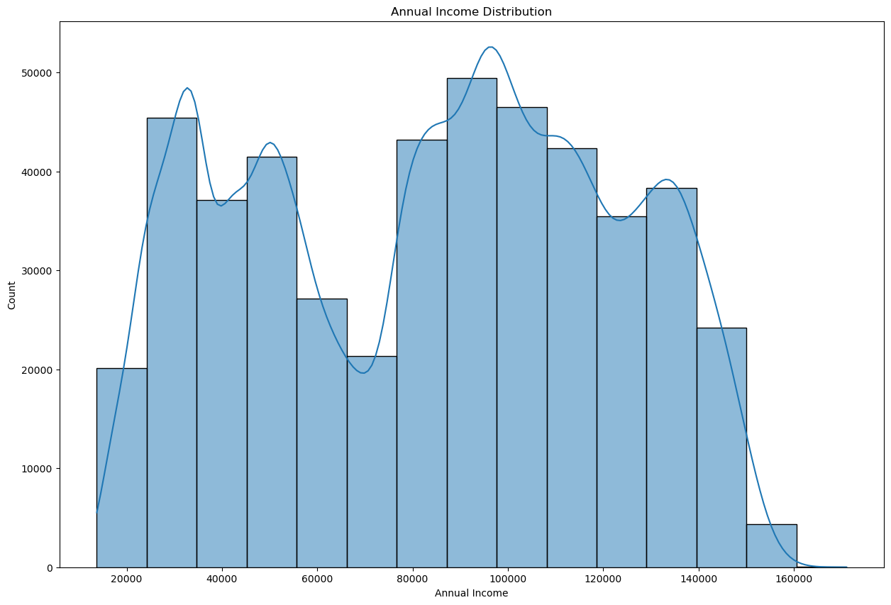

Visualization 3: Spending Score Distribution
Questions
- Do most customers have low or high spending scores?
  - Most customers have moderate spending scores, with an average of 55.48, indicating balanced purchasing behavior.
- Is spending evenly distributed?
  - Yes, the spending scores are fairly evenly distributed across the full range of 1 to 100, showing a mix of low, medium, and high spenders.
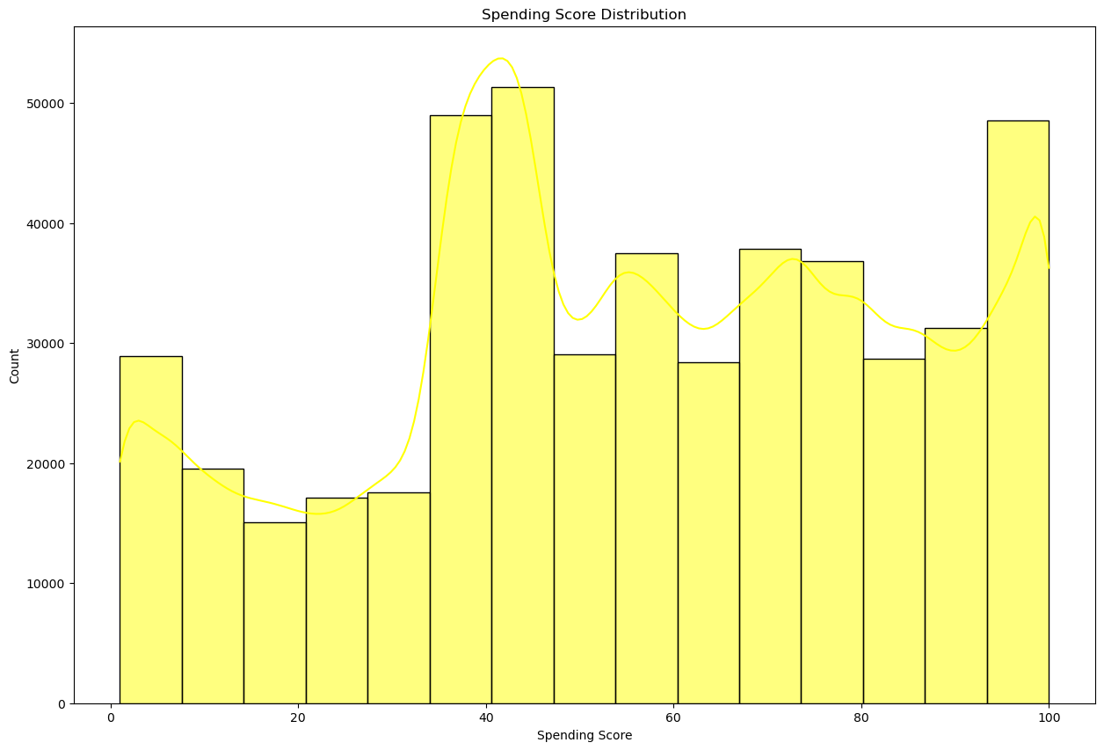
Visualization 4: Gender Distribution
Questions
- What percentage of customers are male and female?
  - Female : 50.8 %
  - Male : 49.2%
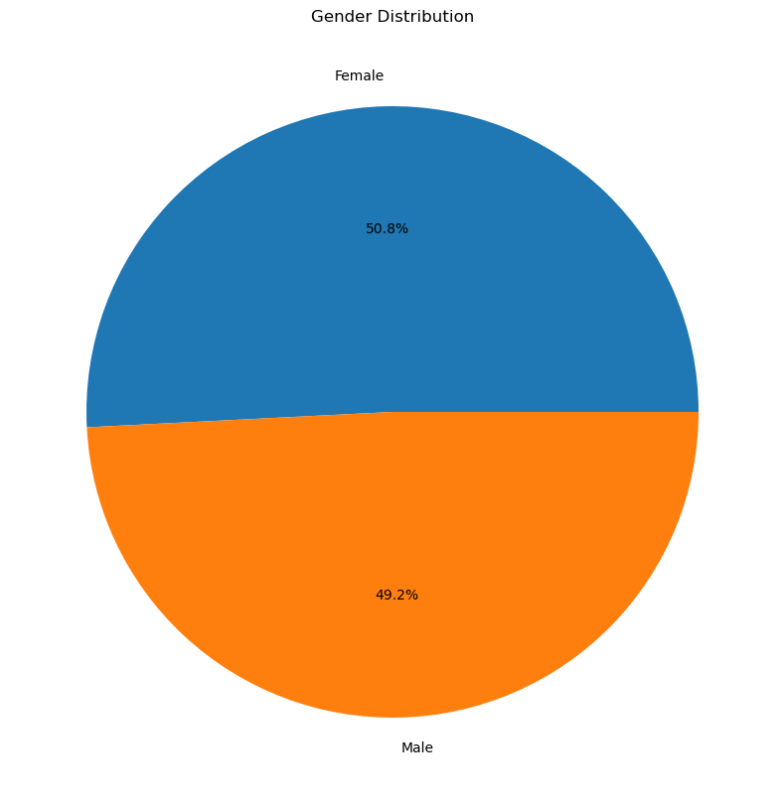

Visualization 5: Income vs Spending Score
Questions
- Do higher-income customers always spend more?
  - No. The weak positive correlation (0.19) indicates that higher income does not necessarily result in higher spending.
- Can you visually identify customer groups?
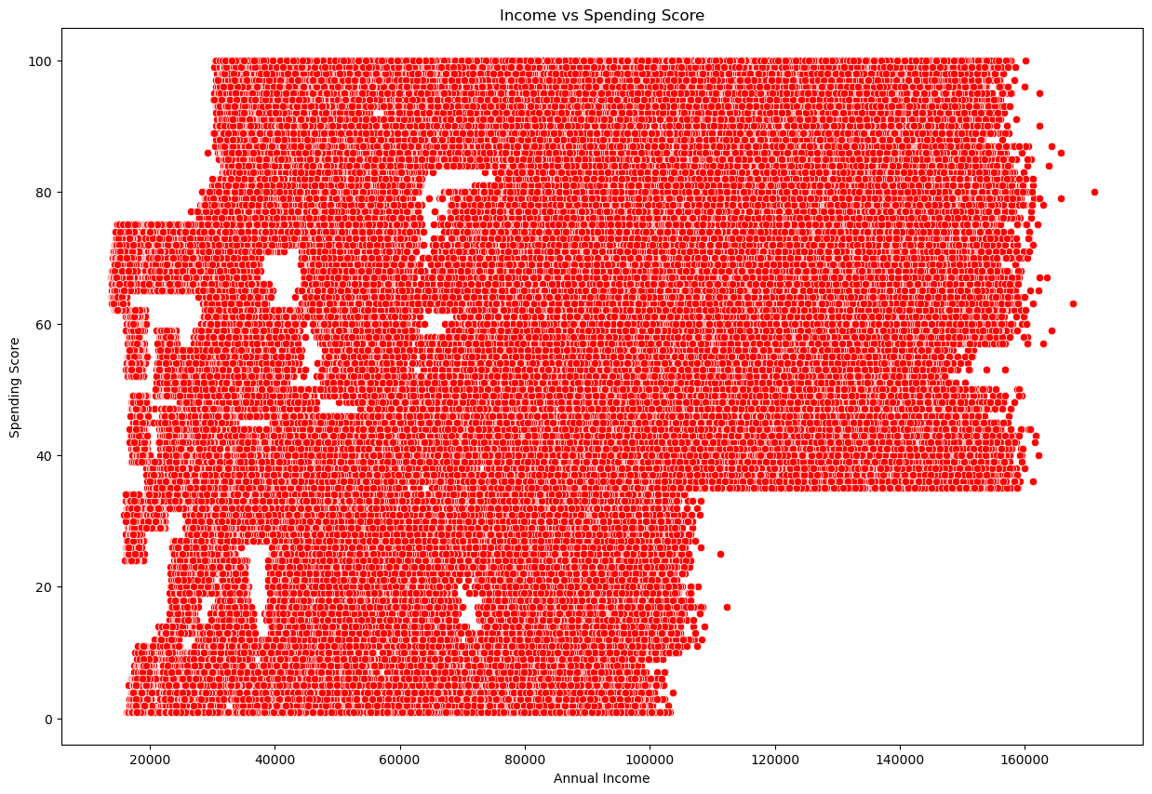
  - Yes. Different customer groups can be visually observed in the scatter plot based on their income and spending score patterns.

Visualization 6: Membership Years Analysis
Questions
- How long have customers stayed with the company?
  - Customers have stayed with the company for an average of 7.7 years, with the longest membership being 16 years.
- Are long-term customers spending more?
  - No clear relationship is observed between membership duration and spending; further analysis is required to confirm whether long-term customers spend more.
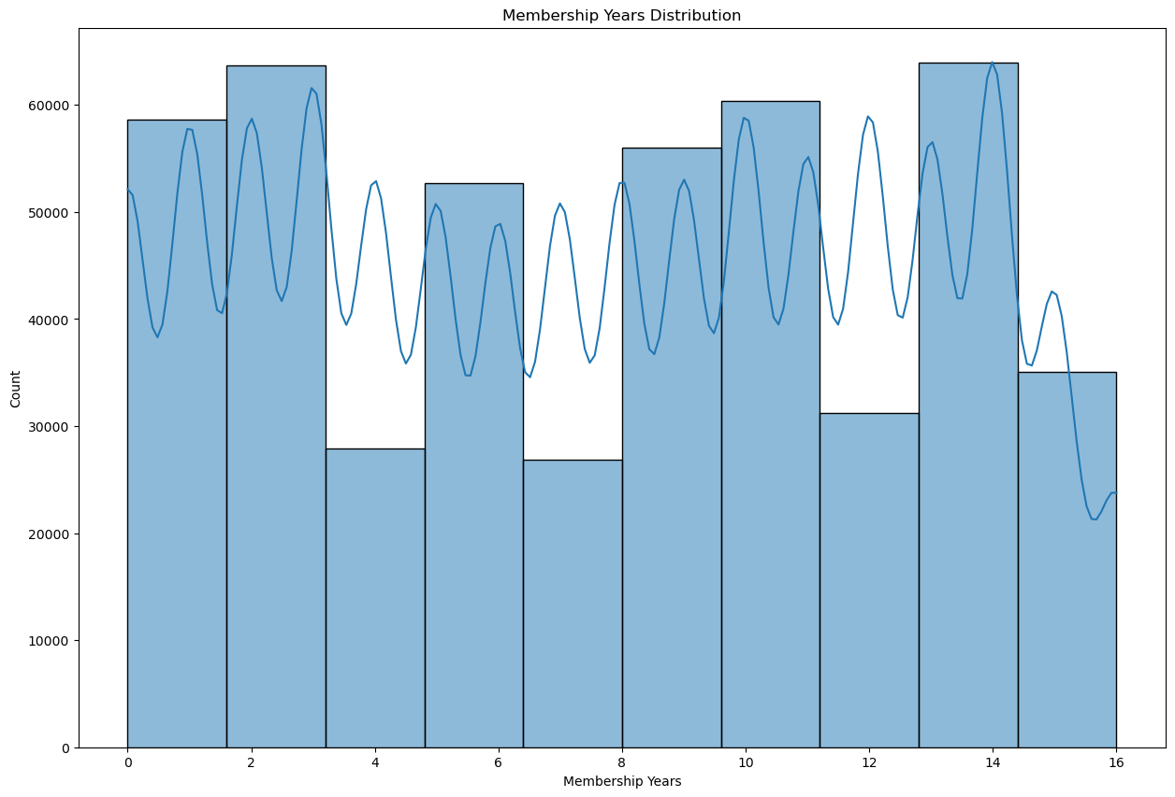
Visualization 7: Pair Plot
Analyze relationships among:
- Age
- Annual Income
- Spending Score
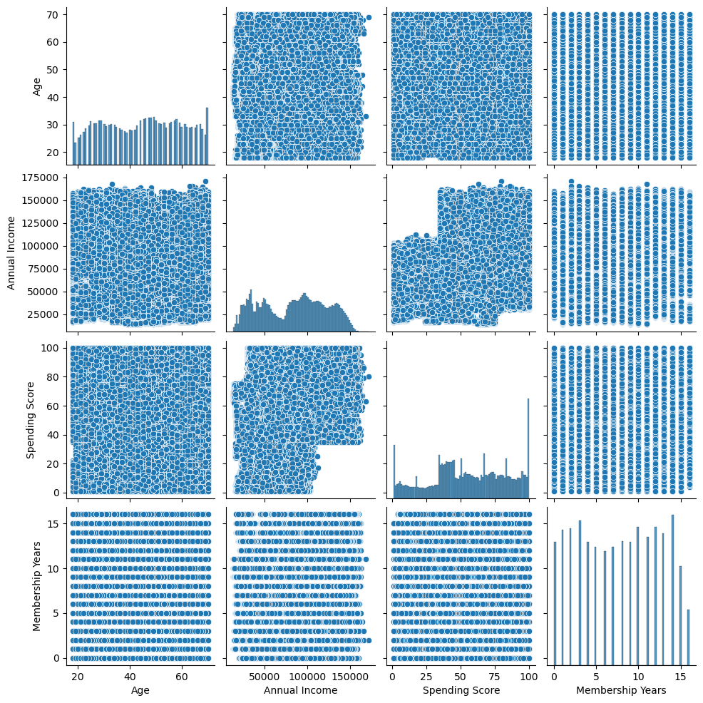
- Membership Years
Visualization 8: Correlation Heatmap
Identifying:
- Which variables are positively correlated?
  - Annual Income–Spending Score (0.19), Annual Income–Membership Years (0.07), Spending Score–Membership Years (0.05), and Age–Annual Income (0.04) show positive correlations.
- Which variables are negatively correlated?
  - Age and Spending Score show a weak negative correlation (-0.04), indicating that age has almost no negative relationship with spending.
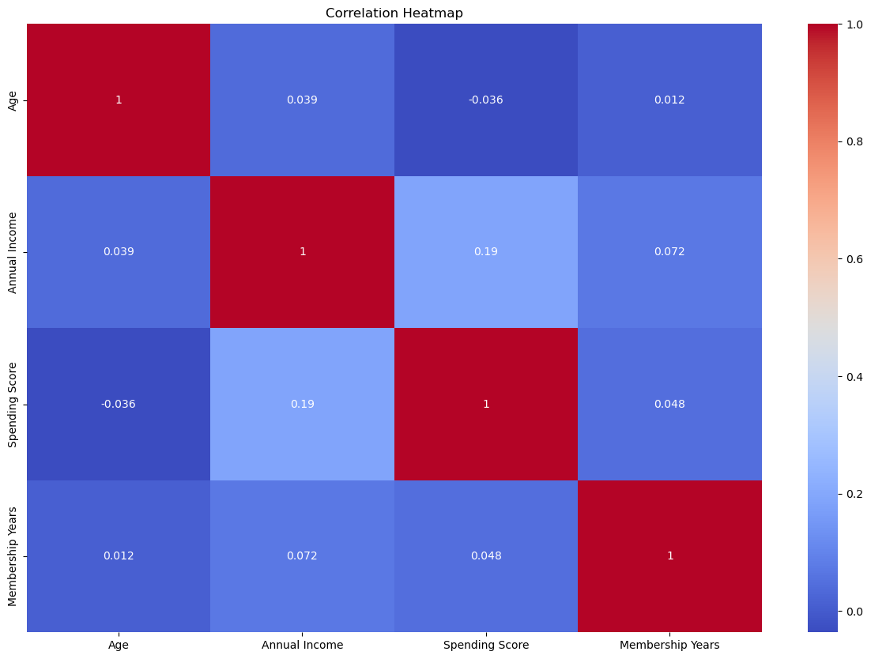

Feature Scaling
K-Means calculates the distance between data points. If one feature (e.g., Annual Income) has much larger values than another (e.g., Spending Score), it can dominate the clustering process.
StandardScaler
Features:
- Age
- Annual Income
- Spending Score
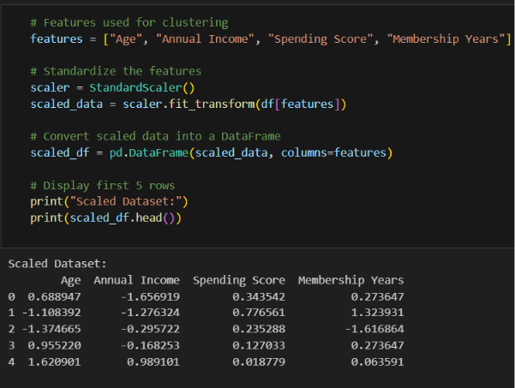
- Membership Years

Finding the Optimal Number of Clusters
We used the Elbow Method to determine the best value of K.
Performed Tasks
- Run K-Means with different values of K (e.g., 1–10).
- Calculate the Within-Cluster Sum of Squares (WCSS) for each value.
- Plot WCSS against the number of clusters.
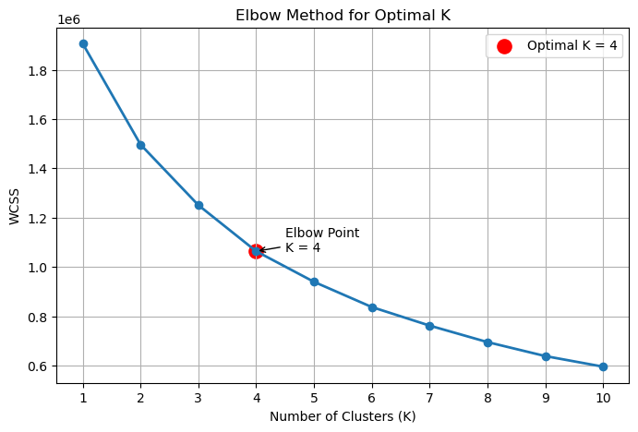
- Identify the "elbow point," where adding more clusters provides diminishing improvements.

Explanation:
The Elbow Method was used to determine the optimal number of clusters by plotting the Within-Cluster Sum of Squares (WCSS) against different values of K (1–10). As the number of clusters increases, the WCSS value decreases because data points are grouped more closely around their cluster centroids.
From the graph, a sharp decline in WCSS is observed from K = 1 to K = 4. After K = 4, the decrease in WCSS becomes much more gradual, indicating that adding more clusters provides only marginal improvement in clustering performance. Therefore, K = 4 is selected as the optimal number of clusters because it represents the elbow point, achieving a good balance between clustering accuracy and model complexity.
Selected Value: K = 4
Reason: After K = 4, the reduction in WCSS is relatively small, so increasing the number of clusters does not significantly improve the clustering quality.

Build the K-Means Clustering Model
We Implement :
- Trained the K-Means model using the optimal value of K.
- Assigned each customer to a cluster.
- Added a new Cluster column to the dataset.
- Displayed the first few clustered records.
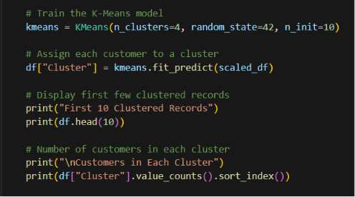

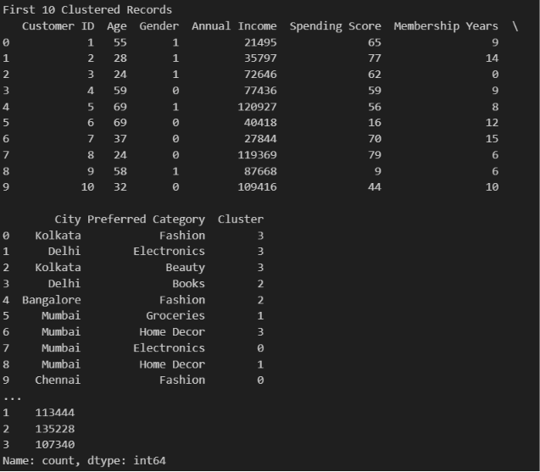
OUTPUT

Visualize Customer Clusters
Createed scatter plots showing the identified customer segments.
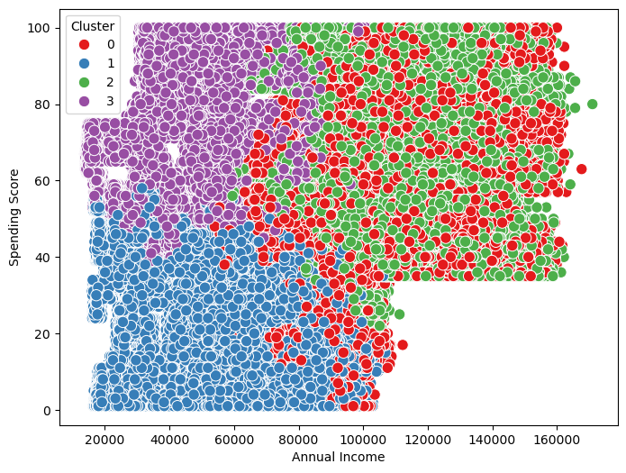
Build a Plot Cluster Centroids
Labelled each cluster clearly.
Customer Segments
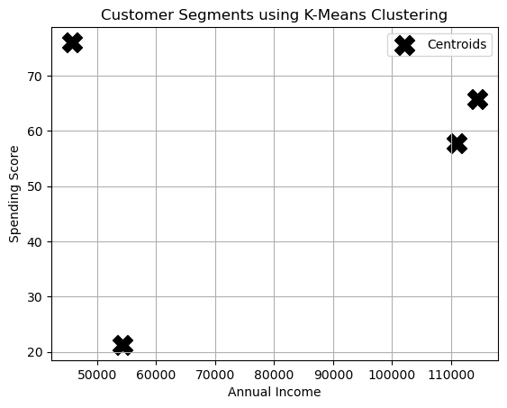
Cluster 1
Cluster 2
Cluster 3
Cluster 4

Cluster Analysis
Analyzed the characteristics of each cluster.
Calculated Clusters and summarised in a table
- Average Age
- Average Annual Income
- Average Spending Score
- Average Membership Years
- Number of Customers
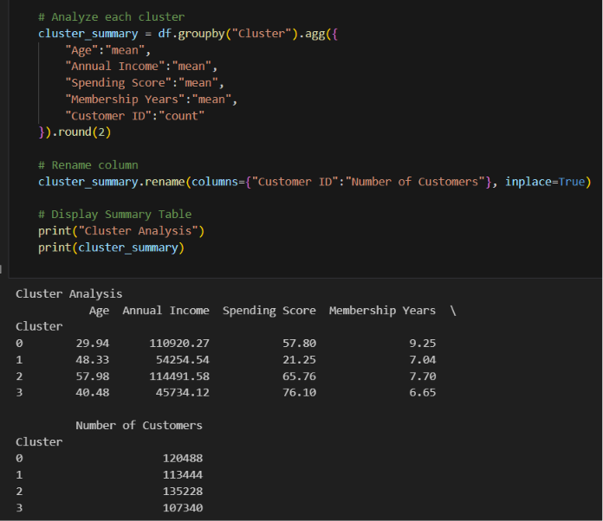

Business Interpretation
Business Interpretation is the process of analyzing the results of a machine learning model and converting them into meaningful business insights that help organizations make informed decisions, improve customer strategies, and achieve business objectives.
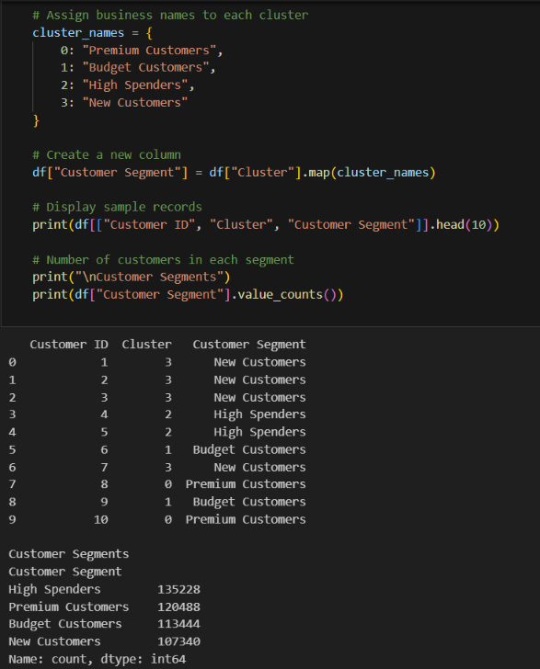

Segments
Premium Customers
Characteristics:
- High Income
- High Spending Score
- Long Membership
Recommendation:
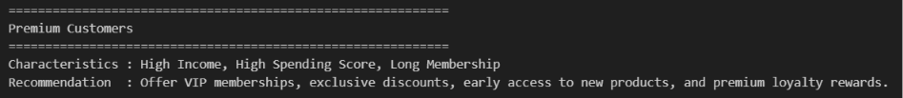
Offer VIP memberships, exclusive discounts, early access to new products, and premium loyalty rewards

Budget Customers
Characteristics:
- Low Income
- Low Spending Score
Recommendation:
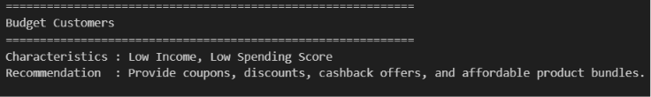
Offer coupons, discounts, and value-for-money products to encourage purchases

High Spenders
Characteristics:
- Moderate Income
- Very High Spending Score
Recommendation:
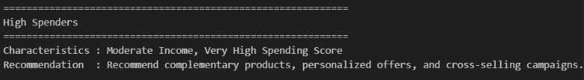
Recommend complementary products, personalized offers, and cross-selling campaigns.
New Customers
Characteristics:
- Short Membership Duration
- Moderate Spending
Recommendation:
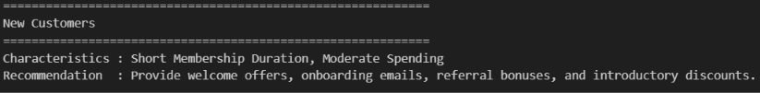
Provide welcome offers, onboarding emails, referral bonuses, and introductory discounts to build loyalty.

Business Recommendations
Based on the customer segmentation results obtained from the K-Means Clustering model, the following business recommendations are proposed:
1. Premium Customers
- Reward customers with VIP memberships, exclusive discounts, premium loyalty points, and early access to new products to strengthen customer loyalty.
2. Budget Customers
- Offer coupons, cashback offers, seasonal discounts, and affordable product bundles to encourage more frequent purchases and improve engagement.
3. High Spenders
- Provide personalized product recommendations, cross-selling, upselling, and premium product suggestions to maximize revenue from high-value customers.
4. New Customers
- Introduce welcome discounts, referral bonuses, onboarding emails, and first-purchase incentives to build long-term customer relationships.

Overall Business Recommendations
- Implement targeted marketing campaigns for each customer segment instead of using a single marketing strategy for all customers.
- Strengthen customer loyalty by offering exclusive rewards and personalized benefits to premium customers.
- Increase engagement among budget customers through promotional offers, coupons, and cashback programs.
- Maximize sales by applying cross-selling and upselling strategies for high-spending customers.
- Improve customer retention by creating effective onboarding campaigns for new customers.
- Use customer segmentation insights to enhance marketing ROI, improve customer satisfaction, and support data-driven business decisions.

Conclusion
This project successfully applied K-Means Clustering to segment customers based on their demographic and purchasing behavior. After data preprocessing, EDA, feature scaling, and determining the optimal value of K = 4 using the Elbow Method, four meaningful customer segments were identified. These insights can help businesses implement targeted marketing strategies, improve customer satisfaction, enhance retention, and support data-driven decision-making. Overall, the project demonstrates the effectiveness of unsupervised machine learning in customer segmentation and marketing analytics.

