**Exercise 7: Financial Forecasting**

import java.util.Scanner;

public class FinancialForecasting {

public static double simpleMovingAverage(double[] revenue, int windowSize) {

if (revenue.length < windowSize) return -1;

double sum = 0;

for (int i = revenue.length - windowSize; i < revenue.length; i++) {

sum += revenue[i];

}

return sum / windowSize;

}

public static void main(String[] args) {

Scanner sc = new Scanner(System.in);

System.out.print("Enter number of months of revenue data: ");

int n = sc.nextInt();

double[] revenue = new double[n];

System.out.println("Enter revenue for each month:");

for (int i = 0; i < n; i++) {

revenue[i] = sc.nextDouble();

}

double predicted = simpleMovingAverage(revenue, 3);

if (predicted != -1)

System.out.println("Predicted next month's revenue: " + predicted);

else

System.out.println("Not enough data to forecast.");

}

}

**OUTPUT:**

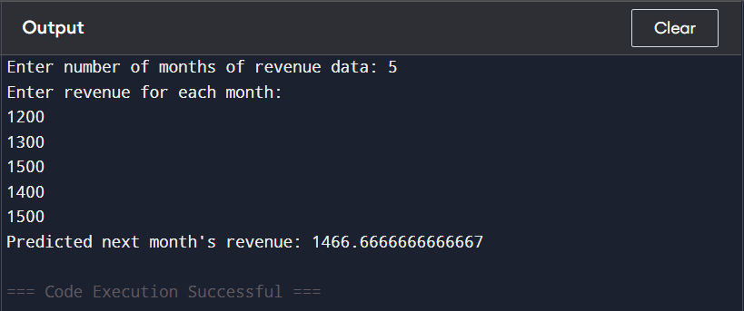

**Why we chose simple moving average logic:**

* We want to **predict the next value** (revenue) using **previous trends**.
* **Simple Moving Average (SMA)** takes the average of the last k months (e.g., last 3 months) to estimate the next month.
* It smooths out fluctuations and gives a **basic but effective** forecast.

**This is commonly used in finance and analytics** due to its simplicity and reliance on recent values only.