**Exercise 1: Configuring a Basic Spring Application**

**Technologies Used:**

* **Java 8**
* **Spring Framework (spring-context)**
* **Maven**
* **VS Code**
* **XML-based Configuration**

**Folder Structure (Standard Maven)**

spring-basic-app/

├── pom.xml

└── src/

├── main/

│ ├── java/

│ │ └── com/example/

│ │ ├── App.java

│ │ └── HelloService.java

│ └── resources/

│ └── beans.xml

**Java Code**

*App.java*

package com.example;

import org.springframework.context.ApplicationContext;

import org.springframework.context.support.ClassPathXmlApplicationContext;

public class App {

public static void main(String[] args) {

ApplicationContext context = new ClassPathXmlApplicationContext("beans.xml");

HelloService service = context.getBean("helloService", HelloService.class);

service.sayHello();

}

}

*HelloService.java*

package com.example;

public class HelloService {

public void sayHello() {

System.out.println("Hello from Spring XML Configured Bean!");

}

}

*beans.xml*

<?xml version="1.0" encoding="UTF-8"?>

<beans xmlns="http://www.springframework.org/schema/beans"

xmlns:xsi="http://www.w3.org/2001/XMLSchema-instance"

xsi:schemaLocation="

<http://www.springframework.org/schema/beans>

<https://www.springframework.org/schema/beans/spring-beans.xsd>">

<bean id="helloService" class="com.example.HelloService" />

</beans>

**pom.xml (Spring Config)**

<?xml version="1.0" encoding="UTF-8"?>

<project xmlns="http://maven.apache.org/POM/4.0.0"

xmlns:xsi="http://www.w3.org/2001/XMLSchema-instance"

xsi:schemaLocation="http://maven.apache.org/POM/4.0.0 <http://maven.apache.org/xsd/maven-4.0.0.xsd>">

<modelVersion>4.0.0</modelVersion>

<groupId>com.example</groupId>

<artifactId>spring-basic-app</artifactId>

<version>1.0-SNAPSHOT</version>

<name>spring-basic-app</name>

<url>http://www.example.com</url>

<properties>

<project.build.sourceEncoding>UTF-8</project.build.sourceEncoding>

<maven.compiler.source>1.8</maven.compiler.source> <!-- Set to match JDK 8 -->

<maven.compiler.target>1.8</maven.compiler.target>

</properties>

<dependencies>

<!-- Spring Context for IoC, DI -->

<dependency>

<groupId>org.springframework</groupId>

<artifactId>spring-context</artifactId>

<version>5.3.30</version>

</dependency>

<!-- JUnit for testing (optional) -->

<dependency>

<groupId>junit</groupId>

<artifactId>junit</artifactId>

<version>4.11</version>

<scope>test</scope>

</dependency>

</dependencies>

<build>

<plugins>

<!-- Compiler Plugin -->

<plugin>

<artifactId>maven-compiler-plugin</artifactId>

<version>3.8.1</version>

<configuration>

<source>1.8</source>

<target>1.8</target>

</configuration>

</plugin>

<!-- Exec Plugin to run the Java Main class -->

<plugin>

<groupId>org.codehaus.mojo</groupId>

<artifactId>exec-maven-plugin</artifactId>

<version>3.1.0</version>

<configuration>

<mainClass>com.example.App</mainClass>

</configuration>

</plugin>

</plugins>

</build>

</project>

**Running Command**

mvn clean compile

mvn exec:java

**Output**

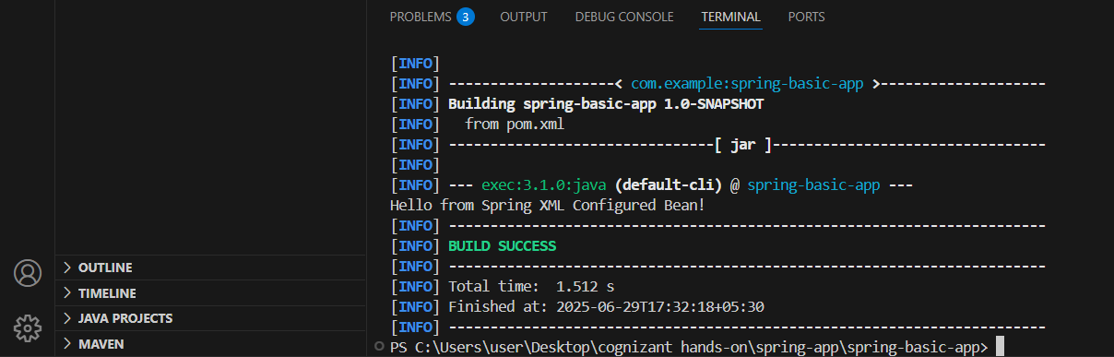

Hello from Spring XML Configured Bean!