**Exercise 9: Creating a Spring Boot Application**

**Project Structure**

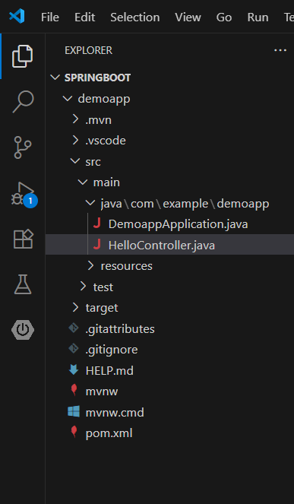

*pom.xml*

<?xml version="1.0" encoding="UTF-8"?>

<project xmlns="http://maven.apache.org/POM/4.0.0" xmlns:xsi="http://www.w3.org/2001/XMLSchema-instance"

    xsi:schemaLocation="http://maven.apache.org/POM/4.0.0 https://maven.apache.org/xsd/maven-4.0.0.xsd">

    <modelVersion>4.0.0</modelVersion>

    <parent>

        <groupId>org.springframework.boot</groupId>

        <artifactId>spring-boot-starter-parent</artifactId>

        <version>3.5.3</version>

        <relativePath/> <!-- lookup parent from repository -->

    </parent>

    <groupId>com.example</groupId>

    <artifactId>demoapp</artifactId>

    <version>0.0.1-SNAPSHOT</version>

    <name>demoapp</name>

    <description>Demo project for Spring Boot</description>

    <url/>

    <licenses>

        <license/>

    </licenses>

    <developers>

        <developer/>

    </developers>

    <scm>

        <connection/>

        <developerConnection/>

        <tag/>

        <url/>

    </scm>

    <properties>

        <java.version>24</java.version>

    </properties>

    <dependencies>

        <dependency>

            <groupId>org.springframework.boot</groupId>

            <artifactId>spring-boot-starter-web</artifactId>

        </dependency>

        <dependency>

            <groupId>org.springframework.boot</groupId>

            <artifactId>spring-boot-starter-test</artifactId>

            <scope>test</scope>

        </dependency>

    </dependencies>

    <build>

        <plugins>

            <plugin>

                <groupId>org.springframework.boot</groupId>

                <artifactId>spring-boot-maven-plugin</artifactId>

            </plugin>

        </plugins>

    </build>

</project>

*DemoappApplication.java*

package com.example.demoapp;

import org.springframework.boot.SpringApplication;

import org.springframework.boot.autoconfigure.SpringBootApplication;

@SpringBootApplication

public class DemoappApplication {

    public static void main(String[] args) {

        SpringApplication.run(DemoappApplication.class, args);

    }

}

*HelloController.java*

package com.example.demoapp;

import org.springframework.web.bind.annotation.RequestMapping;

import org.springframework.web.bind.annotation.RestController;

@RestController

public class HelloController {

    @RequestMapping("/hello")

    public String hello(){

        return "Hello, World!";

    }

}

*Output*

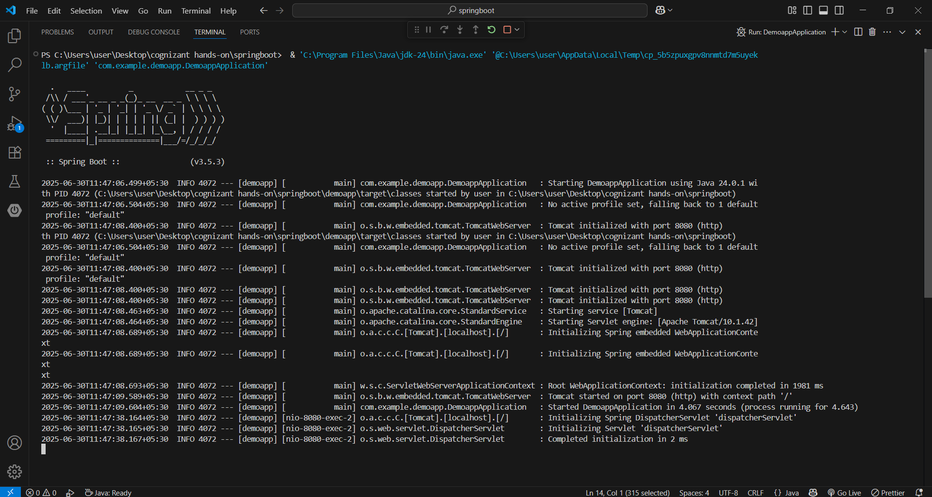

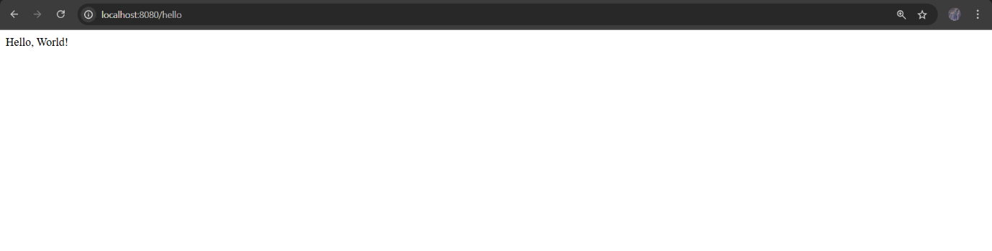

Spring Boot Starter -> Used to bootstrap the app with defaults.

Embedded Tomcat -> No external server required.

REST Endpoint -> @RestController + @RequestMapping

Auto Configuration -> Enabled via @SpringBootApplication

No XML Required.