**Creating Microservices for account and loan and registering to Eureka Discovery Server**

**AccountServiceApplication.java**

package com.debangshu.AccountService;

import org.springframework.boot.SpringApplication;

import org.springframework.boot.autoconfigure.SpringBootApplication;

import org.springframework.cloud.client.discovery.EnableDiscoveryClient;

@SpringBootApplication

@EnableDiscoveryClient

public class AccountServiceApplication {

public static void main(String[] args) {

SpringApplication.run(AccountServiceApplication.class, args);

}

}

**AccountController.java**

package com.debangshu.AccountService.controller;

import org.springframework.web.bind.annotation.GetMapping;

import org.springframework.web.bind.annotation.RestController;

@RestController

public class AccountController {

@GetMapping("/account/status")

public String getStatus(){

return "Account Service is up!";

}

}

**application.yaml**

server:

port: 8081

spring:

application:

name: AccountService

eureka:

client:

service-url:

defaultZone: <http://localhost:8761/eureka>

**pom.xml**

<?xml version="1.0" encoding="UTF-8"?>

<project xmlns="http://maven.apache.org/POM/4.0.0" xmlns:xsi="http://www.w3.org/2001/XMLSchema-instance"

xsi:schemaLocation="http://maven.apache.org/POM/4.0.0 <https://maven.apache.org/xsd/maven-4.0.0.xsd>">

<modelVersion>4.0.0</modelVersion>

<parent>

<groupId>org.springframework.boot</groupId>

<artifactId>spring-boot-starter-parent</artifactId>

<version>3.5.3</version>

<relativePath/> <!-- lookup parent from repository -->

</parent>

<groupId>com.debangshu</groupId>

<artifactId>AccountService</artifactId>

<version>0.0.1-SNAPSHOT</version>

<name>AccountService</name>

<description>Demo project for Spring Boot</description>

<url/>

<licenses>

<license/>

</licenses>

<developers>

<developer/>

</developers>

<scm>

<connection/>

<developerConnection/>

<tag/>

<url/>

</scm>

<properties>

<java.version>24</java.version>

<spring-cloud.version>2025.0.0</spring-cloud.version>

</properties>

<dependencies>

<dependency>

<groupId>org.springframework.boot</groupId>

<artifactId>spring-boot-starter-actuator</artifactId>

</dependency>

<dependency>

<groupId>org.springframework.boot</groupId>

<artifactId>spring-boot-starter-web</artifactId>

</dependency>

<dependency>

<groupId>org.springframework.cloud</groupId>

<artifactId>spring-cloud-starter-netflix-eureka-client</artifactId>

</dependency>

<dependency>

<groupId>org.springframework.boot</groupId>

<artifactId>spring-boot-devtools</artifactId>

<scope>runtime</scope>

<optional>true</optional>

</dependency>

<dependency>

<groupId>org.springframework.boot</groupId>

<artifactId>spring-boot-starter-test</artifactId>

<scope>test</scope>

</dependency>

</dependencies>

<dependencyManagement>

<dependencies>

<dependency>

<groupId>org.springframework.cloud</groupId>

<artifactId>spring-cloud-dependencies</artifactId>

<version>${spring-cloud.version}</version>

<type>pom</type>

<scope>import</scope>

</dependency>

</dependencies>

</dependencyManagement>

<build>

<plugins>

<plugin>

<groupId>org.springframework.boot</groupId>

<artifactId>spring-boot-maven-plugin</artifactId>

</plugin>

</plugins>

</build>

</project>

**LoanServiceApplication.java**

package com.debangshu.LoanService;

import org.springframework.boot.SpringApplication;

import org.springframework.boot.autoconfigure.SpringBootApplication;

import org.springframework.cloud.client.discovery.EnableDiscoveryClient;

@SpringBootApplication

@EnableDiscoveryClient

public class LoanServiceApplication {

public static void main(String[] args) {

SpringApplication.run(LoanServiceApplication.class, args);

}

}

**LoanController.java**

package com.debangshu.LoanService.controller;

import org.springframework.web.bind.annotation.GetMapping;

import org.springframework.web.bind.annotation.RestController;

@RestController

public class LoanController {

@GetMapping("/loan/status")

public String getString(){

return "Loan Service is up!";

}

}

**application.yaml**

server:

port: 8082

spring:

application:

name: LoanService

eureka:

client:

service-url:

defaultZone: <http://localhost:8761/eureka>

**pom.xml**

<?xml version="1.0" encoding="UTF-8"?>

<project xmlns="http://maven.apache.org/POM/4.0.0" xmlns:xsi="http://www.w3.org/2001/XMLSchema-instance"

xsi:schemaLocation="http://maven.apache.org/POM/4.0.0 <https://maven.apache.org/xsd/maven-4.0.0.xsd>">

<modelVersion>4.0.0</modelVersion>

<parent>

<groupId>org.springframework.boot</groupId>

<artifactId>spring-boot-starter-parent</artifactId>

<version>3.5.3</version>

<relativePath/> <!-- lookup parent from repository -->

</parent>

<groupId>com.debangshu</groupId>

<artifactId>LoanService</artifactId>

<version>0.0.1-SNAPSHOT</version>

<name>LoanService</name>

<description>Demo project for Spring Boot</description>

<url/>

<licenses>

<license/>

</licenses>

<developers>

<developer/>

</developers>

<scm>

<connection/>

<developerConnection/>

<tag/>

<url/>

</scm>

<properties>

<java.version>24</java.version>

<spring-cloud.version>2025.0.0</spring-cloud.version>

</properties>

<dependencies>

<dependency>

<groupId>org.springframework.boot</groupId>

<artifactId>spring-boot-starter-actuator</artifactId>

</dependency>

<dependency>

<groupId>org.springframework.boot</groupId>

<artifactId>spring-boot-starter-web</artifactId>

</dependency>

<dependency>

<groupId>org.springframework.cloud</groupId>

<artifactId>spring-cloud-starter-netflix-eureka-client</artifactId>

</dependency>

<dependency>

<groupId>org.springframework.boot</groupId>

<artifactId>spring-boot-devtools</artifactId>

<scope>runtime</scope>

<optional>true</optional>

</dependency>

<dependency>

<groupId>org.springframework.boot</groupId>

<artifactId>spring-boot-starter-test</artifactId>

<scope>test</scope>

</dependency>

</dependencies>

<dependencyManagement>

<dependencies>

<dependency>

<groupId>org.springframework.cloud</groupId>

<artifactId>spring-cloud-dependencies</artifactId>

<version>${spring-cloud.version}</version>

<type>pom</type>

<scope>import</scope>

</dependency>

</dependencies>

</dependencyManagement>

<build>

<plugins>

<plugin>

<groupId>org.springframework.boot</groupId>

<artifactId>spring-boot-maven-plugin</artifactId>

</plugin>

</plugins>

</build>

</project>

**EurekaServiceApplication.java**

package com.debangshu.EurekaService;

import org.springframework.boot.SpringApplication;

import org.springframework.boot.autoconfigure.SpringBootApplication;

import org.springframework.cloud.netflix.eureka.server.EnableEurekaServer;

@SpringBootApplication

@EnableEurekaServer

public class EurekaServiceApplication {

public static void main(String[] args) {

SpringApplication.run(EurekaServiceApplication.class, args);

}

}

**application.yaml**

server:

port: 8761

spring:

application:

name: EurekaService

eureka:

instance:

hostname: localhost

client:

register-with-eureka: false

fetch-registry: false

service-url:

defaultZone: http://${eureka.instance.hostname}:${server.port}/eureka/

**pom.xml**

<?xml version="1.0" encoding="UTF-8"?>

<project xmlns="http://maven.apache.org/POM/4.0.0" xmlns:xsi="http://www.w3.org/2001/XMLSchema-instance"

xsi:schemaLocation="http://maven.apache.org/POM/4.0.0 <https://maven.apache.org/xsd/maven-4.0.0.xsd>">

<modelVersion>4.0.0</modelVersion>

<parent>

<groupId>org.springframework.boot</groupId>

<artifactId>spring-boot-starter-parent</artifactId>

<version>3.5.3</version>

<relativePath/> <!-- lookup parent from repository -->

</parent>

<groupId>com.debangshu</groupId>

<artifactId>EurekaService</artifactId>

<version>0.0.1-SNAPSHOT</version>

<name>EurekaService</name>

<description>Demo project for Spring Boot</description>

<url/>

<licenses>

<license/>

</licenses>

<developers>

<developer/>

</developers>

<scm>

<connection/>

<developerConnection/>

<tag/>

<url/>

</scm>

<properties>

<java.version>24</java.version>

<spring-cloud.version>2025.0.0</spring-cloud.version>

</properties>

<dependencies>

<dependency>

<groupId>org.springframework.boot</groupId>

<artifactId>spring-boot-starter-web</artifactId>

</dependency>

<dependency>

<groupId>org.springframework.cloud</groupId>

<artifactId>spring-cloud-starter-netflix-eureka-server</artifactId>

</dependency>

<dependency>

<groupId>org.springframework.boot</groupId>

<artifactId>spring-boot-starter-test</artifactId>

<scope>test</scope>

</dependency>

</dependencies>

<dependencyManagement>

<dependencies>

<dependency>

<groupId>org.springframework.cloud</groupId>

<artifactId>spring-cloud-dependencies</artifactId>

<version>${spring-cloud.version}</version>

<type>pom</type>

<scope>import</scope>

</dependency>

</dependencies>

</dependencyManagement>

<build>

<plugins>

<plugin>

<groupId>org.springframework.boot</groupId>

<artifactId>spring-boot-maven-plugin</artifactId>

</plugin>

</plugins>

</build>

</project>

**Eureka Service Registery**

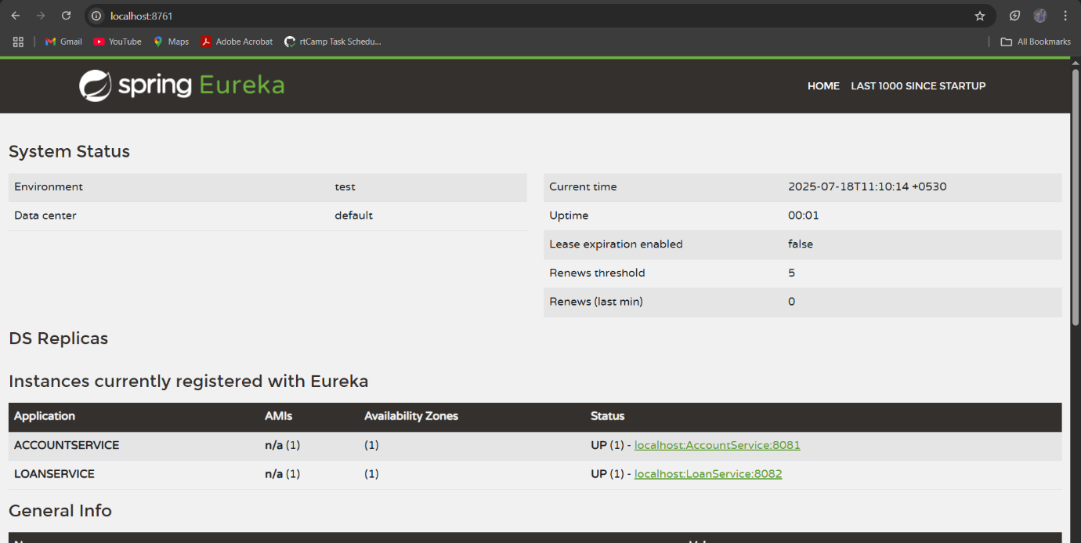

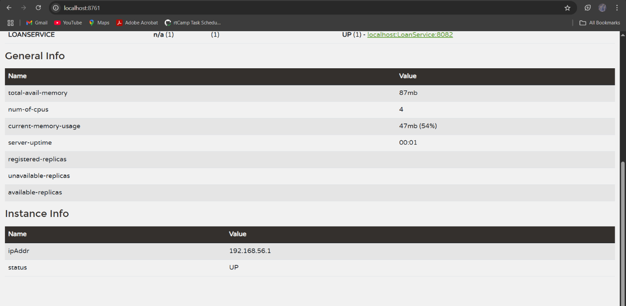

**Request from postman for Account**

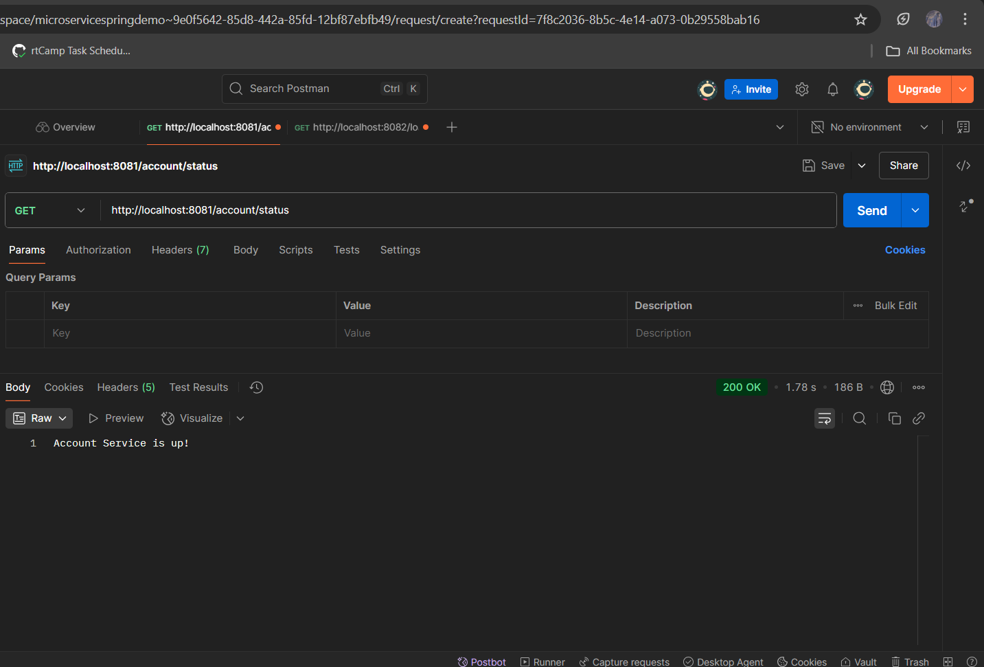

**Request from postman for Loan**

