**Integrating ApiGateway to Microservice for common port**

**ApiGatewayApplication.java**

package com.debangshu.ApiGateway;

import org.springframework.boot.SpringApplication;

import org.springframework.boot.autoconfigure.SpringBootApplication;

import org.springframework.cloud.client.discovery.EnableDiscoveryClient;

@SpringBootApplication

@EnableDiscoveryClient

public class ApiGatewayApplication {

public static void main(String[] args) {

SpringApplication.run(ApiGatewayApplication.class, args);

}

}

**application.yaml**

server:

port: 8080

spring:

application:

name: ApiGateway

main:

web-application-type: reactive

cloud:

gateway:

routes:

- id: AccountService

uri: lb://AccountService

predicates:

- Path=/account/**

- id: LoanService

uri: lb://LoanService

predicates:

- Path=/loan/**

eureka:

client:

service-url:

defaultZone: <http://localhost:8761/eureka/>

**pom.xml**

<?xml version="1.0" encoding="UTF-8"?>

<project xmlns="http://maven.apache.org/POM/4.0.0" xmlns:xsi="http://www.w3.org/2001/XMLSchema-instance"

xsi:schemaLocation="http://maven.apache.org/POM/4.0.0 <https://maven.apache.org/xsd/maven-4.0.0.xsd>">

<modelVersion>4.0.0</modelVersion>

<parent>

<groupId>org.springframework.boot</groupId>

<artifactId>spring-boot-starter-parent</artifactId>

<version>3.5.3</version>

<relativePath/> <!-- lookup parent from repository -->

</parent>

<groupId>com.debangshu</groupId>

<artifactId>ApiGateway</artifactId>

<version>0.0.1-SNAPSHOT</version>

<name>ApiGateway</name>

<description>Demo project for Spring Boot</description>

<url/>

<licenses>

<license/>

</licenses>

<developers>

<developer/>

</developers>

<scm>

<connection/>

<developerConnection/>

<tag/>

<url/>

</scm>

<properties>

<java.version>24</java.version>

<spring-cloud.version>2025.0.0</spring-cloud.version>

</properties>

<dependencies>

<dependency>

<groupId>org.springframework.boot</groupId>

<artifactId>spring-boot-starter-actuator</artifactId>

</dependency>

<dependency>

<groupId>org.springframework.cloud</groupId>

<artifactId>spring-cloud-starter-gateway</artifactId>

</dependency>

<dependency>

<groupId>org.springframework.cloud</groupId>

<artifactId>spring-cloud-starter-netflix-eureka-client</artifactId>

</dependency>

<dependency>

<groupId>org.springframework.boot</groupId>

<artifactId>spring-boot-devtools</artifactId>

<scope>runtime</scope>

<optional>true</optional>

</dependency>

<dependency>

<groupId>org.springframework.boot</groupId>

<artifactId>spring-boot-starter-test</artifactId>

<scope>test</scope>

</dependency>

</dependencies>

<dependencyManagement>

<dependencies>

<dependency>

<groupId>org.springframework.cloud</groupId>

<artifactId>spring-cloud-dependencies</artifactId>

<version>${spring-cloud.version}</version>

<type>pom</type>

<scope>import</scope>

</dependency>

</dependencies>

</dependencyManagement>

<build>

<plugins>

<plugin>

<groupId>org.springframework.boot</groupId>

<artifactId>spring-boot-maven-plugin</artifactId>

</plugin>

</plugins>

</build>

</project>

**Eureka Service Registery**

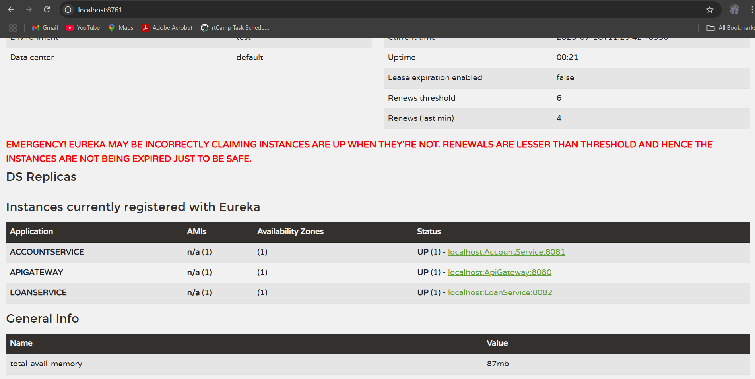

**Request from postman for Account on common port 8080**

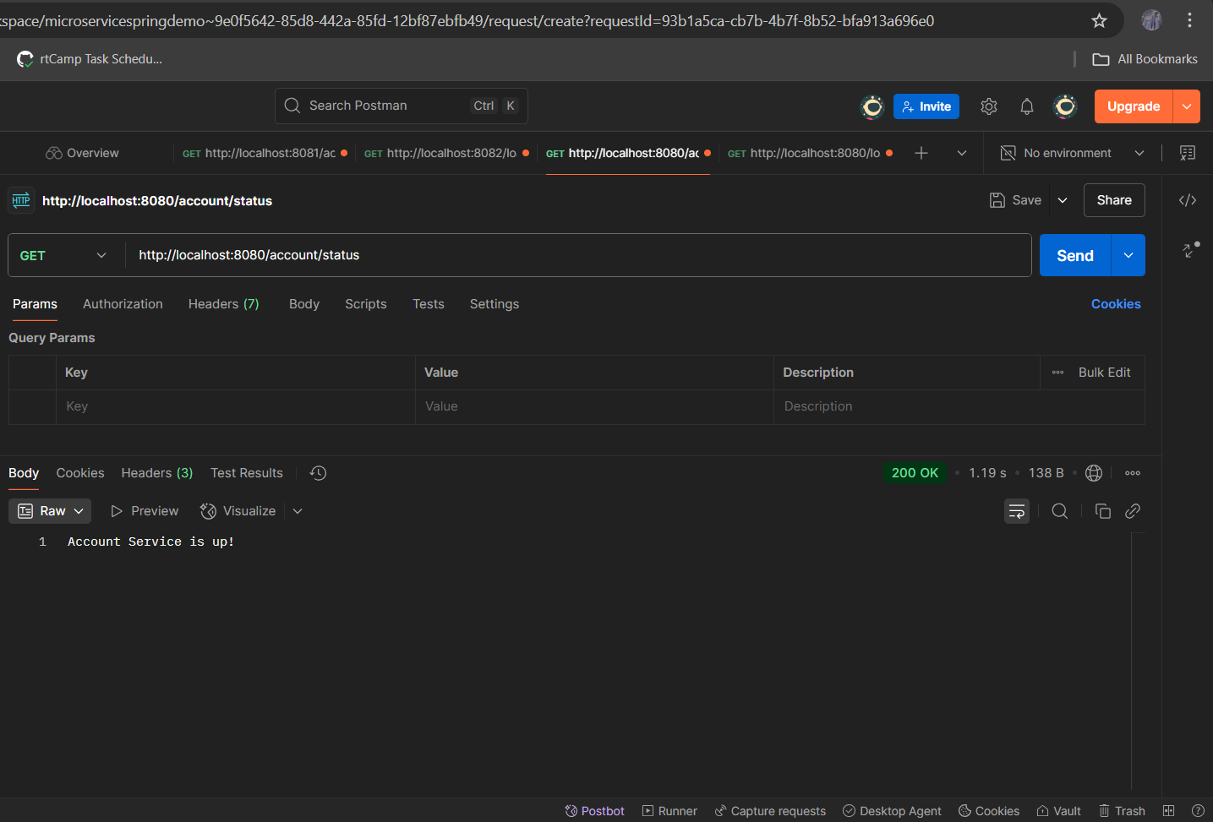

**Request from postman for Loan on common port 8080**

