**Event Examples App**

**App.js**

import React, {useState} from "react";

import CurrencyConverter from "./components/CurrencyConverter.component";

function App() {

const [counter, setCounter] = useState(0);

const increment = () => setCounter(counter+1);

const decrement = () => setCounter(counter-1);

//const welcome = () => alert(welcome);

return (

<div className="App">

<h1>{counter}</h1>

<button onClick={increment}>increment</button> <br />

<button onClick={decrement}>decrement</button> <br />

<button onClick={() => alert("welcome")}>Say welcome</button> <br />

<button onClick={() => alert("I was clicked")}>Click on me</button> <br />

<CurrencyConverter />

</div>

);

}

export default App;

**CurrencyConverter.component.js**

import React, { useState } from "react";

function CurrencyConverter(){

const [amount, setAmount] = useState(0);

const [currency, setCurrency] = useState("USD");

const handleSubmit = () => {

var ans = 0;

if(currency === "USD"){

ans = amount*80;

}else if(currency === "Euro"){

ans = amount*100;

}

alert(`Converting from ${currency} to INR Amount is Rs. ${ans}`);

}

return(

<div>

<h1 style={{color: 'green'}}>Currency Converter!!!</h1>

<form onSubmit={handleSubmit}>

<label>

Enter Amount:

<input type="number" value={amount} onChange={(e) => setAmount(e.target.value)} required></input>

</label>

<br />

<label>

Currency:

<select value={currency} onChange={(e) => setCurrency(e.target.value)}>

<option value="USD">USD</option>

<option value="Euro">Euro</option>

</select>

</label>

<br />

<button type="submit">Submit</button>

</form>

</div>

)

}

export default CurrencyConverter;

**Output:**

When clicked on Say welcome button.

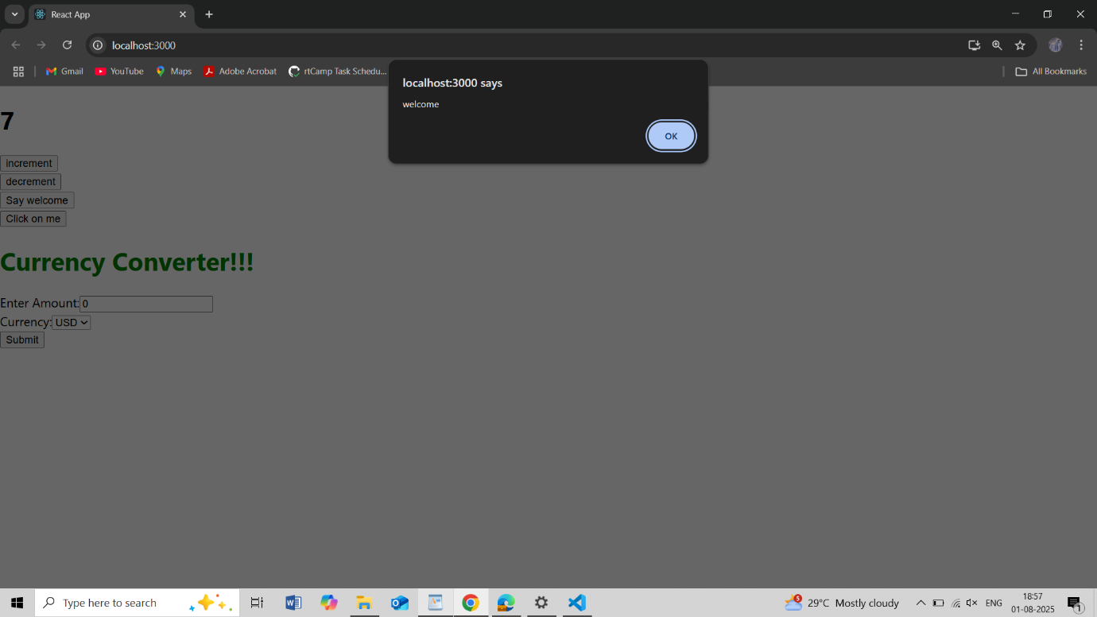

When clicked on Click on me button.

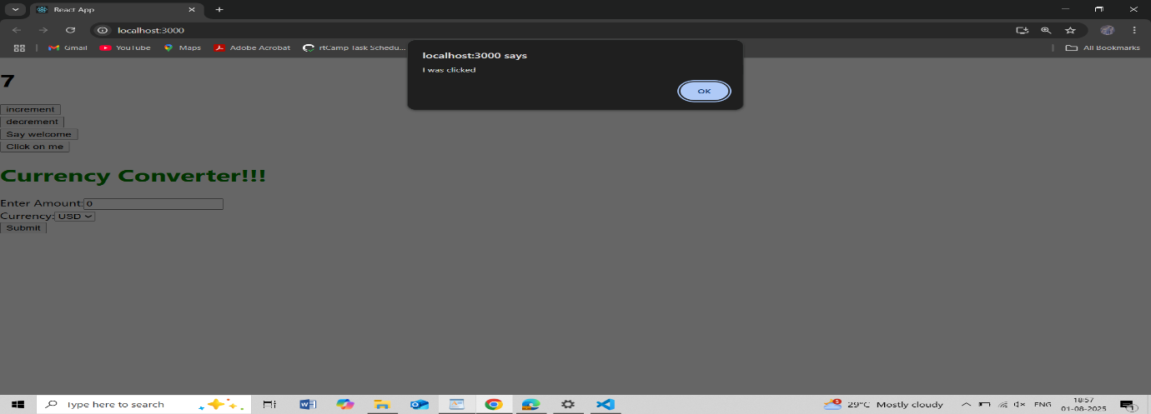

When clicked on submit button for USD.

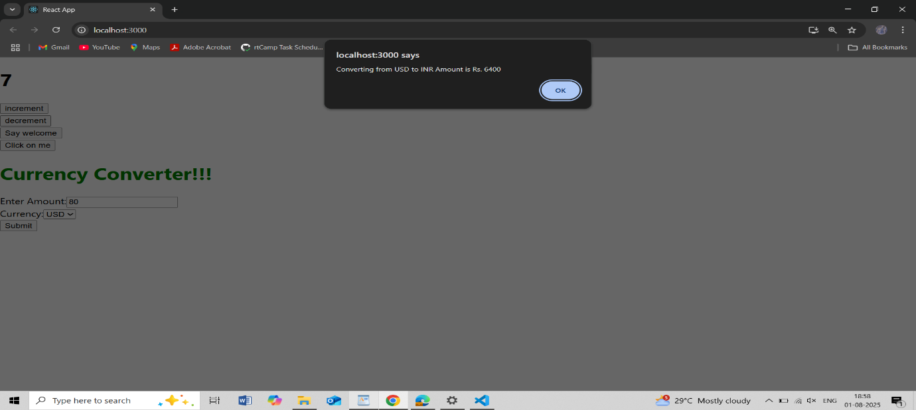

When clicked on submit button for Euro.

