**Office Space Rental App**

**App.js**

import './App.css';

function App() {

const price = 50000;

return (

<div className="App">

<h1>Office Space, at Affordable Range</h1>

<img src="/360_F_384552930_zPoe9zgmCF7qgt8fqSedcyJ6C6Ye3dFs.jpg" alt="Office space interior" height/>

<h2>Name: DBS</h2>

<h3 style={{color: price < 60000 ? 'red' : 'green'}}>Rent: Rs. {price}</h3>

<h3>Address: Chennai</h3>

</div>

);

}

export default App;

**Output: When price is 50000 which is less than 60000.**

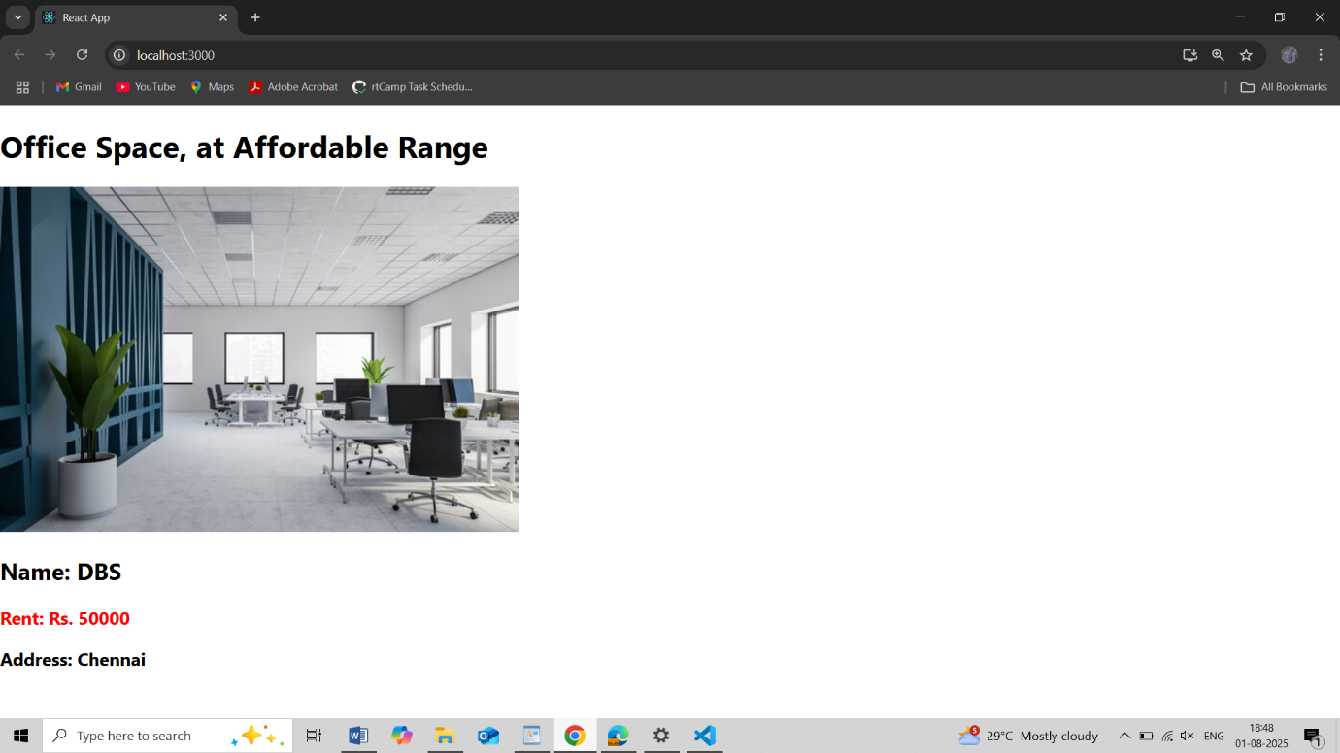

**App.js**

import './App.css';

function App() {

const price = 90000;

return (

<div className="App">

<h1>Office Space, at Affordable Range</h1>

<img src="/360_F_384552930_zPoe9zgmCF7qgt8fqSedcyJ6C6Ye3dFs.jpg" alt="Office space interior" height/>

<h2>Name: DBS</h2>

<h3 style={{color: price < 60000 ? 'red' : 'green'}}>Rent: Rs. {price}</h3>

<h3>Address: Chennai</h3>

</div>

);

}

export default App;

**Output: When price is 90000 which is greater than 60000.**

