**Ticket Booking App**

**App.js**

import React, {useState} from 'react';

import NewUser from './components/NewUser.component';

import SameUser from './components/SameUser.component';

function App() {

const [loggedIn, setLoggedIn] = useState(false);

return (

<div className="App">

{

loggedIn ? <SameUser loggedIn={loggedIn} setLoggedIn={setLoggedIn} /> : <NewUser loggedIn={loggedIn} setLoggedIn={setLoggedIn} />

}

</div>

);

}

export default App;

**NewUser.component.js**

import React from "react";

function NewUser({loggedIn, setLoggedIn}){

return(

<div>

<h1>Please sign up.</h1>

<button onClick={() => setLoggedIn(!loggedIn)}>Login</button>

</div>

)

}

export default NewUser;

**SameUser.component.js**

import React from "react";

function SameUser({loggedIn, setLoggedIn}){

return(

<div>

<h1>Welcome back.</h1>

<button onClick={() => setLoggedIn(!loggedIn)}>Logout</button>

</div>

)

}

export default SameUser;

**Output**

New User

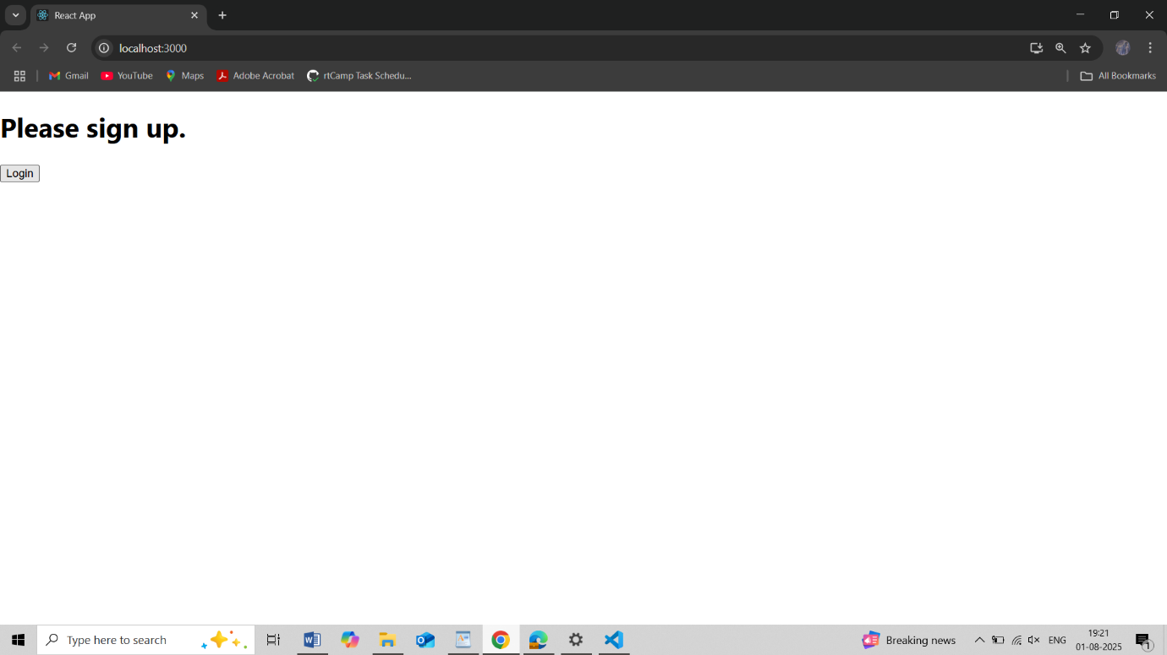

Same User

