1. Module Name and Experiment Title
Module Name: Web Automation Testing
Experiment Title:
Web Application Automation Using Selenium WebDriver and Python
Websites Used:
- https://testautomationpractice.blogspot.com
- https://rahulshettyacademy.com/AutomationPractice

2. Problem Statement
Manual testing of web applications involves repeatedly performing operations such as entering data, selecting radio buttons and checkboxes, handling dropdowns, interacting with alerts, switching between browser windows, and performing mouse operations.
The objective of this experiment is to develop Selenium WebDriver automation scripts using Python to automate different types of web elements and browser interactions. The experiment covers basic as well as advanced Selenium operations, including form handling, dropdowns, date pickers, mouse actions, autocomplete suggestions, JavaScript alerts, and multiple browser windows.

3. Objectives
The objectives of this experiment are:
- To understand web application automation using Selenium WebDriver.
- To automate web applications using Python.
- To locate web elements using different Selenium locator strategies.
- To automate text fields, radio buttons, and checkboxes.
- To handle standard HTML dropdowns using the Select class.
- To handle autocomplete/suggestion fields.
- To handle JavaScript alerts.
- To perform mouse actions such as:
  - Mouse hover
  - Double-click
  - Drag-and-drop
- To automate date picker and date-range fields.
- To understand how Selenium handles multiple browser windows/tabs.
- To use explicit waits for reliable element interaction.
- To understand practical applications of automated functional testing.

4. Tools, Software, and Concepts Used
4.1 Software and Tools
Tool/Software | Purpose
Python | Programming language
Selenium WebDriver | Web browser automation
Google Chrome | Browser used for testing
ChromeDriver | Communication between Selenium and Chrome
VS Code / PyCharm | Development environment
Test Automation Practice | Web automation practice website
Rahul Shetty Academy Automation Practice | Selenium practice website
4.2 Selenium Concepts Used
- WebDriver
- XPath
- ID locator
- CSS Selector
- find_element()
- find_elements()
- send_keys()
- click()
- Select
- Radio buttons
- Checkboxes
- Autocomplete
- Explicit Wait
- JavaScript Alert
- switch_to.alert
- Window handles
- ActionChains
- Mouse hover
- Double-click
- Drag-and-drop
- JavaScript execution
- Browser navigation

5. Source Code / Implementation
Part A – Form and Mouse Automation
The first part of the experiment uses:
Website: https://testautomationpractice.blogspot.com
import time
from selenium import webdriver
from selenium.webdriver import ActionChains
from selenium.webdriver.common.by import By
from selenium.webdriver.support.select import Select

driver = webdriver.Chrome()

driver.get("https://testautomationpractice.blogspot.com")
driver.maximize_window()

# Email
driver.find_element(
By.CSS_SELECTOR, "#email"
).send_keys("test@gmail.com")

# Name
driver.find_element(
By.XPATH, "//input[@id='name']"
).send_keys("Rachel")

# Phone
driver.find_element(
By.XPATH, "//input[@id='phone']"
).send_keys("84656576515")

# Gender
driver.find_element(
By.XPATH, "//input[@id='female']"
).click()

# Day
driver.find_element(
By.XPATH, "//input[@id='sunday']"
).click()

# Country
countrydrop = driver.find_element(
By.CSS_SELECTOR,
"div.form-group > select#country"
)

selectcountry = Select(countrydrop)
selectcountry.select_by_value("germany")

# Colors
colordrop = driver.find_element(
By.ID,
"colors"
)

selectcolors = Select(colordrop)
selectcolors.select_by_value("blue")

# Sorted List
listdrop = driver.find_element(
By.ID,
"animals"
)

selectlist = Select(listdrop)
selectlist.select_by_value("dog")

# Date Picker 1
date1 = driver.find_element(
By.ID,
"datepicker"
)

date1.clear()
date1.send_keys("08/31/2026")
date1.send_keys("\n")

# Date Picker 2
date2 = driver.find_element(
By.ID,
"txtDate"
)

date2.send_keys("10/10/2025")
date2.send_keys("\n")

# Date Range - Start Date
startdate = driver.find_element(
By.ID,
"start-date"
)

startdate.send_keys("10/10/2025")
startdate.send_keys("\n")

# Date Range - End Date
enddate = driver.find_element(
By.ID,
"end-date"
)

enddate.send_keys("31/08/2026")
enddate.send_keys("\n")

# Submit Button
driver.find_element(
By.XPATH,
"//*[@id='post-body-1307673142697428135']/div[8]/button"
).click()

# Mouse Actions
action = ActionChains(driver)

# Mouse Hover
action.move_to_element(
driver.find_element(By.CSS_SELECTOR, ".dropbtn")
).perform()

# Double Click
action.double_click(
driver.find_element(
By.XPATH,
"//*[@id='HTML10']/div[1]/button"
)
).perform()

# Drag and Drop
to_drag = driver.find_element(
By.CSS_SELECTOR,
"#draggable"
)

to_drop = driver.find_element(
By.CSS_SELECTOR,
"#droppable"
)

action.drag_and_drop(
to_drag,
to_drop
).perform()

time.sleep(20)

driver.quit()

6. Part B – Radio Button, Autocomplete, Checkboxes and Alert Handling
Website: https://rahulshettyacademy.com/AutomationPractice
import time
from selenium import webdriver
from selenium.webdriver.common.by import By
from selenium.webdriver.support import expected_conditions
from selenium.webdriver.support.select import Select
from selenium.webdriver.support.wait import WebDriverWait

driver = webdriver.Chrome()

driver.get(
"https://rahulshettyacademy.com/AutomationPractice"
)

# Radio Button
driver.find_element(
By.XPATH,
"//*[@id='radio-btn-example']/fieldset/label[2]/input"
).click()

# Autocomplete / Suggestion Class Example
country = driver.find_element(
By.XPATH,
"//*[@id='autocomplete']"
)

country.send_keys("Germany")

option = WebDriverWait(driver, 5).until(
expected_conditions.element_to_be_clickable(
(By.XPATH, "//li[normalize-space()='Germany']")
)
)

option.click()

# Select all checkboxes
checkboxes = driver.find_elements(
By.XPATH,
"//div[@id='checkbox-example']//input[@type='checkbox']"
)

for checkbox in checkboxes:
if not checkbox.is_selected():
checkbox.click()

# Alert Example
driver.find_element(
By.ID,
"name"
).send_keys("Rachel")

driver.find_element(
By.ID,
"alertbtn"
).click()

alert = driver.switch_to.alert

alert_text = alert.text

print(alert_text)

alert.accept()

time.sleep(20)

driver.quit()

7. Part C – Handling Multiple Browser Windows
The same Rahul Shetty Academy website is used to demonstrate multiple browser windows/tabs.
from selenium import webdriver
import time

driver = webdriver.Chrome()

driver.get(
"https://rahulshettyacademy.com/AutomationPractice"
)

parent_window = driver.current_window_handle

print("Parent window:", parent_window)

driver.execute_script(
"window.open('https://www.google.com', '_blank');"
)

time.sleep(2)

all_windows = driver.window_handles

print("All windows:", all_windows)

for window in all_windows:

if window != parent_window:

driver.switch_to.window(window)

print("Switched to new window")

print("Title:", driver.title)

driver.switch_to.window(parent_window)

print(
"Back to parent:",
driver.title
)

driver.quit()

8. Implementation Steps
Step 1 – Launch the browser
The Chrome browser is initialized using Selenium WebDriver.
driver = webdriver.Chrome()
The required website is then opened:
driver.get("https://testautomationpractice.blogspot.com")

Step 2 – Automate text fields
The script enters data into fields such as email, name, and phone using send_keys().
driver.find_element(
By.CSS_SELECTOR, "#email"
).send_keys("test@gmail.com")

Step 3 – Automate radio buttons and checkboxes
Radio buttons and checkboxes are selected using click().
driver.find_element(
By.XPATH,
"//input[@id='female']"
).click()
The second website also demonstrates selecting all available checkboxes using find_elements() and a loop.

Step 4 – Handle dropdowns
The Selenium Select class is used to interact with standard HTML dropdown menus.
selectcountry = Select(countrydrop)

selectcountry.select_by_value("germany")
Similarly, the color and animal dropdowns are automated.

Step 5 – Handle autocomplete
The autocomplete field is filled with:
country.send_keys("Germany")
Since the suggestion may not appear immediately, an explicit wait is used:
option = WebDriverWait(driver, 5).until(
expected_conditions.element_to_be_clickable(
(By.XPATH, "//li[normalize-space()='Germany']")
)
)
The Germany suggestion is then selected.

Step 6 – Handle date pickers
Different date fields are located and populated using send_keys().
date1.send_keys("08/31/2026")
date1.send_keys("\n")
The experiment demonstrates both individual date fields and a start/end date range.

Step 7 – Handle JavaScript alert
After entering the name, the Alert button is clicked.
driver.find_element(
By.ID,
"alertbtn"
).click()
Selenium switches from the webpage to the alert using:
alert = driver.switch_to.alert
The alert text is retrieved:
alert_text = alert.text
Finally, the alert is accepted:
alert.accept()

Step 8 – Perform mouse actions
ActionChains is used for advanced mouse interactions.
Mouse Hover
action.move_to_element(element).perform()
Double Click
action.double_click(element).perform()
Drag and Drop
action.drag_and_drop(
to_drag,
to_drop
).perform()

Step 9 – Handle multiple windows
The current browser window is stored using:
parent_window = driver.current_window_handle
A new window is opened using JavaScript:
driver.execute_script(
"window.open('https://www.google.com', '_blank');"
)
All available windows are obtained using:
all_windows = driver.window_handles
Selenium then switches to the new window:
driver.switch_to.window(window)
After performing the required operation, it switches back to the parent window.

9. Output and Screenshots
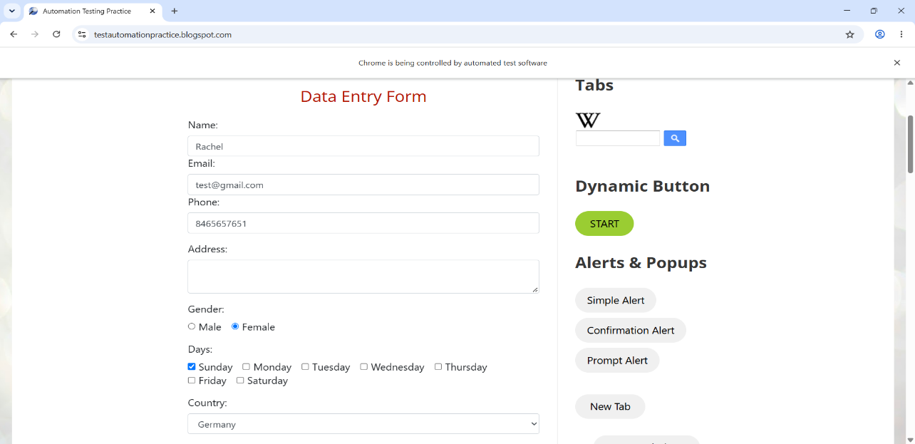

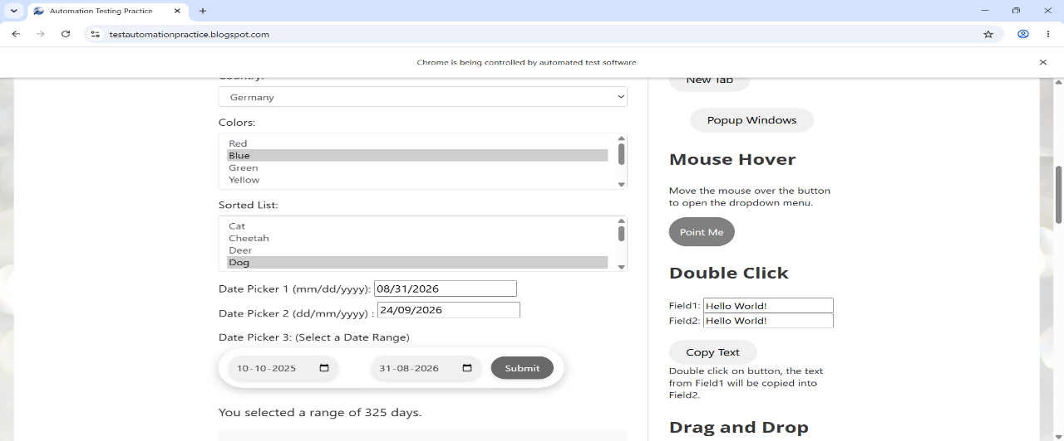

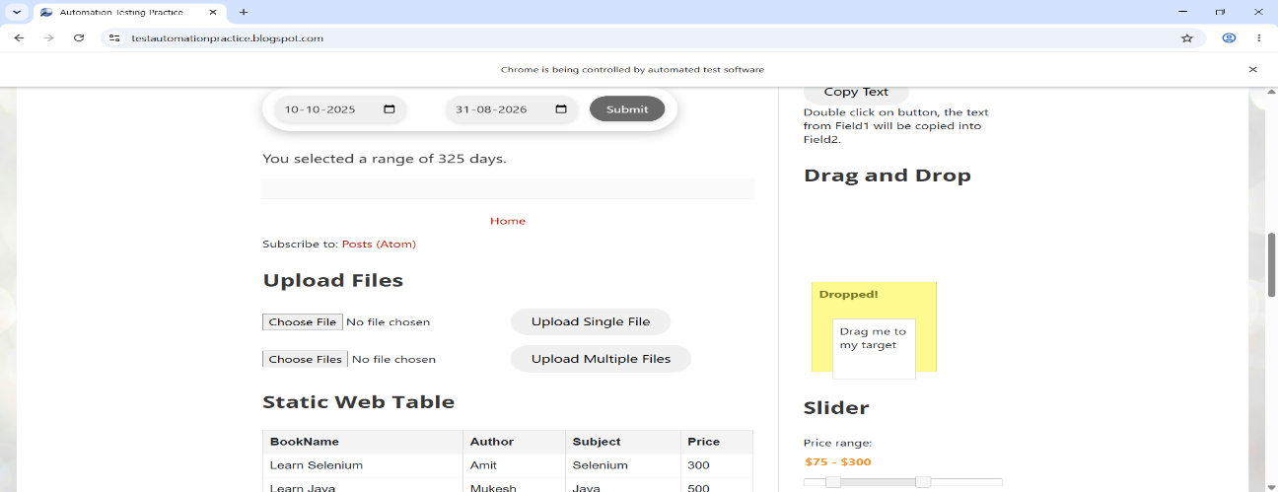

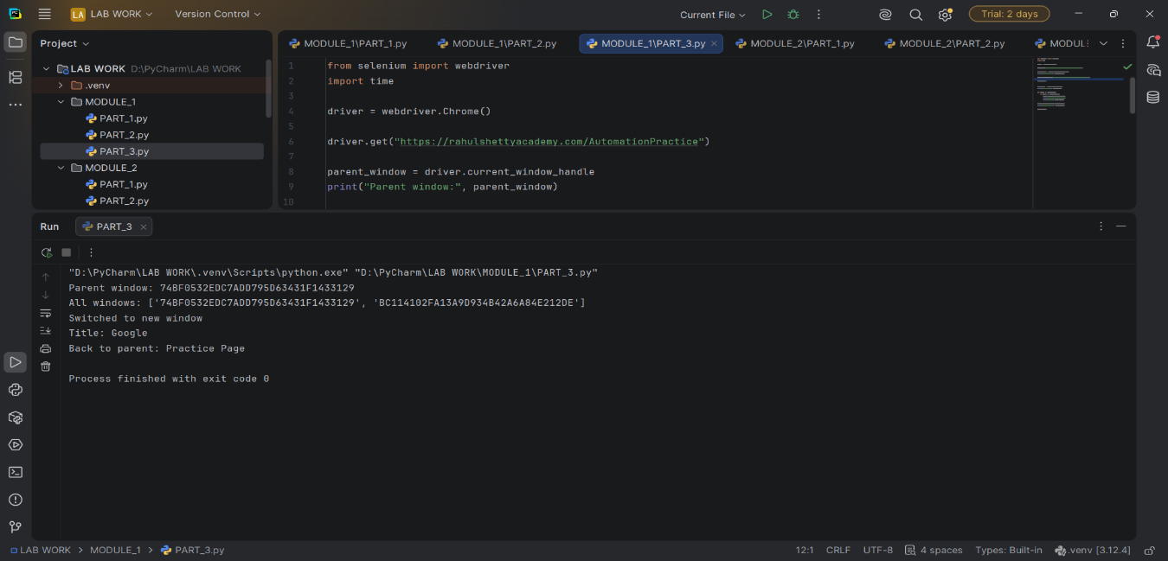

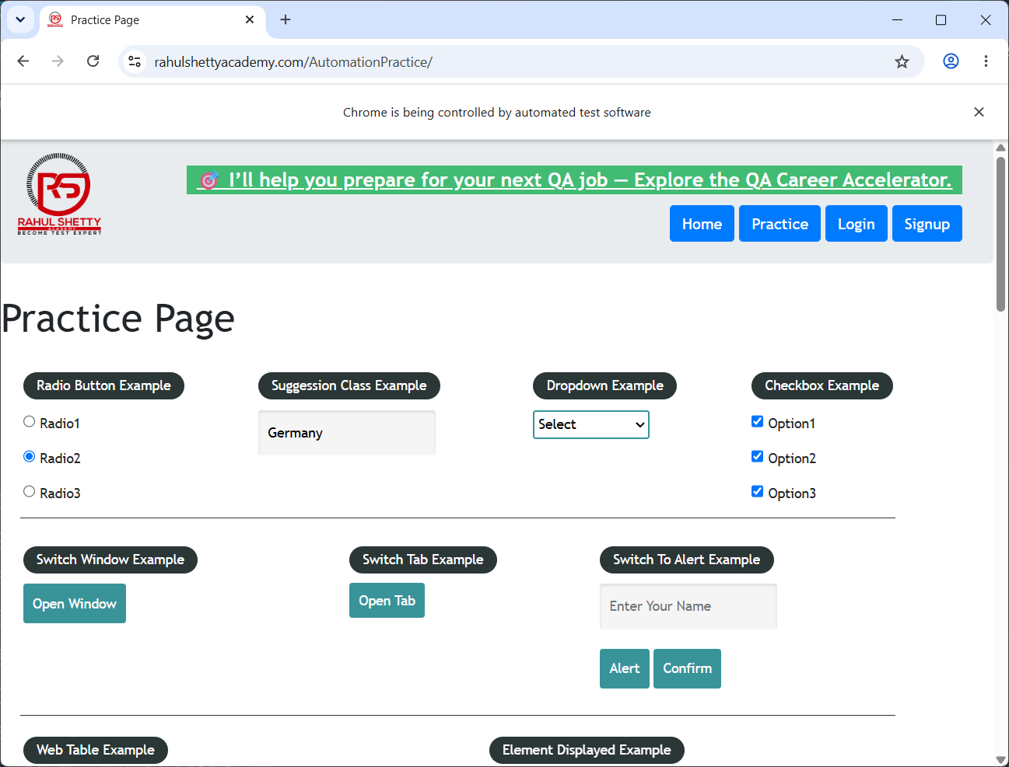

.

10. Expected Output
The automation should perform the following operations successfully:
Operation | Expected Result
Enter Email | Email is entered
Enter Name | Name is entered
Enter Phone | Phone number is entered
Select Gender | Female/radio option is selected
Select Day | Sunday is selected
Select Country | Germany is selected
Select Color | Blue is selected
Select Animal | Dog is selected
Enter Dates | Date fields are populated
Submit Form | Form is submitted
Mouse Hover | Mouse moves over target
Double Click | Target is double-clicked
Drag and Drop | Element moves to destination
Autocomplete | Germany suggestion is selected
Checkboxes | All checkboxes are selected
Alert | Alert is displayed and accepted
Window Handling | New window opens and Selenium switches between windows

11. Result
The Selenium WebDriver automation scripts were successfully implemented using Python on the two practice websites.
The experiment successfully demonstrated:
- Form field automation
- Radio button selection
- Checkbox selection
- Dropdown handling
- Autocomplete handling
- Date picker interaction
- JavaScript alert handling
- Mouse hover
- Double-click
- Drag-and-drop
- Multiple browser window handling
- Explicit waits

12. Observation
The experiment demonstrated that Selenium provides different mechanisms for interacting with different types of web elements.
The By class allows elements to be located using different strategies such as ID, XPath, and CSS selectors. The Select class simplifies interaction with standard dropdowns, while ActionChains allows complex mouse interactions.
The autocomplete example demonstrated the importance of explicit waits, since the suggestion may take some time to become available. WebDriverWait ensures that Selenium waits for the required condition instead of relying only on a fixed delay.
The alert and multiple-window examples also demonstrated that Selenium requires explicit context switching when interacting with browser-level components such as alerts and different windows.

13. Conclusion
This experiment successfully demonstrated web application automation using Selenium WebDriver and Python. Various types of web elements and browser interactions were automated across the two practice websites.
The experiment provided practical knowledge of Selenium's capabilities, including element identification, form automation, dropdown handling, explicit waits, alert handling, mouse actions, and multiple-window management.
Therefore, Selenium WebDriver can be effectively used to automate repetitive web application testing tasks and improve the consistency and efficiency of functional testing.

