1. Module Name and Experiment Title
Module Name: Software Testing and Test Automation
Experiment Title:
Automated Testing Using Selenium, Python unittest, Pytest, and Page Object Model
Web Application Used: Google
URL: https://www.google.com

2. Problem Statement
Modern web applications require systematic testing to ensure that their functionality works correctly and consistently. Manual testing can be repetitive and time-consuming, especially when the same test cases need to be executed repeatedly.
This experiment demonstrates different approaches to automated testing using Python, including the unittest framework, pytest, Selenium WebDriver, and the Page Object Model (POM) design pattern.
The experiment covers browser automation, assertions, test setup and teardown, test skipping and failure handling, exception testing, warning testing, and the creation of a reusable Base Page for Selenium automation.

3. Objectives
The objectives of this experiment are:
- To understand automated testing using Python.
- To use Selenium WebDriver with the Python unittest framework.
- To automate Google Images navigation and Google search.
- To understand test setup and teardown methods.
- To use assertions for validating test results.
- To understand the pytest testing framework.
- To demonstrate approximate value comparison using pytest.approx().
- To demonstrate intentional test failure using pytest.fail().
- To demonstrate conditional test skipping using pytest.skip().
- To demonstrate test-suite termination using pytest.exit().
- To test expected exceptions using pytest.raises().
- To test warnings using pytest.warns().
- To understand the Page Object Model design pattern.
- To create reusable Selenium methods using a Base Page.
- To use explicit waits for reliable element interaction.

4. Tools, Software, and Concepts Used
4.1 Tools and Software
Tool/Software | Purpose
Python | Programming language
Selenium WebDriver | Browser automation
Google Chrome | Browser used for Selenium testing
unittest | Python's built-in unit testing framework
Pytest | Python testing framework
WebDriverWait | Explicit waiting mechanism
VS Code / PyCharm | Code development and execution
4.2 Concepts Used
- Selenium WebDriver
- Python unittest
- Pytest
- Test cases
- Assertions
- Setup and teardown
- Test failure
- Test skipping
- Test termination
- Exception handling
- Warning handling
- Page Object Model
- Base Page
- Explicit waits
- Expected Conditions
- ActionChains
- Select
- Web element interaction

5. Part A – Selenium with Python unittest
The first program demonstrates how Selenium WebDriver can be integrated with Python's built-in unittest framework.
Source Code
from selenium import webdriver
import time
import unittest

from selenium.webdriver.common.by import By

class GoogleTestCase(unittest.TestCase):

def setUp(self) -> None:
self.driver = webdriver.Chrome()
self.driver.maximize_window()
self.driver.get("https://www.google.com")
time.sleep(5)

def test_google_images(self):

images_link = self.driver.find_element(
By.LINK_TEXT,
"Images"
)

images_link.click()

assert 'Google Images' in self.driver.title

time.sleep(5)

def test_google_search(self):

search_box = self.driver.find_element(
By.NAME,
"q"
)

search_box.send_keys(
"Selenium with Python"
)

search_box.submit()

time.sleep(5)

def tearDown(self) -> None:
self.driver.quit()

if __name__ == "__main__":
unittest.main()

6. Implementation of unittest
Step 1 – Create the test class
The test class inherits from unittest.TestCase.
class GoogleTestCase(unittest.TestCase):
This allows the class to use the features provided by Python's unittest framework.
Step 2 – Set up the browser
The setUp() method executes before every test method.
def setUp(self):
self.driver = webdriver.Chrome()
self.driver.maximize_window()
self.driver.get("https://www.google.com")
It creates a new Chrome browser and navigates to Google.
Step 3 – Test Google Images
The Images link is located using the link text locator.
images_link = self.driver.find_element(
By.LINK_TEXT,
"Images"
)
The link is clicked and the page title is verified.
assert 'Google Images' in self.driver.title
Step 4 – Test Google Search
The Google search box is located using its name attribute.
search_box = self.driver.find_element(
By.NAME,
"q"
)
The search term is entered:
search_box.send_keys("Selenium with Python")
The search form is submitted using:
search_box.submit()
Step 5 – Close the browser
The tearDown() method executes after each test.
def tearDown(self):
self.driver.quit()
This ensures that the browser is closed after test execution.

7. Part B – Pytest
The second program demonstrates different features of the Pytest framework.
Source Code
import pytest
import warnings

def test_price():

result = 0.1 + 0.2

assert result == pytest.approx(0.3)

def test_login():

login_successful = False

if not login_successful:
pytest.fail(
"Login was not successful"
)

def test1_login():

browser_available = False

if not browser_available:
pytest.skip(
"Browser is not available"
)

assert True

def test2_login():

server_available = False

if not server_available:
pytest.exit(
"Server is not available"
)

assert True

def test_homepage():

assert True

def divide(a, b):
return a / b

def test_divide_byzero():

with pytest.raises(ZeroDivisionError):
divide(10, 0)

def old_function():

warnings.warn(
"This function is deprecated",
UserWarning
)

def test_old_function():

with pytest.warns(UserWarning):
old_function()

8. Pytest Features Demonstrated
8.1 Approximate Comparison
Floating-point calculations may not always produce an exact decimal result.
result = 0.1 + 0.2
Instead of directly comparing the result with 0.3, Pytest's approx() is used:
assert result == pytest.approx(0.3)
This allows a small floating-point tolerance.

8.2 Intentional Test Failure
The pytest.fail() function is used to explicitly mark a test as failed.
if not login_successful:
pytest.fail(
"Login was not successful"
)
Since login_successful is False, the test fails with the specified message.

8.3 Skipping a Test
The pytest.skip() function prevents a test from executing when a required condition is unavailable.
if not browser_available:
pytest.skip(
"Browser is not available"
)
The test is marked as SKIPPED instead of FAILED.

8.4 Terminating the Test Session
The pytest.exit() function can terminate the current Pytest session.
if not server_available:
pytest.exit(
"Server is not available"
)
This demonstrates how an unavailable critical resource can terminate test execution.

8.5 Successful Test
The following test demonstrates a simple passing assertion:
def test_homepage():
assert True
The test passes because the assertion evaluates to True.

8.6 Testing Exceptions
The pytest.raises() context manager verifies that an expected exception occurs.
with pytest.raises(ZeroDivisionError):
divide(10, 0)
Because division by zero produces a ZeroDivisionError, the test passes.

8.7 Testing Warnings
The pytest.warns() function verifies that a particular warning is generated.
with pytest.warns(UserWarning):
old_function()
The test passes because old_function() generates a UserWarning.

9. Part C – Page Object Model: Base Page
The final program demonstrates the Page Object Model (POM) design pattern.
Source Code
from selenium.webdriver.support.ui import WebDriverWait
from selenium.webdriver.support import expected_conditions as EC
from selenium.webdriver.common.action_chains import ActionChains
from selenium.webdriver.support.ui import Select

class BasePage:

def __init__(self, driver):

self.driver = driver

self.wait = WebDriverWait(
driver,
10
)

def get_title(self):

return self.driver.title

def get_current_url(self):

return self.driver.current_url

def find(self, locator):

return self.wait.until(
EC.presence_of_element_located(locator)
)

def click(self, locator):

element = self.wait.until(
EC.element_to_be_clickable(locator)
)

element.click()

def enter_text(self, locator, text):

element = self.wait.until(
EC.visibility_of_element_located(locator)
)

element.send_keys(text)

10. Implementation of Page Object Model
The BasePage class contains common operations that can be reused by different page classes.
Constructor
def __init__(self, driver):
self.driver = driver
self.wait = WebDriverWait(driver, 10)
The WebDriver instance is stored and a 10-second explicit wait is created.
Get Page Title
def get_title(self):
return self.driver.title
This method returns the current page title.
Get Current URL
def get_current_url(self):
return self.driver.current_url
This method returns the URL of the current page.
Find an Element
def find(self, locator):
return self.wait.until(
EC.presence_of_element_located(locator)
)
The method waits until the required element is present in the DOM.
Click an Element
def click(self, locator):
element = self.wait.until(
EC.element_to_be_clickable(locator)
)
element.click()
The element is clicked only after it becomes clickable.
Enter Text
def enter_text(self, locator, text):
element = self.wait.until(
EC.visibility_of_element_located(locator)
)
element.send_keys(text)
The method waits for the element to become visible before entering text.

11. Output and Screenshots
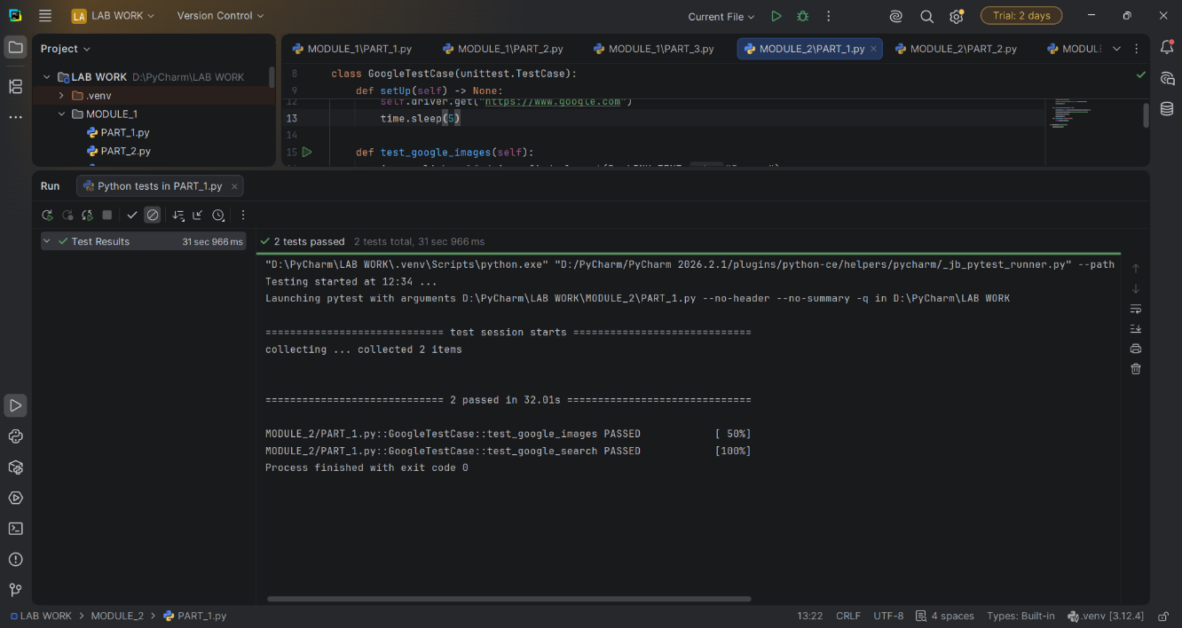

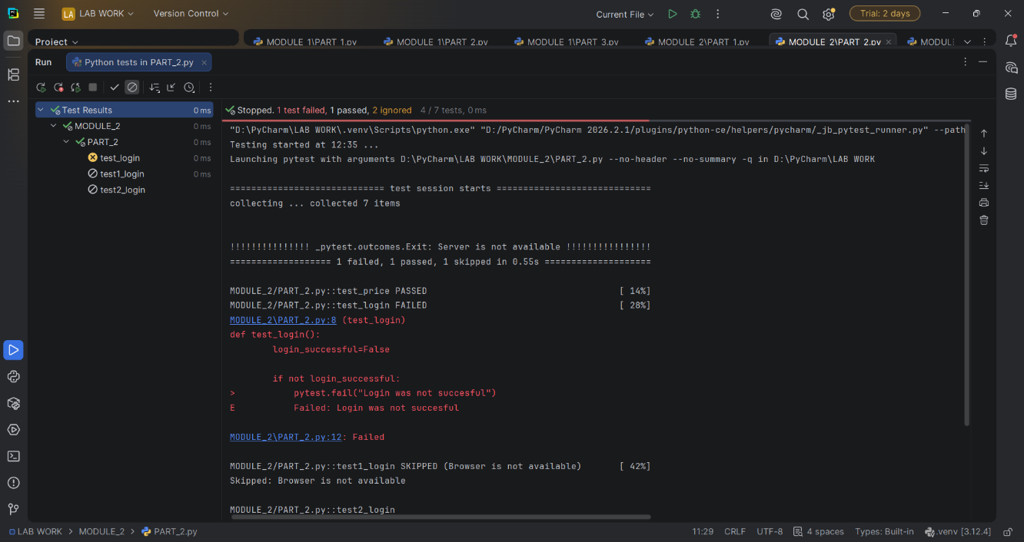

12. Expected Output
Selenium unittest
The program should:
- Launch Chrome.
- Open Google.
- Open Google Images in the first test.
- Search for Selenium with Python in the second test.
- Close the browser after each test.
A successful test run should report the corresponding test cases as passed.

Pytest
The program demonstrates different possible test outcomes:
Test | Expected Behavior
test_price() | PASSED
test_login() | FAILED
test1_login() | SKIPPED
test2_login() | Terminates Pytest session
test_homepage() | PASSED if reached
test_divide_byzero() | PASSED
test_old_function() | PASSED
The exact number of tests reported depends on where the pytest.exit() call terminates the test session.

13. Result
The experiment successfully demonstrated automated testing using Selenium WebDriver, Python unittest, Pytest, and the Page Object Model.
The Selenium program successfully automates Google navigation and searching. The Pytest program demonstrates assertions, approximate comparisons, intentional failures, test skipping, session termination, exception validation, and warning validation.
The Base Page implementation demonstrates how common Selenium operations can be encapsulated into reusable methods using the Page Object Model and explicit waits.

14. Observation
The experiment demonstrates that different testing frameworks provide different mechanisms for organizing and executing automated tests.
The unittest framework provides a structured approach through methods such as setUp() and tearDown(). Pytest provides concise test syntax and useful features for handling failures, skips, exceptions, warnings, and approximate comparisons.
The Page Object Model separates web-page interaction logic from test logic. The use of WebDriverWait and Expected Conditions makes element interaction more controlled than relying entirely on fixed delays.

15. Conclusion
The experiment successfully demonstrated the use of Python-based automated testing frameworks and Selenium WebDriver. Selenium was used to automate browser interactions, while unittest and Pytest were used to organize and validate test cases.
The experiment also demonstrated the Page Object Model, which improves code reusability and maintainability by placing common browser operations in a reusable Base Page class.
Overall, the experiment provided practical knowledge of web automation, test execution, assertions, exception handling, test control mechanisms, explicit waits, and maintainable test architecture.

