1. Module Name and Experiment Title
Module Name: Web Automation Testing
Experiment Title:
Data-Driven Web Automation Using Selenium WebDriver, Behave Framework, and Page Object Model
Website Used:
https://testautomationpractice.blogspot.com

2. Problem Statement
Web applications need to be tested repeatedly with different sets of input data to ensure that their functionality works correctly. Performing such testing manually is time-consuming and may lead to inconsistent results.
The purpose of this experiment is to implement a data-driven web automation framework using Python, Selenium WebDriver, and Behave. The Page Object Model (POM) is used to separate web-page interaction logic from test logic, while test data is maintained externally in a CSV file.
The automation will interact with the Data Entry Form of the Test Automation Practice website by entering different user details and selecting values from radio buttons, checkboxes, and dropdown menus.

3. Objective
The objectives of this experiment are:
- To understand the Behave BDD framework.
- To write test cases using Gherkin language.
- To automate a web application using Selenium WebDriver.
- To implement the Page Object Model (POM).
- To implement data-driven testing using a CSV file.
- To understand the use of Scenario Outline and test data.
- To automate text fields, radio buttons, checkboxes, and dropdowns.
- To understand the separation between feature files, step definitions, page objects, and test data.
- To improve the reusability and maintainability of Selenium automation code.

4. Tools, Software, and Concepts Used
4.1 Tools and Software
Tool / Software | Purpose
Python | Programming language
Selenium WebDriver | Browser automation
Behave | BDD testing framework
Google Chrome | Browser used for automation
ChromeDriver | Communication between Selenium and Chrome
CSV | External test-data source
VS Code / PyCharm | Code development and execution
4.2 Concepts Used
- Behavior Driven Development (BDD)
- Behave Framework
- Gherkin
- Feature files
- Scenario
- Scenario Outline
- Step Definitions
- Selenium WebDriver
- Page Object Model
- Data-driven testing
- CSV test data
- XPath
- ID locators
- CSS selectors
- Radio buttons
- Checkboxes
- Dropdown lists
- Browser setup and teardown

5. Project Structure
The automation project is organized as follows:
Assignment3/
│
├── features/
│ │
│ ├── data_entry.feature
│ │
│ ├── steps/
│ │ └── data_entry_steps.py
│ │
│ └── environment.py
│
├── pages/
│ └── data_entry_page.py
│
├── test_data/
│ └── test_data.csv
│
└── requirements.txt
Description of files
File | Purpose
data_entry.feature | Contains test scenarios written in Gherkin
data_entry_steps.py | Contains Python implementations of Gherkin steps
environment.py | Handles browser setup and cleanup
data_entry_page.py | Contains page locators and page actions
test_data.csv | Contains external test data
requirements.txt | Contains required Python packages

6. Installation
The required packages can be installed using:
pip install selenium behave
The requirements.txt file contains:
selenium
behave

7. Source Code / Implementation
7.1 Page Object Model – data_entry_page.py
from selenium.webdriver.common.by import By
from selenium.webdriver.support.ui import Select

class DataEntryPage:

URL = "https://testautomationpractice.blogspot.com/"

def __init__(self, driver):
self.driver = driver

# Locators

NAME = (By.ID, "name")
EMAIL = (By.ID, "email")
PHONE = (By.ID, "phone")
ADDRESS = (By.ID, "textarea")

MALE = (By.ID, "male")
FEMALE = (By.ID, "female")

SUNDAY = (By.ID, "sunday")
MONDAY = (By.ID, "monday")
TUESDAY = (By.ID, "tuesday")
WEDNESDAY = (By.ID, "wednesday")
THURSDAY = (By.ID, "thursday")
FRIDAY = (By.ID, "friday")
SATURDAY = (By.ID, "saturday")

COUNTRY = (By.ID, "country")
COLORS = (By.ID, "colors")

# Page actions

def open(self):
self.driver.get(self.URL)

def enter_name(self, name):
element = self.driver.find_element(*self.NAME)
element.clear()
element.send_keys(name)

def enter_email(self, email):
element = self.driver.find_element(*self.EMAIL)
element.clear()
element.send_keys(email)

def enter_phone(self, phone):
element = self.driver.find_element(*self.PHONE)
element.clear()
element.send_keys(phone)

def enter_address(self, address):
element = self.driver.find_element(*self.ADDRESS)
element.clear()
element.send_keys(address)

def select_gender(self, gender):

if gender.lower() == "male":
self.driver.find_element(*self.MALE).click()

elif gender.lower() == "female":
self.driver.find_element(*self.FEMALE).click()

def select_day(self, day):

day_locators = {
"Sunday": self.SUNDAY,
"Monday": self.MONDAY,
"Tuesday": self.TUESDAY,
"Wednesday": self.WEDNESDAY,
"Thursday": self.THURSDAY,
"Friday": self.FRIDAY,
"Saturday": self.SATURDAY
}

if day in day_locators:
self.driver.find_element(
*day_locators[day]
).click()

def select_country(self, country):

dropdown = self.driver.find_element(*self.COUNTRY)

Select(dropdown).select_by_visible_text(country)

def select_color(self, color):

dropdown = self.driver.find_element(*self.COLORS)

Select(dropdown).select_by_visible_text(color)

def fill_form(
self,
name,
email,
phone,
address,
gender,
day,
country,
color
):

self.enter_name(name)
self.enter_email(email)
self.enter_phone(phone)
self.enter_address(address)

self.select_gender(gender)
self.select_day(day)

self.select_country(country)
self.select_color(color)

8. Gherkin Feature File – data_entry.feature
Feature: Data Entry Form Automation

Scenario: Enter multiple sets of data into the form
Given I open the Data Entry Form
When I enter all test data from the CSV file
Then the form data should be entered successfully
The feature file describes the behavior of the application in simple English rather than directly containing Selenium code.

9. Test Data – test_data.csv
name,email,phone,address,gender,day,country,color
John Doe,john@gmail.com,9876543210,Kolkata,Male,Monday,India,Red
Jane Smith,jane@gmail.com,9876543211,Delhi,Female,Tuesday,United States,Blue
Rahul Kumar,rahul@gmail.com,9876543212,Mumbai,Male,Wednesday,India,Green
Priya Sharma,priya@gmail.com,9876543213,Bangalore,Female,Friday,Canada,Yellow
The CSV file acts as the external source of test data.
Four different sets of data are supplied to the same automation logic.

10. Step Definitions – data_entry_steps.py
import csv

from behave import given, when, then
from pages.data_entry_page import DataEntryPage

@given("I open the Data Entry Form")
def open_data_entry_form(context):

context.page = DataEntryPage(context.driver)

context.page.open()

@when("I enter all test data from the CSV file")
def enter_test_data(context):

context.results = []

with open(
"test_data/test_data.csv",
mode="r",
encoding="utf-8"
) as file:

reader = csv.DictReader(file)

for row in reader:

context.page.fill_form(
name=row["name"],
email=row["email"],
phone=row["phone"],
address=row["address"],
gender=row["gender"],
day=row["day"],
country=row["country"],
color=row["color"]
)

context.results.append(row)

@then("the form data should be entered successfully")
def verify_form_data(context):

assert len(context.results) > 0

print(
f"\nSuccessfully processed "
f"{len(context.results)} test data sets."
)

11. Browser Setup – environment.py
from selenium import webdriver

def before_scenario(context, scenario):

context.driver = webdriver.Chrome()

context.driver.maximize_window()

def after_scenario(context, scenario):

context.driver.quit()
Purpose
before_scenario() executes before the scenario and launches Chrome.
after_scenario() executes after the scenario and closes the browser.
This prevents browser management code from being repeated inside every step definition.

12. Implementation Steps
Step 1 – Launch the browser
Behave calls the before_scenario() function before executing the scenario.
context.driver = webdriver.Chrome()
The Chrome browser is launched and maximized.

Step 2 – Open the website
The Given step calls the Page Object:
context.page = DataEntryPage(context.driver)
context.page.open()
The website is opened:
https://testautomationpractice.blogspot.com/

Step 3 – Read test data
The step definition opens the CSV file:
with open(
"test_data/test_data.csv",
mode="r",
encoding="utf-8"
) as file:
csv.DictReader reads each row as a dictionary.
For example:
name → John Doe
email → john@gmail.com
gender → Male
country → India

Step 4 – Fill the form
The test data is passed to:
context.page.fill_form(...)
The Page Object then performs the required Selenium operations.

Step 5 – Enter text
The Page Object uses send_keys() to enter the name, email, phone number, and address.
Example:
element.send_keys(name)

Step 6 – Select gender
The program checks the value in the CSV file.
For example:
gender = Male
The corresponding radio button is selected.

Step 7 – Select day
The program uses a dictionary containing the locators for all available days.
day_locators = {
"Sunday": self.SUNDAY,
"Monday": self.MONDAY,
...
}
The appropriate checkbox is then selected based on the CSV value.

Step 8 – Select dropdown values
The Selenium Select class is used for the Country and Colors dropdowns.
Select(dropdown).select_by_visible_text(country)
For example:
Country → India
Color → Red

Step 9 – Verify execution
After processing the CSV file, the program verifies that test data was processed:
assert len(context.results) > 0
A success message is displayed:
Successfully processed 4 test data sets.

Step 10 – Close the browser
After the scenario finishes, Behave calls:
def after_scenario(context, scenario):
context.driver.quit()
The browser is closed automatically.

13. Data-Driven Testing
The major feature of this experiment is data-driven testing.
Instead of writing separate automation code for each user, the same test logic processes multiple rows from the CSV file.
Test Data
Name | Gender | Day | Country | Color
John Doe | Male | Monday | India | Red
Jane Smith | Female | Tuesday | United States | Blue
Rahul Kumar | Male | Wednesday | India | Green
Priya Sharma | Female | Friday | Canada | Yellow
The automation code remains the same while the input data changes.
Advantage
If a fifth test case is required, it can be added to the CSV file without changing the Selenium Page Object or step-definition code.

14. Page Object Model
The implementation follows the Page Object Model structure:
Feature File
│
▼
Behave Step File
│
▼
Page Object
│
▼
Selenium WebDriver
│
▼
Web Application
▲
│
CSV Data
Benefits of POM
- Separates test logic from page interaction.
- Avoids repeating locators.
- Makes the automation code easier to maintain.
- Improves code reusability.
- Changes to page locators can be handled primarily in the Page Object.

15. Execution
Navigate to the project directory in the terminal:
cd Assignment3
Run the Behave test:
behave
Expected output:
Feature: Data Entry Form Automation

Scenario: Enter multiple sets of data into the form
Given I open the Data Entry Form
When I enter all test data from the CSV file
Then the form data should be entered successfully

Successfully processed 4 test data sets.

1 feature passed
1 scenario passed
3 steps passed
The exact terminal formatting may vary depending on the installed Behave version.

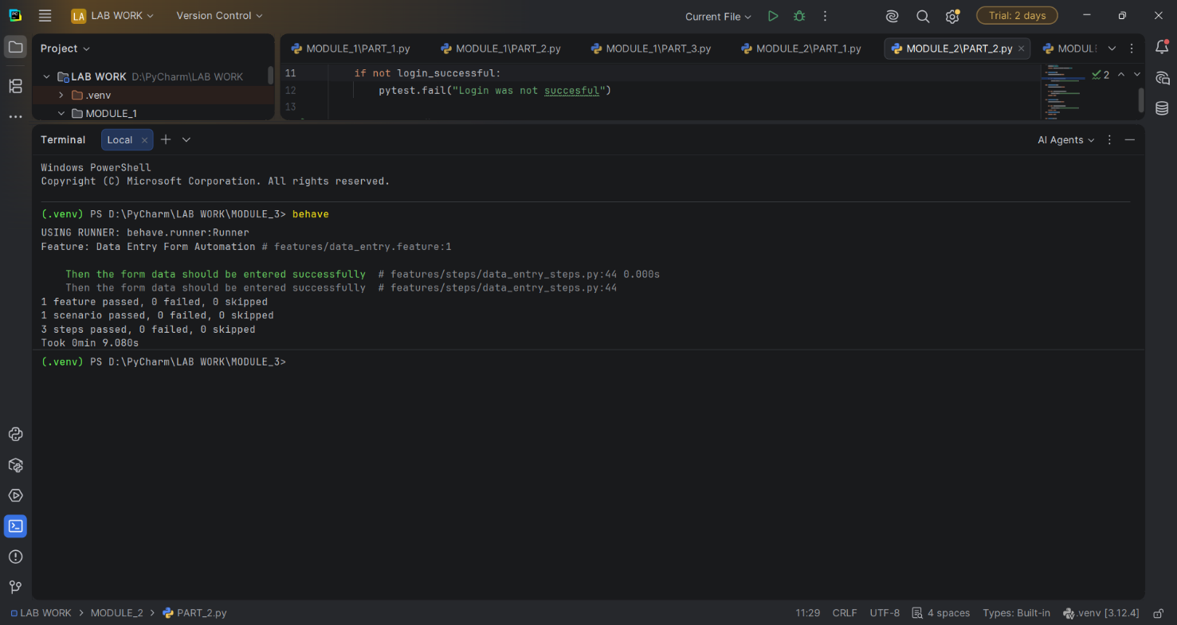
16. Output with Clearly Labelled Screenshots

17. Expected Output
The automation is expected to:
- Open Chrome.
- Navigate to the Test Automation Practice website.
- Enter the first set of CSV data.
- Select the corresponding gender and day.
- Select the country and color.
- Process the remaining CSV records.
- Verify that test data has been processed.
- Display the number of processed test cases.
- Close the browser.
Expected message:
Successfully processed 4 test data sets.
Expected Behave result:
1 feature passed
1 scenario passed
3 steps passed

18. Result
The data-driven web automation framework was successfully implemented using Python, Selenium WebDriver, Behave, Page Object Model, and CSV test data.
The automation successfully reads multiple sets of test data from the CSV file and uses the same Selenium test logic to interact with the Data Entry Form.

19. Observation
The experiment demonstrated that Behave allows test scenarios to be expressed using simple Gherkin statements such as:
Given
When
Then
The Page Object Model separates web-element locators and browser operations from the test steps, improving the organization and reusability of the automation framework.
The CSV-based approach allows multiple test cases to be executed using the same automation code. Therefore, adding or modifying test data does not require changes to the core Selenium implementation.

20. Conclusion
The experiment successfully demonstrated data-driven web application testing using Selenium WebDriver and the Behave framework.
The implementation combined Gherkin-based BDD, Page Object Model, Selenium WebDriver, and external CSV test data into a structured automation framework. Different sets of input data were processed using the same test logic, demonstrating the benefits of reusable and maintainable automated testing.
The experiment provided practical knowledge of BDD, Gherkin, Selenium automation, Page Object Model, data-driven testing, test organization, and browser lifecycle management.

