LAB REPORT
1. Module Name and Experiment Title
Module Name: Web Automation Testing
Experiment Title:
Web Form Automation Using Robot Framework and SeleniumLibrary
Website Used:
https://testautomationpractice.blogspot.com/

2. Problem Statement
Manual testing of web forms requires repeatedly entering data and selecting different controls such as radio buttons, checkboxes, and dropdown menus. This process can be time-consuming and may result in human errors.
The objective of this experiment is to automate the Data Entry Form of the Test Automation Practice website using Robot Framework and SeleniumLibrary. The test will open the browser, enter user information, select the required form controls, choose a country from a dropdown list, and close the browser after execution.

3. Objective
The objectives of this experiment are:
- To understand the basics of Robot Framework.
- To use SeleniumLibrary for web browser automation.
- To automate a web-based data entry form.
- To understand Robot Framework's keyword-driven syntax.
- To automate text fields, radio buttons, checkboxes, and dropdown lists.
- To understand the use of variables in Robot Framework.
- To execute a complete browser automation test case.
- To observe the execution of automated test steps.

4. Tools, Software, and Concepts Used
4.1 Tools and Software
Tool / Software | Purpose
Robot Framework | Automation testing framework
SeleniumLibrary | Selenium-based web automation library
Python | Runtime environment for Robot Framework
Google Chrome | Browser used for testing
Chrome WebDriver | Browser automation
VS Code / PyCharm | Test-case development
4.2 Concepts Used
- Robot Framework
- SeleniumLibrary
- Keyword-driven testing
- Test cases
- Variables
- Browser automation
- Locators
- Text-field automation
- Radio-button selection
- Checkbox selection
- Dropdown selection
- Browser window management
- Explicit test steps
- Test execution

5. Robot Framework Test Structure
The test follows the standard Robot Framework sections:
*** Settings ***
*** Variables ***
*** Test Cases ***
*** Settings ***
This section specifies the libraries required by the test.
*** Variables ***
This section stores reusable values such as the website URL and browser name.
*** Test Cases ***
This section contains the actual test steps using Robot Framework keywords.

6. Source Code
*** Settings ***
Library SeleniumLibrary

*** Variables ***
${URL} https://testautomationpractice.blogspot.com/
${BROWSER} Chrome

*** Test Cases ***
Fill Data Entry Form
Open Browser ${URL} ${BROWSER}
Maximize Browser Window
Input Text id=name John Doe
Input Text id=email john@gmail.com
Input Text id=phone 9876543210
Input Text id=textarea Kolkata
Select Radio Button gender male
Select Checkbox monday
Select From List By Label id=country India
Sleep 2s
Close Browser

7. Explanation of the Source Code
7.1 Importing SeleniumLibrary
*** Settings ***
Library SeleniumLibrary
SeleniumLibrary provides Robot Framework keywords for interacting with web browsers through Selenium WebDriver.
It provides keywords such as:
- Open Browser
- Input Text
- Click Element
- Select Checkbox
- Select Radio Button
- Select From List By Label
- Close Browser

8. Declaring Variables
*** Variables ***
${URL} https://testautomationpractice.blogspot.com/
${BROWSER} Chrome
Two variables are declared:
- ${URL} stores the URL of the website.
- ${BROWSER} stores the browser name.
Variables make the test easier to modify and maintain.
For example, if another browser needs to be used, only the ${BROWSER} variable needs to be changed.

9. Opening the Browser
Open Browser ${URL} ${BROWSER}
The Open Browser keyword launches the specified browser and navigates to the specified URL.
In this experiment:
Browser → Chrome
URL → https://testautomationpractice.blogspot.com/

10. Maximizing the Browser
Maximize Browser Window
This keyword maximizes the browser window.
Maximizing the browser provides a consistent visible environment for interacting with the web elements.

11. Entering Name
Input Text id=name John Doe
The Input Text keyword enters the specified text into a text field.
The locator:
id=name
identifies the Name field.
The value entered is:
John Doe

12. Entering Email
Input Text id=email john@gmail.com
This keyword locates the email field using its ID and enters:
john@gmail.com

13. Entering Phone Number
Input Text id=phone 9876543210
The phone field is identified using:
id=phone
The specified phone number is entered into the field.

14. Entering Address
Input Text id=textarea Kolkata
The address field is identified using:
id=textarea
The following value is entered:
Kolkata

15. Selecting the Radio Button
Select Radio Button gender male
The Select Radio Button keyword selects a radio button.
The parameters are:
Group → gender
Value → male
Therefore, the Male radio button is selected.

16. Selecting the Checkbox
Select Checkbox monday
The Select Checkbox keyword selects the checkbox corresponding to Monday.
The locator used is:
monday
This allows the test to automate selection of a particular day.

17. Selecting Country from Dropdown
Select From List By Label id=country India
The Select From List By Label keyword selects an option from a dropdown list using its visible text.
Here:
Dropdown → id=country
Option → India
Therefore, India is selected from the Country dropdown.

18. Waiting for Two Seconds
Sleep 2s
The Sleep keyword pauses the test execution for two seconds.
This provides time to observe the completed form before the browser is closed.
Note: In production-grade automation, fixed Sleep statements are generally less reliable than condition-based waits because they always wait for a predetermined amount of time.

19. Closing the Browser
Close Browser
The Close Browser keyword closes the browser after all test steps have been completed.
This ensures that the browser session is properly terminated.

20. Execution Flow
The complete automation flow is:
Start
│
▼
Open Chrome
│
▼
Navigate to Website
│
▼
Maximize Browser
│
▼
Enter Name
│
▼
Enter Email
│
▼
Enter Phone
│
▼
Enter Address
│
▼
Select Male Radio Button
│
▼
Select Monday Checkbox
│
▼
Select India from Country Dropdown
│
▼
Wait 2 Seconds
│
▼
Close Browser
│
▼
End

21. Execution of the Test Case
The Robot Framework test file should be saved with the .robot extension, for example:
data_entry.robot
The test can be executed from the terminal using:
robot data_entry.robot
Robot Framework generates execution results after the test finishes.
The main result files are generally:
output.xml
log.html
report.html

22. Expected Output
During execution, Chrome should open automatically and navigate to:
https://testautomationpractice.blogspot.com/
The automation should perform the following actions:
- Open the website.
- Maximize the browser.
- Enter John Doe in the Name field.
- Enter john@gmail.com in the Email field.
- Enter 9876543210 in the Phone field.
- Enter Kolkata in the Address field.
- Select the Male radio button.
- Select Monday.
- Select India from the Country dropdown.
- Wait for two seconds.
- Close the browser.
A successful execution should show the test case as PASS in the Robot Framework report.

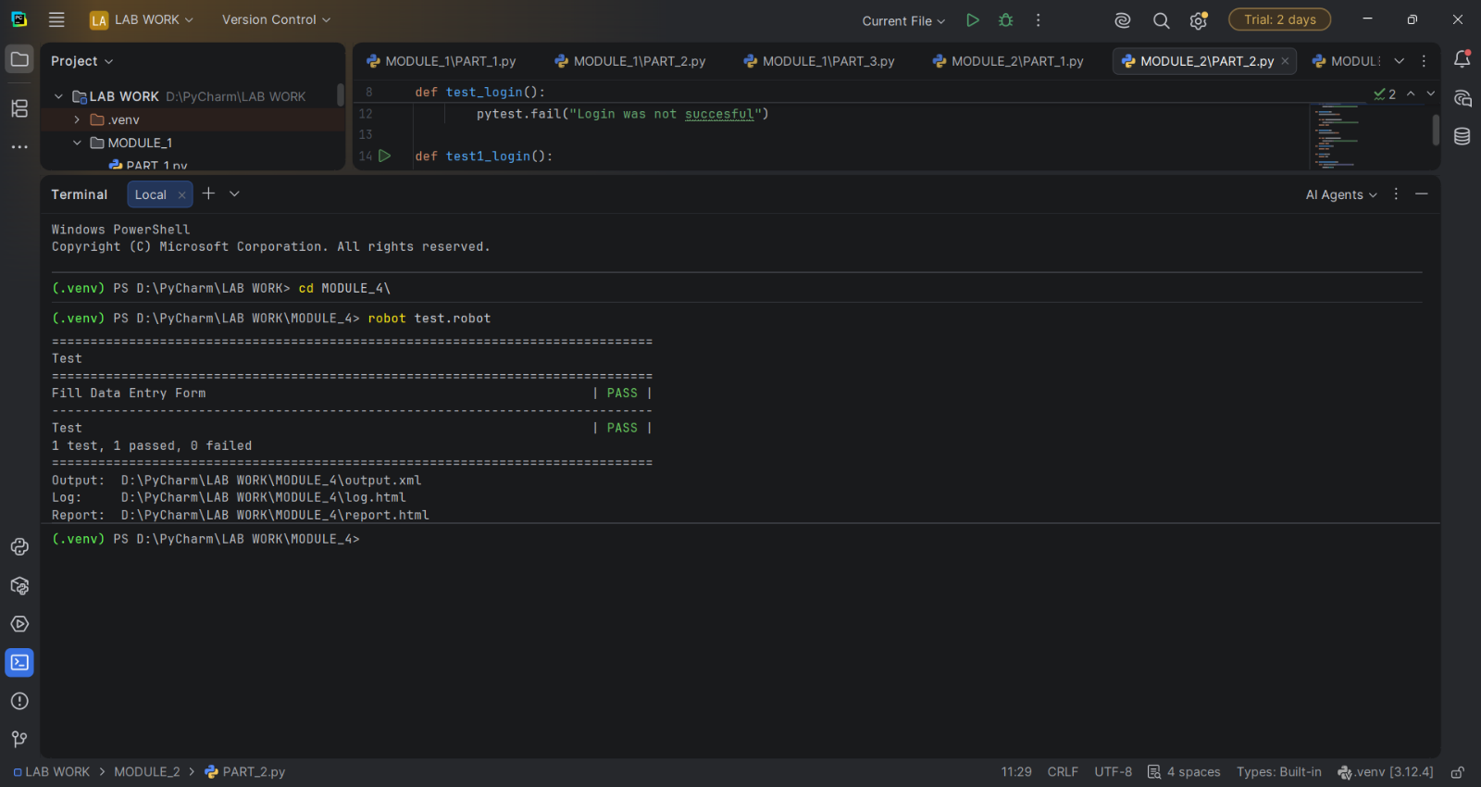
23. Output Screenshots

24. Important Robot Framework Keywords Used
Keyword | Function
Open Browser | Opens the specified browser and URL
Maximize Browser Window | Maximizes the browser
Input Text | Enters text into an input field
Select Radio Button | Selects a radio button
Select Checkbox | Selects a checkbox
Select From List By Label | Selects an option from a dropdown
Sleep | Pauses execution for a specified duration
Close Browser | Closes the browser

25. Advantages of Robot Framework
Robot Framework provides several advantages for web automation:
- Simple syntax: Test cases are written using readable keywords.
- Keyword-driven approach: Complex Selenium operations can be represented by simple keywords.
- Reusable libraries: SeleniumLibrary provides many ready-to-use browser automation keywords.
- Readable test cases: Test steps can be easily understood by technical and non-technical users.
- HTML reports: Robot Framework automatically generates detailed execution reports.
- Easy maintenance: Variables and keywords help make test cases easier to modify.
- Extensibility: Robot Framework can be extended using Python libraries.

26. Observation
During the experiment, the Robot Framework successfully controlled the Chrome browser through SeleniumLibrary.
The test case demonstrated automation of different types of web controls, including:
- Text input fields
- Radio buttons
- Checkboxes
- Dropdown lists
The use of variables for the URL and browser made the test case more organized and reusable.
The keyword-driven syntax of Robot Framework also made the test steps easy to read and understand.

27. Result
The Data Entry Form was successfully automated using Robot Framework and SeleniumLibrary.
The test successfully opened the browser, entered the required user information, selected the appropriate radio button and checkbox, selected India from the dropdown, waited for the specified duration, and closed the browser.

28. Conclusion
This experiment demonstrated the use of Robot Framework with SeleniumLibrary for web application automation. A complete data-entry workflow was automated using Robot Framework's keyword-driven syntax.
The experiment provided practical understanding of browser automation, element identification, text-field handling, radio-button selection, checkbox selection, dropdown handling, browser management, variables, and automated test execution.
Thus, Robot Framework combined with SeleniumLibrary provides a structured and readable approach for developing automated web tests.

