Heart Failure 30-Day Readmission Prediction
Classification Model Training, Evaluation, Comparison, and Overfitting/Underfitting Diagnosis
Month 1 Project — Healthcare Analytics
Dataset: dataset_12000_records.csv | 12,000 patients | 36 columns
Models: Logistic Regression · K-Nearest Neighbors · Decision Tree

Executive Summary
Three classical binary-classification models — Logistic Regression, K-Nearest Neighbors (KNN), and a Decision Tree — were trained to predict whether a heart-failure patient will be readmitted within 30 days of discharge, using a clean, 12,000-row hospital dataset with no missing values and no duplicate records. The target is imbalanced (70% not readmitted vs. 30% readmitted), so accuracy alone is not a reliable metric and Precision, Recall, F1-score, and ROC-AUC were used throughout.
Logistic Regression was the strongest and most reliable model (test ROC-AUC = 0.956, test accuracy = 89.5%, F1 = 0.818) and generalized almost perfectly, with virtually no gap between training and test performance. KNN (tuned to k = 51) generalized well but under-detected readmissions (recall = 0.543). The Decision Tree (depth = 8) showed a clear, evidence-based overfitting pattern once grown beyond moderate depth. Full evidence, diagnosis, and a final recommendation are provided below, followed by direct answers to all required questions (Q1–Q14).

1. Problem Statement
As a junior ML engineer on a healthcare analytics project, the goal is to identify heart-failure patients at higher risk of 30-day readmission so the care team can prioritize follow-up and post-discharge support. Three classifiers are trained on the same train/test split and compared using multiple metrics — not accuracy alone — with an explicit, evidence-based diagnosis of underfitting or overfitting for each.

2. Dataset Overview (Step A — Explore the Dataset)
Property | Value
Rows (patients) | 12,000
Columns | 36 (35 features + 1 target, after dropping the ID)
Missing values | 0 across all columns
Duplicate rows | 0
Duplicate Patient IDs | 0
Target column | Readmitted_30_Days (0 = not readmitted, 1 = readmitted within 30 days)
Class balance | 8,400 negative (70.0%) / 3,600 positive (30.0%) — imbalanced

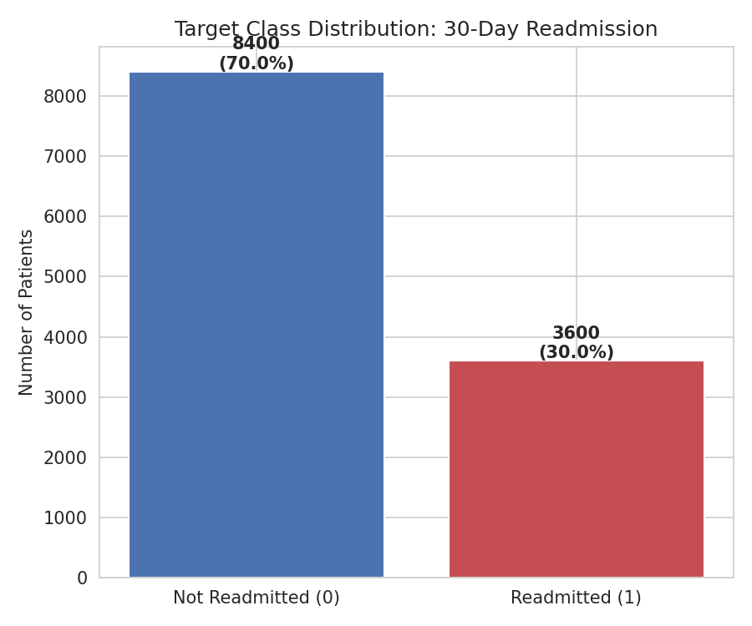
Figure 1. Target class distribution — 30% of patients were readmitted within 30 days.
Feature groups identified: demographics (Age, Gender, BMI), lifestyle (Smoking, Alcohol, Exercise), comorbidities (Hypertension, Diabetes, CKD, CAD, Stroke, AFib), clinical history (Previous HF/Hospital Admissions), admission characteristics (Heart_Failure_Type, NYHA_Class, Ejection_Fraction, vitals, labs, Length_of_Stay, ICU/Emergency flags), and discharge medications (Beta_Blocker, ACE_ARB, Diuretic, SGLT2_Inhibitor). All of these are known at or before the discharge decision point, so all were retained as legitimate predictors (see Q2/leakage discussion below).

3. Data Preparation (Step B)

3.1 Missing values and data quality
No missing values, impossible values, or duplicate rows were found. Numeric ranges were sanity-checked (e.g., Age 30–95, Ejection_Fraction 10–72%, Oxygen_Saturation 84–100%, Length_of_Stay 1–30 days) and all fall within clinically plausible bounds, so no rows were dropped.

3.2 Encoding categorical variables
- Gender (Male/Female), Smoking_Status (Yes/No), Alcohol_Consumption (Yes/No) — binary, mapped to 0/1.
- Heart_Failure_Type (HFrEF, HFmrEF, HFpEF) — nominal with 3 levels, one-hot encoded with drop_first=True to avoid the dummy-variable trap (2 dummy columns retained).
- Patient_ID — dropped. It is a unique row identifier with no predictive information; keeping it risks the tree-based model memorizing individual rows.

3.3 Feature scaling
StandardScaler (zero mean, unit variance) was fit on the training data only and then applied to transform both the training and test sets, to avoid leaking test-set statistics into preprocessing. Scaling was applied for Logistic Regression and KNN, both of which are distance/gradient-based and sensitive to feature magnitude. The Decision Tree was trained on unscaled data, since tree splits are based on ordering thresholds, not distances, and scaling does not change tree structure.

3.4 Data leakage check
Correlations between every numeric feature and the target were inspected. The strongest correlations were moderate and clinically sensible (see table), with none approaching the near-perfect correlation (e.g., > 0.9) that would flag a leaked feature:
Feature | Correlation with target
Previous_Hospital_Admissions | +0.490
Chronic_Kidney_Disease | +0.482
Previous_HF_Admissions | +0.430
Length_of_Stay | +0.424
BNP | +0.413
Ejection_Fraction | -0.355
Diabetes | +0.313
No column encodes information from after the readmission event itself (e.g., a future admission date, a readmission diagnosis code, or days-to-readmission), so no feature was removed for leakage. Length_of_Stay, BNP, Ejection_Fraction, ICU/Emergency flags, and discharge medications all describe the index hospitalization and are legitimately known at the discharge decision point — exactly when a real hospital would want to use this model.

4. Train/Test Split (Step C)
An 80/20 split (9,600 train / 2,400 test) was created with train_test_split(test_size=0.2, random_state=42, stratify=y). Stratification on the target preserves the 70/30 class ratio identically in both sets, which matters because the target is imbalanced — an unstratified split could otherwise under- or over-represent the minority (readmitted) class in the test set and bias the evaluation.

5. Model Training (Step D)

5.1 Logistic Regression
A baseline linear classifier with L2 (ridge) regularization, solver='lbfgs', max_iter=1000, trained on scaled features. Regularization strength C was tuned via 5-fold stratified cross-validation on ROC-AUC over C ∈ {0.001, 0.01, 0.1, 1, 10, 100}:
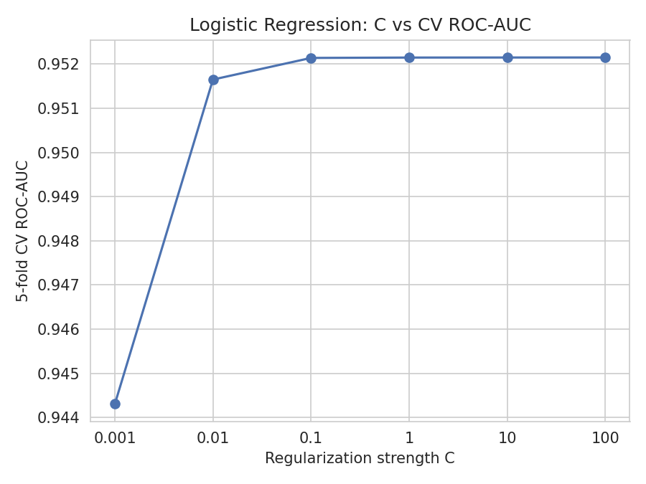
Figure 2. Logistic Regression regularization sweep. CV ROC-AUC rises sharply from C=0.001 to C=0.1 and then plateaus, showing the model is not sensitive to regularization once C ≥ 0.1 — a sign the linear model is well-specified for this feature set rather than needing heavy regularization.
C = 100 (mean 5-fold CV ROC-AUC ≈ 0.952) was selected, though C = 0.1–100 all perform statistically indistinguishably, confirming the model is stable.

5.2 K-Nearest Neighbors (KNN)
KNN was trained on scaled features (Euclidean distance). k was selected by comparing training ROC-AUC against 5-fold CV ROC-AUC across k ∈ {3,5,7,9,11,15,21,31,41,51}:
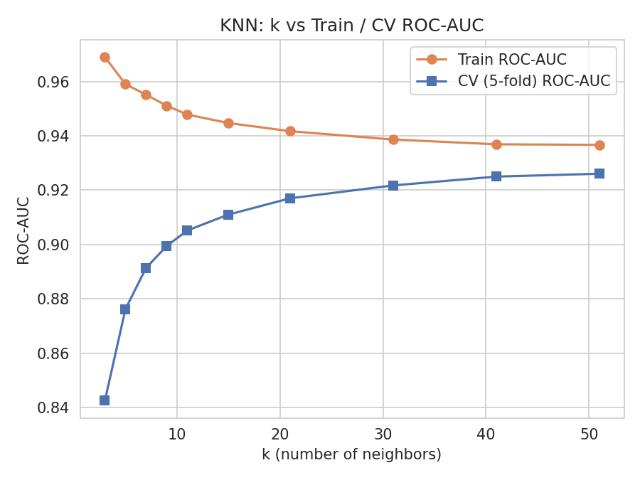
Figure 3. KNN: as k grows, training ROC-AUC steadily falls (from 0.969 at k=3 to 0.937 at k=51) while cross-validated ROC-AUC steadily rises (from 0.843 to 0.926) — the classic small-k-overfits / large-k-generalizes-better pattern.
k = 51 gave the highest CV ROC-AUC and was selected as the final value. Feature scaling was critical: an identical k=51 model trained on unscaled features scored only 0.822 test ROC-AUC, versus 0.929 with scaling — a 10.7-point gap driven entirely by high-magnitude features (e.g., BNP, in the hundreds) dominating the Euclidean distance calculation and drowning out equally-important but small-scale features (e.g., Potassium, roughly 3–6).

5.3 Decision Tree
Trained on unscaled data with min_samples_split=20 and min_samples_leaf=20 to prevent tiny, noise-driven leaves. max_depth was swept from 2 to unlimited, again comparing training vs. CV ROC-AUC:
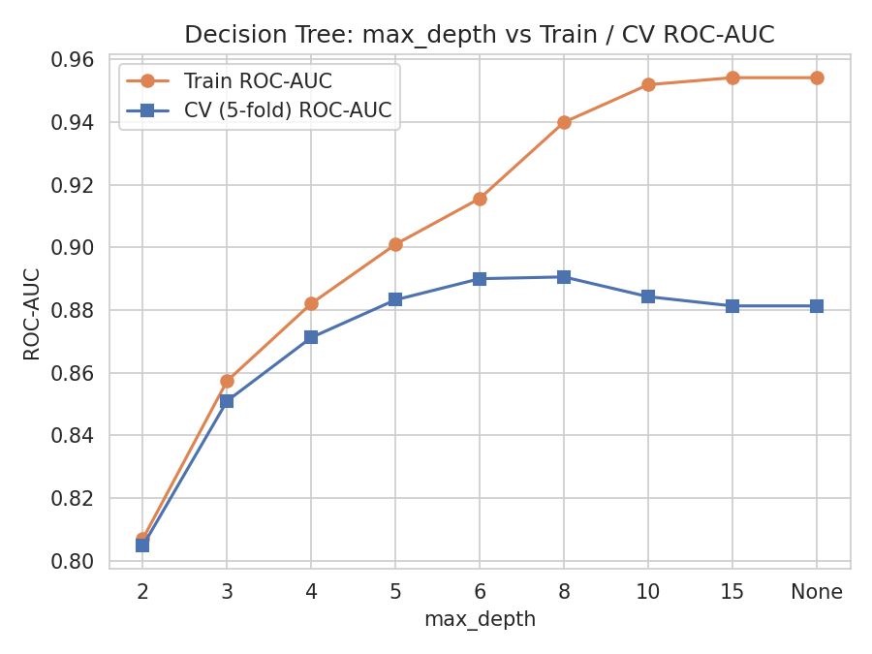
Figure 4. Decision Tree: training ROC-AUC climbs monotonically with depth (toward 0.954 with no depth limit), while CV ROC-AUC peaks at depth 8 (≈0.891) and then declines as deeper trees fit training-set noise rather than generalizable structure.
max_depth = 8 (with min_samples_leaf = 20) was selected as the depth that maximizes cross-validated performance before the tree begins to overfit.

6. Model Evaluation (Step E)
Each model was evaluated on the held-out test set (2,400 patients: 1,680 negative / 720 positive) using Accuracy, Precision, Recall, F1-score, and ROC-AUC, plus a full confusion matrix.
Model | Test Acc. | Precision | Recall | F1 | Test ROC-AUC
Logistic Regression | 89.50% | 0.8524 | 0.7861 | 0.8179 | 0.9562
KNN (k=51) | 84.25% | 0.8886 | 0.5431 | 0.6741 | 0.9288
Decision Tree (depth=8) | 84.54% | 0.7731 | 0.6861 | 0.7270 | 0.8992

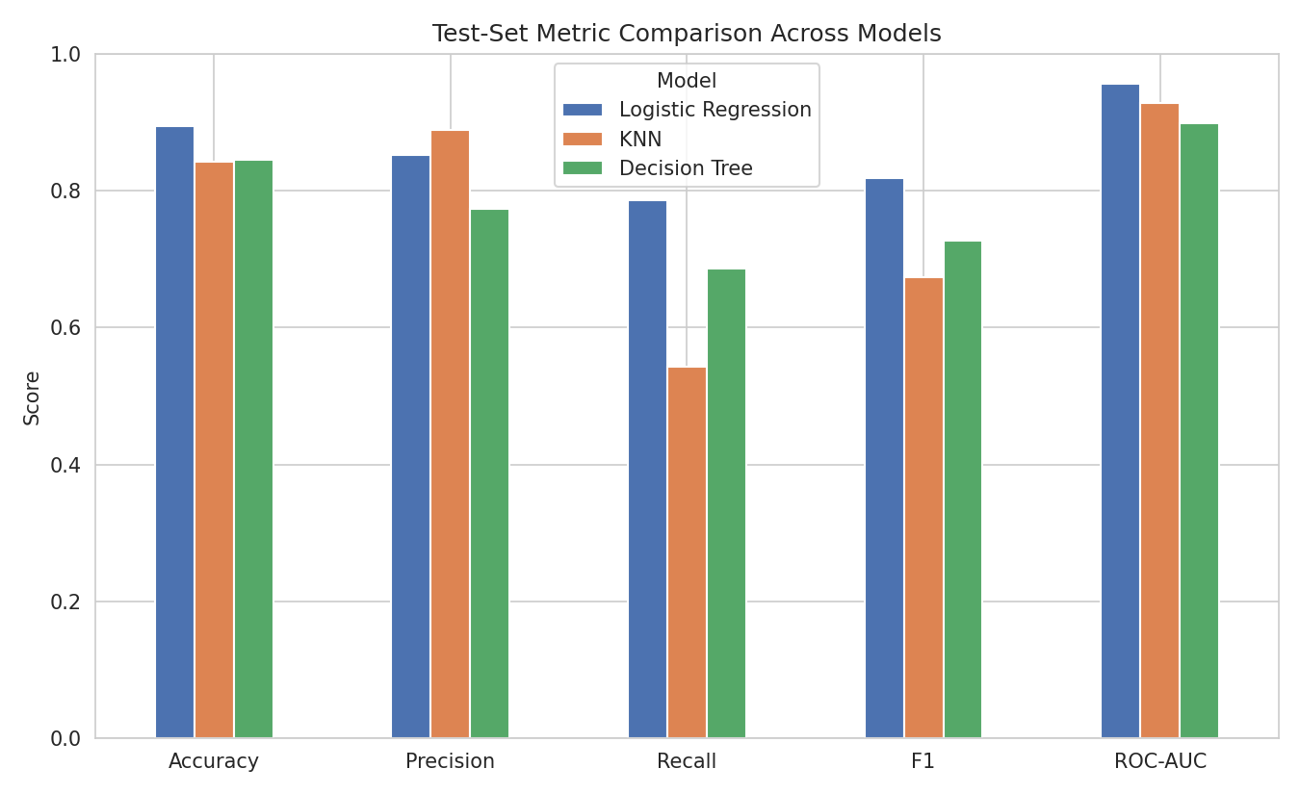
Figure 5. Test-set metric comparison across all three models.

6.1 Confusion Matrices
Confusion matrix definitions in this context — TP: model correctly flags a patient who is readmitted within 30 days (enables timely intervention); TN: model correctly identifies a patient who will not be readmitted; FP: model flags a patient as high-risk who is not actually readmitted (unnecessary follow-up resources); FN: model misses a patient who is readmitted within 30 days (a missed opportunity to intervene — the costliest error type in this setting).
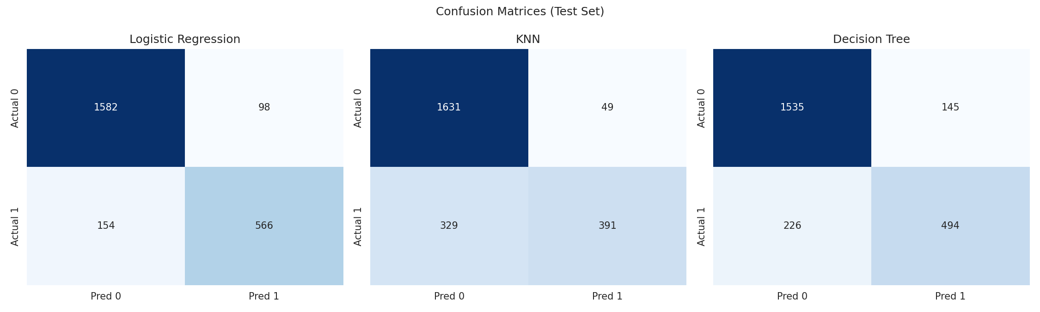
Figure 6. Confusion matrices on the 2,400-patient test set (1,680 negative / 720 positive).
Model | TN | FP | FN | TP
Logistic Regression | 1582 | 98 | 154 | 566
KNN (k=51) | 1631 | 49 | 329 | 391
Decision Tree (depth=8) | 1535 | 145 | 226 | 494

6.2 ROC Curves
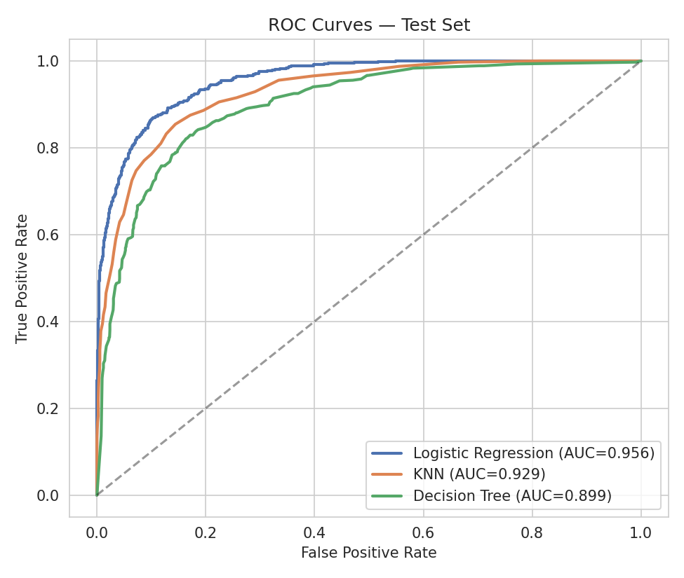
Figure 7. ROC curves for all three models on the test set. Logistic Regression dominates across nearly the entire threshold range.

6.3 Feature Importance / Coefficients
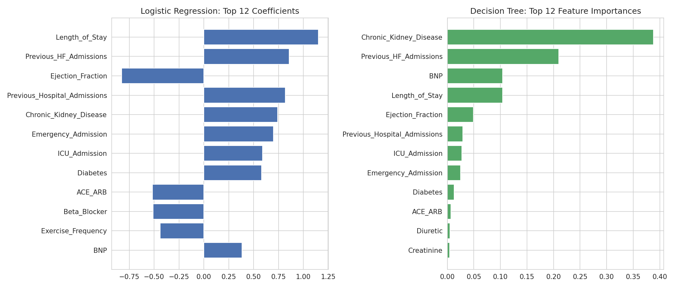
Figure 8. Left: top Logistic Regression coefficients (standardized). Right: top Decision Tree feature importances. Both models agree that prior admission history, kidney disease, BNP, ejection fraction, and length of stay are the strongest drivers of readmission risk.

7. Compare and Diagnose (Step F)
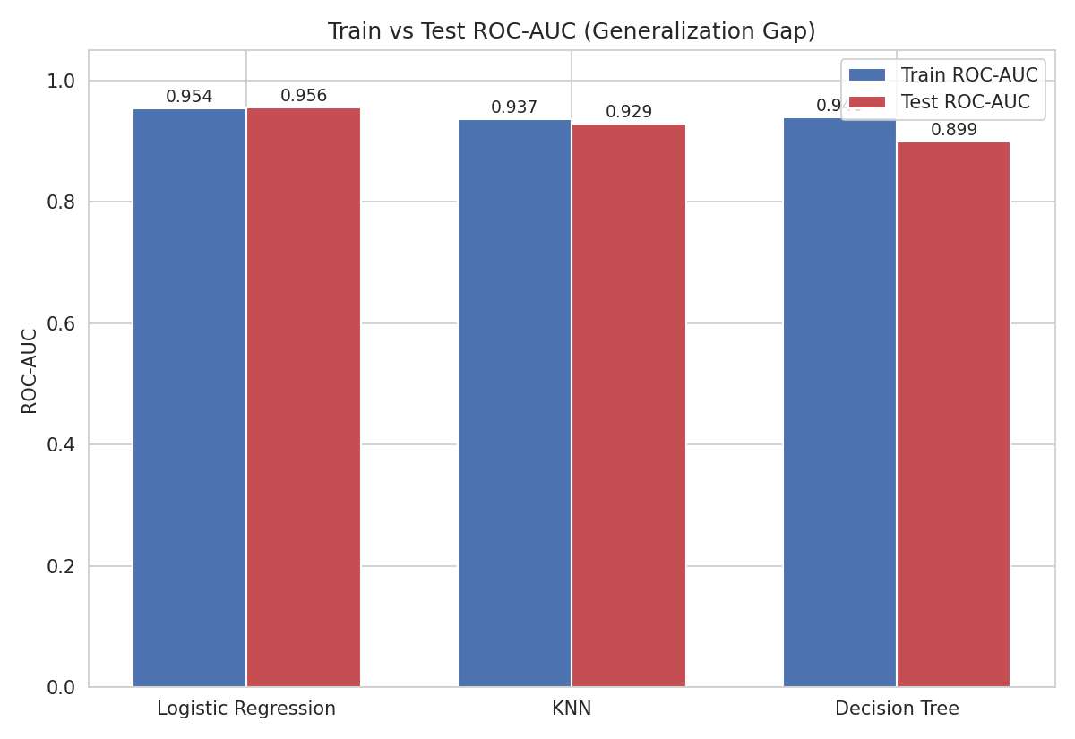
Figure 9. Train vs. test ROC-AUC for each model — the generalization gap.

7.1 Mandatory Model Comparison Table
Model | Train Acc. | Test Acc. | Precision | Recall | F1 | ROC-AUC | Fit diagnosis
Logistic  Regression | 89.45% | 89.50% | 0.8524 | 0.7861 | 0.8179 | 0.9562 | Good fit
KNN (k=51) | 84.44% | 84.25% | 0.8886 | 0.5431 | 0.6741 | 0.9288 | Good fit (mild bias to majority class)
Decision Tree  (depth=8) | 87.86% | 84.54% | 0.7731 | 0.6861 | 0.7270 | 0.8992 | Mild overfitting

7.2 Evidence-based fit diagnosis
- Logistic Regression: train ROC-AUC 0.9537 vs. test ROC-AUC 0.9562 (test is actually marginally higher) and train accuracy 89.45% vs. test accuracy 89.50%. The gap is effectively zero (within normal sampling noise) — this is a textbook example of good generalization, not underfitting or overfitting.
- KNN (k=51): train ROC-AUC 0.9367 vs. test ROC-AUC 0.9288 (gap ≈ 0.008) and train accuracy 84.44% vs. test 84.25% (gap ≈ 0.002). The small, consistent gap indicates good generalization, not overfitting. However, both train and test recall are comparatively low (0.543 on test) — the model is more conservative/biased toward predicting the majority class, which is a capacity/threshold limitation rather than a generalization problem.
- Decision Tree (depth=8): train ROC-AUC 0.9399 vs. test ROC-AUC 0.8992 (gap ≈ 0.041) and train accuracy 87.86% vs. test accuracy 84.54% (gap ≈ 3.3 points). This is a meaningfully larger and consistent gap than the other two models, and Figure 4 shows it grows further at depths beyond 8 (train ROC-AUC keeps climbing to 0.954 while CV ROC-AUC falls to 0.881). This is evidence of mild overfitting — the tree is starting to fit patterns specific to the training data that do not fully transfer to unseen patients — though depth=8 with min_samples_leaf=20 already substantially contains it relative to an unconstrained tree.
No model shows evidence of underfitting: all three achieve test ROC-AUC well above the 0.50 no-skill baseline and above the 0.70 baseline achievable by always predicting the majority class, and their training-set performance is also high (not merely close-to-test but low everywhere), which is what underfitting would look like.

8. Core Questions (Q1–Q14)
Q1. What is the class distribution of the target? Is the dataset balanced or imbalanced, and why does that matter?
8,400 patients (70.0%) were not readmitted within 30 days and 3,600 (30.0%) were readmitted — a moderate class imbalance, not extreme (e.g., not 95/5), but still meaningful. It matters because a trivial model that always predicts "not readmitted" would score 70% accuracy while catching zero true readmissions, so accuracy alone would overstate quality. Stratified splitting and metrics such as Recall, Precision, F1, and ROC-AUC that account for both classes are necessary, and threshold/recall trade-offs deserve explicit attention (see Q7).
Q2. What preprocessing steps did you perform? For each step, explain why it was necessary and whether it was fitted using training data only.
- Dropped Patient_ID — a non-predictive identifier; not "fit" on anything, simply excluded.
- Binary-encoded Gender, Smoking_Status, Alcohol_Consumption to 0/1 — a fixed, deterministic mapping with no parameters to fit on training data, so no leakage risk.
- One-hot encoded Heart_Failure_Type (3 categories → 2 dummy columns) — again a deterministic mapping; the possible categories are known in advance and this can safely be applied to the whole dataset.
- StandardScaler for Logistic Regression and KNN — mean and standard deviation were computed (fit) on the training set only, then used to transform both train and test sets. Fitting the scaler on the full dataset (including test) would leak test-set distribional information into training, producing an overly optimistic evaluation.
- Stratified 80/20 train/test split (random_state=42) — performed before any scaling, so scaling statistics never see the test set.
No imputation was needed (zero missing values), and the Decision Tree deliberately used unscaled features since scaling has no effect on tree-based splits.
Q3. Why does Logistic Regression generally require scaled numeric features less critically than KNN, while KNN is strongly affected by feature scale?
Logistic Regression fits a weighted linear combination of features, and gradient-based optimizers (like lbfgs) converge faster and more reliably with scaled inputs — but the model can still learn an approximately-correct decision boundary on unscaled data because it estimates a separate coefficient for each feature that can absorb differences in scale (a feature measured in the hundreds simply gets a proportionally smaller coefficient). KNN, in contrast, classifies a point by literally measuring Euclidean distance to its neighbors across all features simultaneously. If one feature spans 0–4,000 (e.g., BNP) and another spans 2.8–6.4 (e.g., Potassium), the distance calculation is almost entirely determined by the large-scale feature, and clinically important variation in the small-scale feature becomes numerically invisible. This was confirmed empirically: the same k=51 KNN model scored 0.822 test ROC-AUC unscaled vs. 0.929 scaled.
Q4. What value of k did you use for KNN? Show how you selected it. Discuss what happens when k is too small versus too large.
k = 51 was selected by sweeping k ∈ {3,5,7,9,11,15,21,31,41,51} and choosing the value that maximized 5-fold cross-validated ROC-AUC on the training set (Figure 3). When k is too small (e.g., k=3), each prediction depends on only a handful of nearby points, so the model captures noise and idiosyncrasies of individual training patients — training ROC-AUC is inflated (0.969) while CV ROC-AUC is much lower (0.843), i.e. it overfits and generalizes poorly. When k is too large, predictions are averaged over a large, possibly overly-broad neighborhood that can blur the true local decision boundary and pull predictions toward the global class ratio (which is one reason KNN's recall is comparatively low here); in the extreme, a k equal to the whole training set would just predict the majority class for everyone. Within the tested range, k=51 was still on the generalization-improving side of that trade-off (CV ROC-AUC was still rising, not yet falling), but it also comes with the recall cost described in Q7/Q13.
Q5. What settings did you use for the Decision Tree? Explain how tree depth and minimum-sample constraints can affect generalization.
Final settings: max_depth = 8, min_samples_split = 20, min_samples_leaf = 20, random_state = 42. max_depth caps how many sequential splits a path from root to leaf can have; deeper trees can represent more complex, non-linear interactions but also carve the feature space into ever-smaller regions that fit individual training patients rather than general patterns — Figure 4 shows training ROC-AUC still rising past depth 15 while CV ROC-AUC peaks at depth 8 and then falls, direct evidence of overfitting beyond that point. min_samples_split/min_samples_leaf set a floor on how many training patients must support a split or a leaf; without this floor, the tree can create leaves based on just one or two patients, which is essentially memorization. Setting both to 20 forces every leaf's prediction to be backed by a reasonably sized, more statistically reliable group of patients, which is a form of pre-pruning that improves generalization.
Q6. Compare all three models using Accuracy, Precision, Recall, F1-score, and ROC-AUC. Which model is best for this problem, and what evidence supports your choice?
Logistic Regression leads on every metric that matters for this problem: highest test accuracy (89.5%), highest F1 (0.818), highest ROC-AUC (0.956), the best balance of precision (0.852) and recall (0.786), and — critically — essentially zero train/test gap, meaning its performance is trustworthy on unseen patients. Decision Tree has the second-highest recall (0.686) but noticeably lower precision (0.773) and ROC-AUC (0.899), plus a real overfitting gap. KNN has the highest precision (0.889) but the lowest recall by a wide margin (0.543), meaning it misses nearly half of all patients who will actually be readmitted. Given these results, Logistic Regression is the best model for this problem: it wins on the metric that best summarizes overall discrimination ability (ROC-AUC) and on F1, while also being the most reliably generalizing and most interpretable (see Q14) of the three.
Q7. Which metric should receive the most attention in a healthcare readmission setting? There is no automatic correct answer — justify your choice based on the consequences of false positives and false negatives.
Recall (sensitivity) deserves the most weight, closely followed by ROC-AUC and F1 as supporting metrics. A false negative here means a patient who will be readmitted within 30 days is classified as low-risk and receives no extra follow-up — a missed opportunity for intervention that can translate into a preventable hospitalization, worse patient outcomes, and higher downstream cost. A false positive means a lower-risk patient receives some extra follow-up (a phone call, an earlier clinic visit) that turns out to be unnecessary — wasteful, but comparatively low-harm. Because the cost of a missed at-risk patient (FN) is clinically more severe than the cost of an unnecessary follow-up (FP), recall should be prioritized, generally by tolerating somewhat lower precision — which is exactly the trade-off explored in the class-imbalance extension in Section 9, where shifting Logistic Regression's class weighting raised recall from 0.786 to 0.872 at the cost of precision falling from 0.852 to 0.765, for essentially unchanged ROC-AUC (0.956). Precision, F1 and ROC-AUC still matter as guardrails against flooding the care team with false alarms, so in practice the team would tune the classification threshold to hit a target recall while monitoring precision, rather than optimizing recall in isolation.
Q8. Does any model appear to be overfitting? Use the training-versus-test results to support your answer.
Yes — the Decision Tree (depth=8) shows mild but real overfitting: train ROC-AUC (0.940) exceeds test ROC-AUC (0.899) by about 4 points, and train accuracy (87.9%) exceeds test accuracy (84.5%) by about 3.3 points. This is not merely "a high training score" (the rule this report follows per the project brief) — it is a meaningful, consistent gap on multiple metrics, further corroborated by Figure 4, which shows the gap between training and cross-validated performance widening further as depth increases beyond 8 (e.g., at max_depth=None, training ROC-AUC reaches 0.954 while CV ROC-AUC falls to 0.881). Logistic Regression and KNN do not show this pattern — their train/test gaps are close to zero (≤0.008 ROC-AUC).
Q9. Does any model appear to be underfitting? Again, use evidence from both training and test performance.
No. Underfitting would show up as low performance on both the training set and the test set at the same time. Here, all three models achieve training ROC-AUC ≥ 0.937 and test ROC-AUC ≥ 0.899 — well above both the 0.50 random baseline and the 0.70 majority-class-accuracy baseline — and training accuracy for every model (84–89%) is not depressed relative to what a reasonably capable classifier should achieve on this data. There is no model here where both scores are simultaneously low, so none of the three is underfitting.
Q10. For an overfitting model, propose at least three practical changes that could reduce overfitting. Explain how each change is expected to help.
- Reduce max_depth further (e.g., to 5–6) or increase min_samples_leaf/min_samples_split (e.g., to 40–50): this forces each leaf to summarize a larger group of patients, directly limiting the tree's ability to carve out tiny, noise-specific regions of the feature space, which is exactly the mechanism behind the overfitting seen in Figure 4.
- Use cost-complexity pruning (ccp_alpha in scikit-learn), selected via cross-validation: rather than fixing depth in advance, this grows a full tree and then prunes back branches whose removal doesn't hurt cross-validated performance, typically finding a better bias/variance trade-off than a single fixed max_depth.
- Replace the single Decision Tree with an ensemble (Random Forest or Gradient Boosting) built from many de-correlated, depth-limited trees: averaging over many trees reduces the variance that causes any one tree to overfit its particular training sample, usually raising test ROC-AUC without the single-tree overfitting pattern.
- (Additional option) k-fold cross-validation during hyperparameter selection — already used here — should be extended with a nested CV or a held-out validation set to make the depth/leaf-size choice even more robust, and feature selection could remove very low-importance features (see Figure 8) that mostly add opportunities for spurious splits.
Q11. For an underfitting model, propose at least three practical changes that could improve model capacity or representation. Explain why each change could help.
No model in this project is underfitting, but if one were (for example, a Logistic Regression with an excessively small C or a Decision Tree capped at depth 2, both of which visibly underperform in Figures 2 and 4), practical remedies would include:
- Reduce regularization strength (increase C) for Logistic Regression, or relax depth/leaf constraints for the Decision Tree: both directly increase the model's capacity to fit real signal in the data, reversing the artificial performance ceiling low capacity imposes.
- Engineer richer features — e.g., interaction terms (Ejection_Fraction × NYHA_Class), non-linear transforms of skewed labs (BNP), or clinically-motivated composite risk scores: linear models in particular can only be as good as the relationships explicitly presented to them, so adding informative derived features raises the ceiling.
- Switch to a higher-capacity model class (e.g., Gradient Boosting or a Random Forest instead of a shallow single tree or a heavily regularized linear model): these can capture non-linearities and interactions that a very constrained model architecturally cannot represent.
- Verify preprocessing isn't destroying signal — e.g., confirm scaling was applied correctly for KNN/Logistic Regression and that no informative feature was mistakenly dropped — since underfitting can also stem from data problems rather than the model itself.
Q12. Is the model with the highest accuracy necessarily the best model? Use your results to prove or disprove this statement.
Disproved by these results, though in this particular case the highest-accuracy model does also turn out to be the best overall choice for a different reason. Ranked by test accuracy alone: Logistic Regression (89.50%) > Decision Tree (84.54%) > KNN (84.25%) — KNN and the Decision Tree are nearly tied on accuracy, yet their clinical usefulness is very different: KNN's recall is only 0.543 (missing roughly half of all true readmissions) while the Decision Tree's recall is 0.686. If accuracy alone were the deciding metric, an analyst comparing only KNN and the Decision Tree could easily prefer KNN for its marginally higher accuracy while actually selecting the model that is meaningfully worse at the clinical task of catching at-risk patients. This shows accuracy alone can rank models inconsistently with what actually matters, especially under class imbalance, and is exactly why Precision, Recall, F1, and ROC-AUC were required in Section 6 rather than reporting accuracy alone.
Q13. If two models have similar ROC-AUC but different recall and precision, which would you choose and why?
KNN (ROC-AUC 0.929) and Decision Tree (ROC-AUC 0.899) are the closest pair in this project, with the Decision Tree trading some precision (0.773 vs. 0.889) for substantially higher recall (0.686 vs. 0.543). Given the Q7 argument that missed readmissions (false negatives) are more clinically costly than unnecessary follow-ups (false positives), the model with higher recall — the Decision Tree — would be preferred between this specific pair despite its slightly lower ROC-AUC and its mild overfitting, because it catches meaningfully more of the patients who actually get readmitted (494 vs. 391 true positives out of 720). More generally: when two models have comparable ROC-AUC (which measures ranking ability across all thresholds), the tie should be broken using whichever of precision or recall matches the real-world cost asymmetry of the errors, not by ROC-AUC alone — and in this dataset that favors recall.
Q14. What are the limitations of your best model? Identify at least three limitations or risks before claiming it is suitable for real-world hospital deployment.
- Recall is still incomplete: even the best model (Logistic Regression) misses 154 of 720 truly-readmitted patients in the test set (recall 0.786) — roughly one in five at-risk patients would not be flagged, so this model should augment, not replace, clinical judgement.
- Single-institution, structured-data training: the model was trained on one dataset with a fixed feature set and no external validation on a different hospital, region, or time period; performance could differ under real-world distribution shift (a different patient mix, changes in coding practice, or new treatment protocols).
- Unclear provenance/synthetic-data risk and unmodeled real-world signals: the dataset is clean to an unusual degree (zero missing values, zero duplicates, no outlier or transcription errors) and does not include factors known to affect readmission risk in practice, such as socioeconomic status, post-discharge follow-up adherence, caregiver support, or readmission to a different hospital — real clinical data would need thorough external validation before this model could be trusted for deployment.
- Fairness and threshold considerations: subgroup performance (e.g., by age, sex, or Heart_Failure_Type) was not separately audited here; a model that performs well in aggregate could still under- or over-flag specific subpopulations, and the default 0.5 classification threshold used in this report was not clinically calibrated to the actual cost trade-off a hospital would want (see Q7 and Section 9).

9. Extension Challenge — Does Class-Imbalance Handling Change the Conclusions?
The best model, Logistic Regression, was re-trained with class_weight='balanced', which re-weights the loss function so errors on the minority (readmitted) class count more heavily during training — a standard, lightweight imbalance-handling strategy that requires no resampling of the data.
Variant | Accuracy | Precision | Recall | F1 | ROC-AUC
Baseline Logistic Regression | 89.50% | 0.8524 | 0.7861 | 0.8179 | 0.9562
Class-weighted Logistic Regression | 88.13% | 0.7649 | 0.8722 | 0.8151 | 0.9560

ROC-AUC is essentially unchanged (0.956 vs. 0.956), confirming the model's underlying ability to rank patients by risk does not depend on the class weighting. What does change is the precision/recall balance: recall improves from 0.786 to 0.872 (catching about 63 more of the 720 truly-readmitted test patients) while precision falls from 0.852 to 0.765 and overall accuracy drops from 89.5% to 88.1%. F1 stays essentially flat (0.818 vs. 0.815). Given the Q7 conclusion that missing a true readmission is more costly than an unnecessary follow-up, class-weighting is a worthwhile, low-cost adjustment for this healthcare use case — it does not change which model architecture is best, but it does change the recommended operating point for whichever model is deployed.

10. Final Model Comparison Table
Model | Train Acc. | Test Acc. | Precision | Recall | F1 | ROC-AUC | Fit diagnosis
Logistic Regression | 89.45% | 89.50% | 0.8524 | 0.7861 | 0.8179 | 0.9562 | Good fit — negligible train/test gap
KNN (k=51) | 84.44% | 84.25% | 0.8886 | 0.5431 | 0.6741 | 0.9288 | Good fit, but recall-limited
Decision Tree (depth=8) | 87.86% | 84.54% | 0.7731 | 0.6861 | 0.7270 | 0.8992 | Mild overfitting

11. Final Recommendation
Logistic Regression is the recommended model for the 30-day heart-failure readmission problem. It achieves the best score on the metric most suited to overall discrimination (ROC-AUC = 0.956) and on F1 (0.818), generalizes with essentially no train/test gap (ruling out overfitting), and — unlike a k=51 KNN model or a depth-limited Decision Tree — its coefficients are directly interpretable by clinicians and hospital administrators (Figure 8), which matters for trust and adoption in a healthcare setting. For deployment, it is further recommended to (1) use class_weight='balanced' or an explicitly tuned decision threshold to prioritize recall given the asymmetric cost of missed readmissions (Section 9), (2) validate the model on external/held-out time periods or sites before clinical use, and (3) monitor subgroup performance to check for fairness gaps, consistent with the limitations identified in Q14.

12. Submission Checklist
☑ Dataset loaded and inspected
☑ Target identified and encoded correctly
☑ Missing values / categorical variables handled and explained
☑ Data leakage checked
☑ Train/test split created correctly (stratified, reproducible)
☑ Logistic Regression trained (with C sweep)
☑ KNN trained (with k sweep, scaled vs. unscaled comparison)
☑ Decision Tree trained (with max_depth sweep)
☑ Accuracy, Precision, Recall, F1, ROC-AUC reported for all models
☑ Confusion matrix created for all three models
☑ ROC curves compared on one figure
☑ Train vs. test performance compared (table + chart)
☑ Overfitting/underfitting discussed with evidence (Q8, Q9)
☑ Ways to fix overfitting/underfitting proposed (Q10, Q11)
☑ Best model selected and justified (Q6, Section 11)
☑ Extension: class-imbalance handling investigated (Section 9)

