PROJECT EVALUATION REPORT
AI-Powered Sentiment Analysis System
Month 2 Project | NLP & Machine Learning
Prepared: 30 October 2026
Dataset: month_2_sentiment_analysis_dataset_10000.csv
Target classes: Positive, Neutral and Negative
Final model: TF-IDF + sigmoid-calibrated Logistic Regression

Executive Summary
The project classifies customer reviews into Positive, Negative and Neutral sentiment using text preprocessing, TF-IDF, supervised machine-learning classifiers, cross-validation, hyperparameter tuning and probability calibration. The original CSV contains 10,000 rows, but 9,700 rows repeat review text. After exact duplicate removal, 300 unique reviews remain, with 100 examples per class. An 80:20 stratified split gives 240 training reviews and 60 test reviews.
The tuned calibrated Logistic Regression pipeline achieved 100% accuracy, macro precision, macro recall, macro F1-score and macro one-vs-rest ROC-AUC on this 60-example holdout set. Logistic Regression and Multinomial Naive Bayes also both achieved 100% in the baseline comparison. These unusually high scores require caution because the unique dataset is small and may contain recurring templates or highly separable wording.

1. Project Objective
The objective is to classify a customer review as Positive, Negative or Neutral through an end-to-end NLP and machine-learning workflow: data cleaning, EDA, preprocessing, TF-IDF feature extraction, model training, evaluation, cross-validation, tuning, serialization and Streamlit deployment.

2. Dataset Audit
Dataset property | Observed result
Original rows | 10,000
Columns | 5: review_id, review_text, sentiment, category, source
Missing values | 0 across all columns
Exact duplicate review_text rows | 9,700
Unique review texts | 300
Unique texts with conflicting sentiment labels | 0
Rows after exact-text deduplication | 300

Sentiment distribution
Sentiment | Original rows | Unique reviews
Positive | 3,334 | 100
Negative | 3,333 | 100
Neutral | 3,333 | 100
Total | 10,000 | 300
After deduplication, the unique dataset is exactly balanced with 100 reviews per class. Removing duplicates before splitting reduces the risk of identical text appearing in both training and test sets.

Unique-text category counts
Category | Unique reviews
Home & Kitchen | 43
Food & Grocery | 40
Sports | 39
Books | 39
Clothing | 37
Travel | 36
Beauty | 34
Electronics | 32

3. Preprocessing and Feature Extraction
The cleaning function lowercases text, replaces characters other than lowercase English letters and whitespace with spaces, collapses repeated whitespace and trims the result. The same cleaning logic is used by the Streamlit application. TF-IDF unigrams and bigrams are used for feature extraction. The final tuned vocabulary size is 3,000 features. Stop-word removal is not applied in the corrected workflow, preserving potentially important sentiment terms such as 'not' and 'never'.

4. Experimental Setup
Setting | Configuration
Clean modelling dataset | 300 unique reviews
Train-test split | 80:20 stratified
Training set | 240 (80 per class)
Test set | 60 (20 per class)
Random state | 42
Baseline TF-IDF | Unigrams and bigrams; max_features=5,000
Baseline classifiers | Logistic Regression, Multinomial Naive Bayes, Random Forest
Tuning | GridSearchCV, 5-fold CV, macro F1 scoring
Calibration | Sigmoid calibration with 3-fold internal CV

5. Baseline Model Comparison
Metrics are macro-averaged so each sentiment class receives equal weight.
Model | Accuracy | Precision | Recall | F1-score
Logistic Regression | 1.0000 | 1.0000 | 1.0000 | 1.0000
Multinomial Naive Bayes | 1.0000 | 1.0000 | 1.0000 | 1.0000
Random Forest | 0.9333 | 0.9444 | 0.9333 | 0.9341
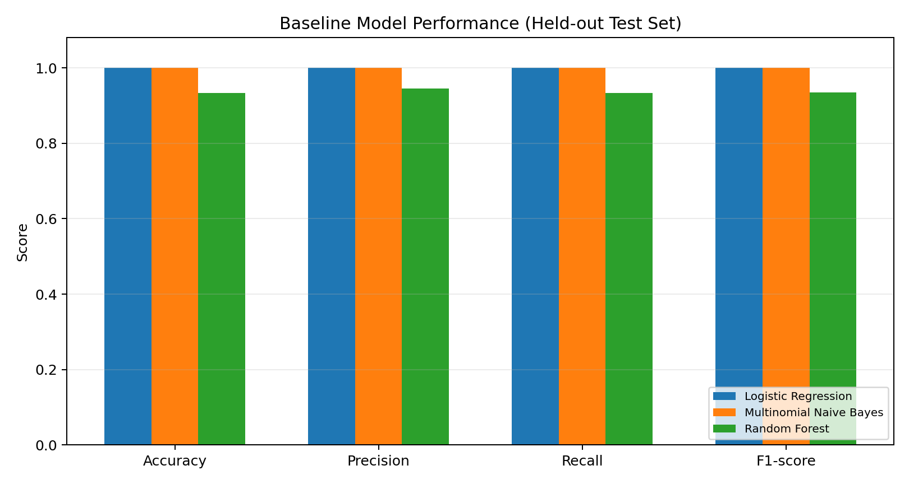

6. Hyperparameter Tuning and Cross-Validation
A sigmoid-calibrated Logistic Regression pipeline was tuned. GridSearchCV tested TF-IDF vocabulary sizes of 3,000 and 5,000 and Logistic Regression C values of 0.1, 1.0 and 10.0. Five-fold cross-validation used macro F1-score.
Tuning result | Observed value
Best TF-IDF max_features | 3,000
Best Logistic Regression C | 1.0
Best mean CV macro F1-score | 1.0000
Calibration method | Sigmoid
Calibration folds | 3
Calibrated probabilities are estimates from the model, not guarantees that predictions are correct.

7. Final Test-Set Evaluation
Metric | Final score
Accuracy | 100.00%
Precision (macro) | 100.00%
Recall (macro) | 100.00%
F1-score (macro) | 100.00%
ROC-AUC (macro, one-vs-rest) | 100.00%

Classification report
Class | Precision | Recall | F1-score | Support
Negative | 1.00 | 1.00 | 1.00 | 20
Neutral | 1.00 | 1.00 | 1.00 | 20
Positive | 1.00 | 1.00 | 1.00 | 20
Macro average | 1.00 | 1.00 | 1.00 | 60
Weighted average | 1.00 | 1.00 | 1.00 | 60
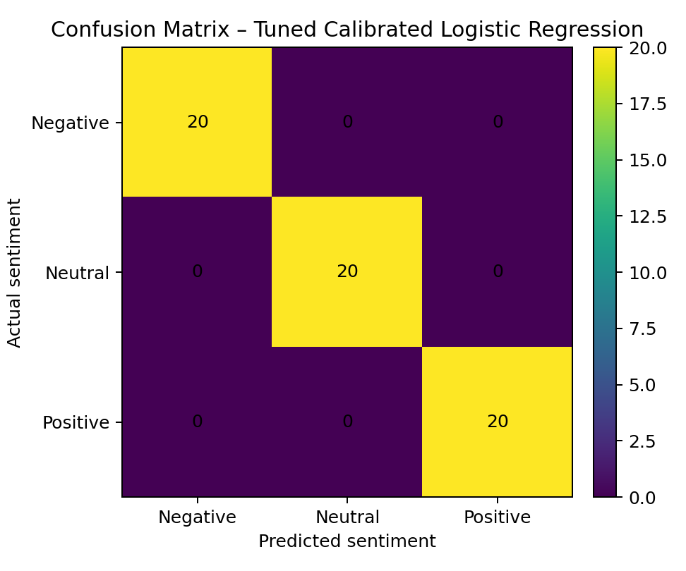
All 60 test reviews were classified correctly in this particular split: 20 Negative, 20 Neutral and 20 Positive.

8. Final Model Selection
Selected model: TF-IDF + sigmoid-calibrated Logistic Regression. It achieved the top observed test performance, tied with Multinomial Naive Bayes at baseline, and supplies probability estimates for the Streamlit application. These results do not establish that it will outperform Naive Bayes on a larger independent dataset.

9. Limitations and Risks
- Small number of independent examples: the 10,000-row CSV contains only 300 distinct review texts; the test set contains 60 unique reviews.
- Potential template or wording effects: exact duplicate removal does not remove near-duplicates or templated variants.
- Limited external validation: only one stratified random split was used; there is no separate external or time-based test set.
- Confidence interpretation: calibrated probabilities are model estimates and should not be presented as certainty.

10. Recommendations
- Collect a substantially larger dataset of genuinely distinct reviews across products, services and sources.
- Remove exact duplicates before splitting and inspect near-duplicate or template-based reviews.
- Keep a final untouched test set; where practical, use grouped or time-based splitting.
- Recompare Logistic Regression and Multinomial Naive Bayes on the expanded dataset using macro F1 and per-class metrics.
- Validate probability calibration on a larger validation set before using confidence scores in a real customer-facing workflow.
- Record the dataset version, random seed, library versions and final model artifact.

11. Conclusion
The project implements the principal stages of an end-to-end sentiment-analysis workflow: data inspection, duplicate handling, text cleaning, TF-IDF feature extraction, baseline comparison, cross-validation, tuning, probability calibration, evaluation and model serialization. The tuned calibrated Logistic Regression model achieved 100% on the current 60-example holdout set. However, because the dataset contains only 300 unique reviews, these results are an initial benchmark rather than proof of production-ready generalization. Evaluation on a larger and more diverse set of unique reviews is the key next step.
Evaluation note: the modelling and metric calculations were executed. Numerical results in this report are based on those calculations; report charts were generated from the computed baseline metrics and confusion matrix.
Github Repo : https://github.com/Debarun-Kanjilal/sentiment-analysis

