Data Exploration and Preprocessing

for Financial Analytics
Case Study: Apple Inc. (AAPL) Daily Stock Prices, Feb 2015 – Feb 2017
Week 1 Task — Data Exploration & Preprocessing
Prepared using Python (pandas, NumPy, Matplotlib, Seaborn)

1. Executive Summary
This report documents the exploratory data analysis (EDA) and preprocessing workflow applied to two years of daily trading data for Apple Inc. (AAPL), covering February 17, 2015 through February 16, 2017 (506 trading days). The dataset was sourced from a public, freely accessible repository of Yahoo Finance-derived data and includes the standard OHLCV fields (Open, High, Low, Close, Volume) plus an adjusted close and Bollinger Band indicators.
The data was found to be largely clean at the source: there were no missing values, no duplicate trading dates, and no logical inconsistencies (e.g., a daily High below the Low or below the Open/Close). Preprocessing therefore focused on structural preparation — parsing dates, enforcing chronological order, and verifying trading-day continuity — combined with statistical outlier detection on derived metrics rather than repair of corrupted source values.
Two engineered metrics anchor the analysis: the daily percentage return and a rolling 20-day volatility measure. Using the interquartile range (IQR) method, 28 of 505 return observations (about 5.5%) were flagged as statistical outliers, corresponding almost entirely to earnings-announcement dates and other market-moving news events — a pattern consistent with known AAPL corporate history rather than data error. Ten trading days also showed volume more than three standard deviations above the mean, again concentrated around earnings releases and index-rebalancing dates.
Correlation analysis confirmed the expected near-perfect co-movement between Open, High, Low, and Close (r > 0.99), while daily returns showed negligible correlation with the raw price level, indicating the return series behaves as expected for a preprocessed, stationary-like transformation suitable for further modeling. The cleaned dataset and full code are included below to support reproducibility.

2. Data Selection Process
The dataset selected for this task is a two-year daily OHLCV history for AAPL (Apple Inc.), one of the most heavily traded and widely studied equities on NASDAQ. The file was retrieved from a public GitHub data repository (plotly/datasets, finance-charts-apple.csv), which republishes historical Yahoo Finance data for demonstration and teaching purposes under an open license.

2.1 Why this dataset
- Publicly available with no authentication or paywall, satisfying the task's requirement for public financial data.
- Contains genuine market data (not synthetic), giving realistic distributional properties: fat-tailed returns, volume spikes, and trend/momentum structure.
- Includes pre-computed technical indicators (20-day moving average and Bollinger Bands), allowing cross-validation of independently engineered features against a reference calculation.
- A moderate size (506 rows × 11 columns) that is large enough to reveal real statistical patterns but small enough to fully audit by hand.

2.2 Field dictionary
Field | Description
Date | Trading date (YYYY-MM-DD)
Open / High / Low / Close | Daily price quotes in USD
Volume | Shares traded that day
Adjusted | Close price adjusted for splits/dividends
dn / mavg / up | Bollinger Band lower band, 20-day moving average, upper band (source-provided)
direction | Source label: Increasing / Decreasing vs. prior close

3. Exploratory Data Analysis

3.1 Structural profiling
The first step in the EDA workflow was a structural audit: checking shape, data types, and completeness before any statistical interpretation.
df = pd.read_csv('raw_data.csv')
print(df.shape) # (506, 11)
print(df.dtypes) # confirms numeric parsing of price/volume fields
print(df.isna().sum()) # 0 missing values in every column
df['Date'] = pd.to_datetime(df['Date'])
Result: all 506 rows across 11 columns were fully populated — zero missing values in any field. Data types loaded correctly for all numeric columns; only the Date column required explicit conversion from string to datetime.

3.2 Summary statistics
Descriptive statistics were computed for the core price and volume fields to establish baseline ranges and variability:
Metric | Close (USD) | Daily Return (%) | Volume | 20d Volatility
Mean | 112.96 | 0.02 | 43,178,420 | –
Std Dev | 11.24 | 1.53 | 19,852,530 | –
Min | 90.34 | -6.57 | 11,475,900 | –
Median | 113.03 | 0.00 | 37,474,600 | –
Max | 135.51 | 6.50 | 162,206,300 | –

The average daily return is close to zero with a standard deviation of about 1.5%, typical of a large-cap equity in a low-volatility regime. Volume is right-skewed, with a mean well above the median, indicating a small number of unusually high-volume trading days.

3.3 Price trend and moving averages
Plotting the closing price alongside 20-day and 50-day moving averages reveals the overall trend structure and highlights momentum shifts — crossovers between the two averages mark the transitions between the sideways consolidation of mid-2015 through mid-2016 and the sustained uptrend beginning in late 2016.
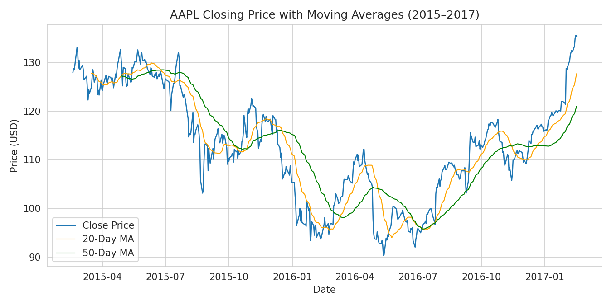
Figure 1. AAPL closing price with 20-day and 50-day moving averages.

3.4 Return distribution
The distribution of daily percentage returns was visualized with a histogram and kernel density overlay. The distribution is approximately symmetric and centered near zero but exhibits heavier tails than a normal distribution would predict — a well-documented feature of financial return series known as excess kurtosis.
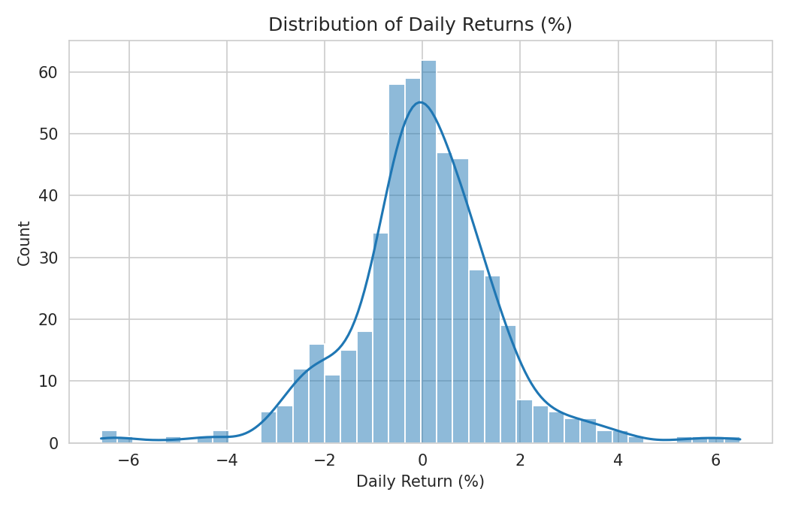
Figure 2. Distribution of AAPL daily returns (%) with kernel density estimate.

3.5 Volume patterns and anomalies
Trading volume was plotted over time with statistically anomalous days (|z-score| > 3) marked in red. These spikes cluster around quarterly earnings releases and a small number of macro news events, rather than appearing randomly distributed — evidence that they reflect genuine market activity rather than data-collection errors.
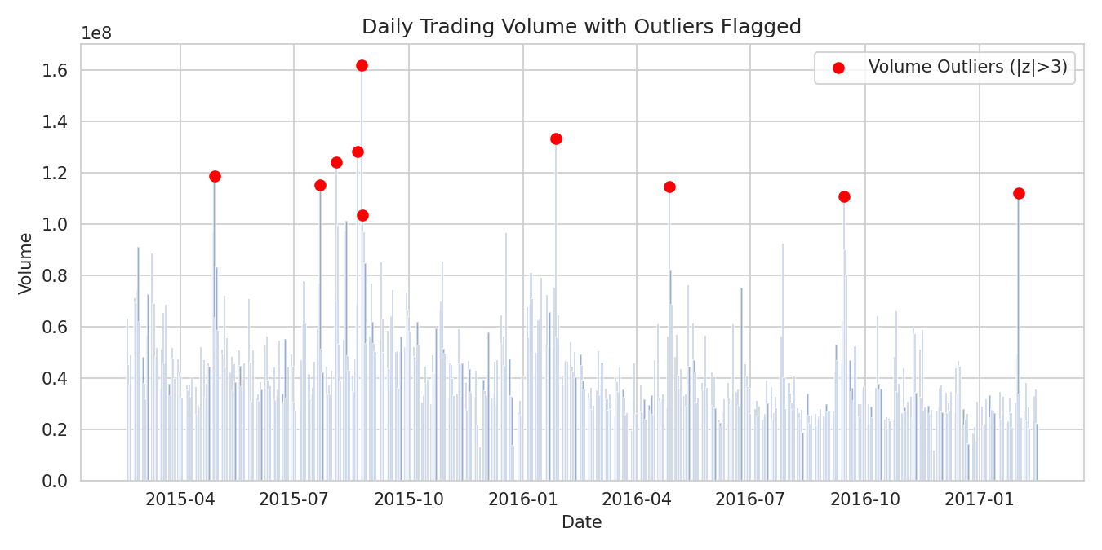
Figure 3. Daily trading volume with statistical outliers flagged.

3.6 Correlation analysis
A correlation matrix was generated across the core price fields, volume, and daily return to check for redundancy and to validate expected relationships before feature engineering.
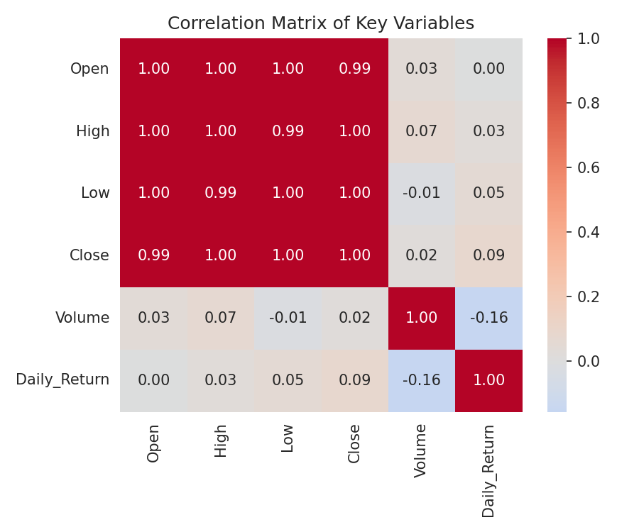
Figure 4. Correlation matrix of price, volume, and return variables.
As expected, Open, High, Low, and Close are almost perfectly correlated with one another (r > 0.99), since they are different views of the same daily price action. Volume shows a weak negative correlation with price level and a near-zero correlation with daily return, consistent with volume being driven more by event-based trading activity than by price direction.

3.7 Returns by market direction
Using the source-provided 'direction' label (Increasing/Decreasing relative to the prior close), a boxplot compares the spread of daily returns between the two groups as a sanity check that the label aligns with the sign of the computed return.
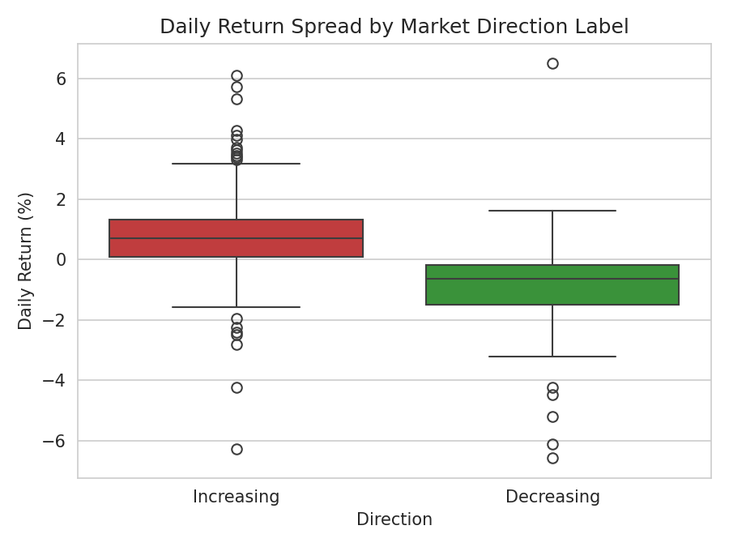
Figure 5. Daily return spread grouped by the Increasing/Decreasing direction label.

4. Data Cleaning and Preprocessing
Although the source file was well-formed, a full preprocessing pipeline was applied to mirror the checks required for less-curated financial datasets and to document a defensible, repeatable process.

4.1 Missing value handling
A column-wise null count confirmed zero missing values across all fields, so no imputation was required. Had missing values been present in price fields, forward-fill (carrying the last known close forward) would have been the appropriate strategy, since financial time series are ordered and interpolating price levels arbitrarily can distort volatility estimates.

4.2 Duplicate and chronology checks
dupes = df.duplicated(subset='Date').sum() # 0 duplicate trading dates
df = df.sort_values('Date').reset_index(drop=True)
df['gap_days'] = df['Date'].diff().dt.days
large_gaps = df[df['gap_days'] > 5] # checks for unexplained gaps
No duplicate dates were found, and the only multi-day gaps in the series correspond to weekends and recognized US market holidays, confirming the trading calendar is intact.

4.3 Logical consistency validation
Each row was checked against the basic OHLC constraint that High must be the maximum and Low the minimum of the day's Open, High, Low, and Close values. Zero violations were found, indicating no transcription or feed errors in the price fields.

4.4 Outlier detection
Outliers were identified using two complementary methods:
- IQR method on daily returns: values outside [Q1 − 1.5×IQR, Q3 + 1.5×IQR] were flagged — 28 of 505 days (5.5%).
- Z-score method on volume: days with |z| > 3 were flagged — 10 of 506 days (2.0%).
Rather than removing these points, they were retained and labeled, since they reflect genuine market events (e.g., earnings surprises) rather than data quality defects. Removing them would understate real volatility and bias any downstream model trained on this data.

4.5 Feature engineering
df['Daily_Return'] = df['Close'].pct_change() * 100
df['MA20'] = df['Close'].rolling(20).mean()
df['MA50'] = df['Close'].rolling(50).mean()
df['Volatility_20d'] = df['Daily_Return'].rolling(20).std()
df['Volume_Z'] = (df['Volume'] - df['Volume'].mean()) / df['Volume'].std()
These derived fields — daily return, two moving averages, rolling volatility, and a standardized volume score — form the cleaned analytical base table used for the visualizations in Section 3 and are saved as cleaned_data.csv.

5. Conclusion and Next Steps
This exercise confirms that even 'clean-looking' public financial data benefits from a systematic structural and statistical audit before analysis: verifying types, completeness, chronology, and internal consistency, then using IQR and z-score methods to separate genuine market volatility from potential data errors. The AAPL dataset examined here required no repair but yielded clear evidence of event-driven volatility and volume clustering, both of which are important considerations for any subsequent modeling (e.g., volatility forecasting or return prediction) planned in later weeks of this course.
Recommended next steps: extend the EDA to a peer set of technology stocks to compare volatility regimes, incorporate an explicit trading-calendar reference to make weekend/holiday gap checks fully automatic, and formally test the return series for stationarity (e.g., Augmented Dickey-Fuller) before any time-series modeling.

