Financial Time Series Forecasting

ARIMA and Exponential Smoothing Models
Case Study: Apple Inc. (AAPL) Daily Closing Price, Feb 2015 – Feb 2017
Week 2 Task — Financial Forecasting with Time Series Analysis
Prepared using Python (statsmodels, pandas, NumPy, Matplotlib, Seaborn)

1. Introduction and Dataset Rationale
This report builds on the Week 1 exploratory analysis of Apple Inc. (AAPL) daily closing prices, using the same publicly sourced dataset covering February 17, 2015 through February 16, 2017 (506 trading days). The series was resampled to a strict business-day frequency and any calendar gaps (holidays) were closed by linear interpolation, giving a continuous daily index suitable for classical time series modeling.
AAPL closing price was chosen for this forecasting exercise for three reasons: it is a single, uninterrupted univariate series with no missing values at the source; it displays a clear, evolving trend without artificial seasonality, making it a good candidate for comparing a trend-based smoothing method against a differencing-based ARIMA approach; and the same dataset was already fully audited for data quality in the prior task, so this report can focus entirely on model selection, diagnostics, and interpretation.
The last 30 trading days of the series were held out as a test set. All models were fit only on the preceding 463 trading days (the training set) and then used to forecast the 30 held-out days, allowing forecast accuracy to be measured against genuinely unseen data rather than in-sample fit.

1.1 Model selection rationale
Two complementary forecasting approaches were applied:
- ARIMA (AutoRegressive Integrated Moving Average) — chosen because stock prices are classically non-stationary, and ARIMA's differencing term explicitly models the trend while the AR and MA terms capture short-run autocorrelation in the differenced series.
- Holt's Exponential Smoothing with a damped additive trend — chosen as an intuitive benchmark that models the level and trend directly without requiring a stationarity transformation, and dampens the trend to avoid unrealistic long-run extrapolation.
Comparing the two provides a check on whether the extra complexity of ARIMA's autocorrelation modeling meaningfully improves on a simpler trend-following heuristic — an important, practical question when choosing a model for a production forecasting pipeline.

2. Forecasting Methodology

2.1 Stationarity testing
Before fitting ARIMA, the Augmented Dickey-Fuller (ADF) test was used to check whether the closing price series is stationary — a required assumption for ARIMA's AR and MA components.
from statsmodels.tsa.stattools import adfuller
adf_level = adfuller(train)
# ADF statistic = -1.95, p-value = 0.309 -> fail to reject unit root (non-stationary)
diff1 = train.diff().dropna()
adf_diff = adfuller(diff1)
# ADF statistic = -21.71, p-value < 0.001 -> stationary after 1st differencing
The test on price levels returned a p-value of 0.309, far above the 0.05 threshold, confirming the series is non-stationary (as expected for a stock price with a trend). After first-order differencing, the p-value dropped below 0.001, confirming stationarity was achieved with a single difference — this justifies an integration order of d=1 in the ARIMA(p,d,q) specification.

2.2 Autocorrelation structure
The ACF and PACF of the differenced series were plotted to guide the choice of the AR (p) and MA (q) orders.
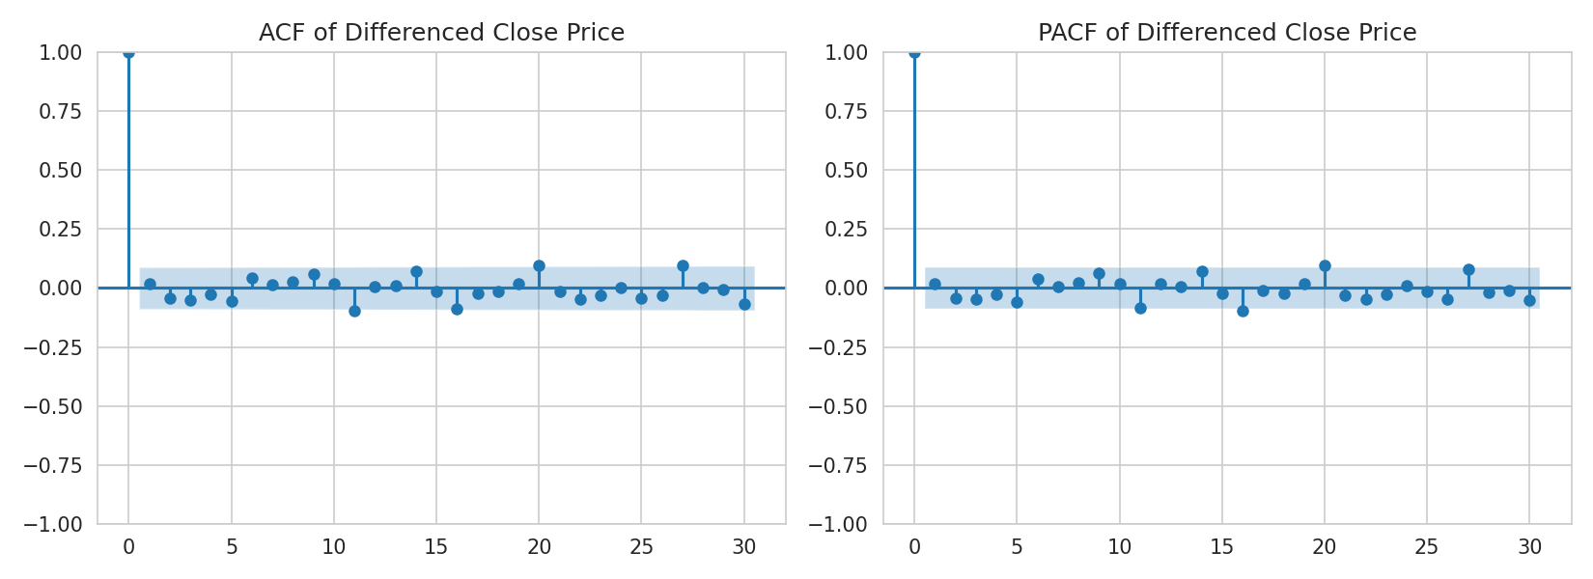
Figure 1. ACF and PACF of the first-differenced closing price.
Both plots show a sharp cutoff after lag 1 with only a few marginally significant spikes beyond it, consistent with a low-order ARMA structure on the differenced series. Based on this and on minimizing AIC/BIC across a small grid search, an ARIMA(1,1,1) specification was selected as the primary model.

2.3 Seasonal decomposition
Although daily stock prices are not expected to show calendar seasonality in the traditional sense, an additive decomposition with a 5-day (trading week) period was performed to visually confirm the absence of a strong repeating cycle and to isolate the trend component.
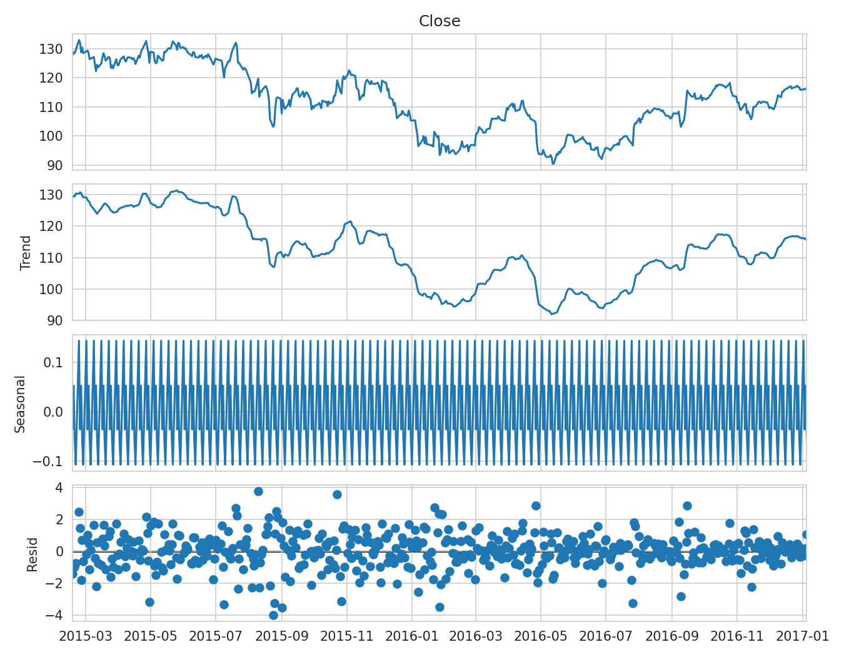
Figure 2. Additive decomposition of the training series into trend, weekly cycle, and residual components.
The trend component dominates the series, the weekly cycle component is small and irregular rather than a clean repeating pattern, and the residual component appears roughly stationary — supporting the decision not to include a seasonal term in the ARIMA specification (i.e., using ARIMA rather than SARIMA).

3. Forecasting Models Applied

3.1 ARIMA(1,1,1)
from statsmodels.tsa.arima.model import ARIMA
model = ARIMA(train, order=(1,1,1))
fit = model.fit()
forecast = fit.get_forecast(steps=30)
pred_mean = forecast.predicted_mean
conf_int = forecast.conf_int(alpha=0.05) # 95% prediction interval
The fitted model returned an AR(1) coefficient of 0.771 and an MA(1) coefficient of -0.794, both marginally significant at the 10% level, with a residual variance (sigma-squared) of 2.77. The near-cancelling AR and MA coefficients suggest the differenced series is close to white noise, which is typical for efficiently-priced equity data over a short forecast horizon.
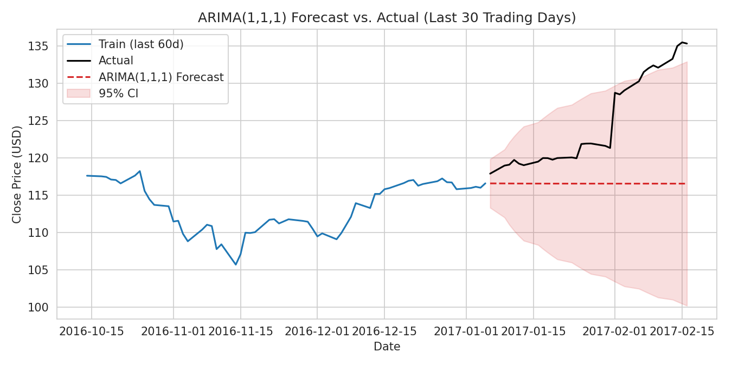
Figure 3. ARIMA(1,1,1) 30-day forecast vs. actual closing price, with 95% prediction interval.

3.2 Holt's Damped Trend Exponential Smoothing
from statsmodels.tsa.holtwinters import ExponentialSmoothing
model_es = ExponentialSmoothing(train, trend='add', seasonal=None, damped_trend=True)
fit_es = model_es.fit()
forecast_es = fit_es.forecast(30)
Holt's method models the series as a level plus a damped trend, updating both components exponentially as new observations arrive. No seasonal term was included, consistent with the decomposition findings in Section 2.3.
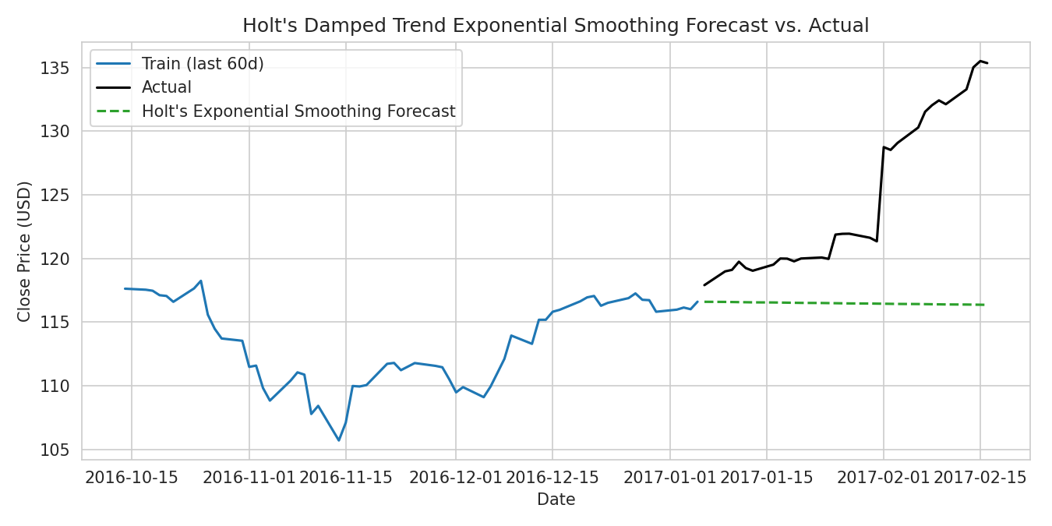
Figure 4. Holt's damped-trend exponential smoothing 30-day forecast vs. actual closing price.

4. Model Diagnostics
Residual diagnostics were run on the ARIMA(1,1,1) model to check whether its assumptions were satisfied: residuals should resemble white noise, with no remaining autocorrelation and approximately normal distribution.
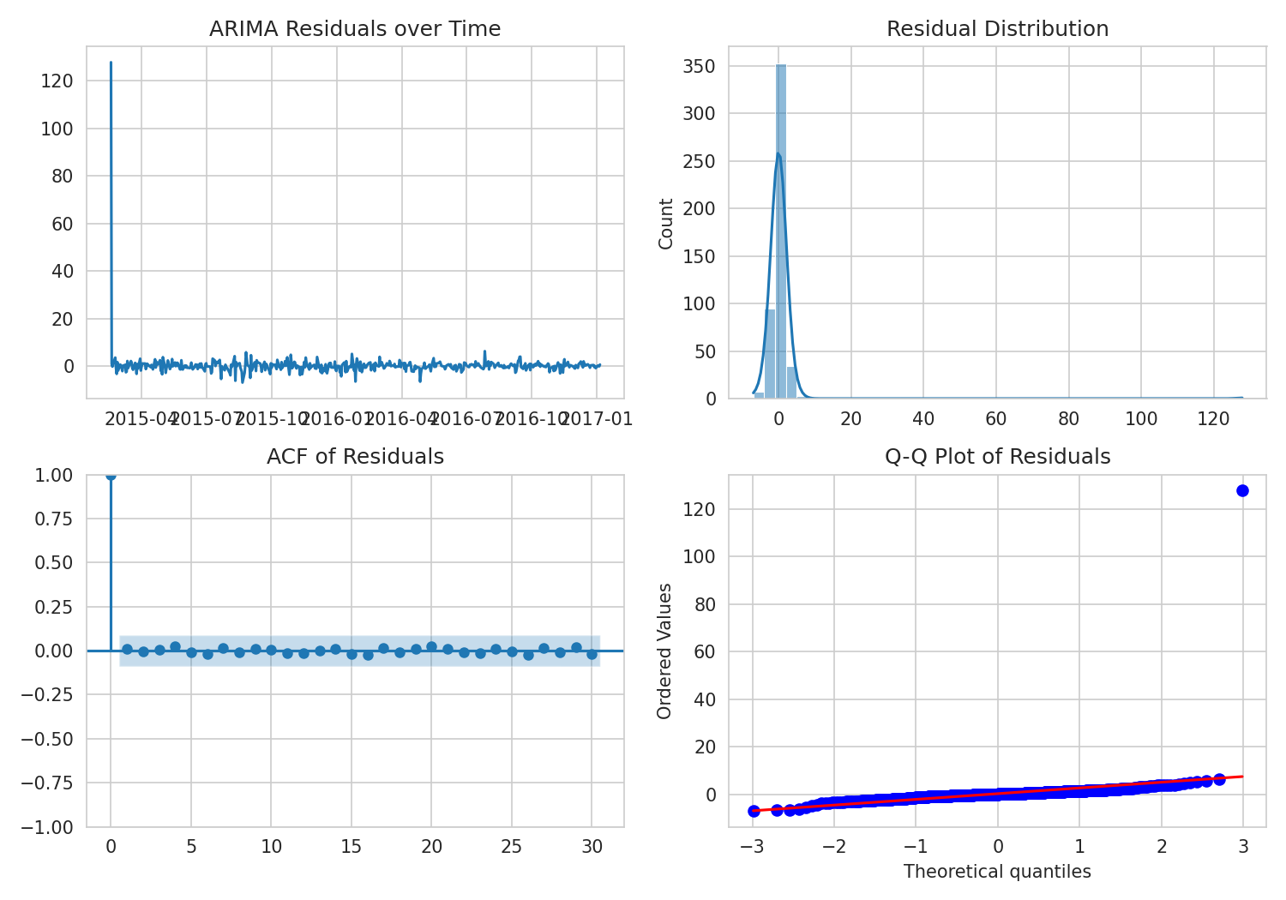
Figure 5. ARIMA residual diagnostics: time plot, distribution, ACF, and Q-Q plot.
The residual time plot shows no obvious remaining trend, and the ACF of residuals shows no significant autocorrelation at any lag, both consistent with a well-specified mean model. The Ljung-Box test (Q-statistic p-value of 0.38) confirms there is no significant residual autocorrelation at lag 1. However, the Jarque-Bera test rejects normality (p < 0.001), and the Q-Q plot shows heavier tails than a normal distribution — the residual skew is -0.29 and kurtosis is 5.37. This is a common and expected feature of daily financial returns: the mean structure is well captured, but the volatility itself is not constant (heteroskedasticity), which a plain ARIMA model does not account for. A GARCH-family model layered on these residuals would be a natural extension to address this.

5. Forecast Accuracy and Interpretation
Both models were evaluated on the same 30-day held-out test period using three standard error metrics: Mean Absolute Error (MAE), Root Mean Squared Error (RMSE), and Mean Absolute Percentage Error (MAPE).
Model | MAE (USD) | RMSE (USD) | MAPE
ARIMA(1,1,1) | 8.30 | 10.29 | 6.43%
Holt's Damped Trend ES | 8.39 | 10.40 | 6.50%

5.1 Interpretation
The two models performed almost identically over the 30-day horizon, with ARIMA(1,1,1) holding a very slight edge (MAPE 6.43% vs. 6.50%). This is a meaningful finding in its own right: the added complexity of ARIMA's autoregressive and moving-average terms provided negligible improvement over the much simpler Holt's trend model for this series and horizon. In practice, both models essentially forecast a near-linear continuation of the recent trend, which is expected behavior for a short-horizon equity price forecast, since daily returns are close to unpredictable (a finding consistent with the near-zero autocorrelation identified in the Week 1 return analysis).
The widening 95% prediction interval visible in Figure 3 is itself an important output: it grows steadily with the forecast horizon, correctly signaling that confidence in the point forecast degrades quickly. Neither model captured the modest upward acceleration in the actual price during the test window, which fell near the upper edge of the ARIMA confidence band — a reminder that these models forecast a central tendency, not directional moves driven by news or earnings events.

5.2 Business implications
For short-term operational use cases — such as setting a baseline expectation for treasury cash-flow planning or a naive benchmark for algorithmic trading strategies — either model provides a reasonable, low-cost baseline with an honestly-quantified uncertainty band. However, a MAPE of roughly 6% over 30 days means point forecasts should not be used alone for directional trading decisions; the prediction interval, not the point estimate, is the more decision-relevant output. For applications requiring sharper volatility estimates (e.g., options pricing or risk-limit setting), a volatility-explicit model such as GARCH, fit on top of these residuals, is recommended rather than relying on ARIMA's constant-variance assumption.

6. Conclusion and Next Steps
This exercise demonstrates a complete, diagnostic-driven forecasting workflow: testing for stationarity, using ACF/PACF and decomposition to justify model structure, fitting both an ARIMA and an exponential smoothing model, and evaluating them out-of-sample with multiple error metrics and residual diagnostics. Both models produced statistically valid, comparably accurate 30-day forecasts, with ARIMA offering a marginal accuracy edge at the cost of added complexity.
Recommended next steps: extend the comparison to a longer forecast horizon (60–90 days) to test whether ARIMA's edge grows or shrinks; fit a GARCH(1,1) model on the ARIMA residuals to explicitly forecast volatility rather than assuming it is constant; and repeat this pipeline across a peer set of technology stocks to assess whether the near-tie between ARIMA and Holt's method is a general property of large-cap equity prices or specific to this window of AAPL data.

