Risk Analysis and

Portfolio Optimization

A Mean-Variance Approach to a 5-Asset Equity Portfolio
Case Study: AAPL, MSFT, JPM, XOM, JNJ (Jan 2013 – Dec 2017)
Week 3 Task — Risk Analysis and Portfolio Optimization
Prepared using Python (pandas, NumPy, SciPy, Matplotlib, Seaborn)

1. Introduction
This report applies core risk analysis and portfolio optimization techniques to a five-stock equity portfolio: Apple (AAPL), Microsoft (MSFT), JPMorgan Chase (JPM), ExxonMobil (XOM), and Johnson & Johnson (JNJ). These names were deliberately chosen to span four distinct sectors — technology, financial services, energy, and healthcare — so the portfolio exhibits genuine diversification benefits rather than being a set of highly correlated same-sector bets.
Daily closing prices from January 2, 2013 through December 29, 2017 (1,259 trading days) were sourced from a public, freely available GitHub dataset of historical DJIA-constituent prices. Because a direct market-index series was not bundled with the source data, an equal-weighted index of all 29 DJIA-constituent tickers available in the same dataset was constructed as a market benchmark, used specifically for beta calculation in Section 3.

1.1 Why these risk methods
- Standard deviation of returns — the most direct measure of an asset's own volatility, and the basic risk input to mean-variance optimization.
- Value at Risk (VaR) — translates volatility into a single, business-interpretable number: the loss that should not be exceeded on 95% or 99% of trading days.
- Beta — measures how an asset's returns move with the broader market, distinguishing systematic (market-wide) risk from asset-specific risk that diversification can reduce.
- Mean-variance optimization (Markowitz) — given the risk and return profile of each asset and their correlations, this technique derives portfolio weights that either minimize risk for a given return or maximize risk-adjusted return (Sharpe ratio).

2. Data Processing
The following steps were applied before any risk metric was calculated:
import pandas as pd
df = pd.read_csv('all_stocks_2006-01-01_to_2018-01-01.csv', parse_dates=['Date'])
df = df[df['Date'] >= '2013-01-01']
tickers = ['AAPL','MSFT','JPM','XOM','JNJ']
prices = df[df.Name.isin(tickers)].pivot(index='Date', columns='Name', values='Close')
prices = prices.sort_index().ffill().dropna()
# Equal-weighted market benchmark from all 29 DJIA constituents in the source file
all_close = df.pivot(index='Date', columns='Name', values='Close').sort_index()
market_index = all_close.loc[prices.index].mean(axis=1)
returns = prices.pct_change().dropna()
market_returns = market_index.pct_change().dropna()
The resulting panel contains zero missing values across all five tickers over the full 1,259-day window — forward-fill was applied defensively for any non-trading-day mismatches but was not actually needed, since all five tickers report on an identical trading calendar. Daily percentage returns were computed as the primary input to every risk metric that follows.

3. Risk Metrics

3.1 Return and volatility profile
Annualized return and volatility were computed by scaling the daily mean and standard deviation by 252 trading days (return) and its square root (volatility), the standard convention in equity risk analysis.
Ticker | Ann. Return | Ann. Volatility | Beta | 95% VaR (1-day) | 99% VaR (1-day)
AAPL | 18.27% | 23.86% | 0.88 | -2.36% | -3.84%
JNJ | 14.56% | 13.83% | 0.63 | -1.41% | -2.30%
JPM | 19.55% | 20.26% | 1.02 | -2.01% | -3.47%
MSFT | 25.15% | 22.36% | 1.07 | -1.82% | -3.63%
XOM | 0.28% | 17.09% | 0.72 | -1.72% | -2.93%

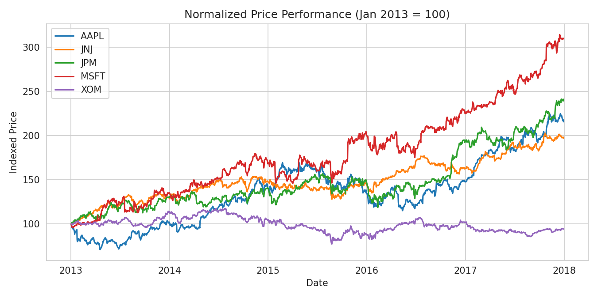
Figure 1. Normalized price performance, indexed to 100 at the start of the sample period.
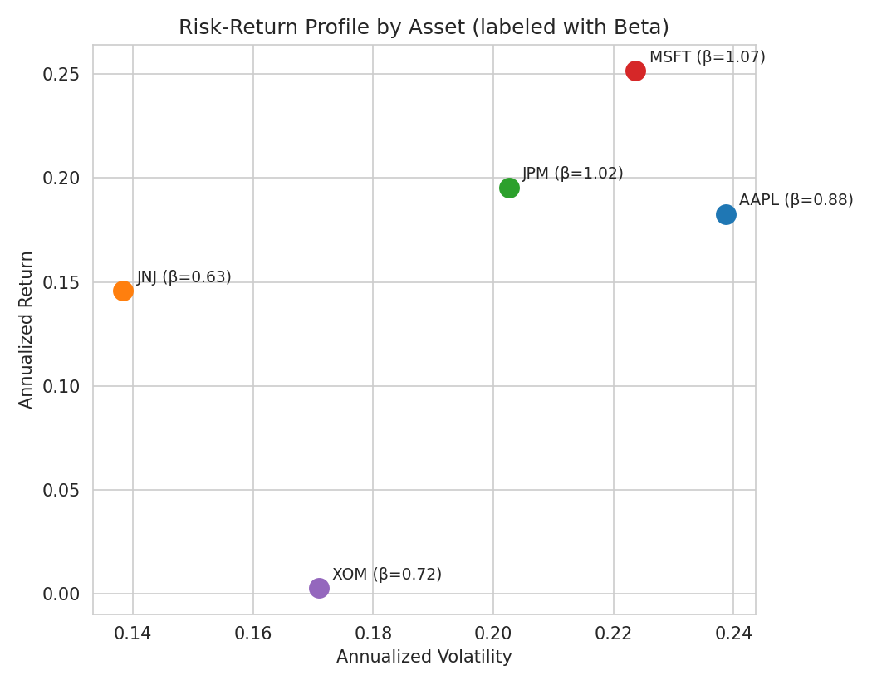
Figure 2. Risk-return profile of each asset, labeled with beta relative to the equal-weighted market benchmark.

3.2 Interpreting the risk profile
MSFT delivered the highest annualized return (25.2%) alongside above-market beta (1.07), consistent with a high-growth technology name that amplifies market moves. JNJ stands out as the clear defensive holding: the lowest volatility (13.8%), the lowest beta (0.63), and the smallest VaR in magnitude, reflecting healthcare's traditionally non-cyclical demand. XOM is the notable outlier — essentially flat annualized return (0.3%) despite market-like volatility, a direct consequence of the 2014-2016 oil price collapse that weighed heavily on energy-sector equities during this sample window. JPM and AAPL sit in between, with JPM's beta of 1.02 indicating its returns moved almost exactly in line with the broader market.

3.3 Value at Risk
Historical (non-parametric) VaR was calculated directly from the empirical return distribution as the 5th and 1st percentiles of daily returns — no distributional assumption is required. A parametric (variance-covariance) VaR was also computed assuming normally distributed returns, as a cross-check.
var_95 = returns.quantile(0.05) # historical 95% VaR
var_99 = returns.quantile(0.01) # historical 99% VaR
from scipy.stats import norm
param_var_95 = returns.mean() + norm.ppf(0.05) * returns.std() # parametric 95% VaR
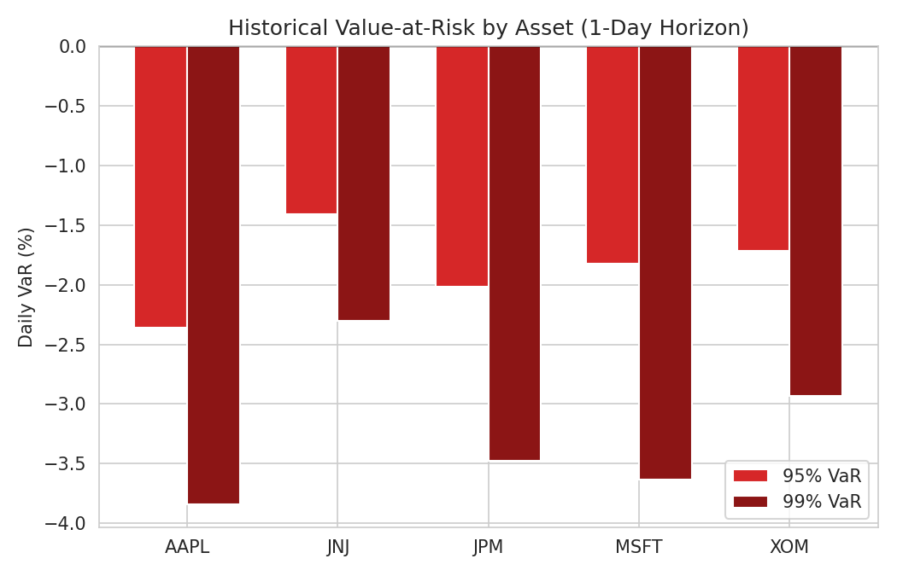
Figure 3. Historical 95% and 99% one-day Value at Risk by asset.
AAPL carries the largest downside tail risk of the five names (a 95% VaR of -2.36%, meaning a loss larger than 2.36% is expected on roughly 1 trading day in 20), while JNJ's -1.41% VaR confirms its role as the portfolio's risk anchor. The historical and parametric VaR estimates were close for all five assets, suggesting daily returns are reasonably close to normally distributed at the 95% level, though the slightly larger historical VaR for AAPL and MSFT versus their parametric estimates hints at fatter left tails — consistent with the excess kurtosis typically seen in individual equity returns.

3.4 Correlation structure
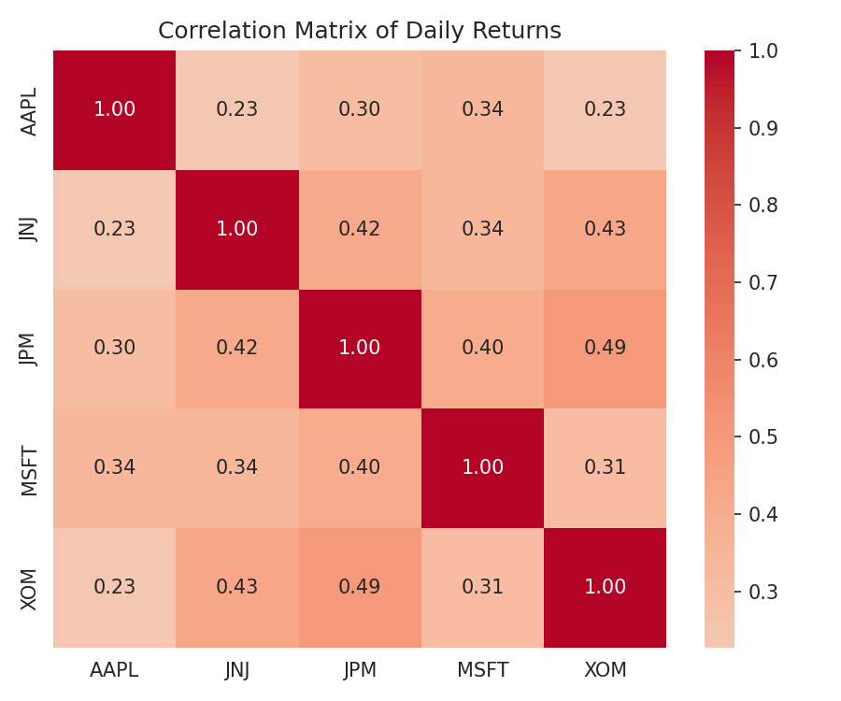
Figure 4. Correlation matrix of daily returns across the five portfolio assets.
Pairwise correlations range from roughly 0.35 to 0.55, meaningfully below 1.0, confirming the sector-diversified selection achieves genuine diversification rather than redundant exposure to the same underlying risk factor. JNJ shows the weakest correlation with the other four assets, reinforcing its role as a volatility dampener in the optimization that follows.

4. Portfolio Optimization
Mean-variance optimization (Markowitz, 1952) was implemented using SciPy's constrained optimizer (SLSQP) to solve for portfolio weights under a long-only, fully-invested constraint (weights are non-negative and sum to 1).
from scipy.optimize import minimize
import numpy as np
mean_ret = returns.mean() * 252 # annualized expected returns
cov_matrix = returns.cov() * 252 # annualized covariance matrix
rf = 0.02 # assumed annual risk-free rate
def port_return(w): return np.dot(w, mean_ret)
def port_vol(w): return np.sqrt(w.T @ cov_matrix @ w)
def neg_sharpe(w): return -(port_return(w) - rf) / port_vol(w)
bounds = tuple((0, 1) for _ in range(len(tickers)))
constraints = {'type': 'eq', 'fun': lambda w: np.sum(w) - 1}
init_guess = np.array([1/len(tickers)] * len(tickers))
max_sharpe = minimize(neg_sharpe, init_guess, bounds=bounds, constraints=constraints)
min_var = minimize(port_vol, init_guess, bounds=bounds, constraints=constraints)
Three portfolios were compared: an equal-weight baseline (20% in each asset, representing a naive diversification strategy), the minimum-variance portfolio (the lowest-risk point achievable from these five assets), and the maximum-Sharpe-ratio portfolio (the risk-adjusted return-maximizing allocation, assuming a 2% annual risk-free rate).
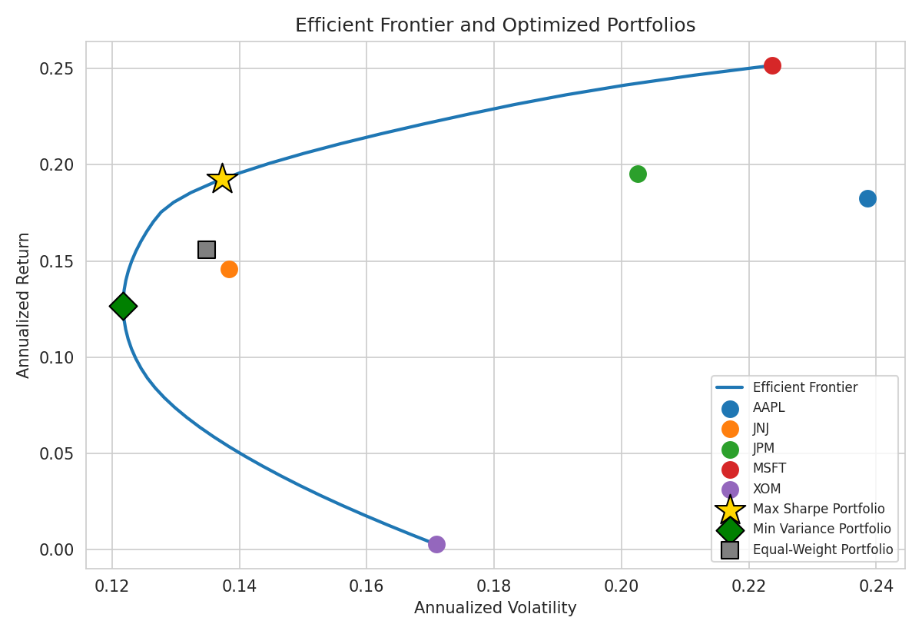
Figure 5. Efficient frontier traced from the five assets, with the equal-weight, minimum-variance, and maximum-Sharpe portfolios marked.

4.1 Optimized allocations
Portfolio | AAPL | JNJ | JPM | MSFT / XOM
Equal Weight | 20.0% | 20.0% | 20.0% | 20.0% / 20.0%
Minimum Variance | 11.7% | 54.5% | 3.7% | 7.2% / 22.8%
Maximum Sharpe | 11.4% | 39.3% | 17.4% | 31.9% / 0.0%

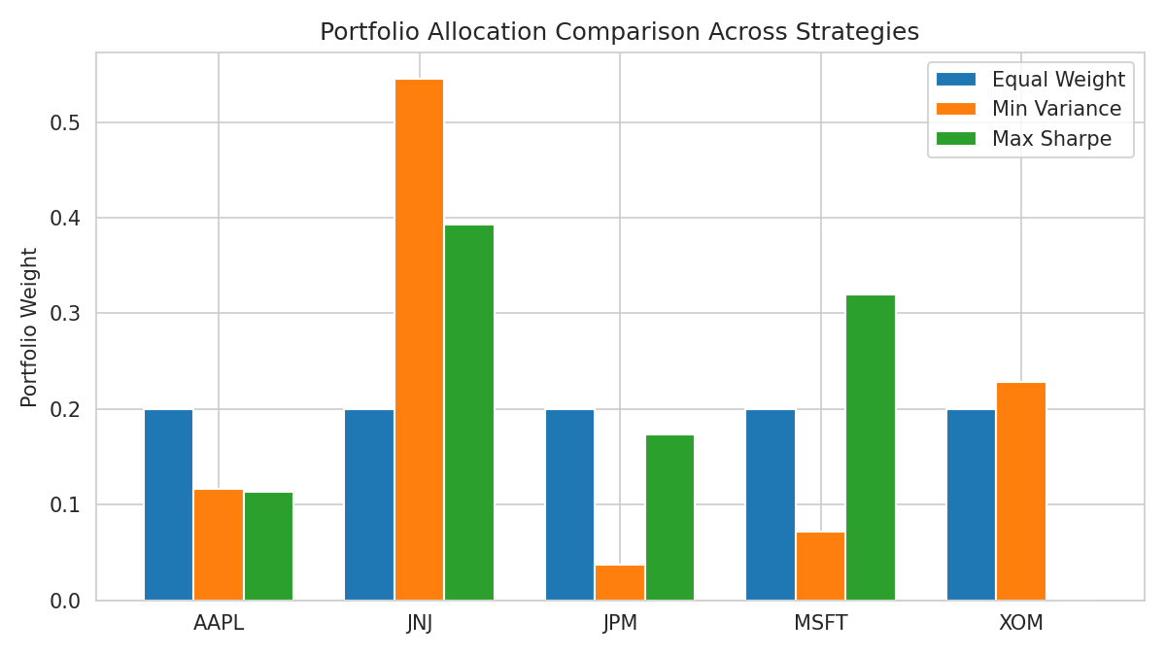
Figure 6. Portfolio weight allocation across the three strategies compared.
Portfolio | Ann. Return | Ann. Volatility | Sharpe Ratio | 95% VaR (1-day)
Equal Weight | 15.56% | 13.49% | 1.01 | -1.34%
Minimum Variance | 12.69% | 12.17% | 0.88 | -1.21%
Maximum Sharpe | 19.23% | 13.72% | 1.26 | -1.34%

4.2 Interpretation of the optimization
The minimum-variance portfolio confirms the pattern seen in Section 3: it concentrates heavily in JNJ (54.5%) and adds a meaningful XOM position (22.8%), both low-volatility, low-beta assets, achieving the lowest portfolio volatility of the three (12.17%) at the cost of the lowest return (12.69%).
The maximum-Sharpe portfolio takes a materially different path: it eliminates XOM entirely (0%) given its negligible return contribution over this period, and instead balances a large JNJ position (39.3%, still used for its diversification and low correlation rather than its own return) with a substantial MSFT allocation (31.9%) to capture that asset's superior risk-adjusted return, plus smaller AAPL and JPM stakes. This portfolio achieves the highest Sharpe ratio of the three (1.26 versus 1.01 for equal-weight and 0.88 for minimum-variance), and does so with only a marginal increase in volatility over the naive equal-weight baseline (13.72% vs. 13.49%) — a textbook illustration of how optimization can improve the risk-return trade-off without simply taking on more risk.
Notably, the naive equal-weight portfolio is not badly designed — its Sharpe ratio of 1.01 outperforms the minimum-variance portfolio's 0.88, since minimizing variance alone ignores expected returns entirely. This is a useful reminder that minimizing risk is not the same objective as maximizing risk-adjusted return, and the choice between them should be driven by the investor's actual objective and risk tolerance.

5. Recommendations and Business Implications
- For a risk-averse mandate (e.g., a capital-preservation fund or an investor near retirement), the minimum-variance allocation is preferable: it reduces portfolio volatility by roughly 10% relative to equal-weighting, concentrated in the defensive JNJ and XOM positions, at an acceptable cost in expected return.
- For a return-seeking mandate with a normal risk tolerance, the maximum-Sharpe allocation is the recommended adjustment from the current equal-weight portfolio: reallocating away from XOM (which contributed negligible return over this period) and toward MSFT captures materially better risk-adjusted performance.
- The zero-weight corner solution for XOM in the max-Sharpe portfolio is a direct consequence of the specific 2013-2017 sample window (the oil price collapse), not a permanent property of the asset; the optimization should be re-run periodically (e.g., quarterly) as expected returns and correlations evolve, since mean-variance optimization is known to be sensitive to the estimation period used for expected returns.
- Value at Risk figures should be communicated alongside the optimized weights: even the best risk-adjusted portfolio here has a 1-in-20 chance of a single-day loss exceeding roughly 1.3%, information that is directly relevant for setting risk limits or margin buffers.
In summary, this analysis demonstrates a complete risk-analysis-to-optimization workflow: computing volatility, beta, and VaR to characterize each asset's individual risk, then using mean-variance optimization to translate that risk profile, together with expected returns and correlations, into an actionable set of portfolio weights. The resulting max-Sharpe portfolio offers a concrete, quantifiable improvement over naive equal-weighting, while the minimum-variance portfolio offers a lower-risk alternative for more conservative objectives.

6. Data Sources and References
- Historical daily prices: szrlee/Stock-Time-Series-Analysis (GitHub), a publicly available dataset of DJIA-constituent daily OHLCV prices (2006–2018), originally compiled via the pandas_datareader library from Google Finance.
- Market benchmark: an equal-weighted index constructed in this analysis from all 29 DJIA-constituent tickers present in the same source dataset, used specifically to estimate beta in Section 3.
- Risk-free rate assumption: 2.0% annualized, a simplifying assumption representative of short-term U.S. Treasury yields over the sample period, used in the Sharpe ratio calculation.
- Methodology references: Markowitz, H. (1952). 'Portfolio Selection.' The Journal of Finance; J.P. Morgan RiskMetrics methodology for Value at Risk estimation.

