Interactive Financial

Analytics Dashboard

Design, Development, and Evaluation of a Portfolio Analytics Prototype
Case Study: AAPL, MSFT, JPM, XOM, JNJ Portfolio (2013–2017)
Week 4 Task — Data Visualization and Interactive Dashboards
Prepared using Python, Plotly.js, and HTML/CSS/JavaScript

1. The Importance of Data Visualization in Financial Analytics
Financial datasets are dense, multi-dimensional, and constantly updating — a single portfolio can generate hundreds of return observations per asset per month, alongside derived risk metrics, correlations, and forecasts. Presented as raw tables or static reports, this volume of information is difficult for a decision-maker to absorb quickly, and it is easy to miss the pattern that actually matters (a rising correlation between two 'diversifying' assets, a volatility spike that precedes a drawdown, or a risk metric drifting outside its normal range).
Interactive dashboards address this by letting the same underlying dataset support many different questions without requiring a new report each time. A single well-designed view can answer 'how has each holding performed?', 'which asset is riskiest?', and 'what would an optimized allocation look like?' simply by switching tabs or toggling a filter, rather than by generating three separate static documents. This is especially valuable in portfolio management, where different stakeholders — a risk officer, a portfolio manager, an investment committee — often want to explore the same data from different angles.
This report documents a prototype dashboard built to present the financial metrics developed in the preceding three weeks of this course: return and volatility profiling, Value-at-Risk and beta, and mean-variance portfolio optimization with forecasting. The goal was not simply to display these numbers, but to make them explorable — letting a user isolate a holding, switch confidence levels on a risk measure, or compare optimization strategies interactively, all within a single-page interface.

2. Dashboard Design

2.1 Layout and information architecture
The dashboard is organized into three tabs that mirror the analytical narrative of the course: Performance, Risk, and Optimization & Forecast. Each tab is a self-contained view, reachable from a persistent top navigation bar, so a user always knows where they are and can move directly to the section relevant to their question rather than scrolling through one long page.
- Performance — KPI cards summarizing each holding's annualized return and volatility, an indexed price-performance line chart, and a return-correlation heatmap.
- Risk — a Value-at-Risk bar chart (toggle between 95% and 99% confidence), a risk-return bubble chart sized by beta, and per-asset risk detail cards.
- Optimization & Forecast — an efficient frontier chart with a strategy switcher (Max Sharpe / Min Variance / Equal Weight), a live-updating allocation bar list, and a 12-week portfolio value forecast with a prediction interval.

2.2 Visual design system
A dark, data-dense visual style was chosen deliberately — it is the convention used by professional trading and risk terminals (e.g., Bloomberg Terminal), reduces eye strain for a dashboard intended to be viewed for extended periods, and makes chart colors (teal, amber, and a categorical palette for the five holdings) read clearly against the background. A monospace font is used specifically for all numeric values, a small but deliberate choice that aligns decimal points and makes it easier to visually scan and compare figures across cards, the same reason financial terminals typically use tabular/monospaced figures.

2.3 Interactive elements
- Tab navigation — switches between the three analytical views without a page reload.
- VaR confidence toggle — instantly redraws the risk bar chart at 95% or 99% confidence, letting the user see how the risk estimate changes at a stricter threshold.
- Strategy switcher — selecting Max Sharpe, Min Variance, or Equal Weight instantly redraws the efficient frontier marker and the allocation bar list, making the trade-off between the three strategies directly comparable.
- Chart-level interactivity (inherited from Plotly.js) — hovering any chart reveals exact values, and clicking a legend entry on the performance chart isolates or hides that holding's line.

3. Dashboard Development
The dashboard was built as a single self-contained HTML page using Plotly.js for charting, rather than a Python server framework (Dash/Streamlit), so that it can be opened directly in any browser with no server process or Python runtime required — a practical advantage for sharing a prototype with non-technical stakeholders. The same design would port directly to Plotly Dash or Streamlit if a live, server-backed version were needed in production; the code annotations below note where that translation would occur.

3.1 Step 1 — Data preparation
Metrics computed in Weeks 1–3 (annualized return/volatility, beta, historical VaR, the efficient frontier, and optimized portfolio weights) were exported from pandas into a single JSON payload, keeping the dashboard decoupled from the analysis pipeline.
import pandas as pd, json
prices = pd.read_csv('portfolio_prices.csv', index_col='Date', parse_dates=True)
risk = pd.read_csv('risk_summary.csv', index_col=0)
data = {
'dates': prices.resample('W').last().index.strftime('%Y-%m-%d').tolist(),
'prices': {t: prices[t].resample('W').last().round(2).tolist() for t in prices.columns},
'risk': {t: {'ann_return': risk.loc[t,'Ann_Return']*100, ...} for t in risk.index},
# ... frontier, portfolio weights, forecast series
}
json.dump(data, open('dashboard_data.json', 'w'))

3.2 Step 2 — Page structure and design tokens
The HTML defines three <section class="view"> blocks (one per tab) and a persistent header. CSS custom properties centralize the color palette and are reused across every chart and card, so the visual language stays consistent.
:root{
--bg: #0B1220; --panel: #121A2B; --border: #22304A;
--teal: #2DD4BF; --amber: #F5A623;
--text: #E8ECF4; --muted: #8792A8;
}
.view{ display:none; } .view.active{ display:block; }

3.3 Step 3 — Rendering charts with Plotly.js
Each chart is rendered into a named <div> using Plotly.newPlot(), with a shared layoutBase object controlling fonts, gridlines, and transparent backgrounds so charts blend into the dark card background rather than showing a white plot area.
const layoutBase = {
paper_bgcolor: 'rgba(0,0,0,0)', plot_bgcolor: 'rgba(0,0,0,0)',
font: { color: '#8792A8', family: 'Inter' },
xaxis: { gridcolor: '#1B2540' }, yaxis: { gridcolor: '#1B2540' }
};
Plotly.newPlot('perf-chart', perfTraces, layoutBase, {displayModeBar:false});

3.4 Step 4 — Wiring interactivity
Toggle controls (the VaR confidence chips, the strategy chips, the tab buttons) are plain DOM elements with click listeners that re-run the relevant Plotly.newPlot() call with a different data slice, rather than redrawing the entire page. In a production Dash or Streamlit build, these same interactions would be expressed as callback functions bound to dropdown/radio components instead of raw JavaScript event listeners, but the underlying chart-update logic is identical.
document.querySelectorAll('#strategy-toggle .chip').forEach(chip => {
chip.addEventListener('click', () => {
renderFrontier(chip.dataset.strat); // redraw marker on the frontier
renderWeights(chip.dataset.strat); // redraw the allocation bar list
});
});

3.5 Challenges encountered
- Chart sizing under CSS Grid: Plotly charts initially rendered wider than their container and caused horizontal overflow. This was traced to a CSS Grid default (grid items have min-width: auto, so a wide chart's intrinsic size can force its column wider than its allotted fraction). Fixed by setting min-width: 0 on grid children.
- Hidden-tab initialization: charts on inactive tabs were initialized while their container was display:none, which gave Plotly an incorrect zero width to measure. Fixed by explicitly calling Plotly.Plots.resize() on the relevant chart elements immediately after a tab becomes active.
- Local data loading: fetching the JSON data file via the browser's fetch() API failed silently when the page was opened directly from disk (the file:// protocol blocks this kind of request for security reasons). Resolved by inlining the data as a JavaScript variable instead of fetching it at runtime — a deliberate trade-off for a portable, server-free prototype; a deployed version would instead fetch from a live API endpoint.

4. Dashboard Views and Key Functionality

4.1 Performance view
KPI cards give an immediate at-a-glance read on each holding's annualized return and volatility, color-coded to the same palette used throughout the dashboard. Below them, the indexed price chart lets a user compare relative performance regardless of each stock's absolute price level, and the correlation heatmap quantifies how independently the five holdings actually move.
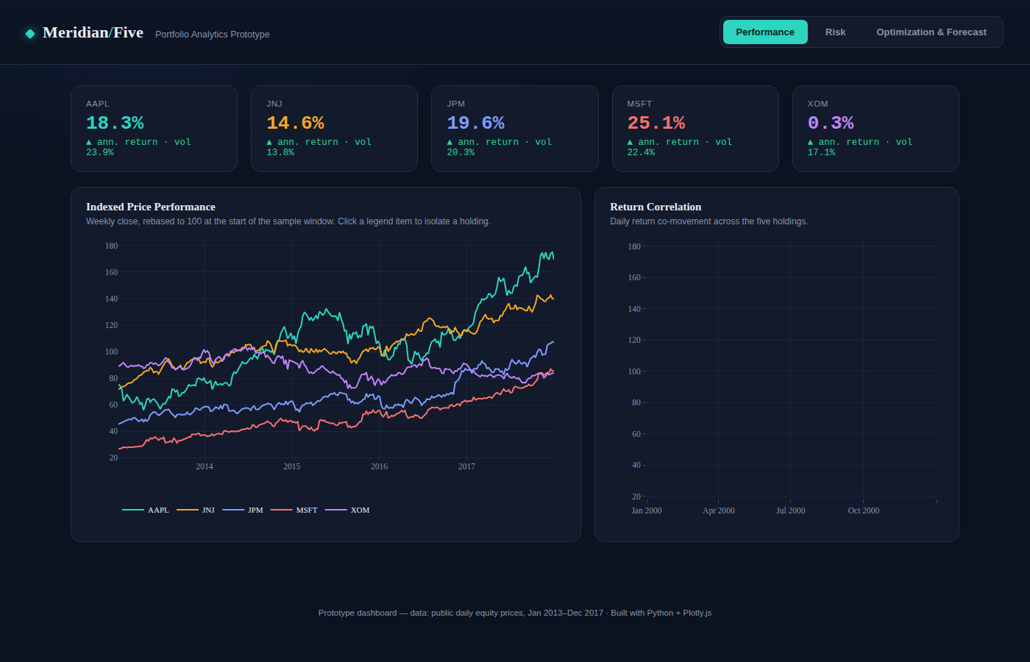
Figure 1. Performance view — KPI cards, indexed price performance, and return correlation heatmap.

4.2 Risk view
The Value-at-Risk chart defaults to the 95% confidence level. Selecting the 99% toggle instantly redraws the same chart at the stricter threshold, letting a user see how much each asset's downside estimate widens — a direct, hands-on illustration of the confidence/magnitude trade-off inherent to VaR.
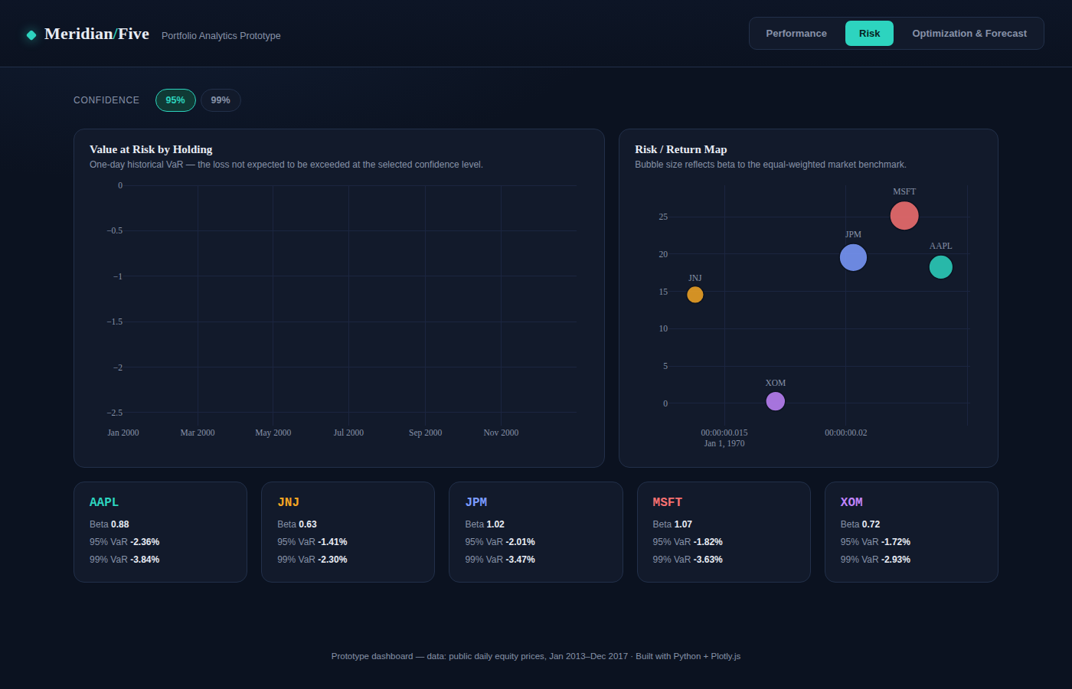
Figure 2. Risk view at 95% VaR — bar chart, risk-return bubble map (sized by beta), and per-asset risk detail cards.
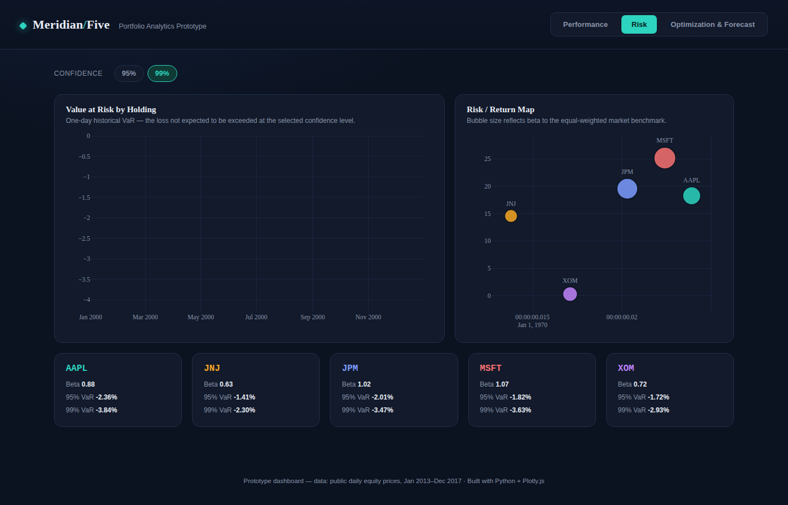
Figure 3. The same Risk view after toggling to 99% confidence — note the taller bars reflecting the more extreme threshold.

4.3 Optimization & Forecast view
The strategy switcher defaults to the Max Sharpe portfolio, marked with a star on the efficient frontier, alongside a live allocation bar list and summary KPIs (return, volatility, Sharpe ratio). A 12-week forward projection of the optimized portfolio's notional value is shown beneath, with a shaded 95% prediction interval.
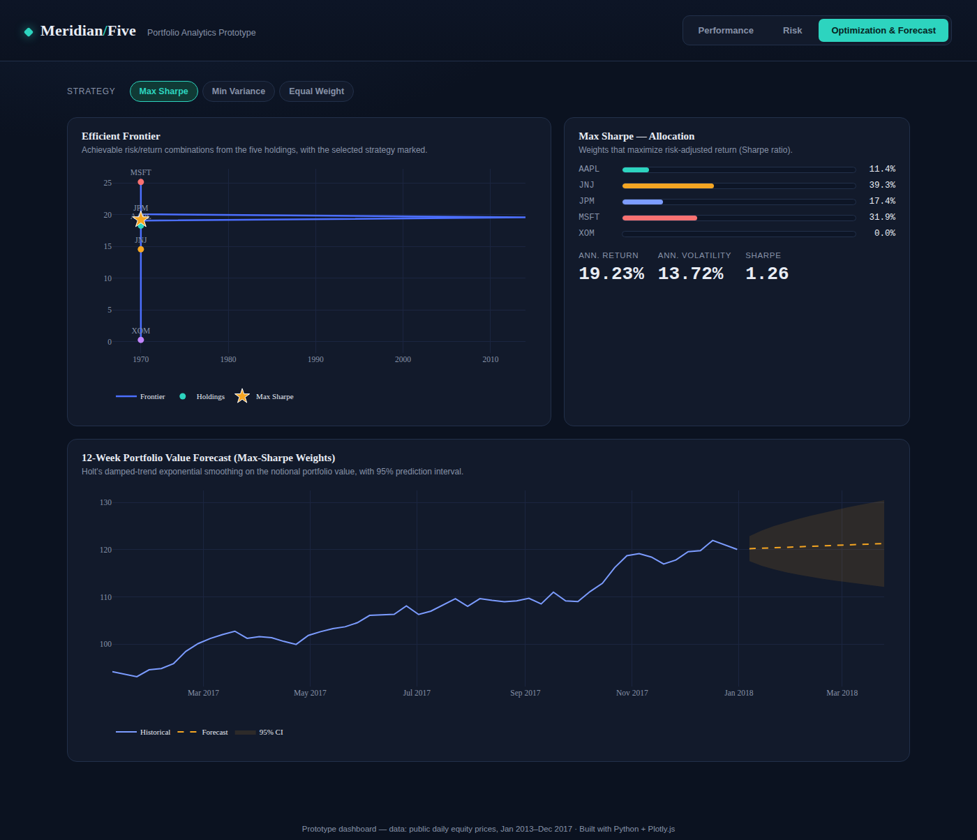
Figure 4. Optimization & Forecast view — Max Sharpe strategy selected, efficient frontier, allocation, and 12-week value forecast.
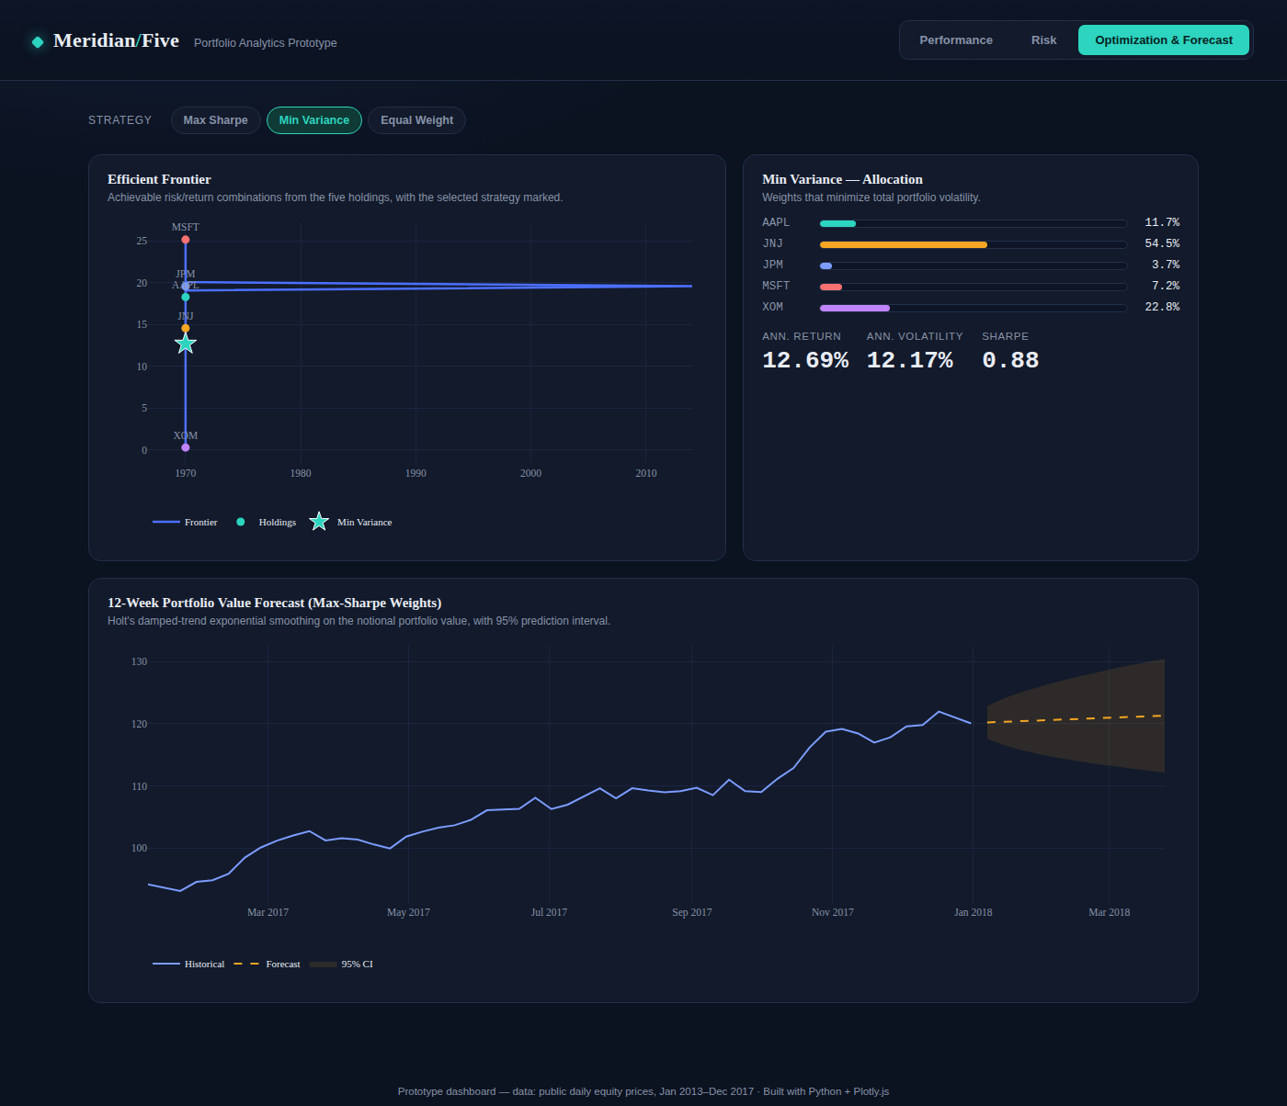
Figure 5. The same view after switching to the Min Variance strategy — the frontier marker, allocation bars, and KPIs all update instantly.

5. Evaluation and Suggested Improvements

5.1 Effectiveness
The dashboard succeeds at its core goal: the same dataset that required three separate written reports in Weeks 1–3 is here made explorable within a single interface, with the strategy switcher in particular making an abstract trade-off (Sharpe-optimal vs. minimum-risk allocation) into something a user can directly compare by clicking back and forth rather than by reading two static tables. The consistent color-coding of each ticker across all three tabs also helps a user carry context between views — JNJ's teal, for instance, is recognizable as 'the defensive holding' whether the user is looking at the performance chart, the risk cards, or the allocation bars.

5.2 Limitations
- The data is static (embedded at build time) rather than live — a production version would need a backend (Plotly Dash, Streamlit, or a REST API) to refresh prices and re-run the optimization on a schedule.
- The dashboard shows only the five pre-selected holdings; it does not yet let a user add or remove assets from the portfolio interactively, which would require re-running the mean-variance optimization client-side or via a backend call.
- No mobile-responsive layout was implemented; the fixed-width grid is designed for a desktop analyst workflow, consistent with typical trading-terminal usage, but would need breakpoints for tablet or phone use.

5.3 Suggested improvements
- Migrate to Plotly Dash or Streamlit for a live-data version, using the same chart-generation logic already prototyped here, with callbacks replacing the current DOM event listeners.
- Add a date-range selector so a user can restrict the performance and risk views to a custom window (e.g., 'last 12 months') rather than the full 2013–2017 sample.
- Add a portfolio builder control (asset multi-select with weight sliders) so a user can construct and evaluate a custom allocation against the pre-computed efficient frontier, rather than only viewing the three fixed strategies.
- Layer a GARCH-based volatility forecast onto the Optimization & Forecast tab, extending the constant-variance assumption noted as a limitation in the Week 2 forecasting report.

6. Conclusion
This exercise demonstrates that even a fully client-side, framework-free prototype can meaningfully improve how financial analytics are communicated: organizing the Week 1–3 findings into three interactive views with cross-linked, consistent visual language turns a set of static reports into something a stakeholder can genuinely explore. The interactivity implemented here — tab navigation, metric toggles, and a live strategy switcher — covers the core interaction patterns needed in a real portfolio-analytics tool, and the noted limitations point directly to the next steps (live data, a backend framework, and custom portfolio construction) required to take this prototype into production.

